ECA5701-NANOELECTRONICS  C02-5  EXPERIMENT 5 | V.NIKHITHA  192512490
MOSFET Scaling Analysis and Subthreshold Swing Calculation using NanoHub
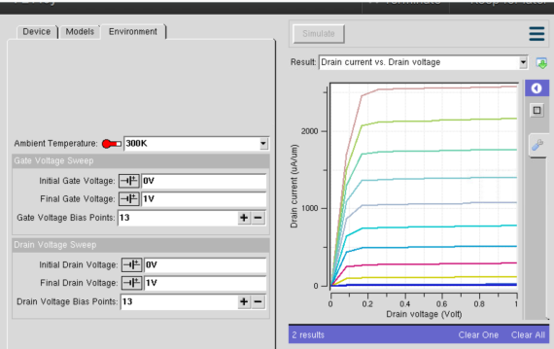 | 