**How to Download & Install Mongo DB on windows**

* **How to Download Mongo DB on Windows**

**Step 1**:

* To download, go to the link <http://www.mongodb.org/downloads> .
* Download the latest version, and a 64-bit or 32-bit version according to the system.
* Click on the **Download** button.

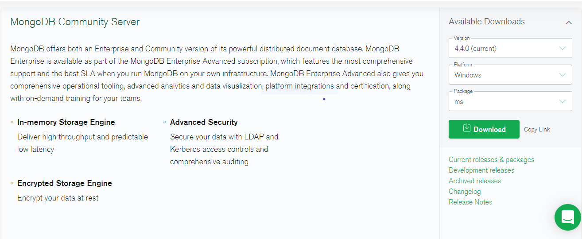

**Step 2**:

* Once the download is complete, following welcoming window will appear.
* Click **Next**.

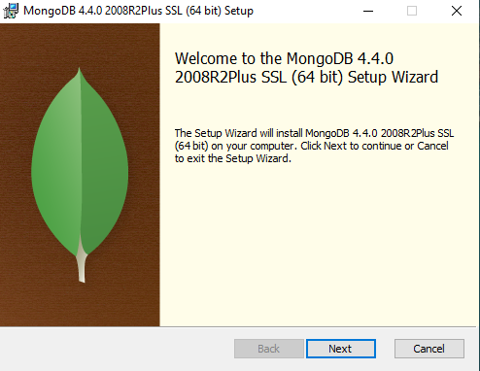

**Step 3:**

* It will ask you to accept some terms from the agreement, click in the checkbox saying **“I accept”** and then click **Next**.

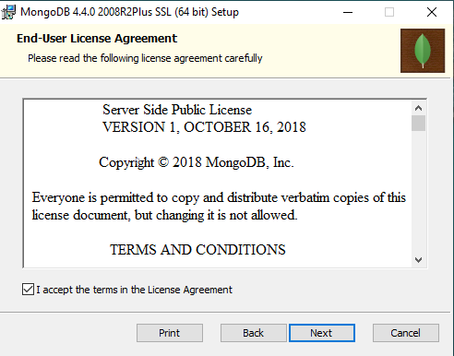

**Step 4:**

* Click on the “**Complete”** button to install all the program features.

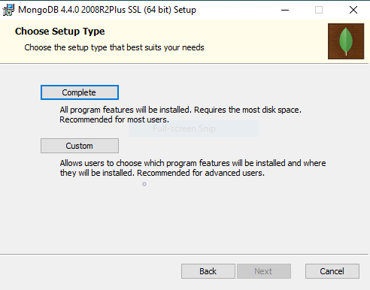

**Step 5:**

* The next step will ask you to select the service to install Mongo DB. Select “**Run service as Network Service User”.**
* Click **Next**.

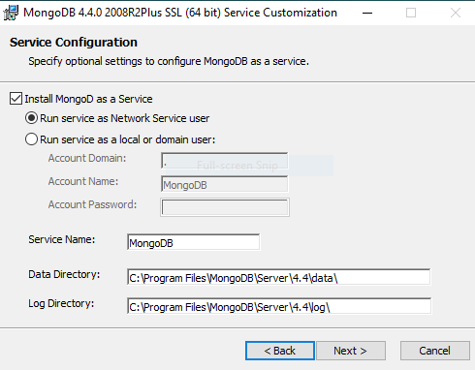

**Step 6:**

* Click the **Install** button to start the installation.

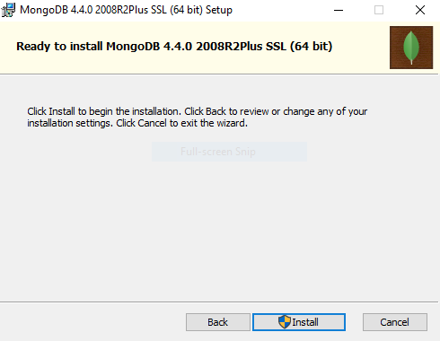

**Step 7:**

* Wait for the setup to complete the installation.

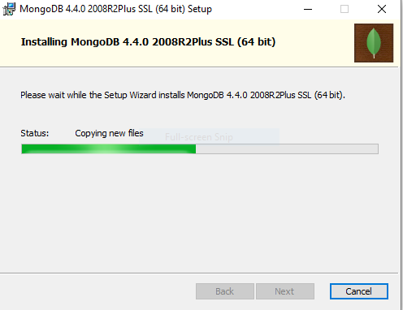

**Step 8:**

* Click the **Finish** button to complete the installation.

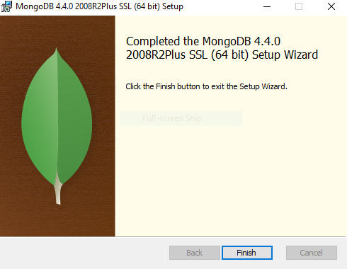

* **Hello world example : Javascript Driver**

Drivers are used for connectivity between the database and the client applications.

**For example**:

If you have some java program and there is a need to connect it with Mongo DB, for that you require Java driver so that the program can work with the Mongo DB database.

The Mongo DB shell is actually a Javascript shell. To access it, follow given steps.

**Step1:**

* Go to **“C:\Program Files\Mongo DB\Server\4.4\bin”** and open the **mongo.exe** file.

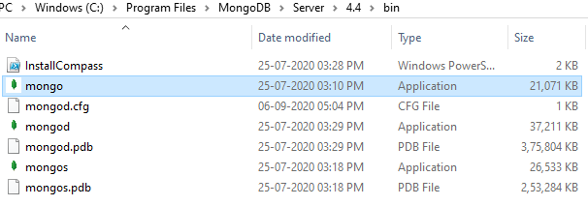

**Step2:**

* Write some code into shell to check the output.

**Example:**

> Var myMessage=’Hello world!’;

> printjson(myMessage);

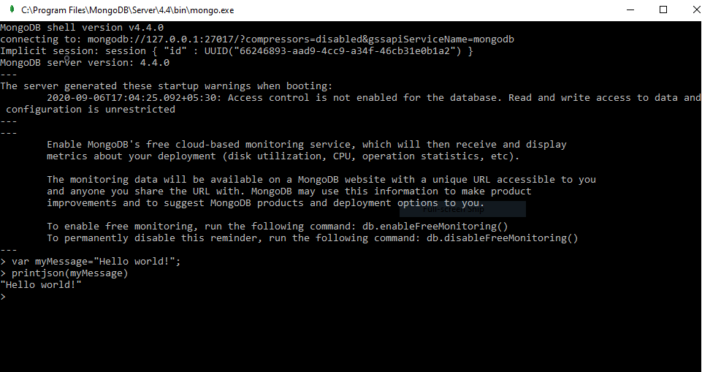

In above example, a variable **myMessage** store the string “**Hello world!**”. And **printjson** method will print that variable to the screen.

* **Install Python Driver**

1. First, ensure that you have Python installed on the system.
2. To install the driver execute the following command

**>**pip install pymongo

* **Install Ruby Driver**

1. First, ensure that you have Ruby installed on your system.
2. In this, you have to ensure that gems is updated also. With the help of following command.

**>**gem update -system

1. To install the driver execute the following command.

**>**gem install mong

* **Install MongoDB Compass**

Mongo DB compass is one of the management tool of MongoDB . It is used as a GUI for MongoDB , for managing MongoDB.

Steps to download this tool:

**Step1:**

* To download, go to the <http://www.mongodb.org/downloads> , and in the **Tools** option click on the **Download** button.

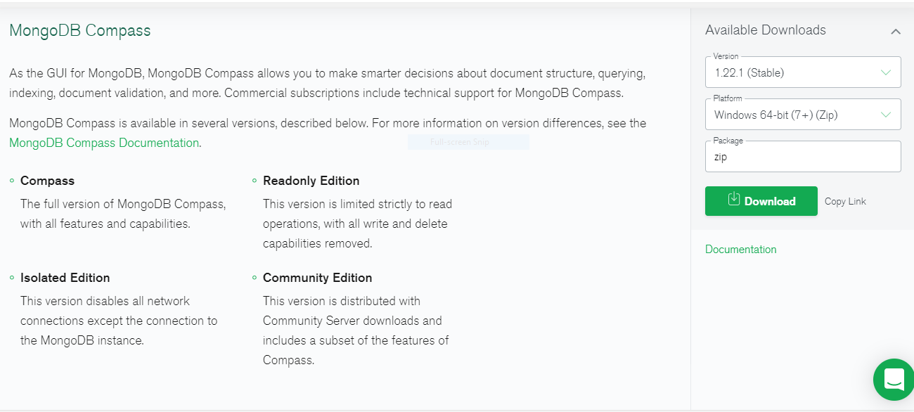

**Step2:**

* By double clicking on the downloaded file, installation will auto start.
* **MongoDB Configuration, Import, and Export**
* Before starting to work in the MongoDB server, first you have to choose the data directory where all the MongoDB data will be stored.
* After creating the directory, mongodb will create the database in that directory or location.

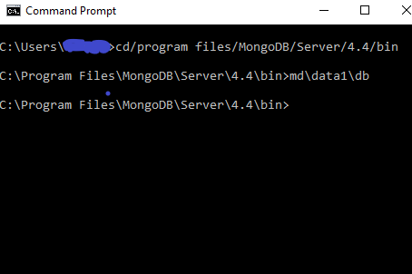

* The command **“mongoimport”** is used to import the data into MongoDB.
* And the command **“mongoexport”** will export the MongoDB.