Please change the following config values to point to the correct path of these files:

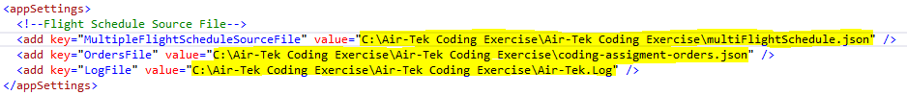

MultipleFlightScheduleSourceFile – This refers to the files schedule json file used in the USE CASE 1. Sample attached below.



OrdersFile – This refers to the order json file used in the USE CASE 2. Sample file attached below.



LogFile – This refers to the log file. No need to provide a file. But the log will be created at this path.