Bug Report – SauceDemo
- Bug ID: BUG-001
- Bug Title
Filter dropdown does not open when clicking inverted triangle icon
- Module
Product Page – Filter Functionality
- Bug Type
UI / Functional Defect
- Severity
Medium
- Priority
P2
- Environment
- Application: SauceDemo (Swag Labs)
- URL: https://www.saucedemo.com/
- Browser: Chrome (also reproducible in Firefox and edge)
- Device: Desktop
- Description
When clicking on the inverted triangle icon near the filter section, the filter dropdown does not appear. However, clicking on the filter symbol/icon correctly opens the dropdown. This creates inconsistent UI behavior and may confuse users.
- Steps to Reproduce
- Open SauceDemo website
- Login with valid credentials:
  - Username: standard_user
  - Password: secret_sauce
- Navigate to the Products page
- Locate the filter section
- Click on the inverted triangle icon
- Observe that no dropdown appears
- Click on the filter icon/symbol
- Observe that dropdown appears
- Expected Result
Filter dropdown should open when clicking on any interactive filter control (including inverted triangle icon, if intended as clickable element)
- Actual Result
- Inverted triangle icon does NOT open dropdown
- Filter icon opens dropdown successfully

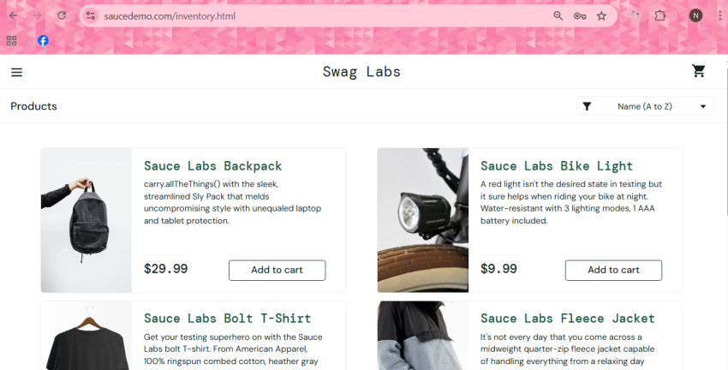
Attachments

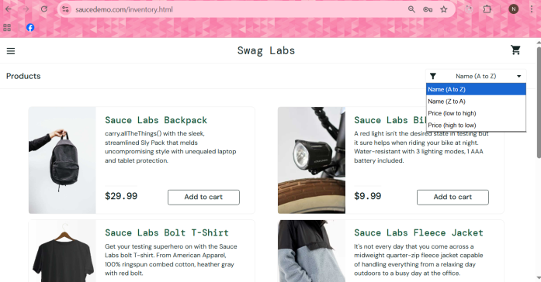

- Reproducibility
Always
- Impact
- Confusing user experience
- Inconsistent UI behavior
- Users may assume filter is broken

- Additional Notes
If the inverted triangle icon is intended to be non-interactive, then its design should be updated to avoid confusion (e.g., remove or disable pointer interaction).

BUG-002
- Title
Error message text is not user-friendly on login failure
- Module
Login
- Type
Usability Bug
- Severity
Low
- Priority
P3
- Steps
- Open login page
- Enter invalid credentials
- Click login
- Expected Result
Clear and user-friendly error message
- Actual Result
Message shows: “Epic sadface…” which is not professional
- Impact
Reduces usability and professionalism of application
- Attachment
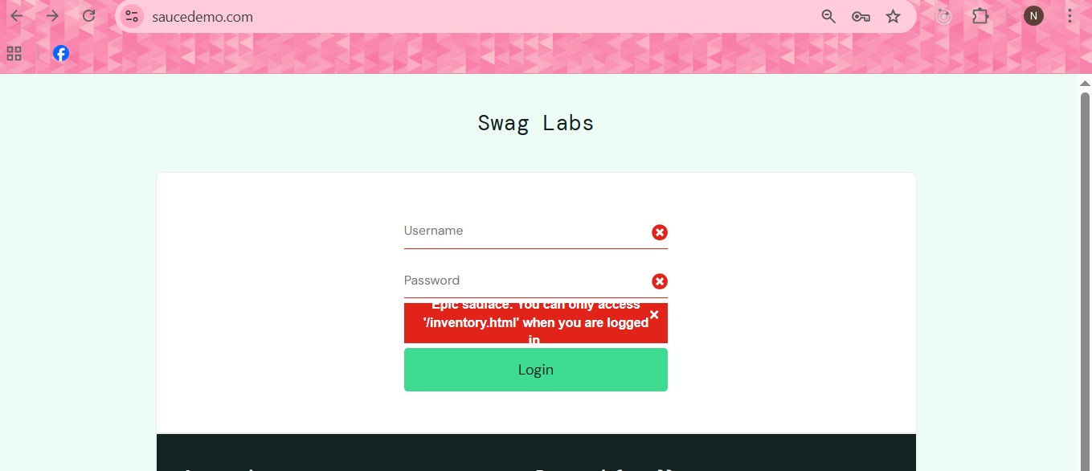

- Reproducibility
Always

