Index-HOME PAGE

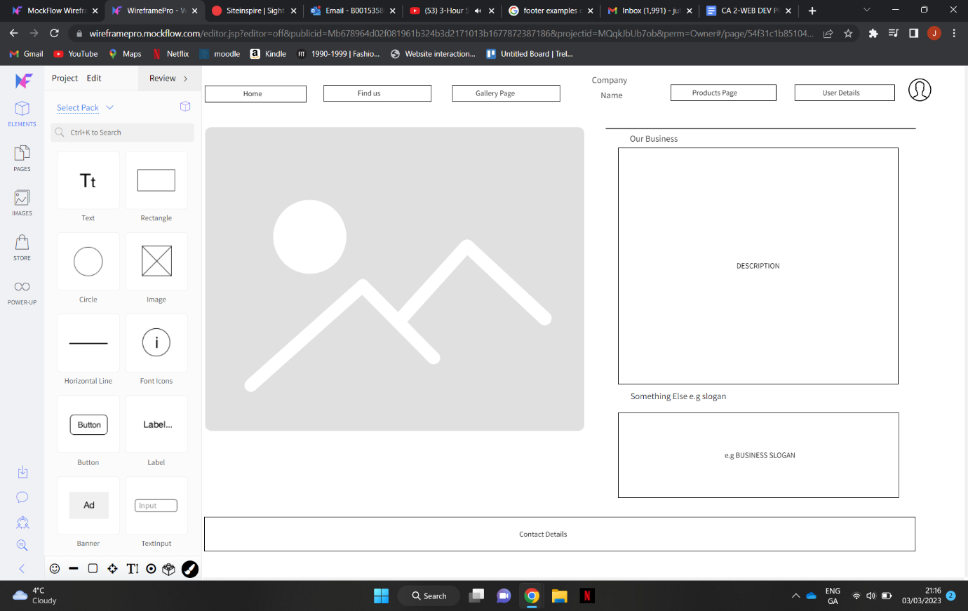

PRODUCTS PAGE

Form details

