**SAMPLE PROJECT REPORT**

**\*Note:** Below Project Report should be used as reference for preparing your own Project Report.



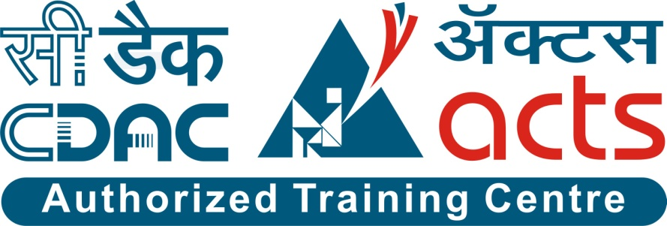

Agency Management System

PG-DAC March-2023

Documentation On

**“Agency Management System”**

PG-DAC MARCH 2023

Submitted By :

* **Preeti Sangapur 230343120063**
* **Nikita Gaikwad 230343120050**
* **Dnyaneshwari Thakare 230343120097**
* **Sampada Gole 230343120074**

**Table of Contents**

**1. Introduction 4**

1.1 Document Purpose **4**

1.2 Project Background **4**

1.3 Aim & Objectives **4**

**2. Business Requirements Overview**…………………………………………………………**5**

**3.Functional Requirements** **5**

3.1 Agency Module **5**

3.2 Customer Module **5**

3.3 Employee Module **6**

**4.** **Non-Functional Requirement………………………………………………………………6**

**5. Use Case Diagram 7**

5.1 Agency **7**

5.2 Customer **8**

**6. Database Design 10**

1 Employee **10**

2 SendEmployee **10**

3 Notification……………………………………………………………………………………………….……………………… ………..**10**

4 User **10**

5 Job_requirement **11**

**7. Snapshots 13**

**8. Conclusion 22**

1. **Introduction:**
   1. **Document Purpose:**

This document communicates the business requirements and scope for developing Agency Management System. The scope of this document is to define the functional and non-functional requirements, business rules and other constraints requirements.

## Project Background:

An agency management system is a comprehensive software solution developed to streamline and optimize the processes and workflows of agencies operating in different sectors. The system aims to centralize data, improve collaboration among team members, enhance customer relationship management, and automate routine tasks. The purpose of developing an agency management system is to address the challenges faced by agencies in handling diverse tasks such as client onboarding, communication, documentation, sales tracking, reporting, and more. The system aims to replace manual and disjointed processes with a unified digital platform, leading to increased efficiency and improved customer service.

## Aim & Objectives:

The main objective of this project is building a website for individual users who are looking for employees.

* Client Database: Develop a comprehensive database that stores and organizes client information, communication history, and transaction records.
* Communication Tools: Implement email integration, notifications, and messaging features to enable effective communication with clients and team members.
* User-Friendly Interface: Create an intuitive and user-friendly interface that requires minimal training for users to navigate and operate the system.
* Document Management: Design a system for storing, categorizing, and retrieving documents related to clients, contracts, and transactions.

1. **Business Requirements Overview:**

* Online Agency Management System is the public web application.
* Online Agency Management System will be opened to the global, but in the phase 1, the main target is limited to a specific city.
* There are mainly two types of users. One is the customer and other is employee.
* Customer can send his job post requirement to Agency.
* Agencies will search for the employees and will send the list of employee to Customer.
* Admin will verify the employees and send the notification mail to customer thereafter Customer select the employees and send mail to respective employees.
* This system provides the functions which connect the customer and the employees efficiently.

# Functional Requirements Overview:

Agency Management System consists of three modules described as below.

1. Agency
2. Customer
3. Employee

# 3.1 **Agency Module**

* The agency can make registration process as well as login process.
* The agency can make forgot password process.
* The agency can make change password process.
* Agency will get notified whenever the new job post is uploaded.
* All the notification received by the agency is maintained in the notification table in the database.
* Agency will provide the list of vacant employees to the customer as a response.

# 3.2 **Customer Module**

* Account creation process or registration process.
* Login process.
* The agency can make forgot password process.
* The agency can change password process.
* Customer will upload job post by filling the appropriate information in the job post form.
* Data of uploaded job post is maintained in the job_requirement table in database.
* Customer can select the employees from the vacant employee table sent by the particular agency.
* After selection, data of the selected employee will be maintained in the sendemployee table in the database.

# 3.3 **Employee Module**

* We have the module employee.
* Although we have the data for employee which will be kept as static in the database.
* Whenever customer will select the employee, that particular employee will get an immediate selection email message.

# 4. Non-functional Requirements

* + Response Time: The system should provide fast response times for user interactions, such as retrieving client data or generating reports.
  + Authentication and Authorization: Users should be required to authenticate before accessing the system, and access should be based on defined roles and permissions.
  + User Interface: The user interface should be intuitive, user-friendly, and consistent across different sections of the system.
  + Integration Compatibility: The system should be able to integrate with other tools or systems commonly used by the agency, such as email Employees and agency.
  + Documentation: The system should be well-documented, including user manuals, technical documentation, and code comments.
  + Modularity: The system's architecture should be modular, allowing for easier maintenance and updates without disrupting the entire system.
  + Browser Compatibility: The system's web interface should work seamlessly across different web browsers and versions.

## 5. Use-Case Diagram

**5.1 Agency:**

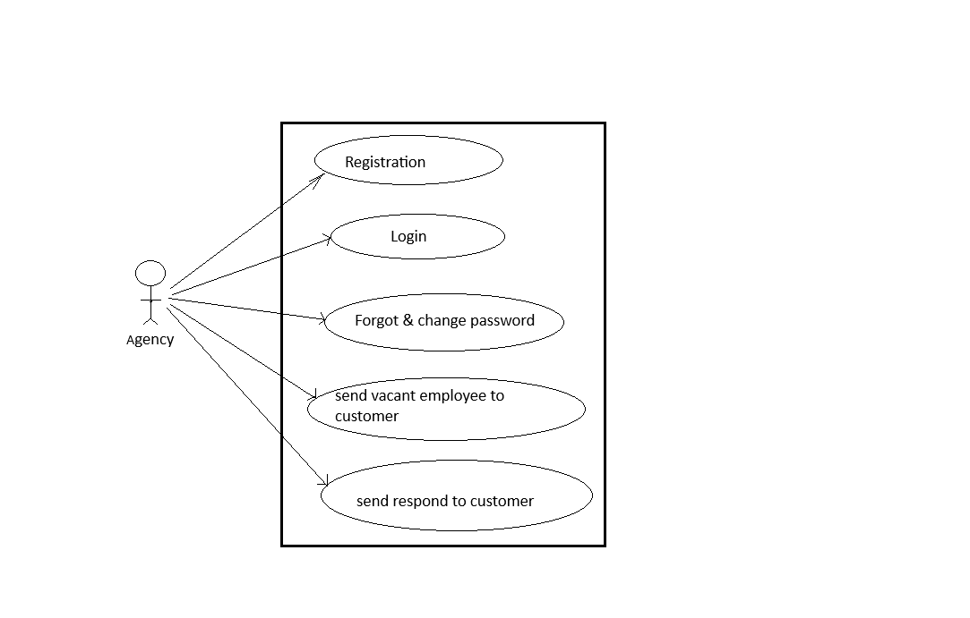

Fig. Use-Case Diagram for Admin

## 5.2 Customer

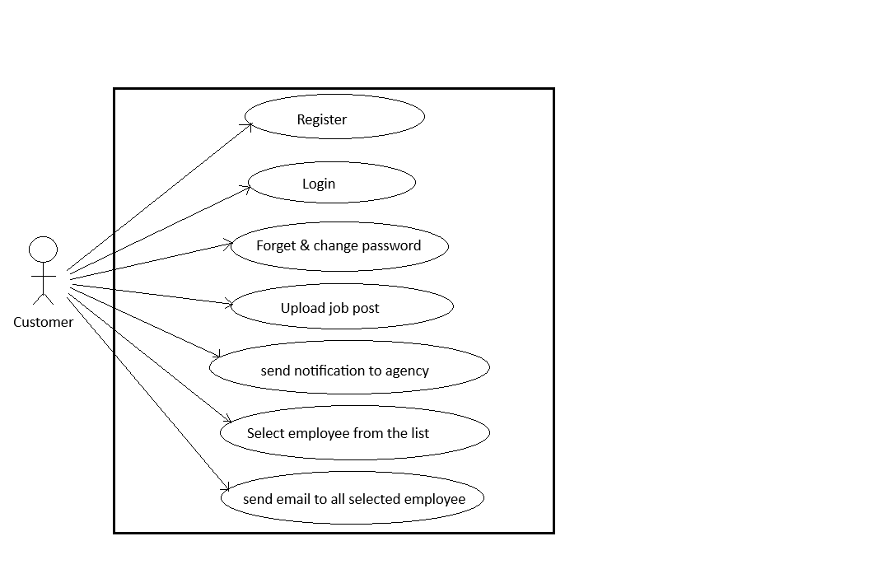

Fig. Use-Case Diagram for Tenant

**6. Database Design:**

**1]Employee Table**

|  |  |  |  |  |  |
| --- | --- | --- | --- | --- | --- |
| **Field** | **Type** | **Null** | **Key** | **Default** | **Description** |
| Id | int | Not Null | Primary key | Auto_increment | Employee ID |
| name | Varchar(20) | yes |  | NULL | Employee name |
| Email | Varchar(20) | yes | unique | NULL | Employee email |
| dob | date | yes |  | NULL | Employee DateOfBirth |
| qualification | Varchar(30) | yes |  | NULL | Employee qualification |
| agencyid | int | yes |  | NULL | Employee agency id |
| status | Varchar(10) | yes |  | vacant | Employee status |
| mobile | Varchar(11) | No |  | NULL | Employee mobile number |

**2] SendEmployee Table**

|  |  |  |  |  |  |
| --- | --- | --- | --- | --- | --- |
| **Field** | **Type** | **Null** | **Key** | **Default** | **Description** |
| id | Integer | Not Null | Primary key |  | Employee ID |
| Customerid | Integer | Yes |  | NULL | Customer ID |
| empid | Integer | Yes |  | NULL | Employee ID |
| jobid | Integer | Yes |  | NULL | Job ID |
| agencyid | Integer | Yes |  | NULL | Agency ID |
| status | Varchar(10) | Yes |  | Vacant | Status of Employee |

**3] Notification Table**

|  |  |  |  |  |  |
| --- | --- | --- | --- | --- | --- |
| **Field** | **Type** | **Null** | **Key** | **Default** | **Description** |
| id | Integer | Not Null | Primary key | Auto_increment | Notification id |
| Message | Varchar(150) | Yes |  | Null | Notification Message |
| jobid | Integer | Yes |  | Null | Job id |
| empid | Integer | Yes |  | 0 | Employee id |

**4] User Table**

|  |  |  |  |  |  |
| --- | --- | --- | --- | --- | --- |
| **Field** | **Type** | **Null** | **Key** | **Default** | **Description** |
| User_id | Integer | Not Null | Primary key | Auto_Increment | User id |
| name | Varchar(50) | yes |  | Null | User name |
| email | Varchar(45) | yes |  | Null | User email |
| mobile | Varchar(11) | yes | Unique | Null | User mobile |
| password | Varchar(20) | yes |  | Null | User password |
| role | Varchar(11) | Yes |  | Null | User role |
| agencyid | integer | Yes |  | 0 | Agency id |

**5] Job_requirement Table**

|  |  |  |  |  |  |
| --- | --- | --- | --- | --- | --- |
| **Field** | **Type** | **Null** | **Key** | **Default** | **Description** |
| id | Integer | NOT NULL | Primary key | AUTO_INCREMENT | Job id |
| Job_type | Varchar(30) | yes |  | NULL | Type of the job |
| No_of_emp | Integer | yes |  | NULL | Number of employee |
| Job_desc | Varchar(45) | yes |  | NULL | Job description |
| qualification | Varchar(10) | yes |  | NULL | Qualification of employee |
| Time_period | Varchar(30) | Yes |  | No Bond | Time Period |
| salary | Integer | Yes |  | Null | Salary of employee |
| userid | Integer | Yes |  | Null | Id of the user |

**8. Snapshots:**

**8.1 Home Page:**

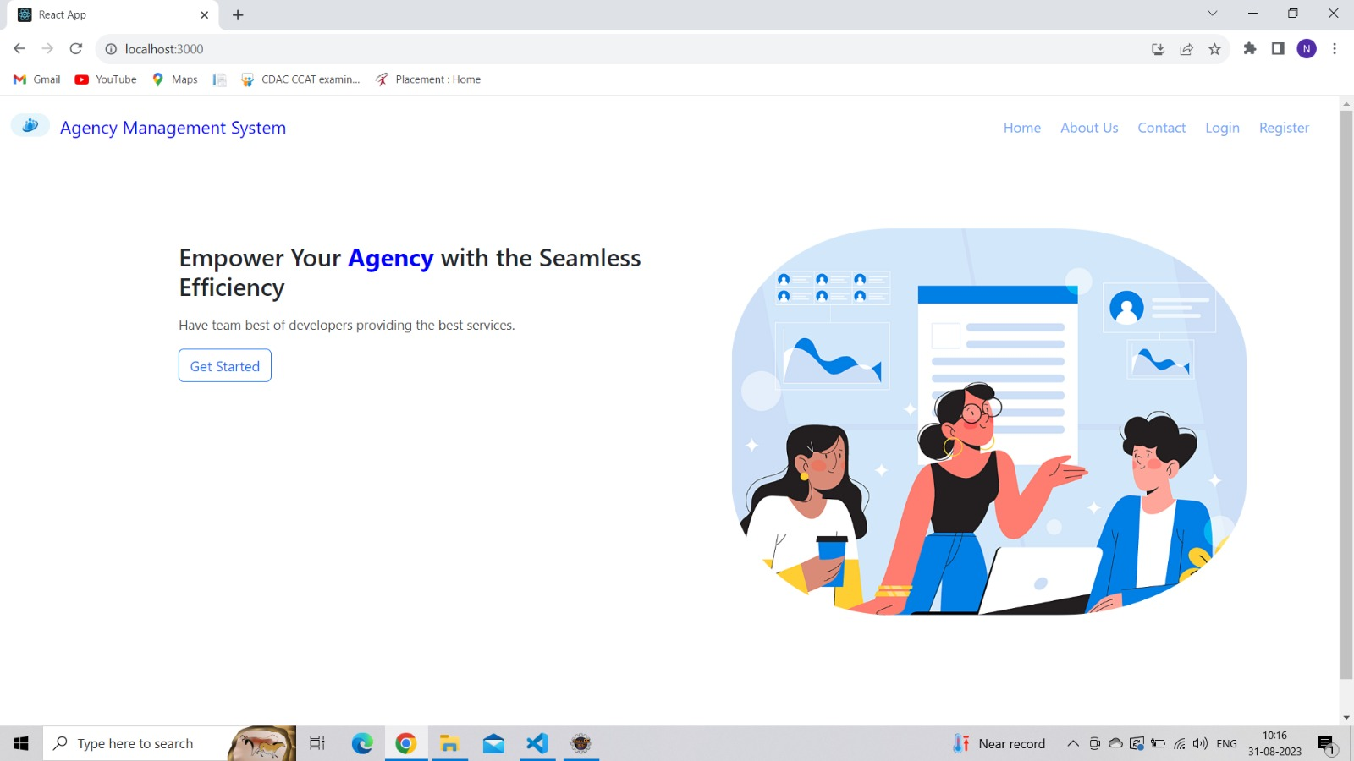

**8.2 Register Page**

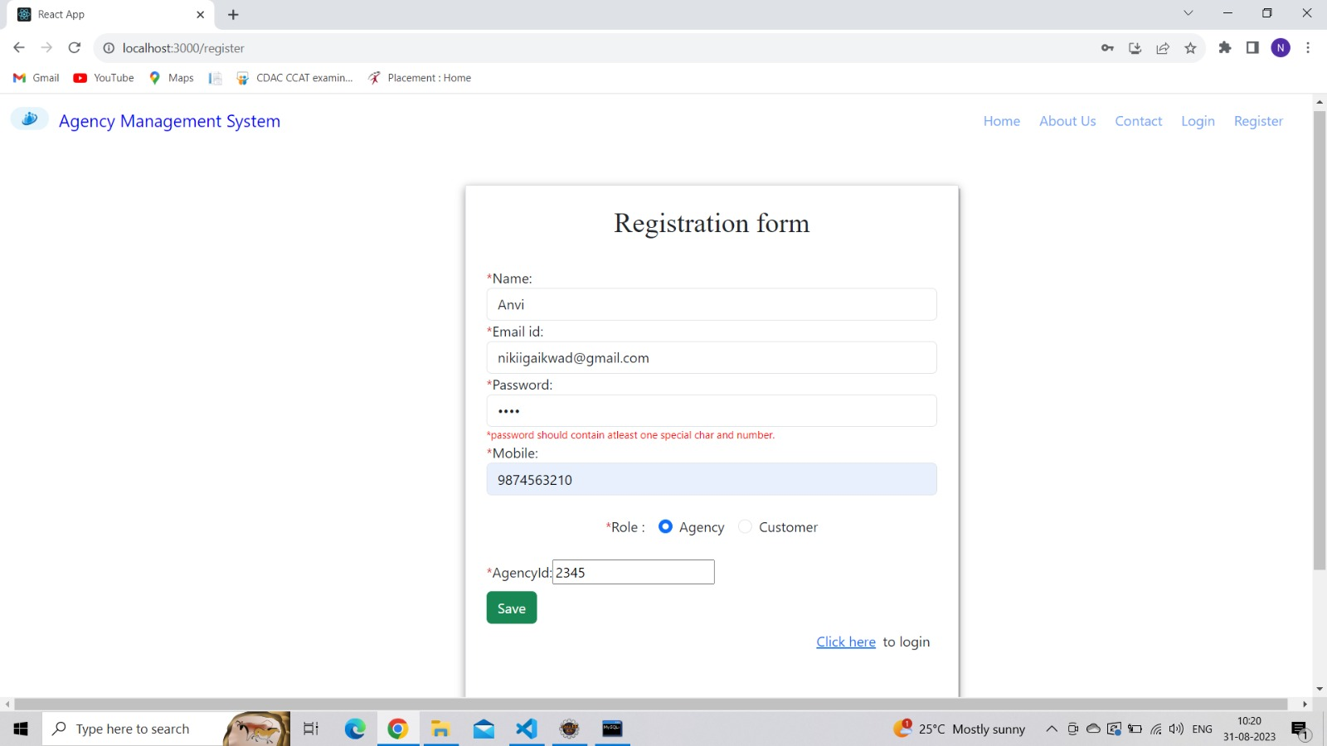

**8.3 Login Page**

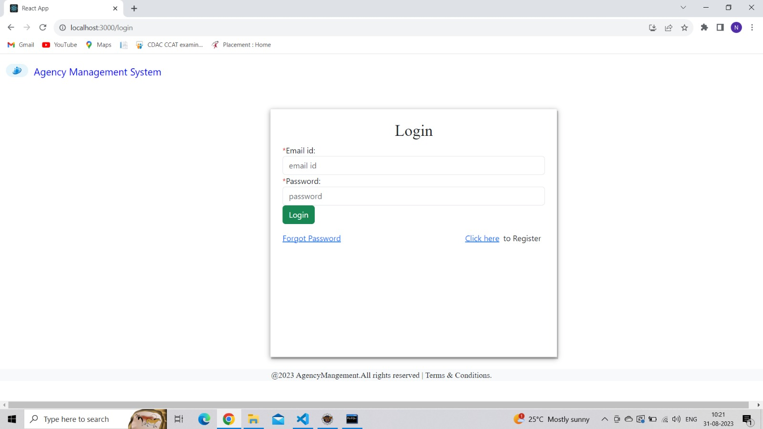

**8.4 About Us Page**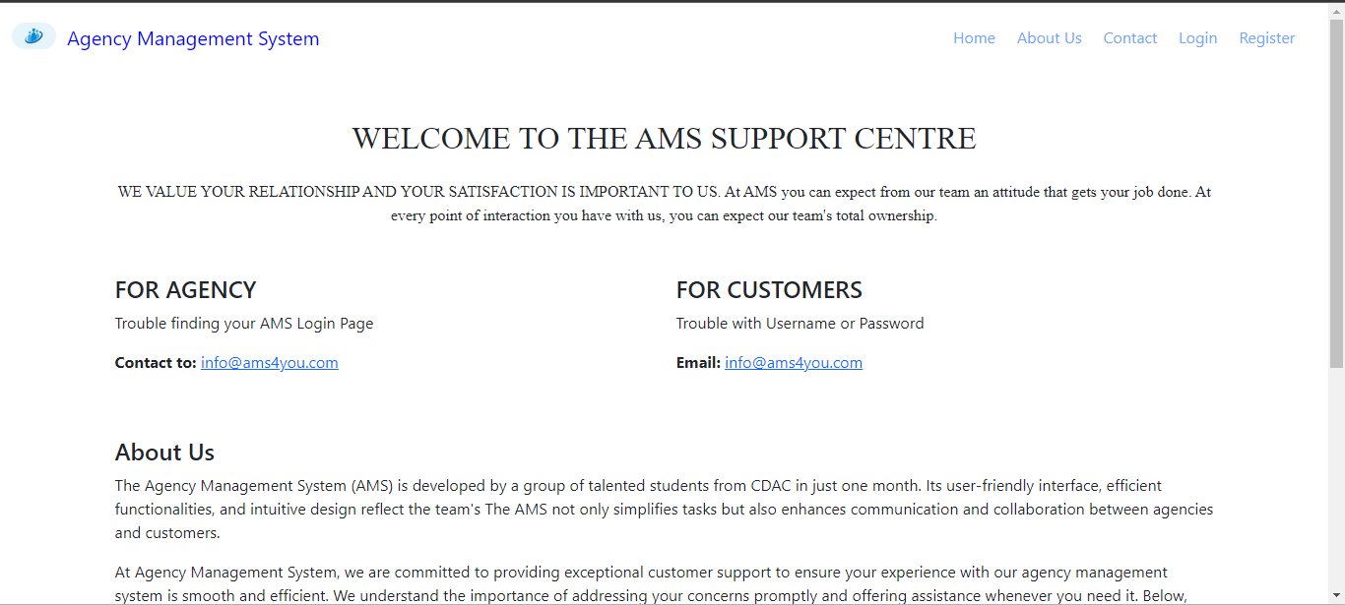

**8.4.1 Contact Us Page**

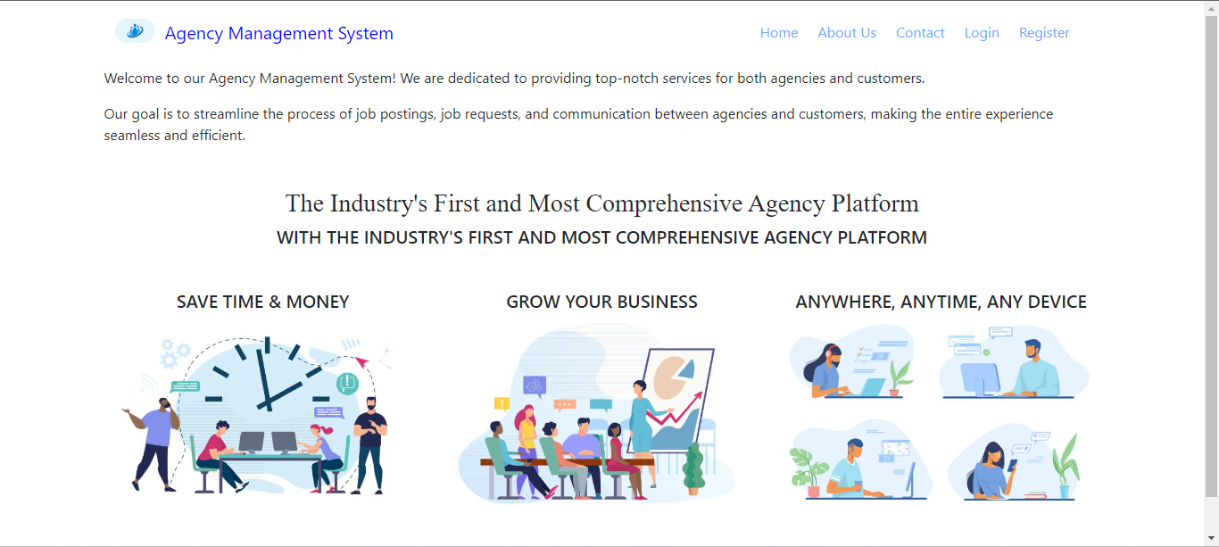

**8.4.2 Customer Dashboard Page**

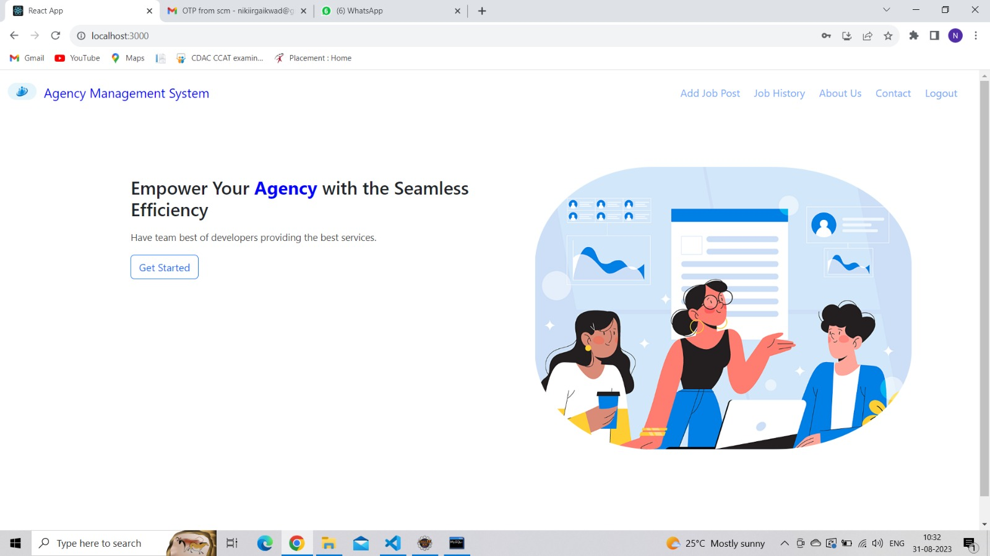

**8.4.3 Forget Password page**

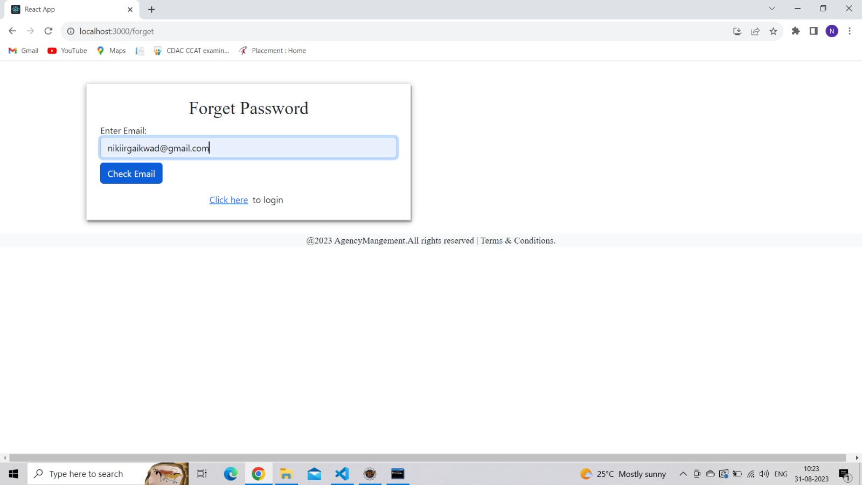

**OTP match**

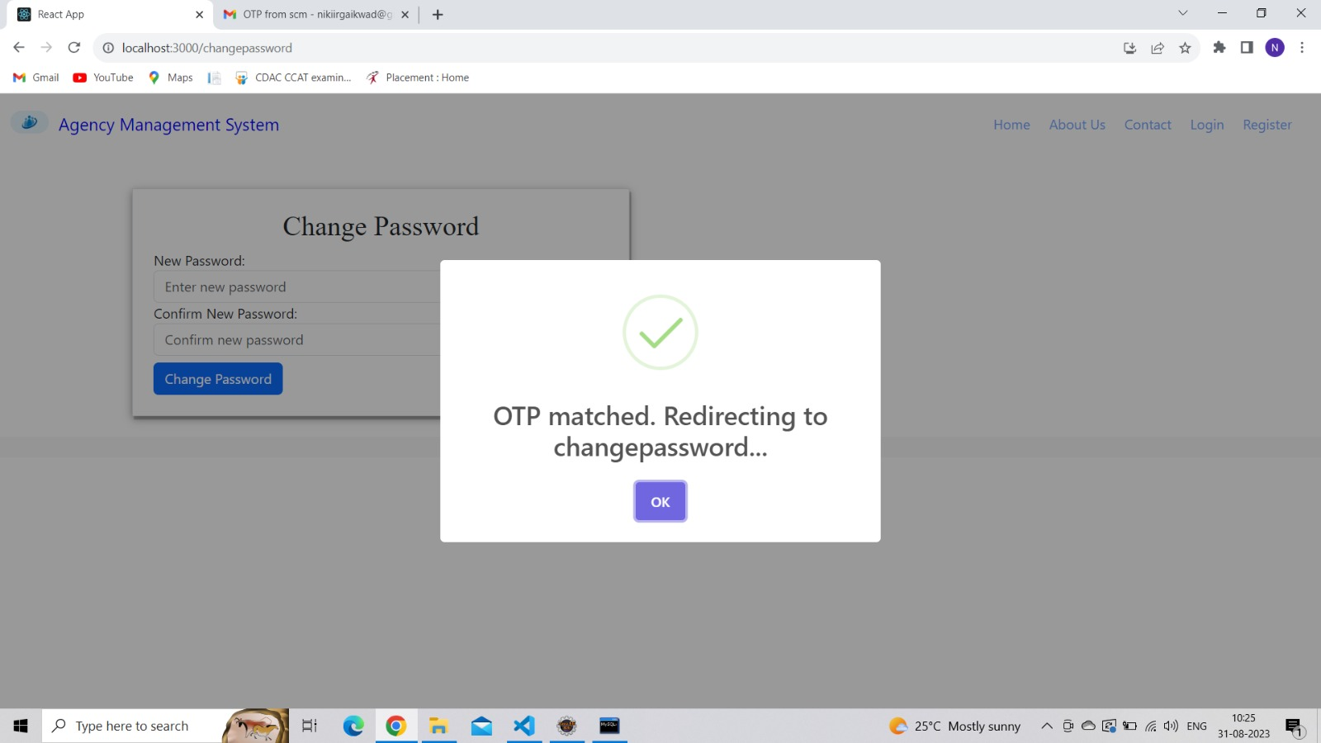

**Password change successful**

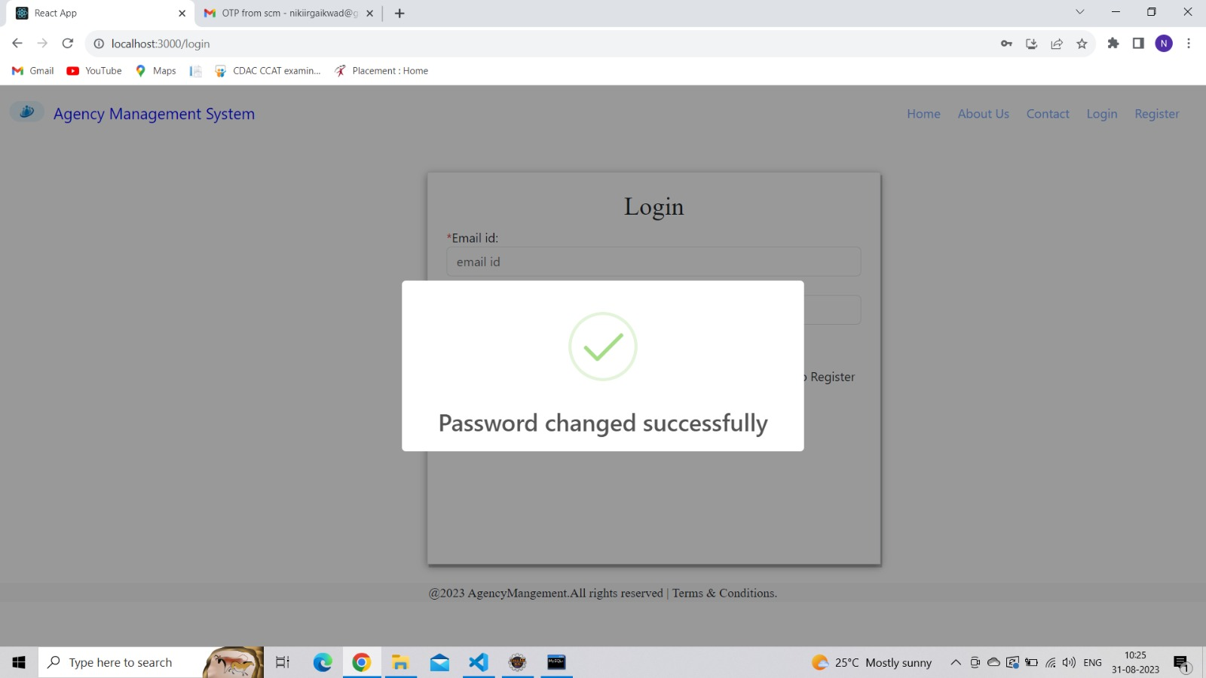

**8.5 Job Post Page**

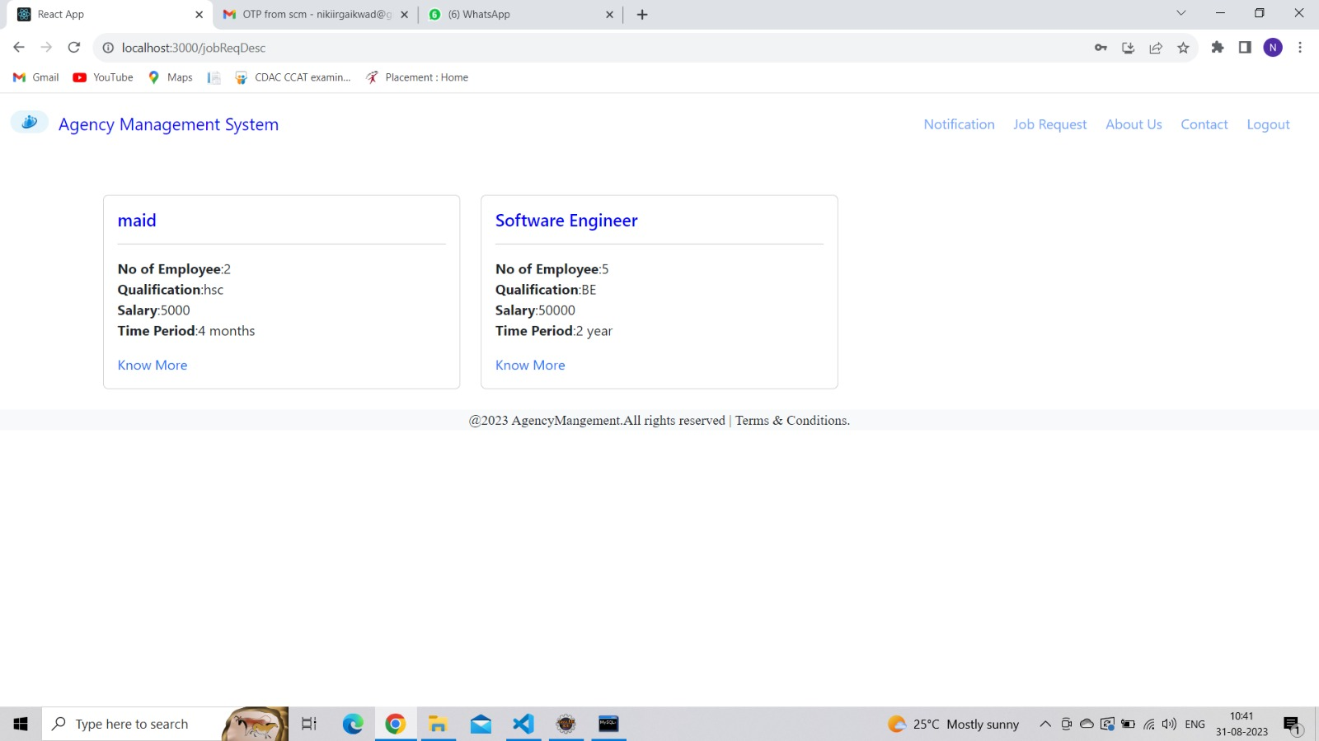

**Apply Job**

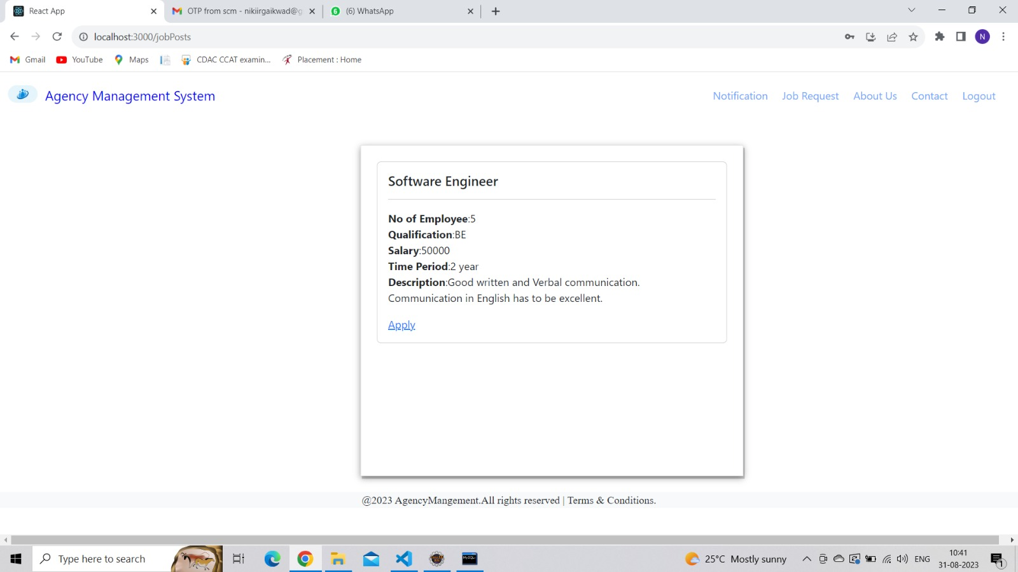

**Search job**

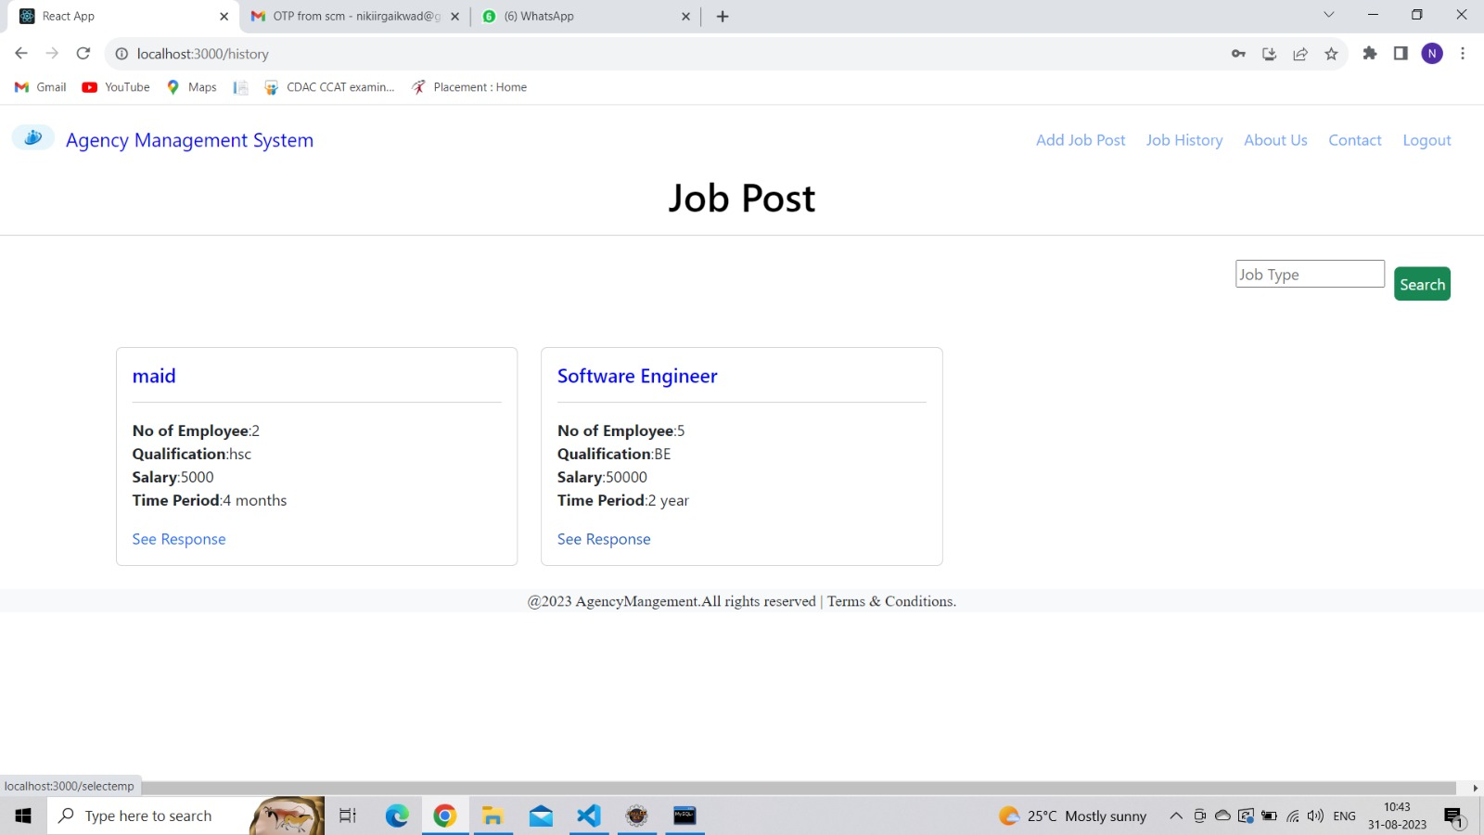

**8.5.1 Employee List Page**

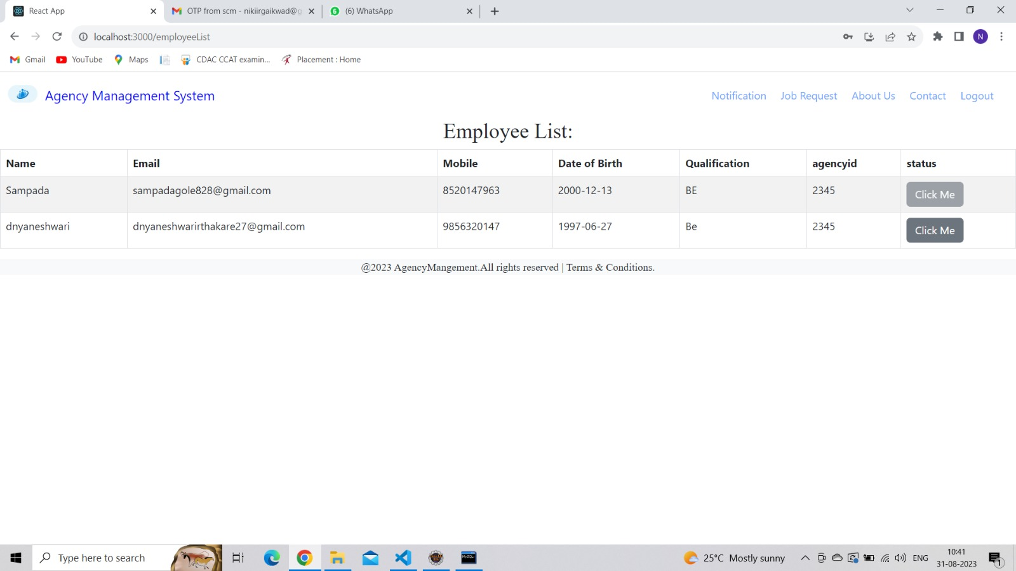

**Selected employee sent successful**

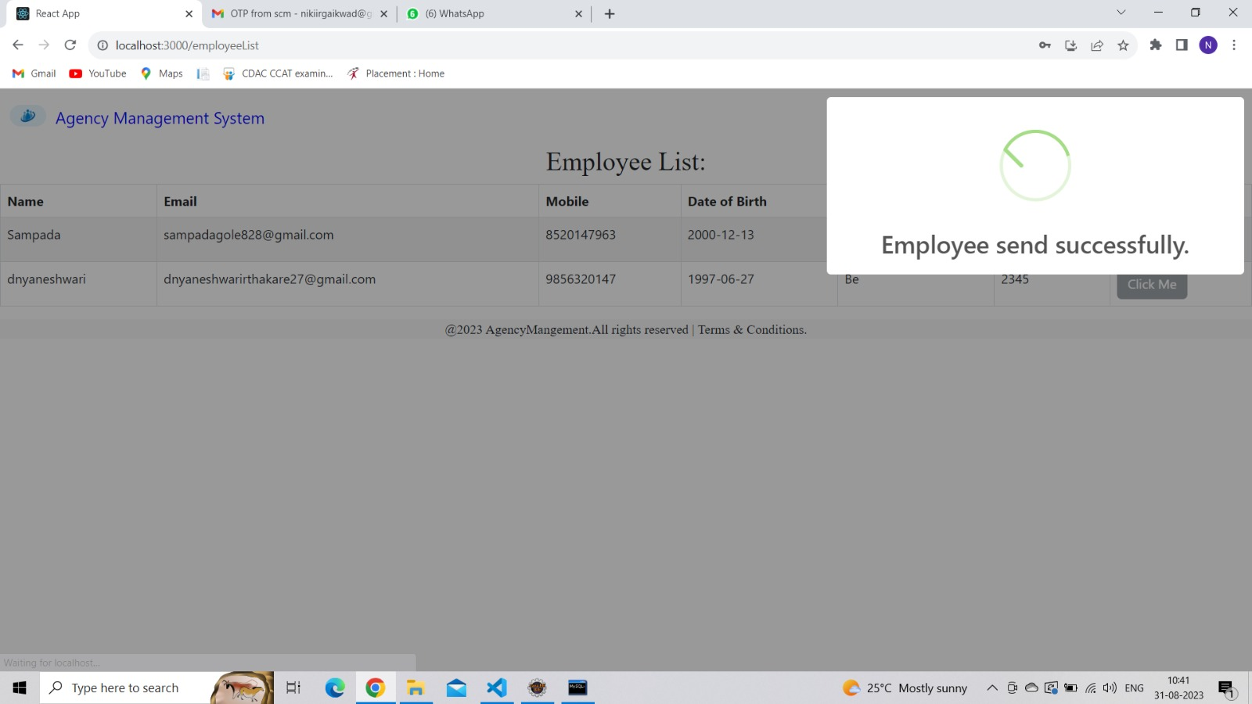

**8.5.2 Email sent to selected employee**

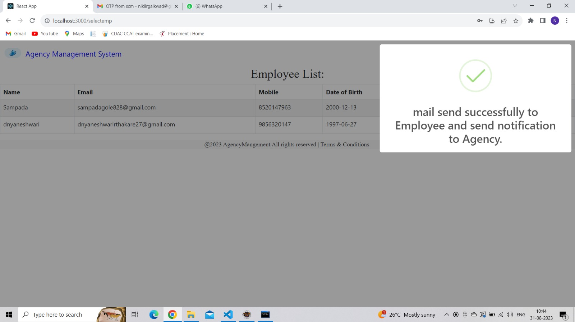

**9. CONCLUSION AND FUTURE SCOPE**

The integration of employee, customer, and agency modules within an agency management system represents a pivotal step towards achieving comprehensive efficiency, enhanced customer satisfaction, and streamlined operations. In our project, employee data is kept as static. But in future we can add that feature where every individual employee can make registration and login. Employee data can be manipulated similar as of the agency and customer. Tracking of time period of employees can be done. We can show the time period validity of particular employees under specific agency.