System Requirements Statement (SRS) –

Agency Management System

Created by:

NIKITA GAIKWAD (230343120050)

PREETI SANGAPUR(230343120063)

SAMPADA GOLE(230343120074)

DNYANESHWARI THAKARE(230343120097)

Date : 31/08/2023

:

1. Introduction 3

2. Functional Requirements 4

2.1 Agency 8

2.2 Customer 14

2.3 Employee 16

2.4 USECASE DIAGRAM……………………………………………………………………...21

# Introduction

* This document explains the system requirements and scope for developing Agency Management System.
* Agency Management System could divide the three main parts,
* Agency
* Customer
* Employee
* There are mainly two types of users. One is the customer and other is agency.
* First of all, there will be an home page which will have some options in it’s navigation menu like About Us, Contact, Login and Register.
* Agency and Customer can register and login themselves. When agency will register, we’ve to provide particular agency id which have to match with that particular static employee data.
* Customer can send his job post requirement to agency.
* When the job post is uploaded, agency will get the notification where after it’ll the responsibility of agency to select the appropriate agency and respond back to the customer with list of an eligible employees to the job post criteria. After selection, employee will get an e-mail message from the agency and the status will get changed from vacant to selected in the database.
* This system provides the functions or an efficient way which connect the customer and the employees efficiently.

# Functional Requirements

The Account part of Agency Management System has three modules Employee, Agency and Customer which are divided 16 processes described as below.

Employee module data is kept as static, using which we can perform all the operation regarding agency and customer.

|  |  |  |
| --- | --- | --- |
| **No** | **BRS requirement ID** | **Description** |
| **2.1** | **Agency Module** | |
| **2.1.1** | **F1** | **Registration Process** |
| **2.1.2** | **F2** | **Login Process** |
| **2.1.3** | **F3** | **Forgot Password Process** |
| **2.1.4** | **F4** | **Change Password Process** |
| **2.1.5** | **F5** | **Walkthrough Customer Request** |
| **2.1.6** | **F6** | **Send Valid Vacant Employees** |
| **2.1.7** | **F7** | **Send response to Customer request** |
| **2.2** | **Customer Module** | |
| **2.2.1** | **F11** | **Registration Process** |
| **2.2.2** | **F12** | **Login Process** |
| **2.2.3** | **F13** | **Forgot Password Process** |
| **2.2.4** | **F14** | **Change Password Process** |
| **2.2.5** | **F15** | **Upload job post** |
| **2.2.6** | **F16** | **Send notification message to the agency** |
| **2.2.7** | **F17** | **Select employees from the list sent by agency** |
| **2.2.8** | **F18** | **Send email to all selected employees** |
| **2.2.9** | **F19** | **Change the status of employee from vacant to selected in database.** |

## Employee Module

* Employee is the static module in the system i.e by default present.
* Using it, we can perform all the operation regarding agency and customer.

## Agency Module

Agency can be of any domain, for example :

* Travelling agency
* Security Agency

Each and every agency will have specific number of employees working under them.

### Account creation Process

* Before creating an account, Agency first needs to fill the registration form and submit it.
* During Registration, Agency needs to provide information such as
* Name
* Email-id
* Mobile no
* Password
* Role
* Agencyid

All items are compulsory demanded.

1. Name

* The First Name has constraints described as below:
* Capital alphabet (A-Z)(first letter should be capital.
* Small alphabet (a-z)(remaining letter should be small)

2. E-mail ID

* If the Email ID correspond with not case-sensitive to other which is previously registered, the Email-ID should not be registered as an account.

3. Mobile-no:

* It should 10 digit integer format.

4. Password:

The password should consist of more than or equal 8 and less than or equal 16 characteristics including at least a numeric figure, a capital alphabet, a small alphabet, and a special character.

5. Role:

Role of the Agency should be cleary specified.

6.Agency-id:

Agency id is the number which is maintained for the purpose of identification of employee corresponds to their respective agencies.

After registering the details for Agency, agency will get provided credentials for login purpose.

### Login Process

Once after the account has been created , Agency needs to login the account using the credentials to perform necessary operations.

* When the User Type is "Agency", then user can be placed on “Agency’s Dashboard”.
  1. The “Agency Dashboard” provides some of the features described as below.
* Notification
* Job Request
* Logout

### Forgot and Change Password Process

Forgot Password process:

When system Agency lost their Password, the recovery method should be provided by Agency Management System.

The recovery method is described as below.

1. First, system Agency enters their Email-id for Agency Management System and verify it using the otp generation.

2. Agency will be redirected to change password page.

3. Agency needs to enter the new Password having the following constraints such as:

* the new password should consist of more than or equal 8 and less than or equal 16 characteristics including at least a numeric figure, a capital alphabet, a small alphabet, and a special character.

Change Password Process:

* When Agency wants to change their Password, the measure should be provided by

Agency Management System.

* The function demands the current password and the new password.
* Of course, the new password should consist of more than or equal 8 and less than or equal 16 characteristics including at least a numeric figure, a capital alphabet, a small alphabet, and a special character.
* The new password is demanded to enter twice to avoid a typing error.

### Provide Employee List to Customer

Agency compares the job post information with the details of the employees present in database and provide the employees information whose details match the job criteria to the customer for further processing.

## Customer Module

* Customer send the job post requirement containing the information of job like job type, number of employees, qualification, time period, salary, job description.

### Account Creation Process

* Agency Management System compels to create the account before using it.
* When Customer creates new account, the function demands information described as below.
  + 1. Registration
* The Registration information consists of some items described as below.
* Name
* Email-id
* Mobile no
* Password
* Role

All items are compulsory demanded.

1. Name

The Name has constraints described as below.

* Capital alphabet (A-Z)(first letter should be capital)
* Small alphabet (a-z)(remaining letter should be small)

1. E-mail ID

If the Email ID correspond with not case-sensitive to other which is previously registered, the Email-ID should not be registered as an account.

1. Mobile

* Mobile name is in integer format
* It must have 10 digit.

1. Password:

* The password should consist of more than or equal 8 and less than or equal 16 characteristics including at least a numeric figure, a capital alphabet, a small alphabet, and a special character.

1. Role: Role of customer should be mentioned.

### Login Process

* Agency Management System always compels Customer authentication before using itself except when a new account is successfully created.
* The Login information
  + 1. Email-ID
    2. Password
* The user authentication demands Email-ID and Password. The Email-ID and the Password should be checked in three ways.
  1. First, The Email-ID and the Password should be existed and correct.
* If The Email-ID and the Password are not equal to what the user has registered, the user authentication cannot be provided.
  1. If the User Type linked to the Email-ID is linked with "Customer".
* When the User Type is "Customer", then user can be placed on “Customer’s Dashboard”.
  1. The “Customer Dashboard” provides some of the features described as below.
* Add Job Post
* Job History
* Logout

### Forgot Password Process

* When system customer lost their Password, the recovery method should be provided by Agency Management System.

The recovery method is described as below.

* 1. First, system customer enters their Email-ID for Agency Management System and click on search button.
  2. Customer will be redirect to change password page.
  3. Customer needs to enter the new password having following constraints:
* The new password should consist of more than or equal 8 and less than or equal 16 characteristics including at least a numeric figure, a capital alphabet, a small alphabet, and a special character.

### Change Password Process

* When customer wants to change their Password, the measure should be provided by Agency Management System.
* The function demands the current password and new password.
* The function demands the current password and the new password.
  1. Of course, the new password should consist of more than or equal 8 and less than or equal 16 characteristics including at least a numeric figure, a capital alphabet, a small alphabet, and a special character.
  2. The new password is demanded to enter twice to avoid any typing error.
* Only when the current password is correct, admin could change their Password.
* When the current password is changed into new password, Agency Management System compels user authentication again.

### Upload Job Requirement

* Customer will upload the job details and submit the form.
* It contains following constraints:
  + 1. Number of employee
    2. Qualification of employee
    3. Salary
    4. Location of job
    5. Experience of employee
    6. Time Period
    7. Job description

All items are compulsory demanded.

### Send notification message to agency:

Customer will upload the job post and then immediately sends the notification message to the agency.

### Select the employees

Customer will select the valid vacant employees from the employee list sent by agency**.**

### Send the email to employees:

Employees will get an immediate email after the selection done by the customer.

### Change the status

Customer will change the status of employee from vacant to selected after selection.

## Use Case Diagram

1. Employee module have static data hence no use case diagram will be created.
2. **Agency:**

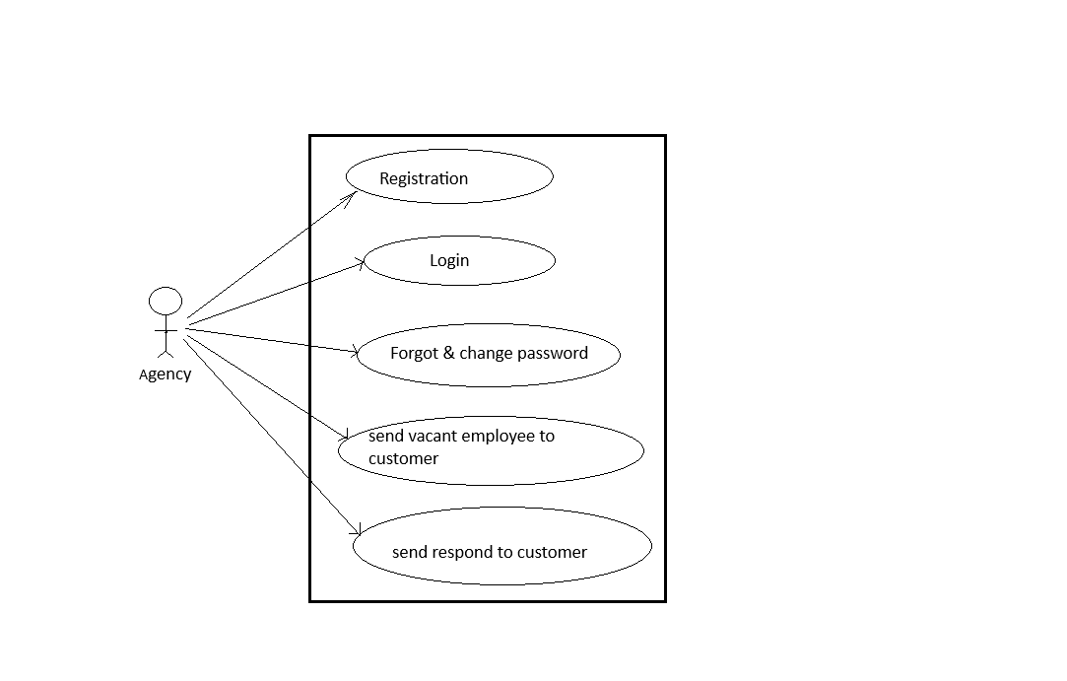

*Fig. Use case diagram for Agency*

1. In Agency use case diagram agency is the Actor**.**
2. Agency can handle following use cases:
3. Register
4. Login
5. Forget & change password
6. Send vacant employees to customer
7. Send respond to customer

3.**Customer:**

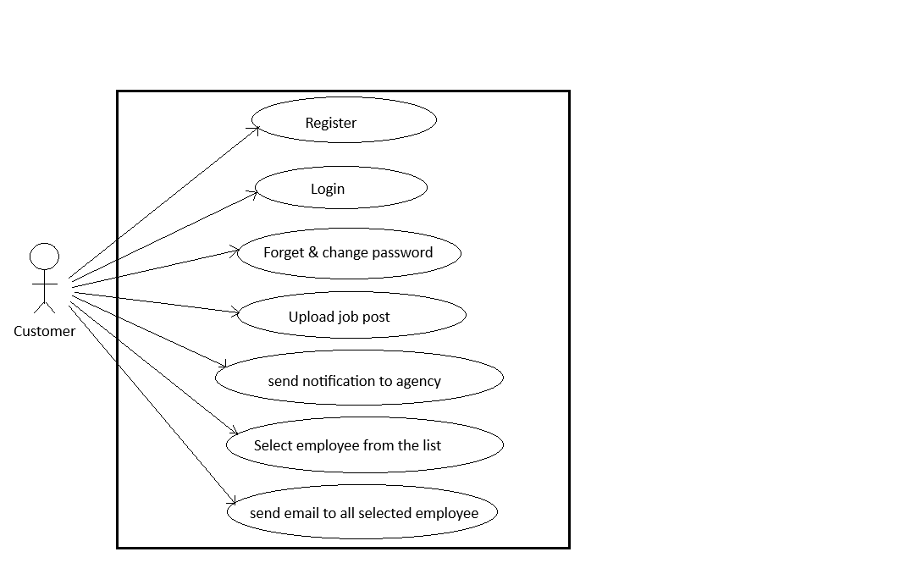

*Fig. Use case diagram for Customer*

In Customer use case diagram customer is the Actor**.**

1. Customer can handle following use cases:
2. Register
3. Login
4. Forget & change password
5. Upload job post
6. Send notification to agency
7. Select employees
8. Sends email to all the selected employees.