**CRIMES _IN_ INDIA_2001-2013**

**DATASET** = By kaggle(<https://www.kaggle.com/datasets/meruvulikith/crimes-in-india-dataset-2001-2013>)

**Feature of Database:**

1. STATE/UT

2. DISTRICT

3. YEAR

4. MURDER

5. ATTEMPT TO MURDER

6 . CULPABLE HOMICIDE NOT AMOUNTING TO MURDER

7. RAPE

8. CUSTODIAL RAPE

9. OTHER RAPE

10. KIDNAPPING & ABDUCTION

11. KIDNAPPING AND ABDUCTION OF WOMEN AND GIRLS

12. KIDNAPPING AND ABDUCTION OF OTHERS

13, DACOITY

14 PREPARATION AND ASSEMBLY FOR DACOITY

15. ROBBERY

16 BURGLARY

17, THEFT

18, AUTO THEFT

19, OTHER THEFT

20. RIOTS

21, CRIMINAL BREACH OF TRUST

22. CHEATING

23, COUNTERFIETING

24. ARSON

25. HURT/GREVIOUS HURT

26. DOWRY DEATHS

27. ASSAULT ON WOMEN WITH INTENT TO OUTRAGE HER MODESTY

28, INSULT TO MODESTY OF WOMEN

29. CRUELTY BY HUSBAND OR HIS RELATIVES

30. IMPORTATION OF GIRLS FROM FOREIGN COUNTRIES

31. CAUSING DEATH BY NEGLIGENCE

32. OTHER IPC CRIMES

32. TOTAL IPC CRIMES

**Df Variable in the dataset :**

df

**Libraries Used :**

1. Pandas

2. Numpy

3. Matplotlib

4. Seaborn

**Contents:**

1. Import the required libraries.

2. Import and reading dataset.

3. Data- Cleaning

4. Data- Mining.

4. Data- Visualization

**Conclusion of Data Anlysis:**

1. These are the head part and tail part of data.

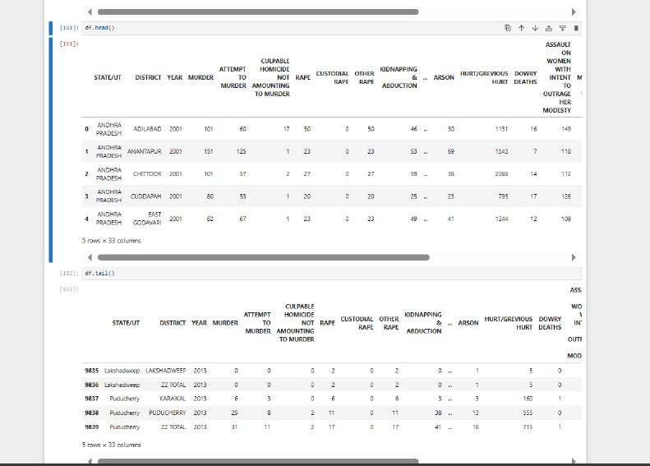

2**. Description of data**.

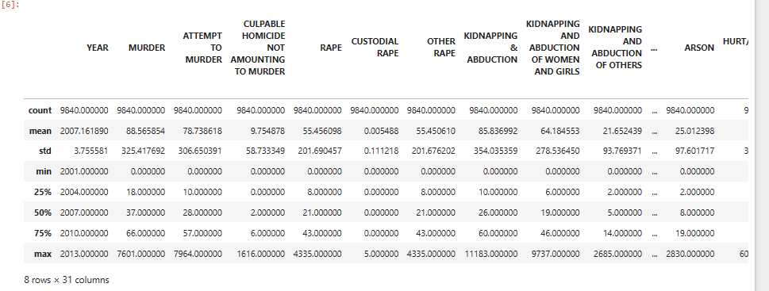

**3. Columns of data.**

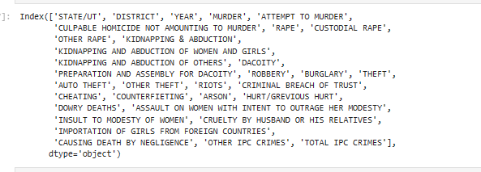

**4. Shape and info of data.**

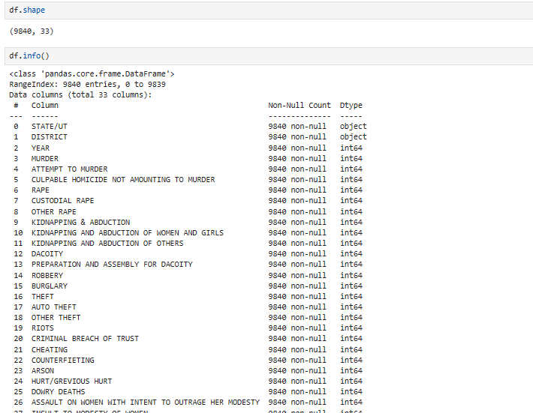

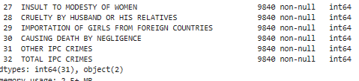

**5. List of States/ UT.**

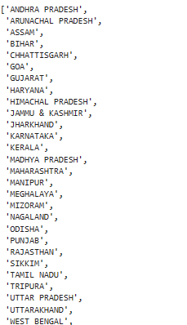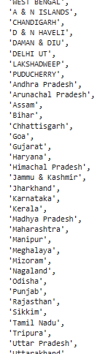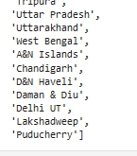

**6. List of District**

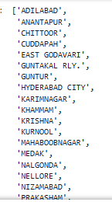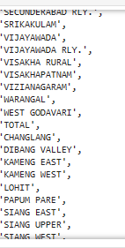 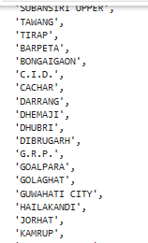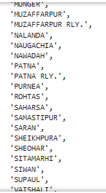

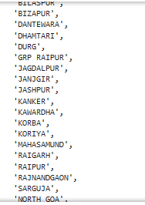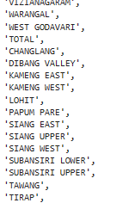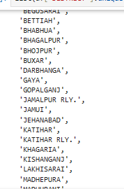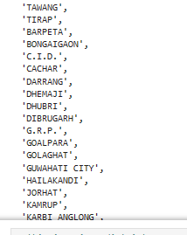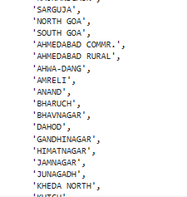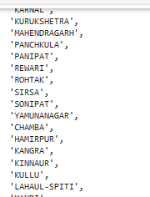

**7. In this graph We can See that Every Year Crimes are increasing every year ---**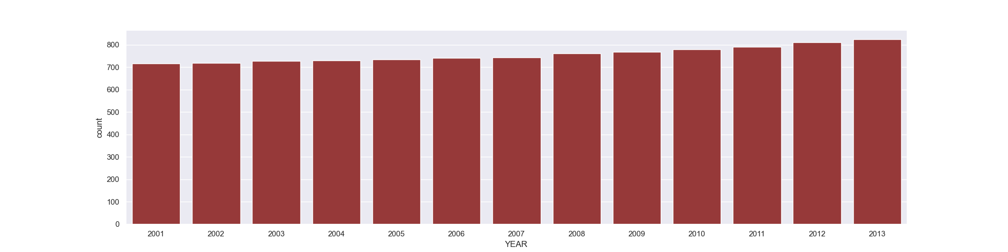

**8. There is percentage wise distribution based on 2001 – 2013.**

**1. MURDER --------**

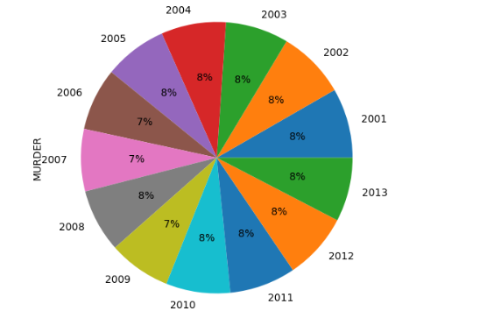

**2. ATTEMPT TO MURDER----------**

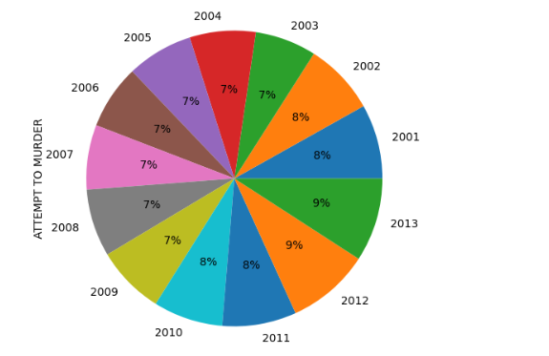

**3. CULPABLE HOMICIDE NOT AMOUNTING TO MURDER ------**

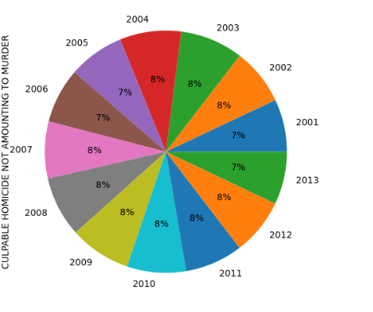

**4. RAPE ------**

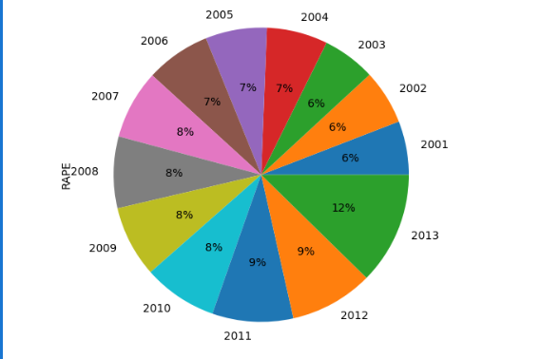

**5. KIDNAPPING & ABDUCTION ------------**

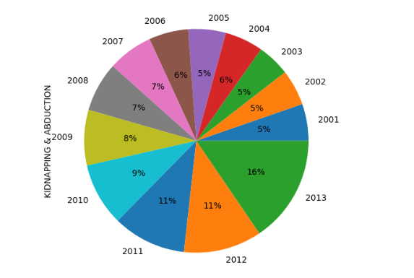

**6. KIDNAPPING AND ABDUCTION OF WOMEN AND GIRLS --------**

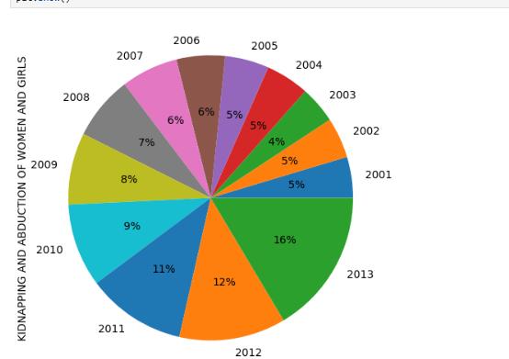

**7. DACOITY -----------**

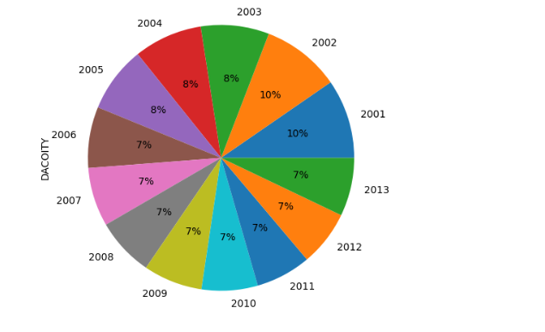

**8. PREPARATION AND ASSEMBLY FOR DACOITY-----------**

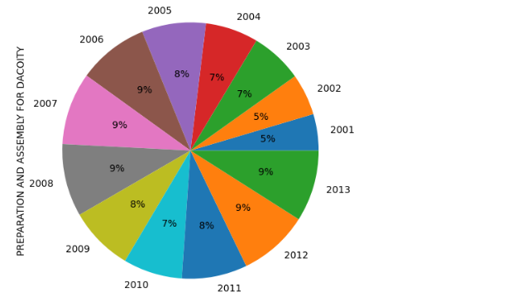

**9. ROBBERY----**

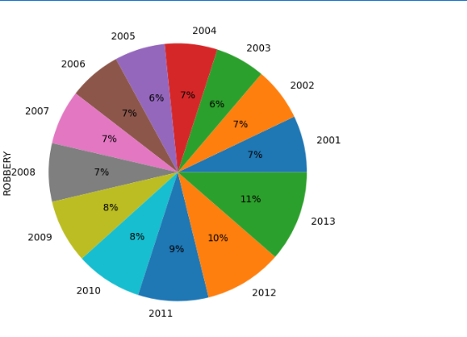

**10. BURGLARY------**

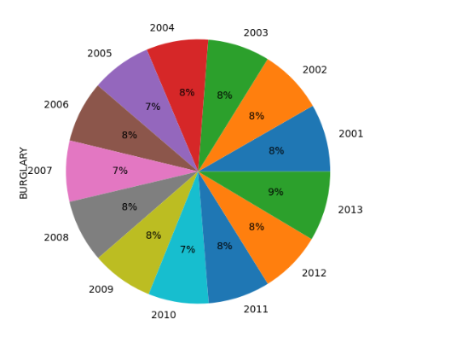

**11. THEFT-----**

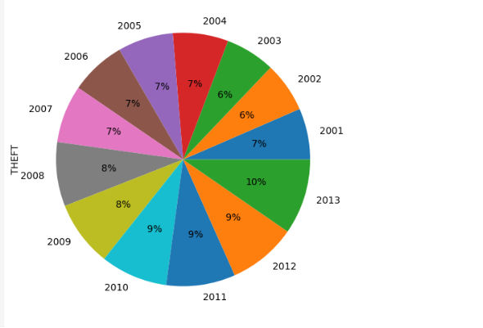

**12. AUTO THEFT ----------**

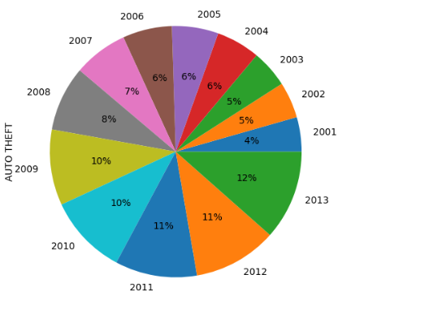

**13. OTHER THEFT------**

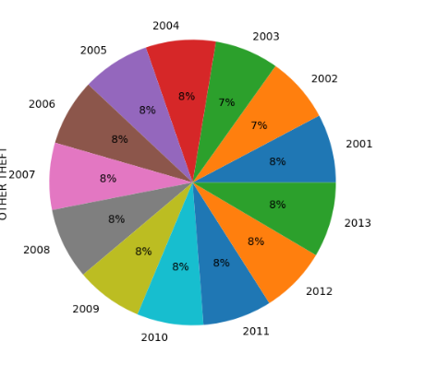

**14. RIOTS-----**

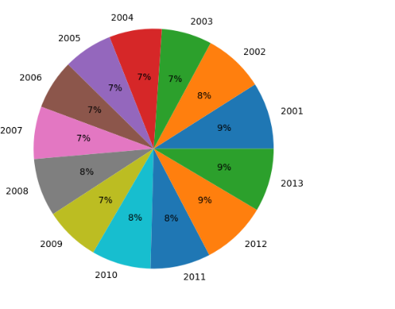

**15. CRIMINAL BREACH OF TRUST -----**

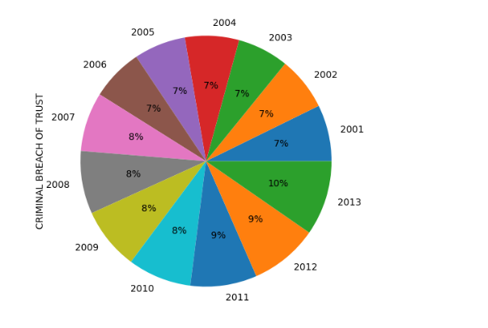

**16. CHEATING --------**

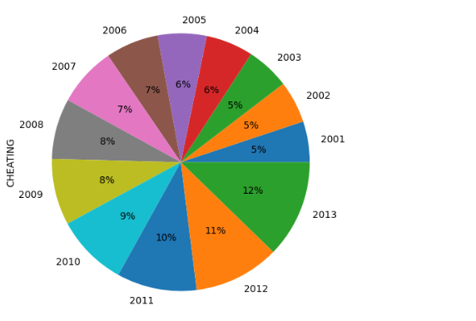

**17. COUNTERFIETING ----------**

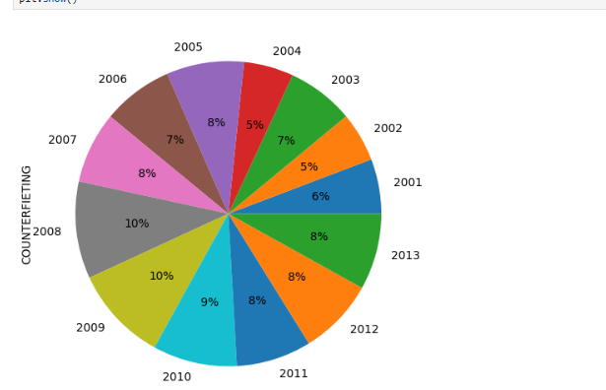

**18. ARSON ------------**

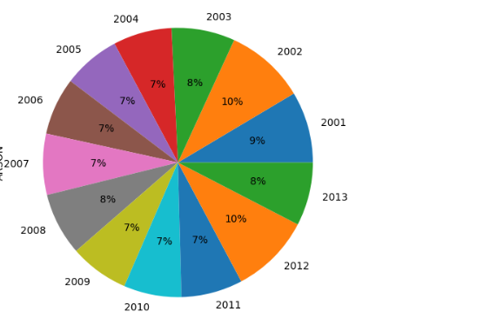

**19. HURT/GREVIOUS HURT ------**

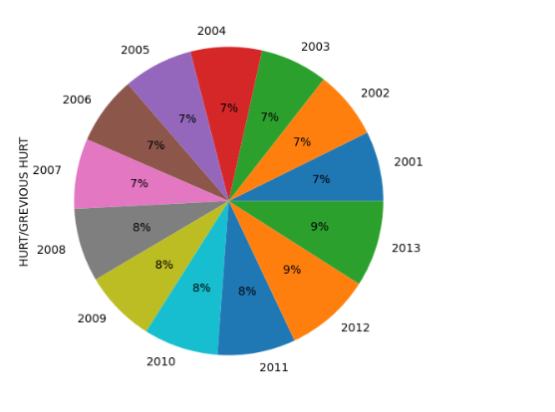

**20. DOWRY DEATHS -------**

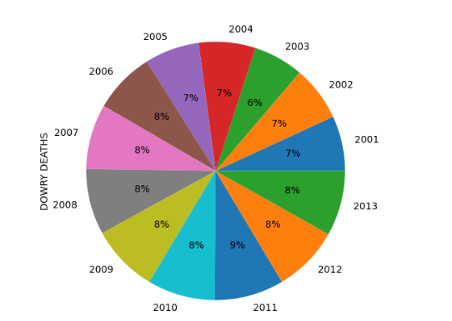

**21. ASSAULT ON WOMEN WITH INTENT TO OUTRAGE HER MODESTY--------**

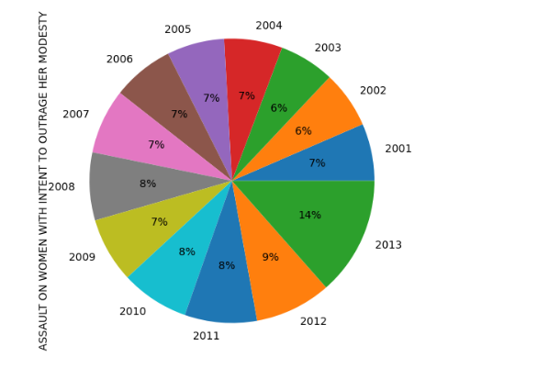

**22. INSULT TO MODESTY OF WOMEN--------**

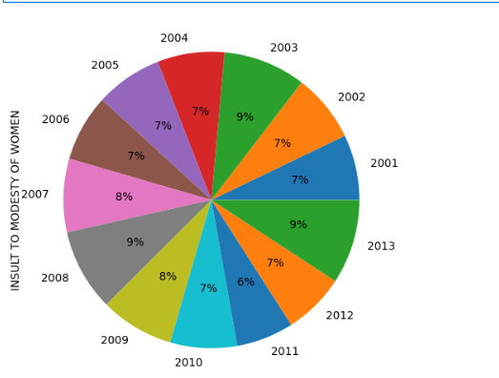

**23. CRUELTY BY HUSBAND OR HIS RELATIVES -------------**

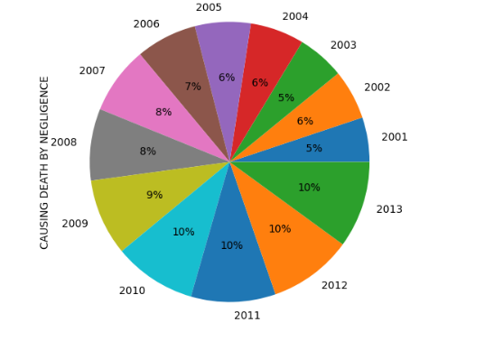

**24. OTHER IPC CRIMES---------**

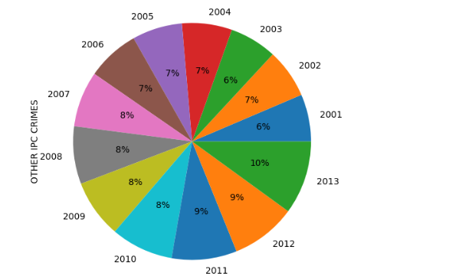

**25. TOTAL IPC CRIMES--------**

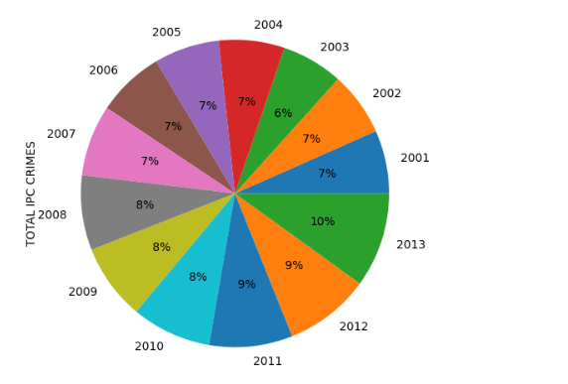

**9. There is Top 10 STATE/UT wise comparison based on Cases.**

1. If We talk about How Many **Murders** Cases There are in each States , Then we can see that **Uttar Pradesh** Has the highest number of murder Cases.

**Rajasthan** has the lowest number of Murder cases.

**Madhaya Pradesh** is in the middle.

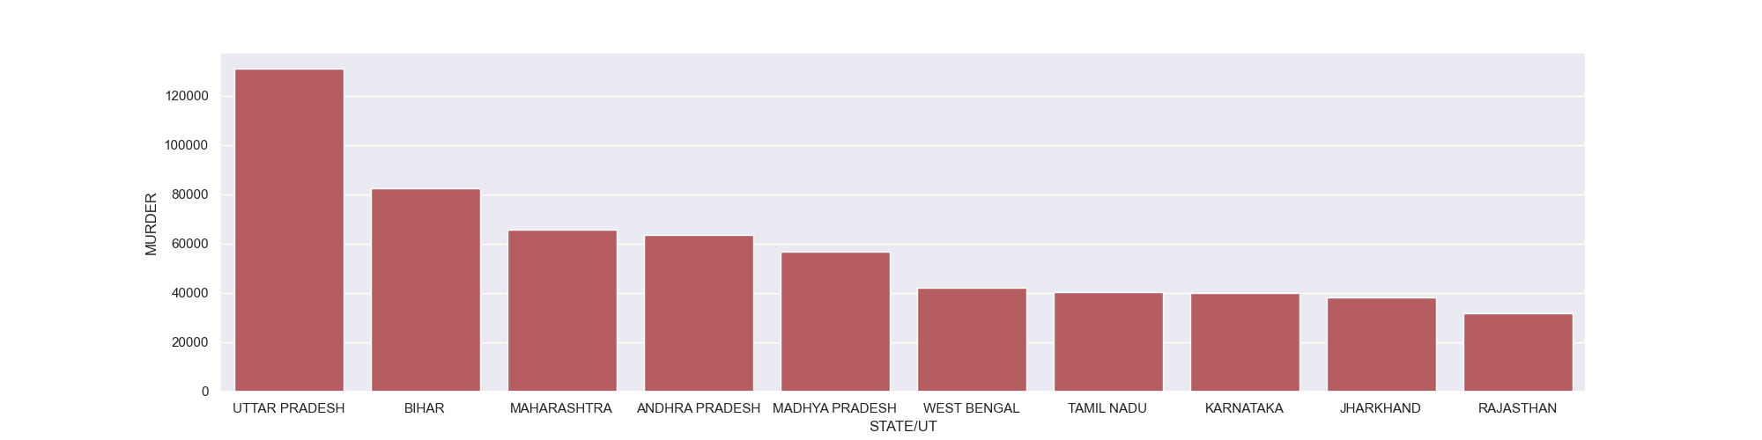

2**. Attempt to Murder**

**Uttar Pradesh** First in Attempt to murder and **West Bengal** has the least number of cases.

**Andhra Pradesh** is in the middle.

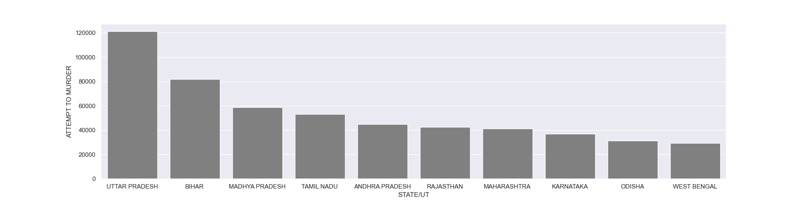

**3. CULPABLE HOMICIDE NOT AMOUNTING TO MURDER**

**Uttar Pradesh** has highest cases and **Jharkhand** has lowest Cases**, Madhya Pradesh** is in middle.

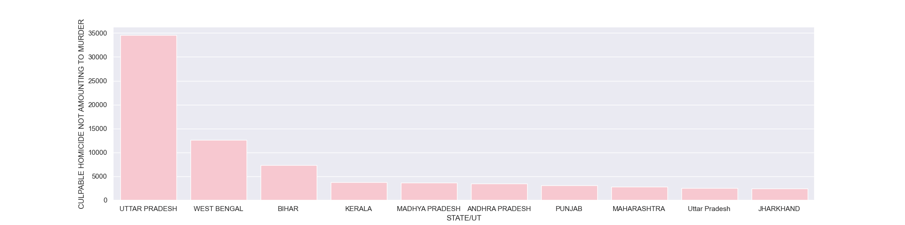

**4. RAPE**

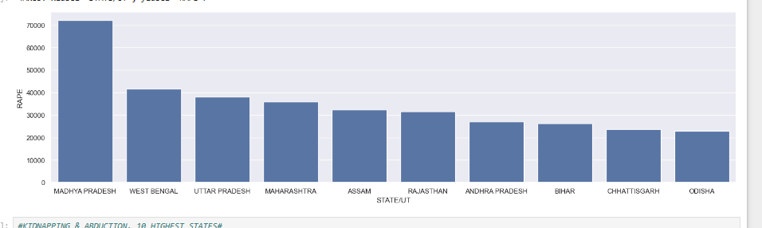

Highest **Rape** Cases in **Madhya Pradesh**, Second State is **West Bengal,** and third is **Uttar Pradesh.**

**5. KIDNAPPING & ABDUCTION**

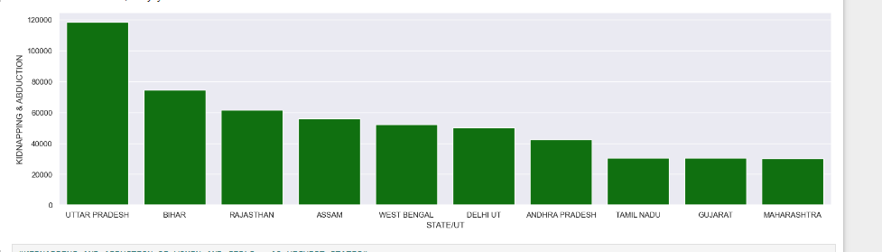

**Uttar Pradesh**, **Bihar** and **Rajasthan** maximum cases Occurred.

**6. KIDNAPPING AND ABDUCTION OF WOMEN AND GIRLS**

**Uttar Pradesh , Rajasthan,** and **Assam** Top 3 State’s.

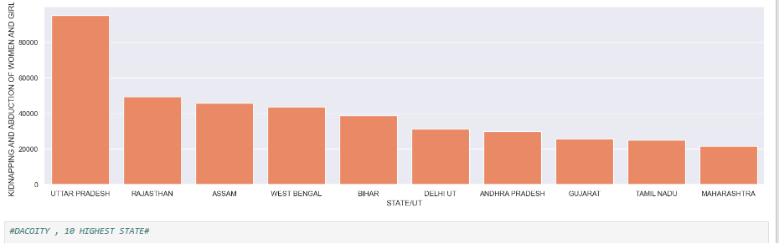

**7. DACOITY**

Graph represent that the maximum number of **DACOITY** Cases in Bihar, Maharashtra, Jharkhand.

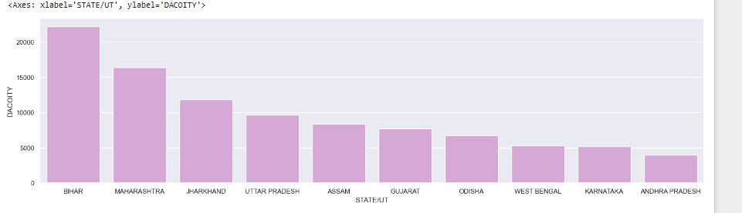

**8. PREPARATION AND ASSEMBLY FOR DACOITY**

Maximum number of Cases in **Bihar, Maharashtra,** and **Rajasthan.**

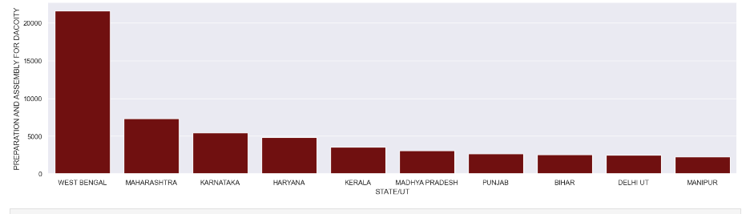

**9. ROBBERY**

Most of the Robbery Cases Happened in **Maharashtra**, **Uttar Pradesh**, and **Bihar.**

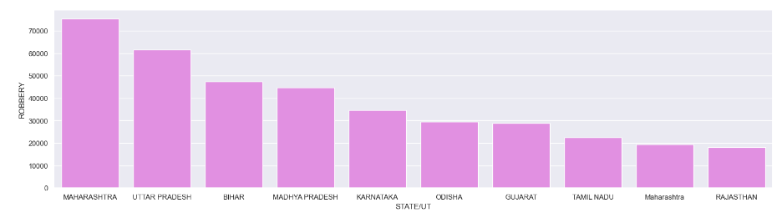

**10. BURGLARY**

We can see that the highest number of cases **in Maharashtra**, **Madhya Pradesh**, and **Andhra Pradesh**.

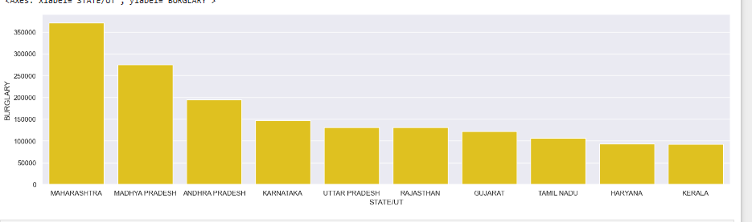

**11. THEFT** 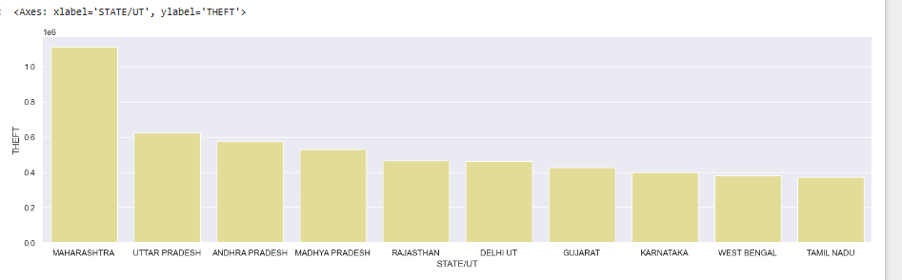

Most of the Theft Cases is also in **Maharashtra, Uttar Pradesh**, and **Andhra Pradesh.**

**12. AUTO THEFT**

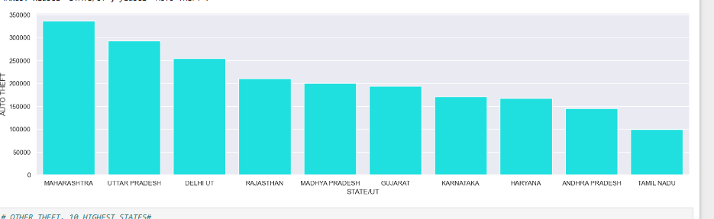

**Auto Theft** Cases is also happened in **Maharashtra**, **Uttar Pradesh** and **Dehli/Ut**

**13. OTHER THEFT**

Highest Number of Cases in **Maharashtra, Andhra Pradesh**, and **Uttar Pradesh** and Bihar, Gujarat,, Karnataka are equal number of Cases.

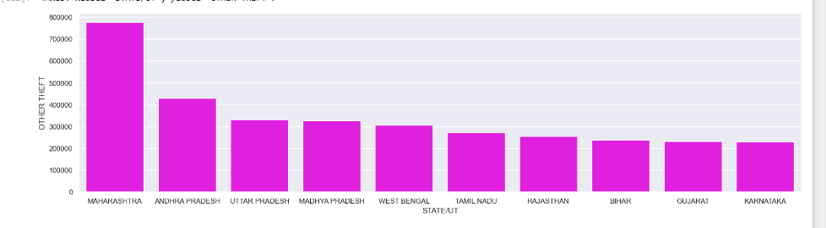

**14. RIOTS**

**Bihar, Kerala, and Maharashtra** have highest number of Cases.

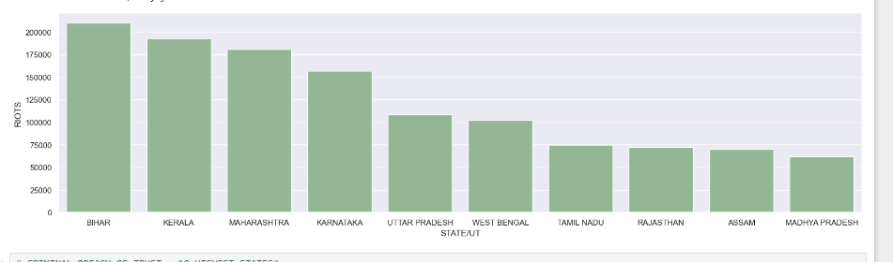

**15. CRIMINAL BREACH OF TRUST**

**Uttar Pradesh** have maximum number of Cases, and **Maharashtra** in second, **Gujarat** is Third number.

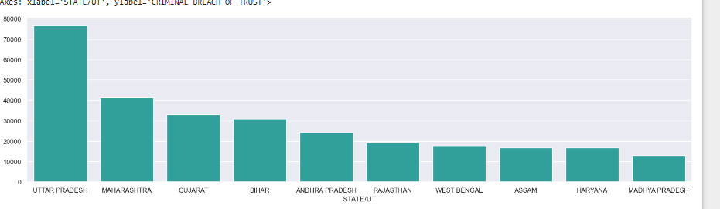

**16. CHEATING**

In the cheating matter, highest cases is in **Rajasthan**, **Andhra Pradesh**, **Uttar Pradesh** and in ten number **Bihar.**

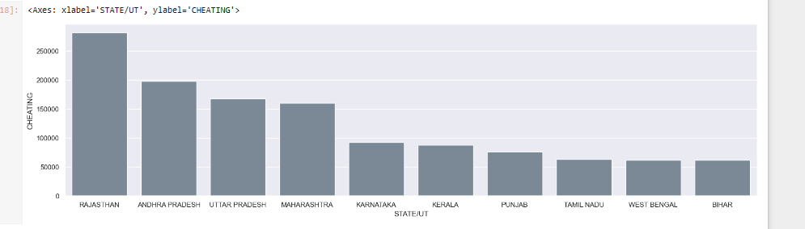

**17. COUNTERFIETING**

**Maharashtra, Uttar Pradesh** and **Andhra Pradesh** is top 3 States in COUNTERFIETING.

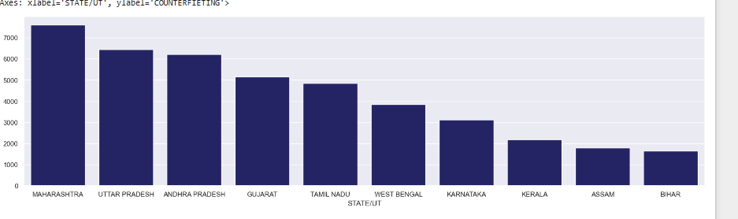

**18. ARSON**

If we talk about Arson Cases, so there is so many cases in every State but maximum number of cases occurred in **Maharashtra,** **Andhra Pradesh**, and **Madhya Pradesh**.

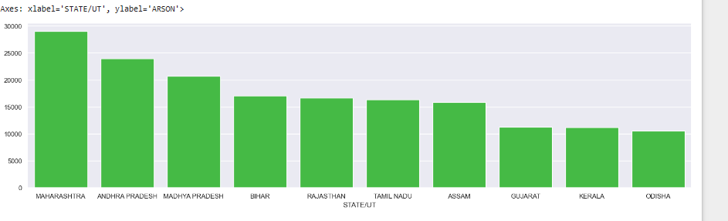

**19.** **HURT/GREVIOUS HUR**

**Andhra Pradesh, Madhya Pradesh** and **Maharashtra**  have More Cases, **Uttar Pradesh** and **Gujarat**  also have equal number of Cases.

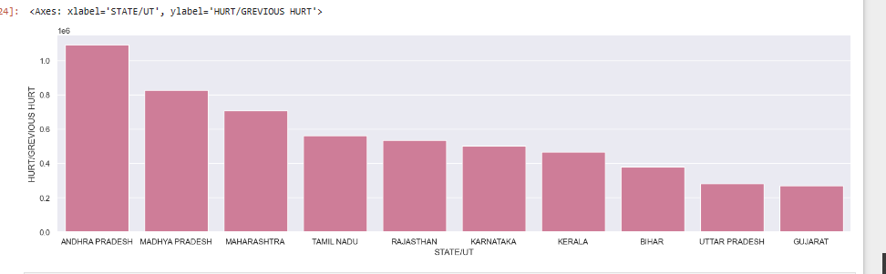

**20.** **DOWRY DEATHS**

In this we can see that the maximum number of Deaths have occurred In **Uttar Pradesh**, **Bihar** And **Madhya Pradesh**.

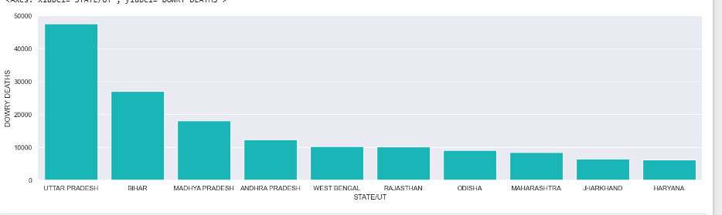

**21. ASSAULT ON WOMEN WITH INTENT TO OUTRAGE HER MODESTY**

**Madhya Pradesh**  is in top one in **ASSAULT ON WOMEN WITH INTENT TO OUTRAGE HER MODESTY.**

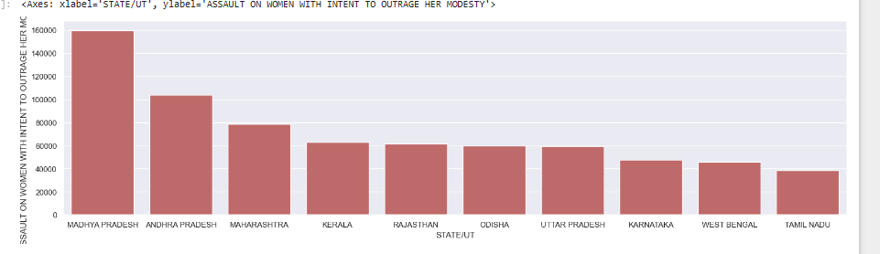

**22. INSULT TO MODESTY OF WOMEN**

**Andhra Pradesh** and **Uttar Pradesh** have also Most Of the Cases.

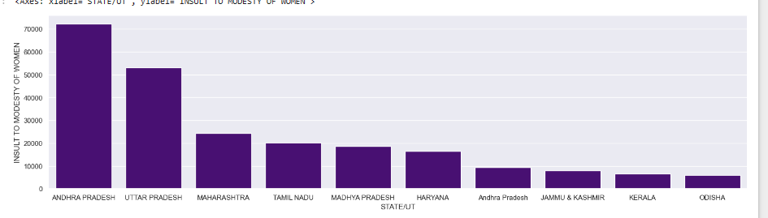

**23. CRUELTY BY HUSBAND OR HIS RELATIVES**

**West Bengal, Andhra Pradesh, Rajasthan , Maharashtra** and **Uttar Pradesh** These are the top 5 States where the highest number of Cases.

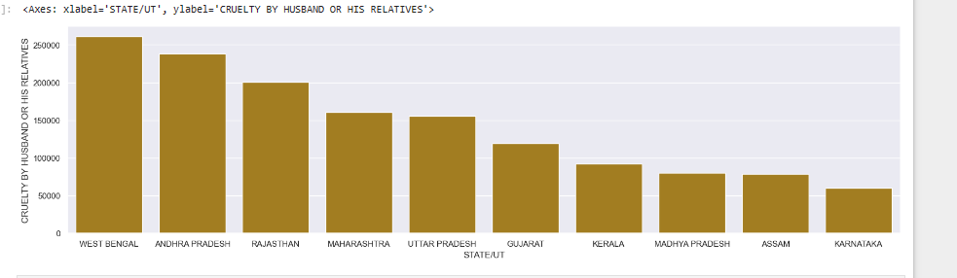

**24. CAUSING DEATH BY NEGLIGENCE**

**Tamil Nadu, Andhra Pradesh** and **Maharashtra** top 3 maximum number of Cases Occurred in **CAUSING DEATH BY NEGLIGENCE.**

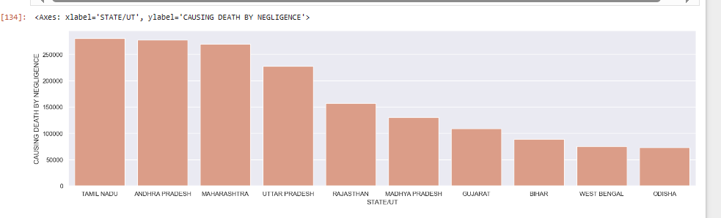

**25. OTHER IPC CRIMES**

**Madhya Pradesh** and **Tamil Nadu** These Two states have Equal number of IPC Crimes.

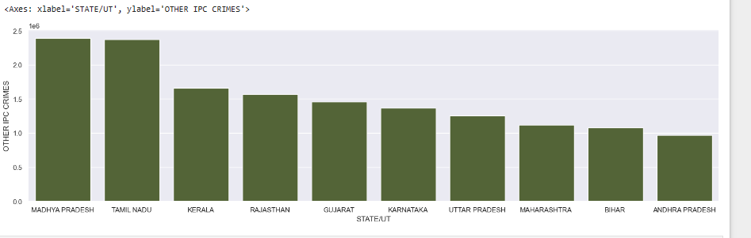

**26. TOTAL IPC CRIMES**

**Madhya Pradesh, Maharashtra and Tamil Nadu** Top 3 States in Total IPC Crimes and Kerala , Gujarat and **Bihar e**qual number of Cases.

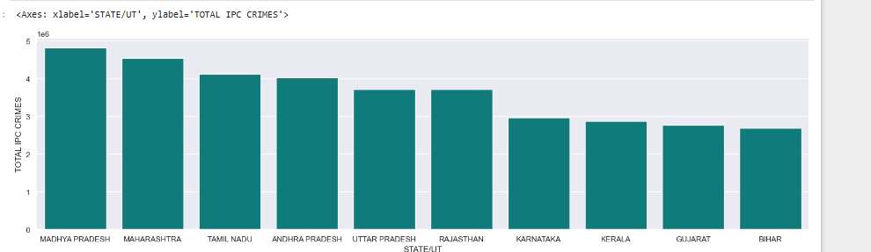

**10. ADD TOTAL NUMBER OF CASES COLUMN**

‘MURDER', 'ATTEMPT TO MURDER', 'CULPABLE HOMICIDE NOT AMOUNTING TO MURDER' ‘RAPE’, 'KIDNAPPING & ABDUCTION', 'KIDNAPPING AND ABDUCTION OF WOMEN AND GIRLS', 'KIDNAPPING AND ABDUCTION OF OTHERS', 'DACOITY', 'COUNTERFIETING', 'ARSON', 'HURT/GREVIOUS HURT', 'DOWRY DEATHS', 'ASSAULT ON WOMEN WITH INTENT TO OUTRAGE HER MODESTY','INSULT TO MODESTY OF WOMEN', 'CRUELTY BY HUSBAND OR HIS RELATIVES', 'CAUSING DEATH BY NEGLIGENCE', 'OTHER IPC CRIMES', 'TOTAL IPC CRIMES'. When we define these Columns In Ascending order we will get the highest state from the total number in which maximum crime have been committed.

Five Maximum Crimes States --- **Maharashtra,**   **Madhya Pradesh, ANDHRA PRADESH, TAMIL NADU, UTTAR PARDESH**

Five Minimum Crimes States --- **A&N Islands, LAKSHADEEP, D&N Haveli, Daman & Diu, Lakshadweep.**

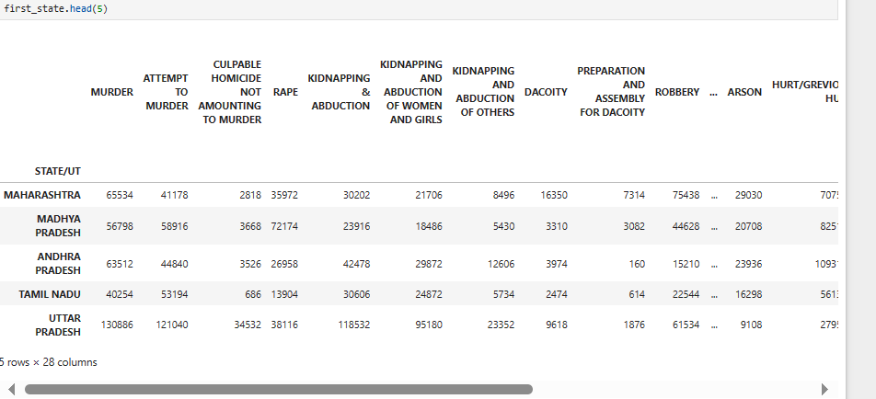 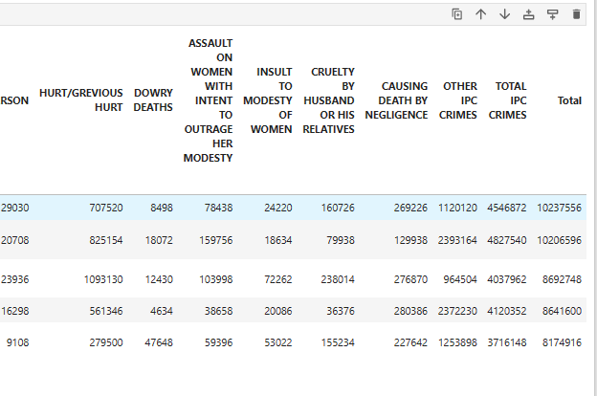

Five Minimum Crimes States --- **A&N Islands, LAKSHADEEP, D&N Haveli, Daman & Diu, Lakshadweep.**

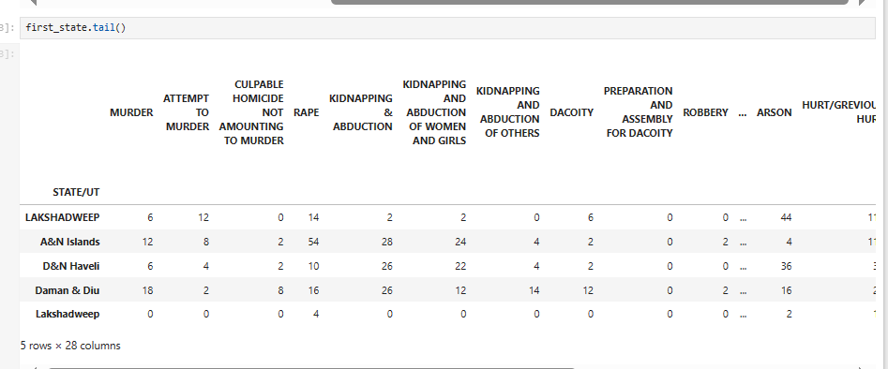

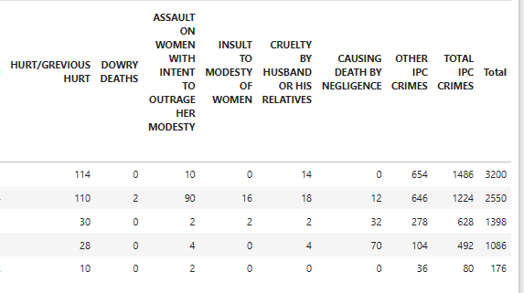

**11. TOTAL STATE / UT GRAPH REPRENTATION**

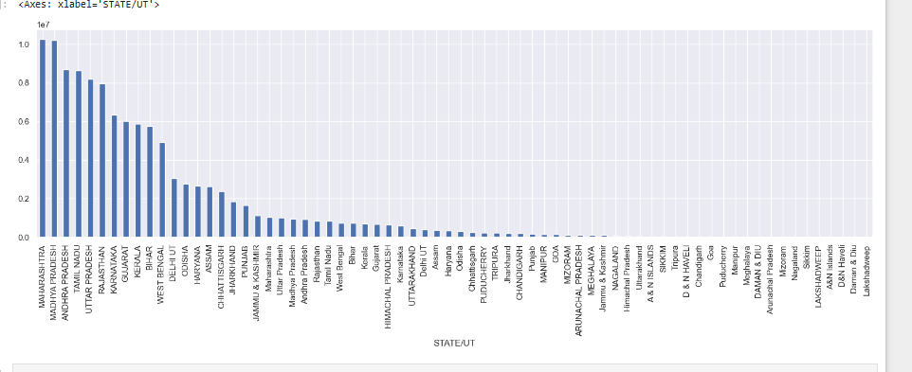

**12. Define the highest STATE’S crimes.**

**MAHARASHTYA-------**

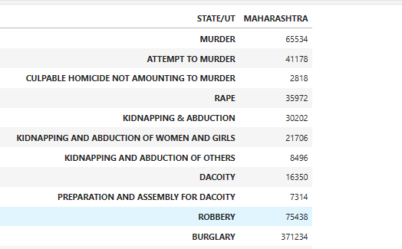

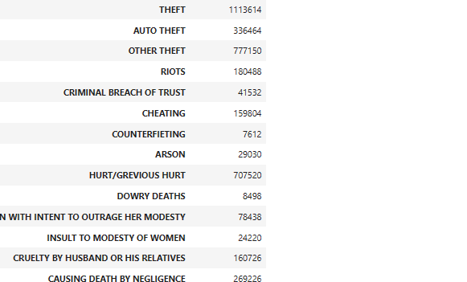



**MADHYA PRADESH---------**

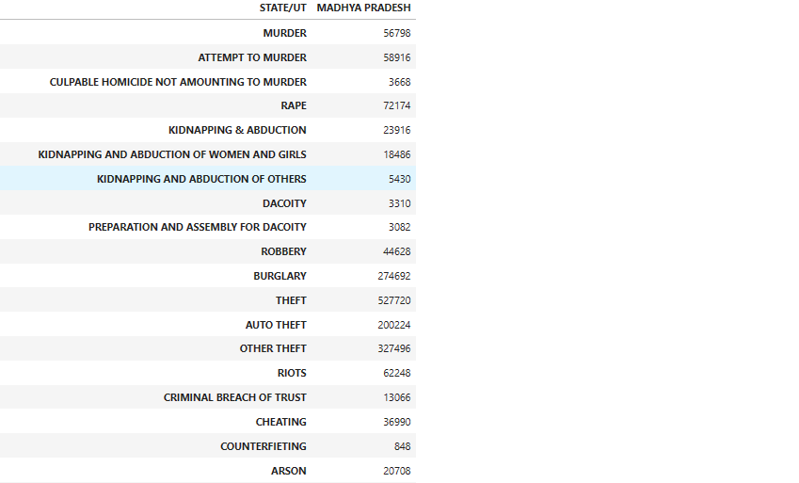

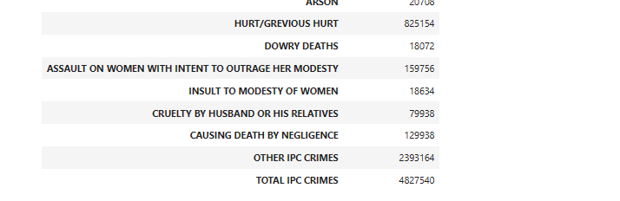

**ANDHRA PRADESH----------**

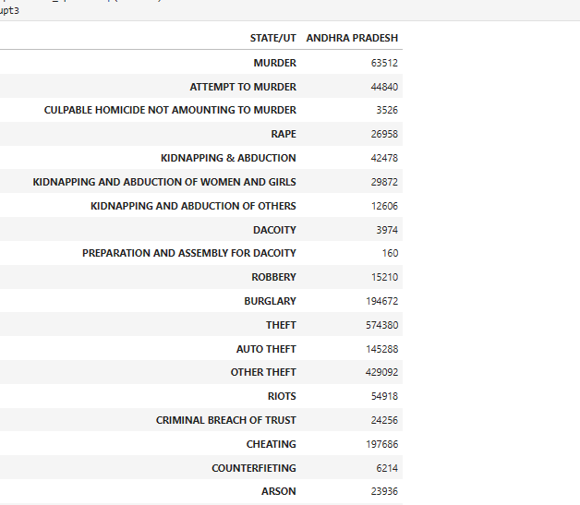

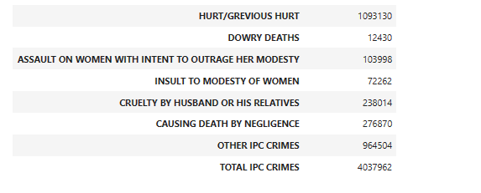

**TAMIL NADU----------**

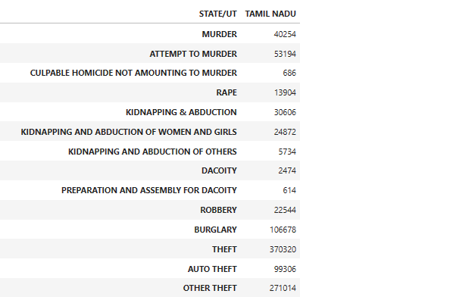

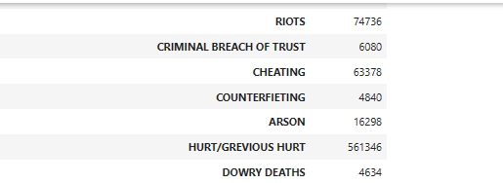

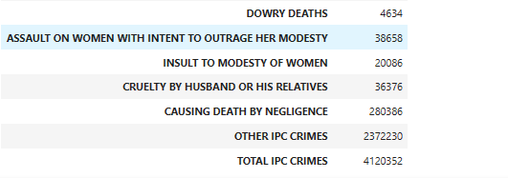

**UTTAR PRADESH -------**

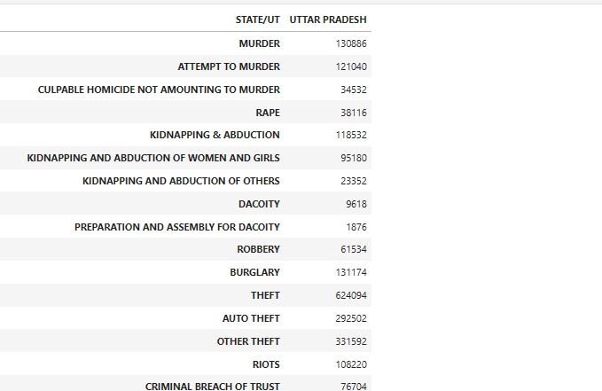

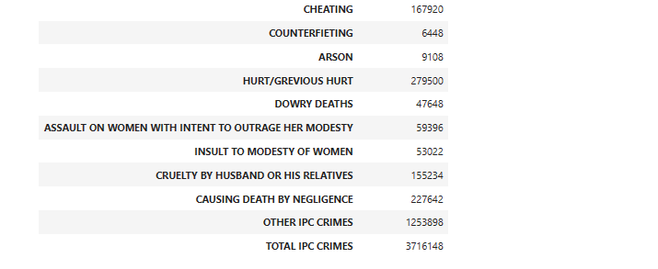

**12. Define the lowest STATE’S crimes.**

**LAKSHADWEEP------------**

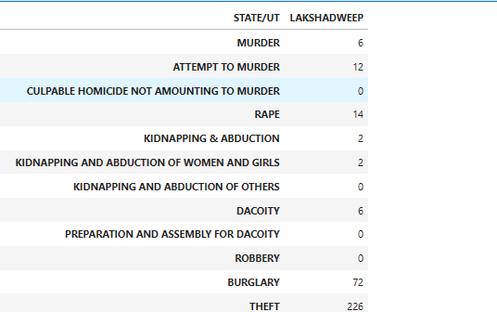

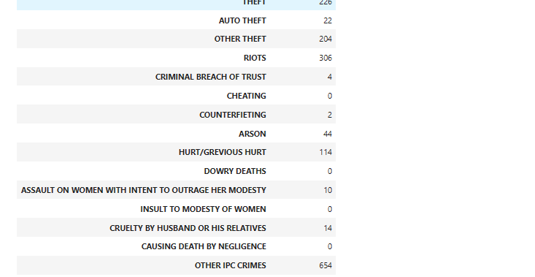



**A&N Islands--------**

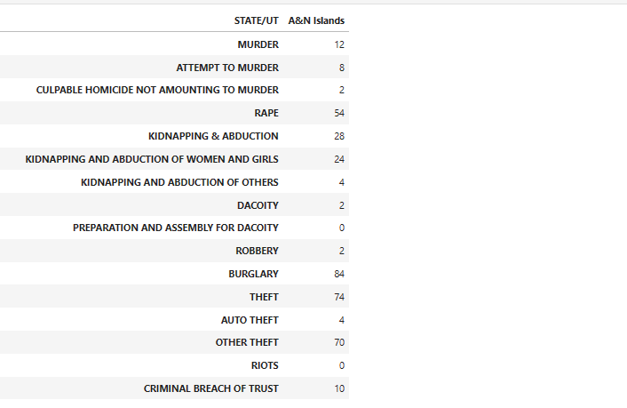

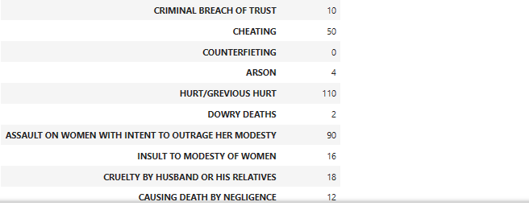

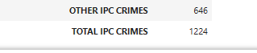

**D&N Haveli--------**

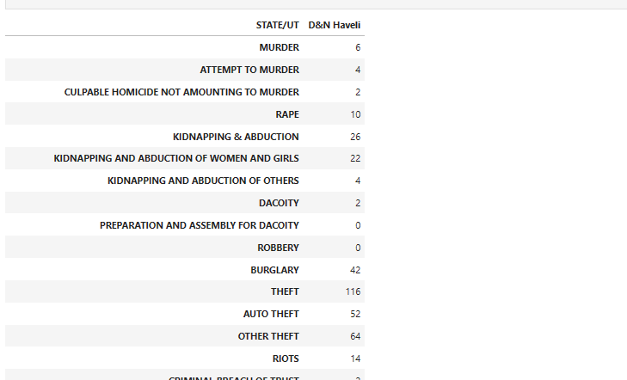

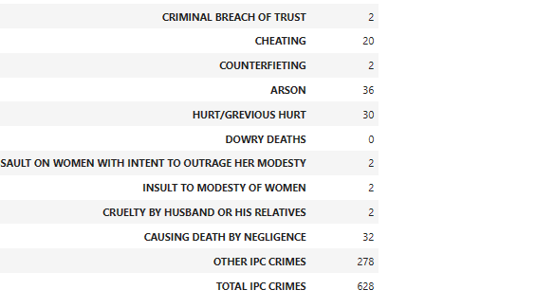

**Daman & Diu--------**

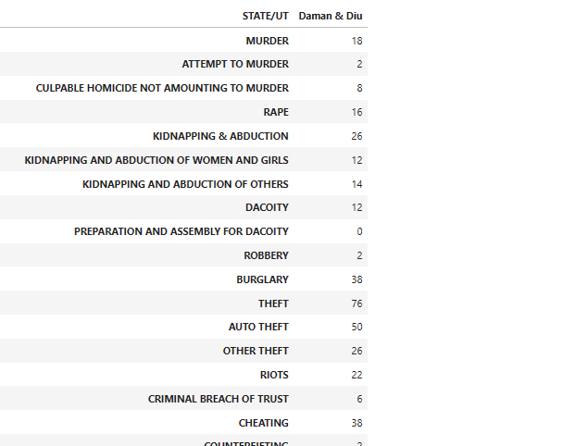

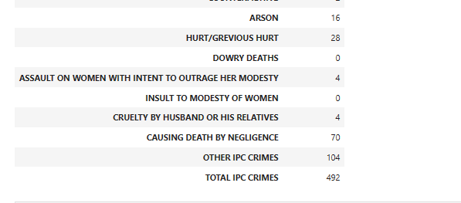

**Lakshadweep(LAKSHADWEEP)----------**

