# Tribhuvan University (TU)-BBS | BBS colleges in Nepal

# TRIBHUWAN UNIVERSITY

Institute Of Engineering

Pulchowk Campus

**A LAB REPORT**

ON

## DATA STRUCTURE, CONDITIONS AND LOOP IN PYTHON

LAB NO: 01

SUBMITTED BY:

Name: Niki Kumari Jaiswal

Roll no. 081BEL050

**LAB 1**

**#Question 1**

**# Write a Python program to remove all duplicates from a list and print the unique elements.**

numbers = [1, 1, 2, 2, 3, 3, 3, 4, 5]

unique = []

for num in numbers:

    if num not in unique:

        unique.append(num)

print("Unique elements are:")

for num in unique:

    print(num)

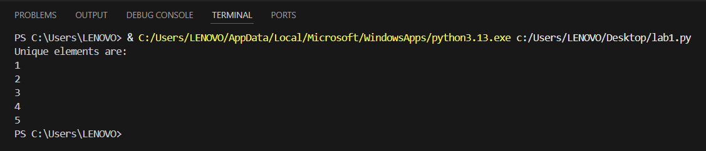

**#Question 2**

**#Create a tuple of 10 integers. Write a program to display the maximum and minimum numbers from the tuple.**

tuple = (16, 98, 45, 67, 43, 5, 65, 43, 56, 23)

print("Maximum number:", max(tuple))

print("Minimum number:", min(tuple))

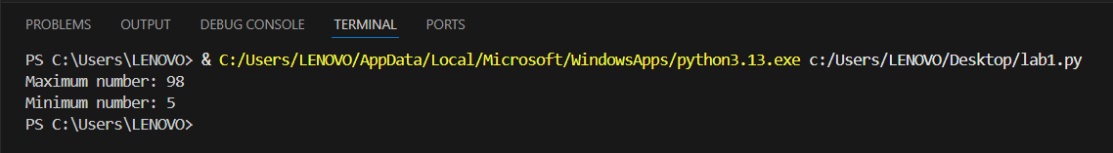

**#Question 3**

**#Write a Python function that accepts a list and returns a new list with only the even numbers from the original list.**

numbers = []

for i in range(10):

    num = int(input(f'Enter number {i+1}:'))

    numbers.append(num)

even = []

for x in numbers:

    if x % 2 == 0:

        even.append(x)

print(even)

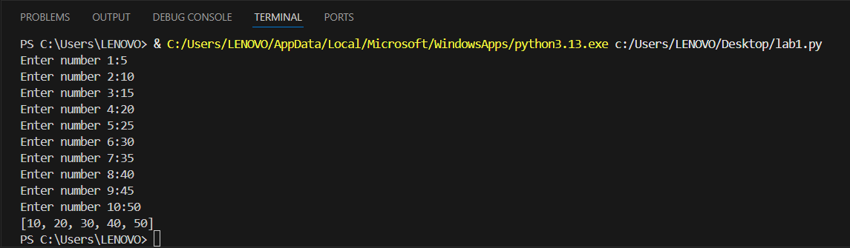

**#Question 4**

**#Write a program to count the number of each character in a given string using a dictionary.**

s = "Namaste Nepal"

d = {}

for i in s:

    d[i] = d.get(i, 0) + 1

print(d)

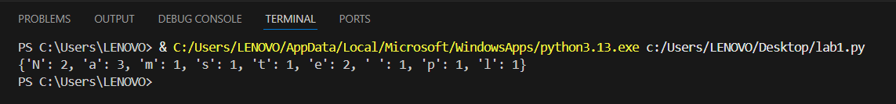

**#Question 5**

**#Create a set of prime numbers less than 50. Write a program to check whether a given number exists in the set or not.**

primes = set()

for num in range(2, 50):

    is_prime = True

    for i in range(2, num):

        if num % i == 0:

            is_prime = False

            break

    if is_prime:

        primes.add(num)

check = int(input("Enter a number to check: "))

if check in primes:

    print(f"{check} is a prime number.")

else:

    print(f"{check} is NOT a prime number.")

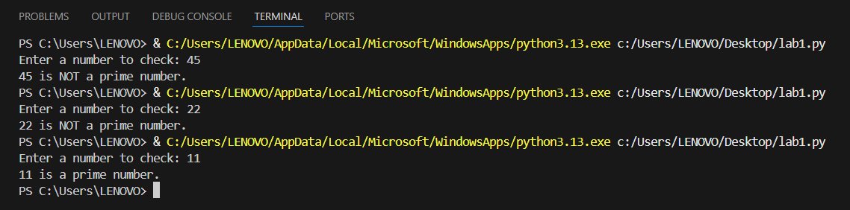

**#Question 6**

**#Given two lists, write a program to find their intersection using sets.**

a = [2, 4, 6, 8, 10, 12]

b = [3, 6, 9, 12]

print(f'List 1:{a}')

print(f'List 2:{b}')

print("The intersection of the two lists is:")

print(list(set(a) & set(b)))

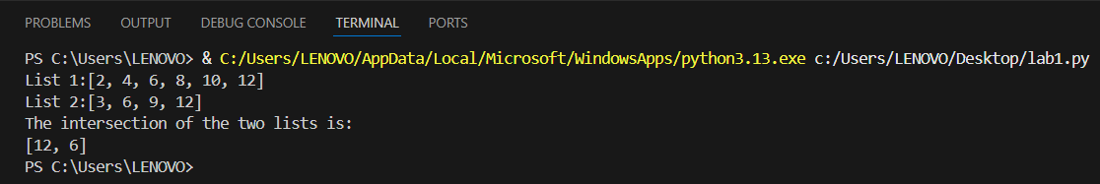

**#Question 7**

**#Write a Python program to merge two dictionaries and sum the values of common keys.**

a = {'x': 5, 'y': 10}

print(f'Dictionary 1: {a}')

b = {'y': 3, 'z': 8}

print(f'Dictionary 2: {b}')

c = {k: a.get(k, 0) + b.get(k, 0) for k in sorted(set(a) | set(b))}

print(c)

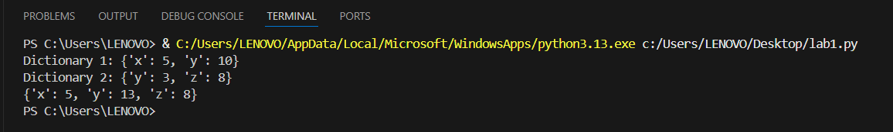

**#Question 8**

**#Given a list of names, write a program to count how many times each name appears using a dictionary.**

names = ["Laxmi", "Sweta", "Sweta", "Ayusha", "Muskan", "Muskan", "Sweta"]

print(f"Names: {names}")

d = {}

for name in names:

    d[name] = d.get(name, 0) + 1

print(f'Count of names: {d}')

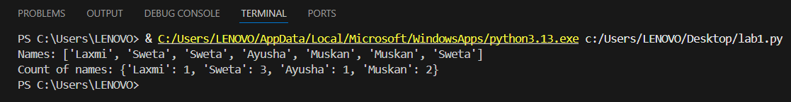

**#Question 9**

**#Write a Python program to remove elements from a list that are also present in another list.**

list1 = [1, 2, 3, 4, 5, 6]

print("list1:", list1)

list2 = [2, 4, 6]

print("list2:", list2)

result = []

for item in list1:

    if item not in list2:

        result.append(item)

print("Resulting list:", result)

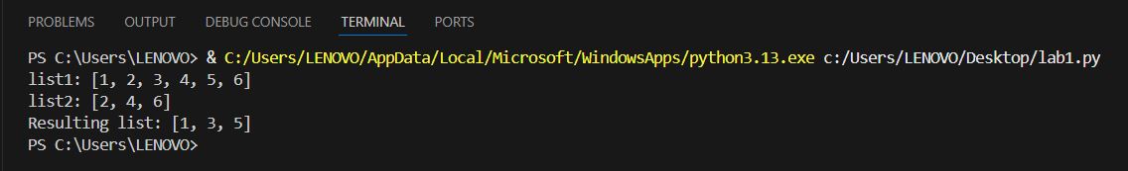

**#Question 10**

**#Write a program to input key-value pairs from the user and store them in a dictionary. Allow the user to search for a key and display its value.**

d = {}

n = int(input("Enter no. of key values to enter: "))

for i in range(n):

    k = input("Enter key: ")

    v = input("Enter value: ")

    d[k] = v

key = input("Enter key to search: ")

if key in d:

    print(d[key])

else:

    print("Key not found")

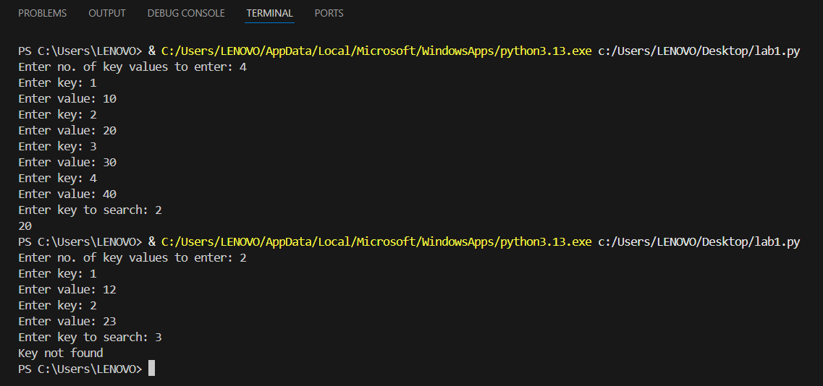

**LOOP**

**#Question 1**

**#Write a program to check whether a given number is prime or not.**

num = int(input("Enter a number: "))

if num <= 1:

    print(num, "is not a prime number.")

else:

    is_prime = True

    for i in range(2, num):

        if num % i == 0:

            is_prime = False

            break

    if is_prime:

        print(num, "is a prime number.")

    else:

        print(num, "is not a prime number.")

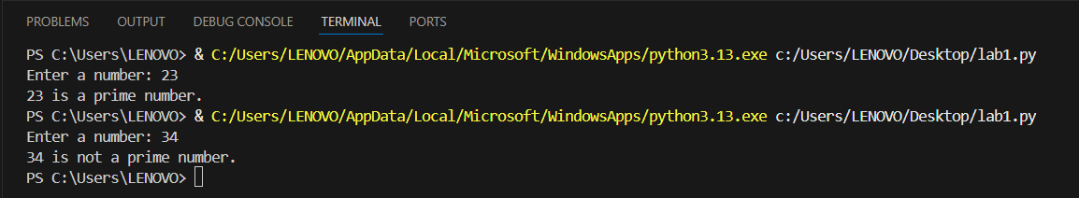

**#Question 2**

**#Write a program to print all the even numbers between 1 and 100 using a loop.**

for num in range(2, 101, 2):

    print(num, end=“ “)



**#Question 3**

**#Write a program that reads a number and prints the factorial of that number using a while loop.**

num = int(input("Enter a number: "))

fact = 1

i = 1

while i <= num:

    fact = fact * i

    i = i + 1

print("Factorial of", num, "is", fact)

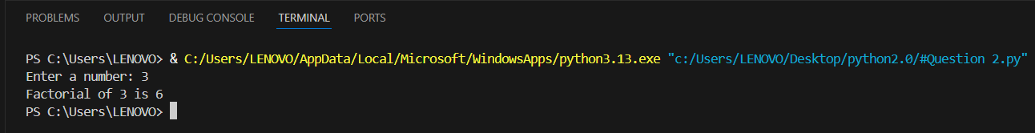

**#Question 4**

**# Write a program to print the multiplication table of a given number using a for loop.**

num = int(input("Enter a number: "))

for i in range(1, 11):

    print(num, "*", i, "=", num * i)

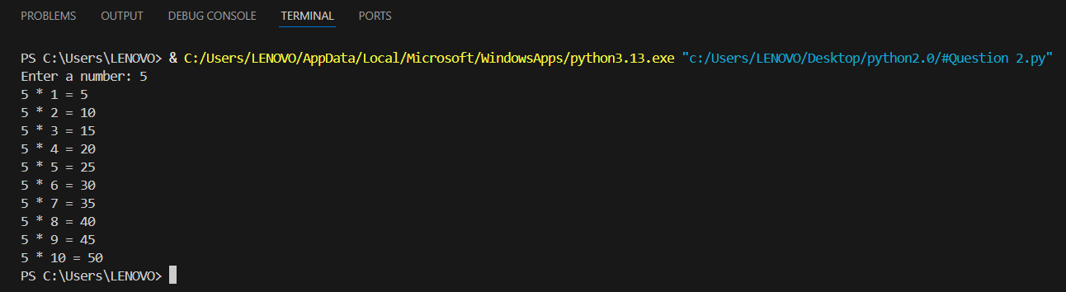

**#Question 5**

**#Write a program to find the largest and smallest number in a list entered by the user.**

nums = []

for i in range(5):

    nums.append(int(input(f"Enter {i+1} number: ")))

largest = nums[0]

smallest = nums[0]

for num in nums[1:]:

    if num > largest:

        largest = num

    if num < smallest:

        smallest = num

print("Largest:", largest)

print("Smallest:", smallest)

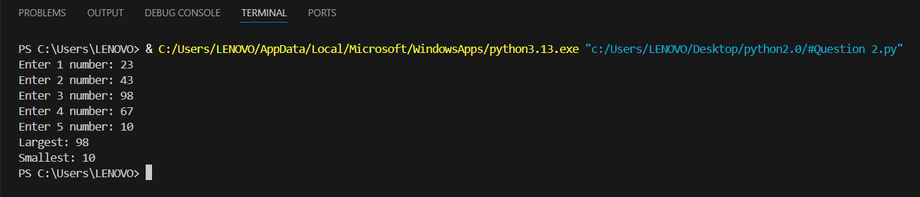

**#Question 6**

**#Write a program that accepts 10 integers from the user and counts how many are positive, negative, and zero.**

pos = 0

neg = 0

zero = 0

for i in range(10):

    num = int(input(f"Enter number {i+1}: "))

if num > 0:

        pos += 1

    elif num < 0:

        neg += 1

    else:

        zero += 1

print("Positive:", pos)

print("Negative:", neg)

print("Zero:", zero)

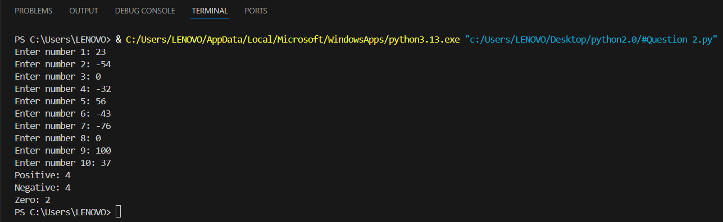

**#Question 7**

**#Write a program to generate the Fibonacci sequence up to n terms.**

n = int(input("Enter number of terms: "))

x = 0

y = 1

for i in range(n):

    print(x, end='\t')

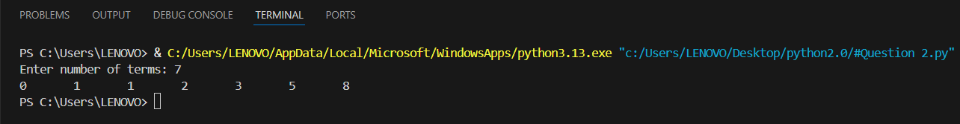    x, y = y, x + y

**#Question 8**

**#Write a program that reads a number and prints whether it is a palindrome or not.**

n = input("Enter a number: ")

rev = ""

for ch in n:

    rev = ch + rev

if n == rev:

    print("Palindrome")

else:

    print("Not Palindrome")

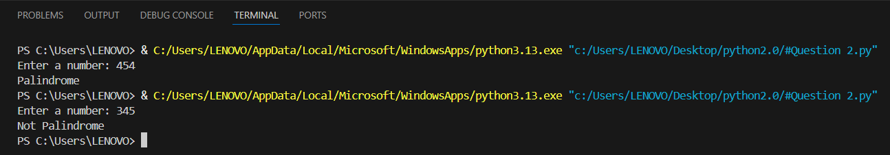

**#Question 9**

**#Write a program that finds all numbers between 100 and 999 where the sum of the cubes of the digits equals the number itself (Armstrong numbers).**

print("The Armstorng numbers are:")

for num in range(100, 1000):

    s = 0

    for d in str(num):

        digit = int(d)

        s += digit ** 3

    if num == s:

        print(num)

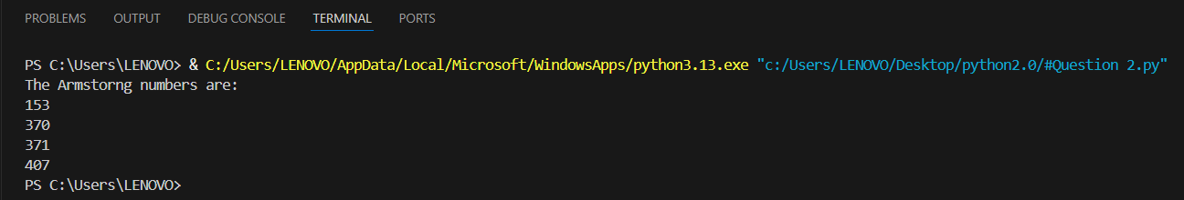

**#Question 10**

**#Write a menu-driven program to perform arithmetic operations (+, -, *, /) based on user choice using conditional statements.**

a = float(input("Enter first number: "))

b = float(input("Enter second number: "))

print("Choose operation:")

print("1. Add")

print("2. Subtract")

print("3. Multiply")

print("4. Divide")

print("5. Modulus")

choice = input("Enter choice: ")

if choice == '1':

    print("Result:", a + b)

elif choice == '2':

    print("Result:", a - b)

elif choice == '3':

    print("Result:", a * b)

elif choice == '4':

    if b != 0:

        print("Result:", a / b)

    else:

        print("Error: Division by zero")

elif choice == '5':

    print("Result:", a % b)

else:

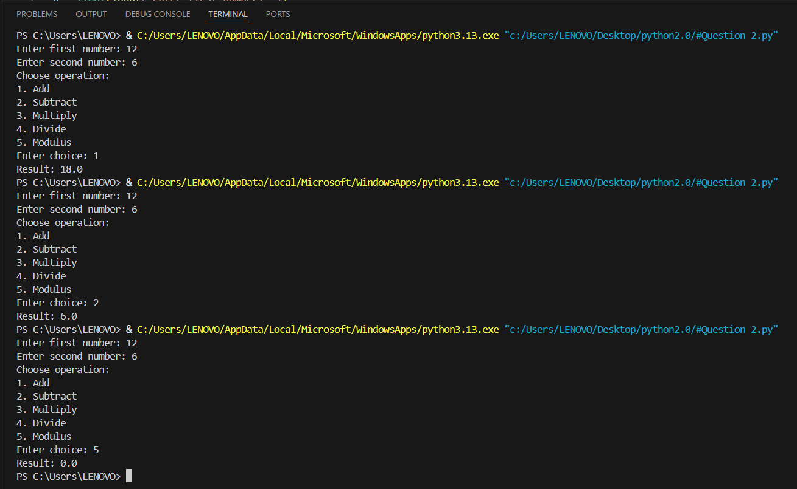    print("Invalid choice")