

App Name: TunePick

Team Members:

Sahithi Yamasani

Sreeja Vasa

Nikith Kumar Bandaru

Dimple Masamsetty Suresh

* **Problem/Issue Addressed:**

An effortless way to uncover new tracks without being overwhelmed by features is something that many beginner music aficionados wish to have, as they frequently struggle to find the latest music that suits their taste. A straightforward, user-friendly platform for finding and enjoying music is what TunePick offers to remedy this.

* **Activities and Their Intended Purposes:**

**Music Exploration:**

**Purpose**: Allows users to explore a curated collection of songs based on popular genres or mood categories.

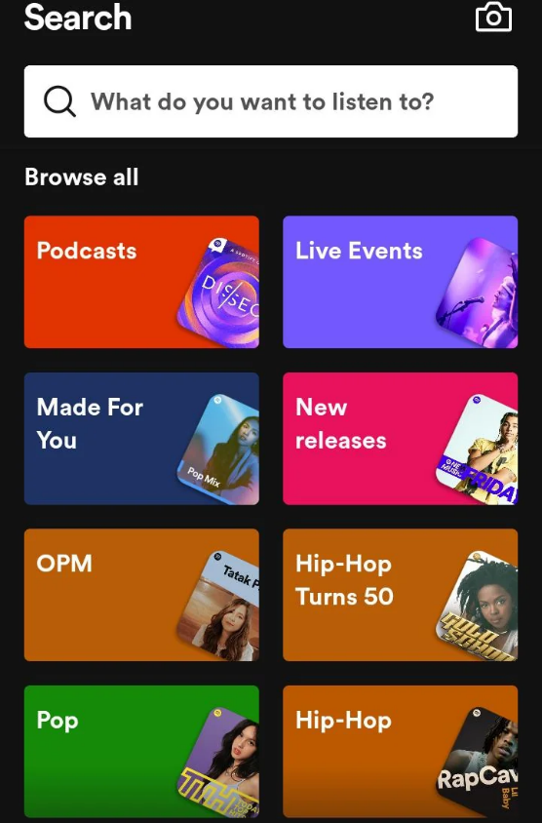

**Song Playback:**

**Purpose**: Enables users to listen to selected songs with basic playback controls (play, pause, skip).

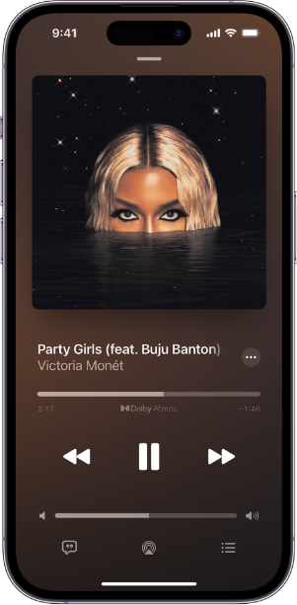

**Favorite Songs Collection:**

**Purpose**: Provides a space for users to bookmark and access their favorite songs for easy playback.

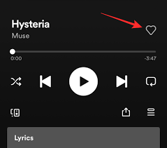

* **Flow Between Activities:**
* Users open TunePick and are immediately presented with the Music Exploration screen, where they can browse songs by genre or mood.
* Upon finding a song they like; users can tap on it to start playback in the Song Playback screen.
* While listening to a song, users can add it to their Favorite Songs Collection for future listening.
* Users can return to the Music Exploration screen at any time to continue discovering the latest music or revisit previous selections.

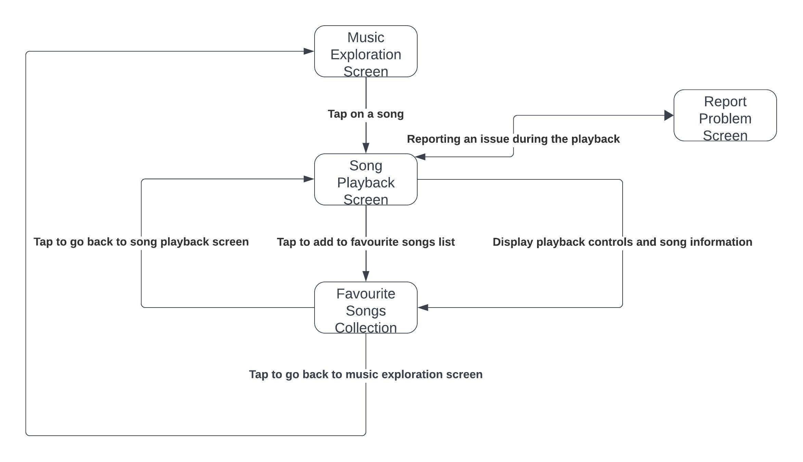

Activity Diagram

* **Data Considerations:**

Song data: Information about songs available for exploration, including title, artist, genre, and mood.

User favorites: Data on songs bookmarked by users for easy access in the Favorite Songs Collection.

* **References**:

Reference images: Reference images in this document are acquired from “Spotify” the existing music application from Play Store.

Activity diagram: Activity diagram in this document is generated using lucid Chart.