Difficulties faced during the tasks

1. The corpora was not getting downloaded and kept showing some error, turns out it was already partially downloaded in my system
2. Since it was only partially downloaded there were errors incurred while using new libraries so these libraries required explicit installation of the packages.
3. There were a few errors while working with countvectorization, required nltk.data.path to be imported.
4. Nltk.book.import showed the following error

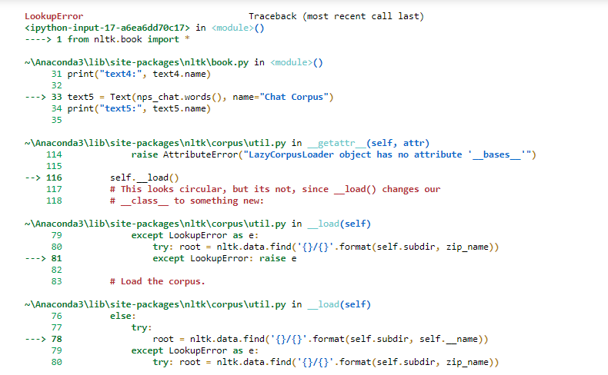

Was not successful in fixing the error.

1. Magnum opus was very confusing and was not able to implement.