**NATURAL LANGUAGE AND PROCESSING – TASK 1**

Hindi text

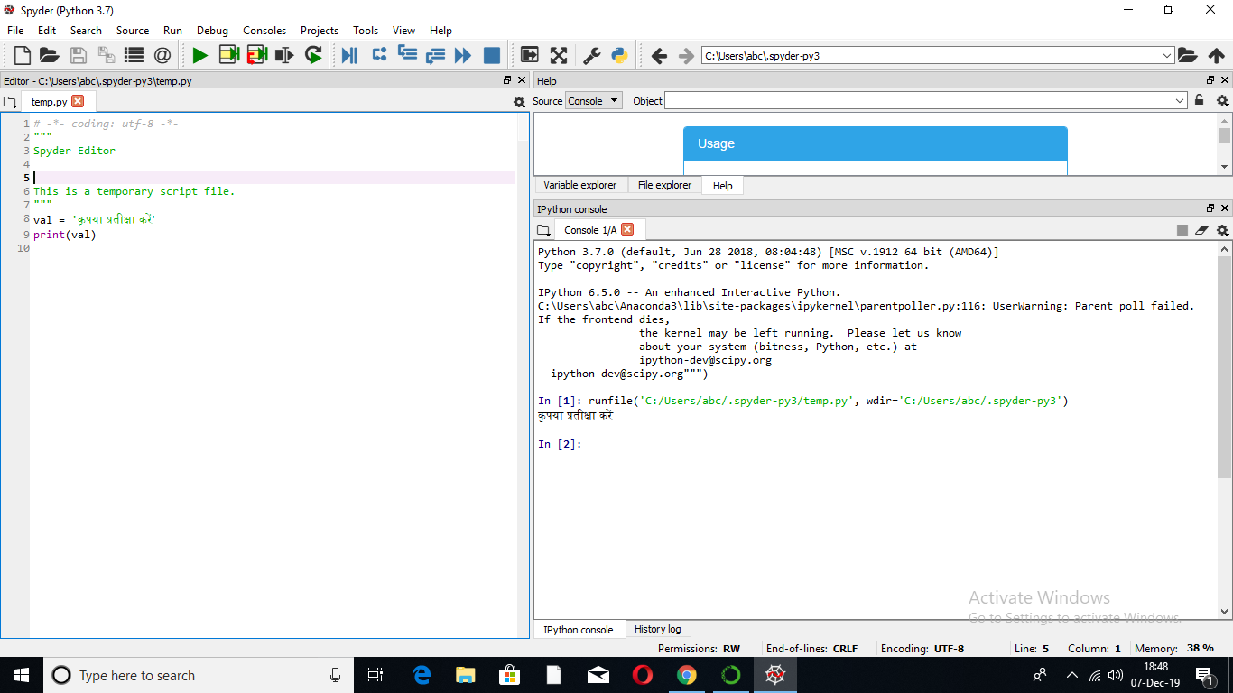

Single sentence

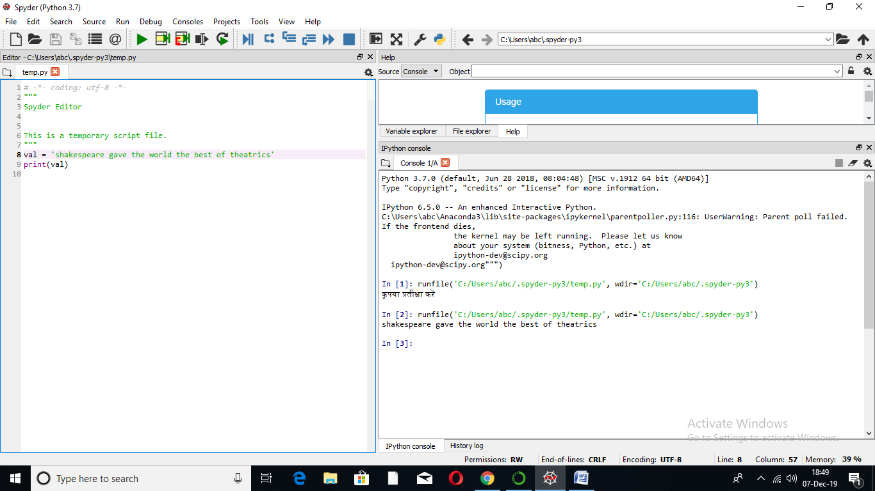

Multiline sentence

