In Azure, a Function App is the core component of what is called "Serverless Computing." Up until now, we have talked about Virtual Machines and Scale Sets. With those, you have to build the server, install the operating system, install your runtime (like Node.js), and manage the network. You also pay for those servers as long as they are turned on, even if no one is using them.
A Function App completely removes the server management part. Here is exactly how it works.

1. What is a Function App?
A Function App is an environment where you simply upload a single piece of code (like a raw JavaScript or Python script) and tell Azure to run it.
You do not see the Virtual Machine. You do not manage the operating system. Azure keeps your code stored safely, and when it is needed, Azure automatically finds available hardware, runs your exact lines of code, and then instantly shuts the hardware down.
2. How It Works: "Triggers"
A Function App does not run continuously 24/7. It sits completely frozen until a specific event—called a Trigger—wakes it up.
Here are the most common ways to trigger a Function:
- HTTP Trigger: The code runs exactly when a user hits a specific URL (just like an API endpoint).
- Timer Trigger: The code runs on a strict schedule (e.g., exactly at midnight every day).
- Database Trigger: The code runs the exact millisecond a new piece of data is saved into your database.
3. The Pricing Difference (Execution Time)
With a Virtual Machine, you pay per hour. If your VM is running at 3:00 AM and no users are visiting your application, you are still paying full price for that hour.
With a Function App, you pay strictly for execution time.
- If your JavaScript code takes exactly 200 milliseconds to run, you only pay for those 200 milliseconds of compute power.
- If nobody triggers your code for a whole week, you pay absolutely $0.00 for that week.
4. Real Architecture Example
Let's apply this to a real scenario, such as building a platform that manages function hall bookings.
The Scenario: Sending a Confirmation Email
When a user books a venue, you need to generate a PDF receipt and email it to them.
- The Old Way (Virtual Machine): You keep a large Node.js server running 24/7 just waiting for someone to make a booking so it can generate the PDF. This is expensive and wastes resources.
- The Serverless Way (Function App): 1. You write a small, isolated JavaScript function that only knows how to generate a PDF and send an email.
2. You upload it to an Azure Function App.
3. You set a Database Trigger.
4. When your main application saves a new "Booking" document into your database, the Function App wakes up instantly.
5. It grabs the booking details, generates the PDF, sends the email, and then immediately turns itself off.
Azure handles everything. If 1,000 people book a hall at the exact same second, Azure will instantly create 1,000 temporary copies of your code, run them all simultaneously, and then shut them all down.

FUNCTION APPS:
You are completely right to be concerned about that. Code absolutely cannot run on completely random, unconfigured hardware. I oversimplified by saying Azure finds "available hardware," and that created a valid technical gap in the explanation.
Here is the exact reality of how Azure ensures your code has the perfect environment, followed by a direct comparison between Function Apps and Virtual Machines.

1. The Reality: It is Not "Random" Hardware
When you create a Function App in the Azure Portal, you do not just upload code blindly. The very first step is defining your Runtime Stack and your Operating System.
You explicitly tell Azure, for example: "This Function App requires Node.js version 20 running on Linux."
How Azure Handles This:
- Azure maintains massive "warm pools" of servers that are already turned on, fully updated, and pre-configured with every standard environment (Node.js, Python, Java, .NET, etc.).
- When your HTTP Trigger or Database Trigger fires, Azure does not grab a random server. It specifically goes to the "Node.js 20 on Linux" pool.
- It drops your code onto one of those perfectly matched servers, executes the code, and then clears the server for the next task.
What if you need a highly specific or custom environment?
If your code requires a rare software dependency, a specific C++ background library, or an older operating system that Azure doesn't offer in its standard list, you use a feature called Custom Containers. You package your code and its exact operating system requirements into a Docker Container. Azure will then execute your custom container, guaranteeing 100% control over the runtime environment.

2. The Clear Difference: Function Apps vs. Virtual Machines
To understand exactly when to use which, here is the direct technical comparison across four main categories.
A. Infrastructure Management
- Virtual Machine (VM): You have full administrative control. You must log in, install the operating system, run security updates, install the runtime (like Node.js), and manage the hard drive space. If the OS crashes, you have to fix it.
- Function App: You have zero administrative control over the server. Azure handles all OS updates, security patches, and runtime installations invisibly. You are strictly responsible only for the code you write.
B. Billing and Cost
- Virtual Machine (VM): You pay for "uptime." If you leave a VM turned on for 24 hours, you pay for 24 hours of compute power—even if zero users visited your application during that time.
- Function App: You pay strictly for "execution time" (called the Consumption Plan). You are billed based on the gigabytes of memory used per millisecond. If your code runs for 300 milliseconds to process a database entry, you pay for exactly 300 milliseconds. If it doesn't run for a week, your bill is $0.00.
C. Scaling (Handling Traffic)
- Virtual Machine (VM): Scaling takes time. If traffic spikes, your Scale Set (VMSS) detects the high CPU load, requests a new VM, boots up the OS, starts your application, and adds it to the Load Balancer. This can take several minutes.
- Function App: Scaling is instantaneous and event-driven. If 10,000 HTTP requests hit your URL at the exact same second, Azure instantly grabs 10,000 pre-warmed servers from its pool and runs your code simultaneously.
D. Execution Length (Time Limits)
- Virtual Machine (VM): Designed for continuous, long-running processes. A web server or database runs 24/7 without interruption.
- Function App: Designed for short, rapid tasks. By default, Azure strictly limits a Function App execution to a maximum of 5 minutes. If your code takes 6 minutes to run, Azure will forcefully terminate the process. (You can manually increase this limit to 10 minutes, but it is not meant for hours-long processing).

A Trigger is the exact event that causes your Azure Function App to wake up, execute your code, and then shut down. Without a trigger, the code simply sits in storage doing nothing.
Here is a clear, technical breakdown of the four main triggers, including why they are used and how the JavaScript (Node.js) code actually looks.

1. HTTP Trigger
- What it is: The code executes the moment a specific URL receives a web request (like a GET or POST request).
- Why we use it: To build standard APIs or webhooks. It allows a frontend application (like a React UI) to request data or trigger an action directly.
- Real Scenario: A user clicks "Confirm Booking" on a venue management platform. The frontend sends a POST request with the user's payment details to the HTTP Trigger URL. The function wakes up, processes the payment, returns a success message, and shuts down.
The Code (Node.js):
JavaScript
const { app } = require('@azure/functions');

app.http('processPayment', {
methods: ['POST'],
authLevel: 'anonymous',
handler: async (request, context) => {
// 1. Read the booking details sent from the frontend
const bookingData = await request.json();

// 2. Process the payment logic here
context.log(`Processing payment for venue: ${bookingData.venueId}`);

// 3. Send the response back to the user
return {
status: 200,
body: "Payment successful and booking confirmed."
};
}
});

2. Timer Trigger
- What it is: The code executes on a strict, automated schedule based on a clock. You define the schedule using a format called a "CRON expression" (e.g., 0 0 0 * * * means exactly at midnight every day).
- Why we use it: For routine maintenance, generating daily reports, or cleaning up expired data without requiring any human interaction or web requests.
- Real Scenario: When users reserve a function hall, they have 24 hours to pay the deposit. A Timer Trigger runs every night at midnight, scans the database for unpaid reservations older than 24 hours, and automatically cancels them to free up the calendar.
The Code (Node.js):
JavaScript
const { app } = require('@azure/functions');

// The schedule "0 0 0 * * *" means run at 12:00 AM daily
app.timer('cleanupUnpaidBookings', {
schedule: '0 0 0 * * *',
handler: async (myTimer, context) => {
context.log('Timer triggered. Scanning for expired bookings...');

// Logic to connect to the database and delete unpaid holds
// db.collection('bookings').deleteMany({ status: 'unpaid', age: '> 24h' });

context.log('Expired bookings cleared successfully.');
}
});

3. Database Trigger (Cosmos DB / MongoDB)
- What it is: The code executes automatically the exact millisecond a new document is inserted, updated, or deleted inside your database.
- Why we use it: To react to data changes instantly without building heavy logic into your main web server. It keeps your primary application fast because it hands off background tasks the moment data is saved.
- Real Scenario: Your main Express backend saves a new Booking document into MongoDB. Instantly, the Database Trigger detects this new document, wakes up, reads the customer's email address from the document, and generates a PDF receipt.
The Code (Node.js):
JavaScript
const { app } = require('@azure/functions');

app.cosmosDB('generateReceiptOnBooking', {
connection: 'MyDatabaseConnectionString',
databaseName: 'VenuePlatformDB',
containerName: 'Bookings',
createLeaseContainerIfNotExists: true,
handler: async (documents, context) => {
// 'documents' contains the exact database records that were just saved
for (const doc of documents) {
context.log(`New booking detected for customer: ${doc.customerEmail}`);

// Logic to generate PDF and send email
// sendEmail(doc.customerEmail, doc.totalPrice);
}
}
});

4. Queue Trigger
- What it is: A Queue is a digital waiting line for data. A Queue Trigger executes whenever a new message (a piece of text or JSON data) is dropped into that waiting line.
- Why we use it: To decouple heavy, time-consuming tasks from your main web server so users do not experience lag. If your web server has to do 500 things at once, it will crash. Instead, it drops 500 separate "messages" into a Queue. The Function App picks them up one by one and processes them safely in the background.
- Real Scenario: A venue owner wants to send a promotional SMS to 10,000 past customers. Instead of the web server trying to send 10,000 texts at once, it drops 10,000 messages containing phone numbers into an Azure Storage Queue. The Queue Trigger wakes up, reads the first phone number, sends the SMS, deletes the message from the queue, and moves to the next one.
The Code (Node.js):
JavaScript
const { app } = require('@azure/functions');

app.storageQueue('sendPromoSMS', {
queueName: 'sms-outbound-queue',
connection: 'MyStorageAccountConnection',
handler: async (queueMessage, context) => {
// 'queueMessage' contains the exact data dropped in the queue
context.log(`Processing SMS for phone number: ${queueMessage.phoneNumber}`);

// Logic to connect to an SMS provider (like Twilio) and send the text
// await smsProvider.send(queueMessage.phoneNumber, queueMessage.promoText);

context.log('SMS sent successfully. Message removed from queue.');
}
});

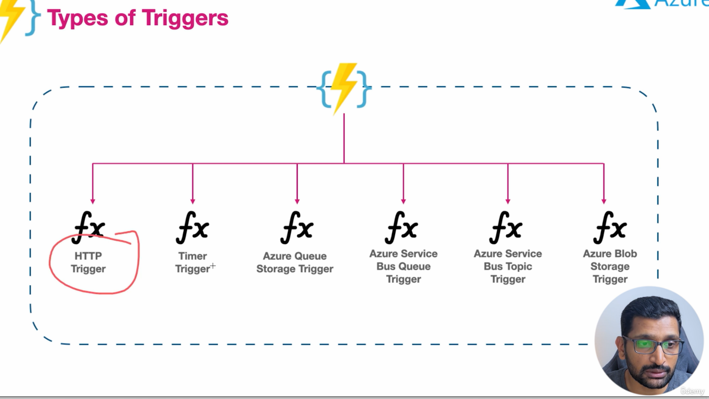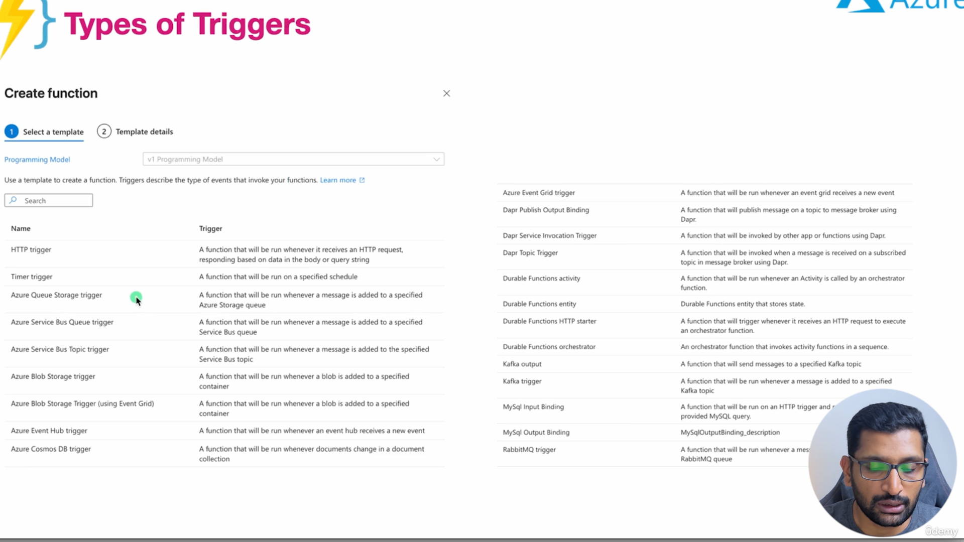

To understand Microsoft Entra ID (which was formerly known as Azure Active Directory or Azure AD), we need to shift our focus from networks and servers to Security and Identity.
Up until now, we have discussed how to build a network, block IP addresses, and run code. Entra ID is the system that manages exactly who is allowed to press the buttons to build those things, and who is allowed to log into the applications you create.
Here is the complete, clear technical breakdown of what Entra ID is, how it works, and exactly where it is used.

1. What is Entra ID?
Entra ID is a cloud-based Identity and Access Management (IAM) service. Its entire job is to handle two specific security actions:
- Authentication (Verification): Proving a user or a system is exactly who they claim to be. This is the process of checking a username, a password, and a Multi-Factor Authentication (MFA) code.
- Authorization (Permissions): Checking what that verified user is actually allowed to do. Just because you successfully logged in does not mean you are allowed to delete a production database.
Instead of building your own login systems from scratch and storing passwords in your own database (which is highly insecure), you outsource all of that security to Entra ID.

2. Where and How We Use It (The Two Main Scenarios)
Entra ID is generally used to solve two completely different problems. Here are the exact scenarios.
Scenario A: Securing the Cloud Infrastructure (Internal Team)
Imagine a scenario where a 3-member development team is building cloud infrastructure. You cannot share one master "admin" password because if someone makes a mistake and deletes a Virtual Network, you will not know who did it.
How Entra ID solves this:
- You create exactly three distinct User Accounts inside Entra ID (e.g., dev1@yourdomain.com, dev2@yourdomain.com).
- You use a feature called Role-Based Access Control (RBAC) to assign specific permissions.
- You tell Entra ID: "Developer 1 is strictly allowed to manage the Node.js Virtual Machines. Developer 2 is strictly allowed to view the MongoDB database, but cannot delete it."
- When Developer 2 logs into the Azure Portal, Entra ID checks their identity and physically hides the "Delete" button on the database screen.
Scenario B: Securing a Web Application (Customer-Facing)
If you are building a custom web application, such as a function hall management platform using a React frontend and a Node.js backend, you need a way for customers to securely register, log in, and book a venue.
How Entra ID (specifically Entra External ID / B2C) solves this:
- You do not write code in your Node.js backend to encrypt passwords or manage user sessions.
- Instead, when a customer clicks "Log In" on your React frontend, React redirects them to a highly secure Microsoft Entra ID login screen.
- The customer enters their credentials. Entra ID verifies them.
- Entra ID sends a secure digital passport (called a JSON Web Token or JWT) back to your React frontend.
- When React wants to fetch the user's past bookings, it sends that digital passport to your Node.js backend.
- Node.js looks at the passport, mathematically verifies it was signed by Entra ID, and returns the private data.

3. Key Features You Configure in Entra ID
When you use Entra ID, you configure these specific security features to protect your users and infrastructure:
- Single Sign-On (SSO): A user logs in exactly one time and gains access to multiple different applications without having to type their password again.
- Multi-Factor Authentication (MFA): Forcing users to approve a login on their mobile phone or enter a text message code after typing their password.
- Conditional Access Policies: Strict, automated rules. For example, you can configure Entra ID to say: "If a developer tries to log into the Azure Portal from an IP address outside of India, immediately block the login, even if they type the correct password."
- Managed Identities: This is how you authenticate resources, not just humans. If your App Service (where your Node.js code lives) needs to read data from your database, you don't hardcode the database password into your code. You give the Node.js server its own Entra ID identity, and the database verifies the server itself before allowing the connection.

Summary
Entra ID is the central security directory. It stores user accounts, enforces passwords and MFA, and generates the secure digital tokens required to access both your Azure portal and your custom-built applications

Here is the complete picture. To understand exactly why companies use Microsoft Entra ID, we have to look at what happens when you choose not to use it.
When you need an Identity and Access Management (IAM) system—to log users into your web application or to secure your cloud servers—you basically have three paths. You can use Entra ID, you can build it completely by yourself, or you can use a direct competitor.
Here is the exact technical breakdown of your alternatives, along with the advantages and disadvantages of each.

Path 1: Microsoft Entra ID (The Native Azure Path)
As discussed, this is Microsoft’s built-in security directory. You outsource all password handling, Multi-Factor Authentication (MFA), and login screens directly to Azure.
- Advantage: Native integration. If your entire architecture (Virtual Networks, Load Balancers, VMs) is already in Azure, Entra ID is built directly into those tools. You can lock down an Azure Function App with Entra ID using just a few clicks.
- Disadvantage: It is heavily designed for enterprise businesses. Setting up a simple login screen for a small, customer-facing web application can be overly complex compared to other developer-focused tools.

Path 2: The "Do It Yourself" Alternative (Custom Authentication)
If you do not want to use Entra ID or any third-party service, you have to write the entire security system from scratch in your backend code (e.g., inside your Node.js server) and store the credentials in your own database (e.g., MongoDB).
How it works:
- A user creates an account on your frontend.
- Your backend code receives the raw password.
- Your code runs a mathematical algorithm (like bcrypt) to scramble the password into unreadable text (hashing).
- You save that scrambled text into your database.
- When they log in, you write the code to check the password, generate a secure digital token (JWT), and send it back to the user.
The Advantages:
- Total Control: You own 100% of the data and the login experience. You design the exact flow without relying on Microsoft's screens.
- No Subscription Fees: You are not paying a third-party company per user login.
The Disadvantages (Why most companies avoid this):
- Massive Security Risk: If you make a single mistake in your backend code, hackers can breach your database and steal every user's email and password.
- High Development Time: You have to write and maintain the code for password resets, email verification, account lockouts, and Multi-Factor Authentication (MFA) entirely by yourself. This takes weeks of engineering time.

Path 3: Third-Party Identity Providers (The Direct Competitors)
If you do not want to build it yourself, but you also do not want to use Microsoft Entra ID, you use a dedicated Identity Provider (IdP). These are companies whose only product is security and login systems.
The most common alternatives are:
- Auth0 (by Okta): Heavily focused on developers. It is extremely popular for custom web applications.
- AWS Cognito: Amazon’s direct equivalent to Entra ID.
- Google Cloud Identity: Google’s equivalent.
The Advantages of using Auth0 / Competitors:
- Developer Friendly: Platforms like Auth0 provide pre-written code specifically for frontend frameworks (like React) and backend frameworks (like Express). You can implement a secure login system in a few hours.
- Platform Independence: If you decide to move your servers out of Azure and into Amazon Web Services (AWS) next year, your user logins won't break because your security is handled by a separate, independent company.
The Disadvantages:
- Pricing: These services often have generous free tiers, but once your application gets thousands of users, they charge a monthly fee based on the number of active logins.
- Separation of Systems: If you use Auth0 for your web app users, but Azure for your servers, you are now managing security across two completely different platforms.

Summary Table: Making the Choice
Path | Best For... | Biggest Risk
Custom Built | Learning the absolute fundamentals of backend security; projects with zero budget. | Storing passwords incorrectly and getting hacked.
Auth0 / Competitors | Building a fast, customer-facing web application (like a booking platform) across any cloud. | Paying high licensing costs when your user base grows.
Microsoft Entra ID | Securing internal developers, corporate employees, and strict Azure infrastructure. | Complex initial setup and strict enterprise rules.

Up until now, if you wanted to create a Virtual Network or a Load Balancer in Azure, you would log into the Azure web browser (the Portal), click "Create," fill out text boxes, and hit "Submit."
Terraform replaces that manual clicking. It is a tool for Infrastructure as Code (IaC).
Here is the complete, clear technical breakdown of what Terraform is, how it works, and what happens if you choose not to use it.

1. What is Terraform?
Terraform is an open-source software tool created by a company called HashiCorp. Its entire purpose is to let you write standard, readable code to deploy your cloud infrastructure.
Instead of navigating the Azure website to create your databases and servers, you open a code editor (like VS Code), write exactly what you want your infrastructure to look like using a specific language called HCL (HashiCorp Configuration Language), and execute the file. Terraform talks directly to Azure's backend API and builds everything for you in seconds.
2. How and Where We Use It (The Core Workflow)
Terraform operates on a very strict three-step process.
Step 1: Write the Code (.tf files)
You declare the exact resources you need. For example, if you are setting up the network for a function hall management platform, you write a block of code requesting an Azure Resource Group and a Virtual Network.
The Code Example (HCL):
Terraform
# 1. Tell Terraform to use Azure
provider "azurerm" {
features {}
}

# 2. Create a Resource Group
resource "azurerm_resource_group" "main" {
name = "booking-platform-rg"
location = "East US"
}

# 3. Create the Virtual Network (VNet)
resource "azurerm_virtual_network" "main_vnet" {
name = "backend-vnet"
location = azurerm_resource_group.main.location
resource_group_name = azurerm_resource_group.main.name
address_space = ["10.0.0.0/16"]
}
Step 2: Plan (terraform plan)
Before Terraform builds anything, you run a command called terraform plan. Terraform reads your code, connects to Azure, and outputs a strict list: "I am going to create exactly one Resource Group and one VNet. I will not touch any of your existing databases." This prevents catastrophic mistakes.
Step 3: Apply (terraform apply)
When you approve the plan, Terraform executes the API calls and physically builds the VNet inside Azure.
The Secret Mechanism: The "State" File
When Terraform finishes building, it creates a file on your computer called terraform.tfstate. This is a strict record of exactly what it built. If you change your code later to add a Subnet and run terraform apply again, Terraform checks the State file, realizes the VNet already exists, and only builds the new Subnet.

3. Why We Use It (The Real-World Team Scenario)
Imagine you are working in a three-member development team. You all need to build out the React frontend, the Node.js backend, and the MongoDB database environments.
If you use the Azure Portal manually, Developer 1 might click a wrong button and set the wrong IP range. You cannot easily undo it, and there is no record of what they clicked.
If you use Terraform:
- Version Control (Git): Your infrastructure code lives in a GitHub repository right next to your Node.js code. If someone wants to change a Network Security Group (NSG) rule, they submit a Pull Request. The team reviews the code before it is applied.
- Instant Replication: If you spend two weeks building a complex "Testing" environment in Azure, you do not have to spend another two weeks manually clicking to build the "Production" environment. You simply change the variable environment = "prod" in your Terraform code, run the script, and an exact replica is built instantly.
- Disaster Recovery: If someone accidentally deletes your entire Azure Virtual Network, you do not panic. You just run terraform apply again, and Terraform rebuilds the entire network exactly as it was.

4. Alternatives to Terraform (What if you don't use it?)
If you choose not to use Terraform, you have two primary alternatives.
Alternative A: "ClickOps" (Manual Azure Portal)
You physically log into the Azure website and click through the menus to build everything.
- Advantage: Extremely easy for beginners. You can visually see all the options. Zero code to learn.
- Disadvantage: It is slow, prone to human error, impossible to replicate quickly, and completely unmanageable for large-scale applications.
Alternative B: Azure Bicep / ARM Templates (Native Microsoft IaC)
Microsoft has its own specific Infrastructure as Code languages called ARM (Azure Resource Manager) Templates and a newer, cleaner version called Bicep.
- Advantage: It is built directly by Microsoft for Azure. The very day Azure releases a new feature, Bicep supports it. You don't have to manage a "State" file yourself because Azure handles it internally.
- Disadvantage: Vendor Lock-in. Bicep only works on Azure. If your startup decides to move the database to AWS next year, or if you want to use code to configure a third-party tool like Auth0, Bicep cannot do it.
Summary Table: Making the Choice
Path | Best For... | Biggest Risk/Disadvantage
Manual Clicking | Learning the absolute basics of Azure; tiny test projects. | Errors; impossible to track who changed what.
Azure Bicep | Teams that are 100% committed to Azure forever and want native tools. | Completely useless if you ever use AWS or Google Cloud.
Terraform | Professional engineering teams; managing infrastructure across multiple different cloud providers simultaneously. | Managing the .tfstate file securely requires careful team coordination.

Would you like me to map out how a team securely stores that terraform.tfstate file in the cloud (using Azure Storage and Resource Locks) so that all three developers can work on the same infrastructure without overwriting each other's changes?

