Part 1: The Architecture (Microservices)
Before you can package or manage code, you have to write it.
The Old Way: Monolithic Architecture
Historically, applications were built as one single, massive block of code (a "Monolith"). If you built a web application, the code for user logins, processing payments, and sending emails were all tangled together in one giant file structure.
- The Problem: If the code handling "Payments" encounters an error and crashes the server, the entire application goes offline. Users cannot even log in. Furthermore, if only the "Payments" section needs more CPU power during a busy day, you cannot scale just that piece. You have to duplicate the entire giant application across multiple Virtual Machines.
The Solution: Microservices Architecture
Microservices is a design pattern where you completely split that massive application into tiny, isolated, independent pieces of code.
- You write one small application strictly for "Logins."
- You write a second, completely separate application strictly for "Payments."
- You run them independently. They communicate with each other over the network using standard HTTP requests (APIs).
- The Result: If the Payments microservice crashes, the Login microservice continues running perfectly. If Payments needs more CPU, you only scale the Payments code, saving massive amounts of compute power.

Part 2: The Packaging (Docker)
Now that your application is split into 20 separate Microservices, you have a new problem: how do you run 20 different applications without creating 20 heavy, expensive Virtual Machines?
What is Docker?
Docker is a software tool that creates Containers.
Virtual Machines vs. Containers:
- A Virtual Machine (VM) requires its own massive Operating System (like a full installation of Windows or Linux). Booting it takes minutes, and it wastes gigabytes of RAM just keeping the OS running.
- A Docker Container does not contain an Operating System. It is a highly compressed package that contains only your exact Microservice code and the specific software libraries it needs to run (like Node.js or Python).
Why we use Docker:
- Speed and Size: Because they don't have an OS, containers are measured in megabytes, not gigabytes. They boot up and start executing code in milliseconds. You can easily run 50 Docker containers on a single Azure Virtual Machine.
- Absolute Consistency: A Docker container locks in your exact software versions. If your Microservice runs perfectly inside its Docker container on your local laptop, it is mathematically guaranteed to run the exact same way on Azure's servers.

Part 3: The Management (Kubernetes)
Docker is perfect for packaging your code into containers. However, Docker alone cannot manage an entire enterprise system.
If you have 500 Docker containers running across 10 different Virtual Machines, you face critical operational problems:
- If a Virtual Machine physically loses power, all 50 containers on it die. Who restarts them on a surviving machine?
- If a sudden spike in internet traffic hits your Load Balancer, who creates 100 new "Payment" containers to handle the load?
- Who monitors the health of all 500 containers every single second?
What is Kubernetes (K8s)?
Kubernetes is an automated management software (an "Orchestrator") specifically designed to control thousands of Docker containers.
How it works:
You do not manually start or stop containers. Instead, you write a configuration file for Kubernetes stating your strict rules.
- You tell Kubernetes: "I always need exactly 5 copies of the Login container and 10 copies of the Payment container running at all times."
- Kubernetes continuously scans your servers. If it detects that a Payment container has crashed, it instantly deletes the broken container and commands Docker to boot up a fresh one to maintain the strict rule of 10.
- It automatically handles the internal routing, so the Login containers always know the exact internal IP addresses of the Payment containers, even as containers are constantly being destroyed and created.

Part 4: How This Fits into Azure
In the cloud, managing the underlying servers that run Kubernetes is notoriously difficult. Azure provides specific services so you only have to focus on your code.
1. Azure Container Registry (ACR)
This is a secure, private storage vault in Azure. When you finish writing your code and use Docker to package it into a Container, you upload that finished container file into your ACR.
2. Azure Kubernetes Service (AKS)
This is Azure's official hosting environment for Kubernetes.
- You tell AKS how many base Virtual Machines you want to pay for (these are called "Worker Nodes").
- You connect AKS to your ACR vault.
- AKS automatically pulls your Docker containers out of the vault and deploys them onto the Virtual Machines, managing the scaling, health checks, and networking automatically based on your rules.

Here is the complete, technical deep dive into Kubernetes (K8s), Azure Kubernetes Service (AKS), Azure Container Registry (ACR), and your alternative options.

Part 1: The Anatomy of Kubernetes (How It Actually Works)
When you build a Kubernetes "Cluster," you are grouping multiple Virtual Machines together to act as one giant machine. Kubernetes divides these machines into two strict roles:
1. The Control Plane (The Brain)
This is the master server. It does not run your application code. Its only job is to store your rules and monitor the system. It contains the API server (how you send commands) and the scheduler (which decides exactly which Virtual Machine should run your container).
2. The Worker Nodes (The Muscle)
These are the standard Virtual Machines that actually execute your Docker containers.
How K8s runs your code (The Three Core Components):
Kubernetes does not just place a raw Docker container on a server. It wraps it in three layers of control:
- The Pod: Kubernetes cannot run a Docker container directly. It wraps your container inside a "Pod." A Pod is the smallest unit in Kubernetes. It has its own Private IP address. If your Node.js application is running, it is running inside a container, which is running inside a Pod.
- The Deployment: You never manually create a Pod. You create a "Deployment" file. You write: "I want 3 replicas of the Node.js Pod." The Deployment constantly monitors the cluster; if a Pod is deleted, the Deployment instantly builds a new one to maintain the strict count of 3.
- The Service: Because Pods are constantly being destroyed and recreated by the Deployment, their Private IP addresses change constantly. A "Service" fixes this. It creates one permanent, static internal IP address. When your frontend needs to talk to the Node.js backend, it sends traffic to the Service's static IP, and the Service forwards the traffic to whichever backend Pods are currently alive.

Part 2: Deep Dive into the Azure Components (ACR & AKS)
If you install Kubernetes entirely by yourself on standard Virtual Machines, you have to manually configure the Control Plane, secure the database that holds the cluster state, and handle all encryption. Azure provides two services to eliminate this manual work.
1. Azure Container Registry (ACR)

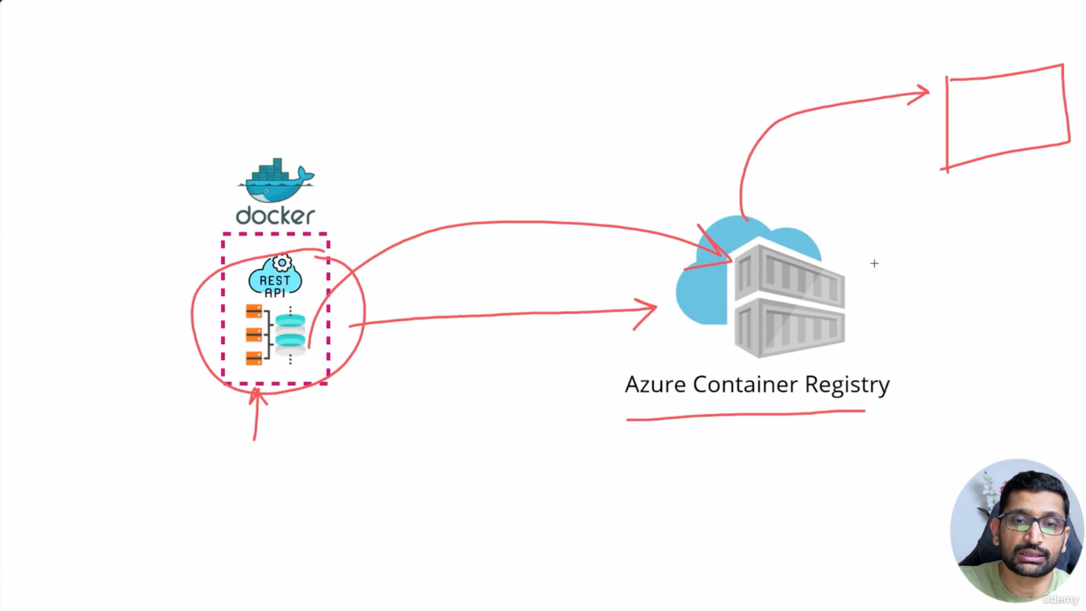
- What it is: A secure, private storage vault specifically for your finished Docker container images.
- Why we use it: You could store your Docker containers on the public "Docker Hub" website, but that is a massive security risk for private corporate code. ACR lives inside your Azure environment.
- How it works: When you finish writing code on your laptop, you run the docker push command to upload the packaged container directly into ACR. You then lock ACR down using Entra ID so only your specific Azure servers have permission to download the code.
2. Azure Kubernetes Service (AKS)
- What it is: A managed Kubernetes environment.
- Why we use it: Managing the Kubernetes "Control Plane" is notoriously difficult. If the Control Plane crashes, your entire cluster breaks. With AKS, Microsoft completely hides the Control Plane from you. Microsoft manages it, updates it, and keeps it online for free.
- How it works: You only configure the Worker Nodes (the Virtual Machines). You tell AKS to build a cluster with 3 Worker Nodes. AKS automatically connects them to a hidden Control Plane. You then use code to tell AKS to pull your Docker images from your ACR and run them on your Worker Nodes.

Part 3: What if you don't use Kubernetes? (The Alternatives)
Kubernetes is incredibly powerful, but it is also highly complex. If you choose not to use it, you have three distinct alternatives for running Docker containers in Azure.
Alternative A: Raw Docker on a Virtual Machine
You create one standard Azure Virtual Machine, log into it, install Docker, and manually start your containers.
- Advantage: Extremely simple. Zero complex Kubernetes configurations to learn.
- Disadvantage: No high availability. If that single Virtual Machine crashes, your entire application goes completely offline. There is no automated system to restart your containers on a different server.
Alternative B: Azure App Service (Platform as a Service)
You do not use Docker or Kubernetes at all. You just take your raw Node.js or React code and upload it directly to Azure App Service. Azure handles all the infrastructure automatically.
- Advantage: The absolute fastest way to get a web application onto the internet. You do not manage networks, OS updates, or container configurations.
- Disadvantage: You lose deep control. You cannot build a complex architecture with 20 different interacting microservices efficiently. It is designed for monolithic applications or simple APIs.
Alternative C: Azure Container Apps (Serverless Containers)
This is the middle ground between App Service and AKS. It actually uses Kubernetes under the hood, but Azure completely hides it from you. You just give Azure your Docker container and say, "Run this."
- Advantage: You get the scaling benefits of Kubernetes (including scaling down to zero to save money) without having to learn how to write complex Kubernetes Deployment or Service files.
- Disadvantage: Vendor lock-in. Because Azure abstracts the K8s API away, you cannot easily migrate this exact setup to AWS or Google Cloud later.

Part 4: The Complete Traffic Flow
To tie everything together, here is the exact, step-by-step path a user's web request takes when your application is running inside Azure Kubernetes Service (AKS).
Plaintext
[ INTERNET USER ]
|
| (Request hits the Public IP)
v
[ AZURE LOAD BALANCER ]
|
| (Routes traffic into the Virtual Network)
v
[ KUBERNETES INGRESS CONTROLLER ] (Running on a Worker Node)
|
| (Reads the URL, e.g., /api/bookings, and finds the correct Service)
v
[ KUBERNETES SERVICE ] (The static internal IP for the backend)
|
| (Forwards traffic to an available Pod)
v
[ NODE.JS POD ]
|
v
[ DOCKER CONTAINER ] (Your exact code executes here)

