Lab – Submission:
NAME:B G NIKIL KUMAR REDDY
SRN :PES2UG24CS107
SEC:B

Project: Alumni Mentorship & Mock Interview Platform

Screenshot 1 – Jira Backlog with Epics and User Stories
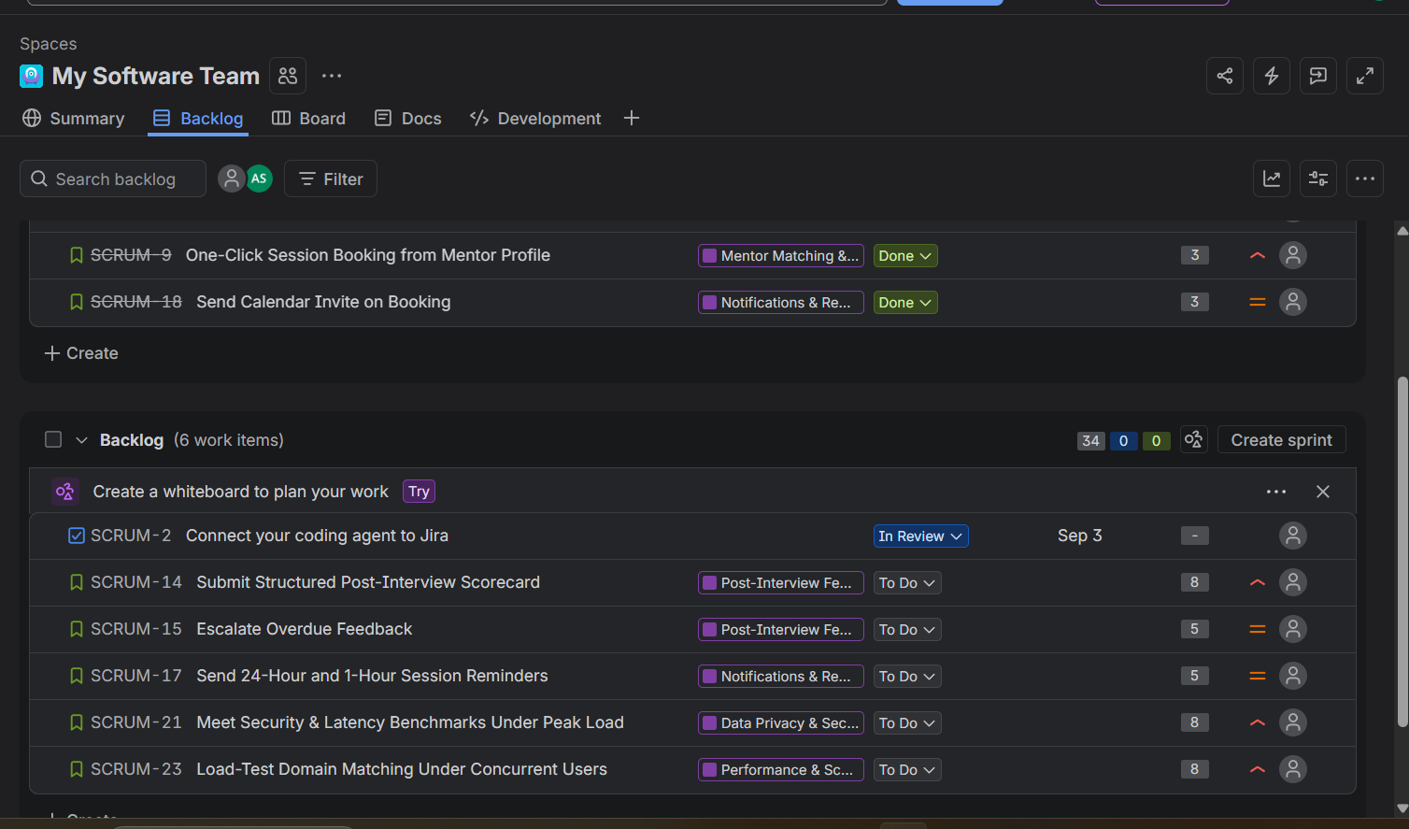

Screenshot 2 – Story Point Assignments

Screenshot 3 – Active Sprint Board
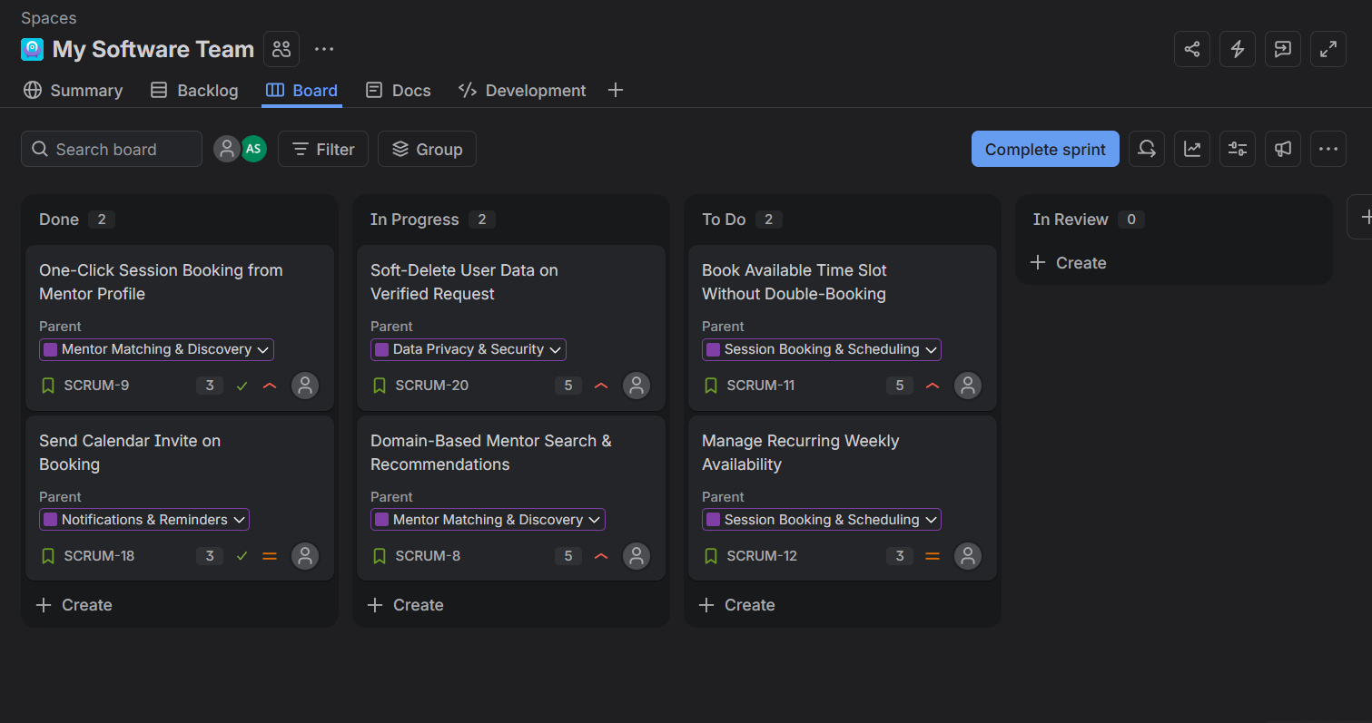

Screenshot 4 – Sprint Burndown Chart
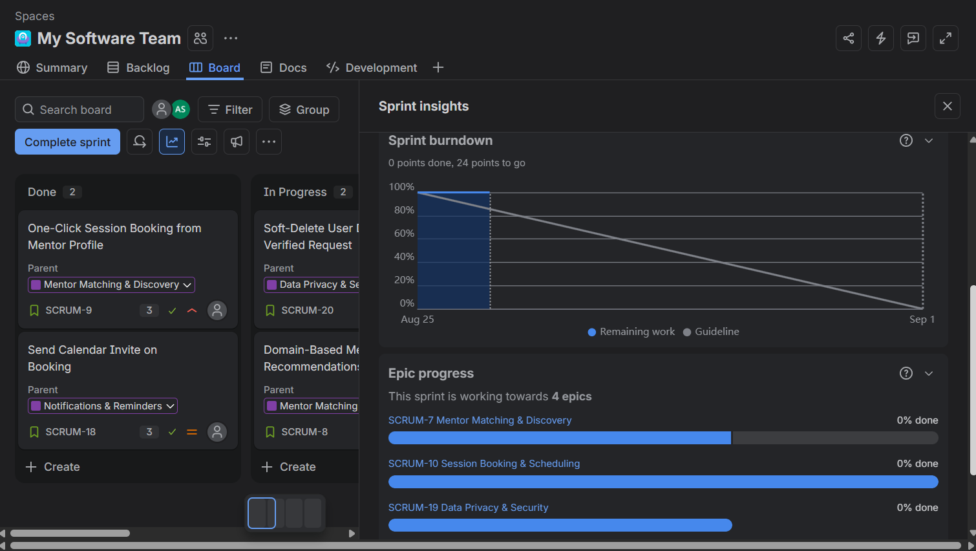

Reflection
Introduction
This lab provided practical experience in using Jira to manage a software project using Agile and Scrum practices. I worked with a backlog, Epics, User Stories, Story Points, an active Sprint board, and a Sprint Burndown view.
What I learned
I learned how larger project requirements can be organized as Epics and then divided into smaller User Stories. I also learned how Story Points can be used to estimate the relative effort of different stories. In the project backlog, the stories were associated with their respective Epics and assigned values such as 3, 5, and 8 points.
Sprint management
The Active Sprint board helped me understand how work is tracked through different stages. The board showed stories in Done, In Progress, and To Do, making the current state of the Sprint easy to understand. This demonstrated how Scrum teams can visually monitor work and identify what has been completed and what still needs attention.
Burndown chart
The Sprint Insights view showed the Burndown Chart and the remaining work for the Sprint. The chart indicated that 24 Story Points were still to be completed at the time of the screenshot. This helped me understand how a Burndown Chart can be used to compare remaining work against the expected Sprint progress.
Difficulties and understanding
One difficulty was understanding how the different Jira elements are connected. After completing the workflow, it became clearer that Epics represent larger areas of work, User Stories represent specific requirements, Story Points estimate effort, and the Sprint provides a fixed period in which selected work is completed.
Conclusion
Overall, the lab improved my understanding of Agile project management and gave me hands-on experience with Jira. I learned how to organize requirements, estimate work, track Sprint progress, and use the Burndown Chart to monitor remaining work. This practical workflow showed how Jira can help a development team plan and communicate project progress effectively.

