PES University – Dept. of CSE
Lab 1: Requirements Engineering & UML Use-Case Modelling
Problem Statement #06 – Alumni Mentorship & Mock Interview Platform
Name: B G Nikil kumar reddy
SRN: PES2UG24CS107

1. Requirements Table
Actors: Student Mentee, Alumni Mentor, Platform Admin
Req ID | Type | Description | Priority | Acceptance Criteria | Rationale
FR-001 | Functional | The system shall recommend Alumni Mentors to Student Mentees based on domain matching (e.g., Embedded Systems, Cloud Computing) and facilitate one-click session booking. | High | Pass: Mentorship session is added to both calendars with a meeting link. Fail: Double-booking of mentor slots. | Core matchmaking value proposition of the platform; given as sample requirement.
FR-002 | Functional | The system shall allow a Student Mentee to book an available time slot on an Alumni Mentor's calendar, and shall prevent the same slot from being booked by more than one student. | High | Pass: Once a slot is confirmed, it is immediately removed from the mentor's public availability and a second student attempting to book it sees “Slot unavailable.” Fail: Two students are able to confirm the same slot. | Prevents double-booking and wasted mentor time, directly supporting FR-001's one-click booking.
FR-003 | Functional | The system shall allow an Alumni Mentor to define, publish, and update recurring weekly availability windows for mentorship and mock-interview sessions. | Medium | Pass: A change to a mentor's availability is reflected in student-facing search results within 5 minutes. Fail: Students see slots the mentor has already removed. | Keeps the matching/booking engine accurate and respects mentors' limited volunteer time.
FR-004 | Functional | The system shall allow an Alumni Mentor to submit a structured post-interview scorecard (numeric ratings across at least three criteria plus free-text feedback) within 48 hours of a completed mock-interview session. | High | Pass: Scorecard is saved, visible to the Student Mentee, and the session status changes to “Reviewed.” Fail: Session remains “Pending Feedback” more than 48 hours after completion with no escalation triggered. | Structured, timely feedback is the core educational outcome the platform promises students.
FR-005 | Functional | The system shall automatically send reminder notifications (email and/or SMS) to both the Student Mentee and the Alumni Mentor 24 hours and again 1 hour before a scheduled session. | Medium | Pass: Notification log shows exactly two reminders sent to each participant at the correct offsets. Fail: A reminder is missing, duplicated, or sent at the wrong time. | Reduces no-shows, which is a common failure mode for volunteer-mentor scheduling systems.
NFR-001 | Non-functional (Performance & Security) | All user profile data and feedback scorecards shall adhere to data-privacy guidelines and support soft-deletion of a user's data within 24 hours of a verified deletion request. | High | Pass: Benchmarking tests confirm target latency and security standards under simulated peak load, and a deletion request is fully soft-deleted within 24 hours. Fail: Data remains accessible after 24 hours or benchmarks miss target. | Protects sensitive personal and career-related data shared by students and alumni; given as sample requirement.
NFR-002 | Non-functional (Performance) | The domain-matching/search feature shall return a ranked list of eligible mentors within 3 seconds for at least 95% of requests under normal load (up to 500 concurrent users). | High | Pass: Load testing shows a 95th-percentile response time ≤ 3 seconds at 500 concurrent users. Fail: p95 response time exceeds 3 seconds. | Ensures a responsive experience during peak usage periods such as placement season.
Shaded rows (FR-001, NFR-001) were provided in the problem statement as sample requirements.

2. UML Use-Case Diagram
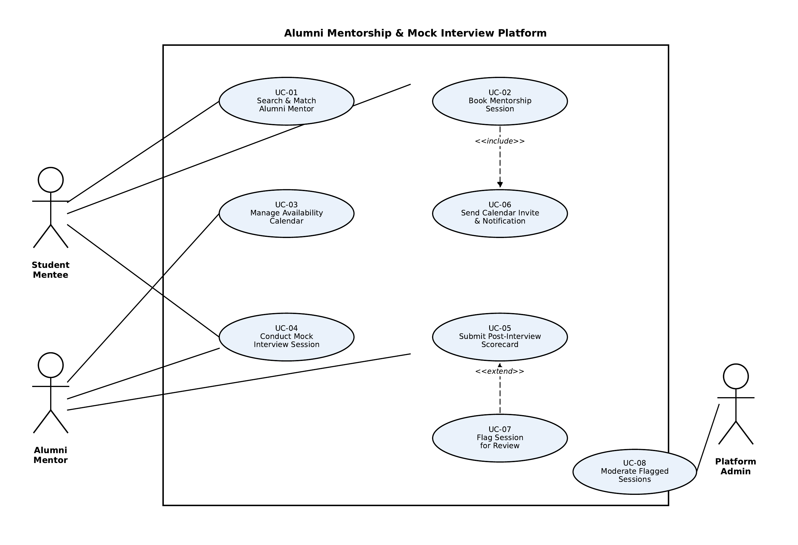
Includes an «include» relation (Book Mentorship Session → Send Calendar Invite & Notification) and an «extend» relation (Flag Session for Review → Submit Post-Interview Scorecard).

3. Use-Case Flow Specification
Use Case | UC-02: Book Mentorship Session
Primary Actor | Student Mentee
Secondary Actors | Alumni Mentor, Notification Service (via included use case)
Related Requirements | FR-001, FR-002, FR-005

Preconditions
• The Student Mentee is authenticated and logged into the platform.
• The Student Mentee has already viewed a ranked list of matched Alumni Mentors (UC-01: Search & Match Alumni Mentor).
• The selected Alumni Mentor has published at least one open availability slot (UC-03: Manage Availability Calendar).

Postconditions
• Success: The selected time slot is marked “Booked”, is removed from the mentor's public availability, and the session is added to both the Student Mentee's and Alumni Mentor's calendars with a meeting link (via the included use case UC-06: Send Calendar Invite & Notification).
• Failure: No slot is booked and the mentor's availability remains unchanged.

Main Success Scenario
1. Student Mentee selects “Book Session” from an Alumni Mentor's profile.
2. System displays the mentor's open time slots for the next 14 days.
3. Student Mentee selects a preferred date and time slot.
4. System checks real-time availability of the selected slot.
5. System temporarily locks the slot to prevent a race condition with another student.
6. Student Mentee confirms session details (topic/domain focus, duration).
7. System executes «include» UC-06: Send Calendar Invite & Notification — a calendar event with a meeting link is created for both participants.
8. System marks the slot as “Booked” and removes it from the mentor's public availability.
9. System displays a booking confirmation to the Student Mentee.
10. Use case ends successfully.

Alternate Flow — 4a. Slot No Longer Available (Double-Booking Attempt)
4a1. System detects that the selected slot was booked by another student moments earlier.
4a2. System displays a “Slot no longer available” message to the Student Mentee.
4a3. System refreshes and displays the mentor's updated list of available slots.
4a4. Student Mentee selects a different slot; flow resumes at step 3 of the Main Success Scenario.

