CRYOTRACK
Pharmaceutical Cold-Chain Monitoring
and Logistics Management System

DATABASE MANAGEMENT SYSTEMS – PROJECT REPORT
BACSE202 – Database Management Systems
Fall Semester 2026–2027
Slot: D1 + TD1 | Class: CH202670101707

Submitted by
NIKIL SIDDAARTH T – 25BCE5373
PRAVEEN V – 25BCE5413
SHAILESH K – 25BCE5707

Faculty: Dr. S. Geetha
School of Computer Science and Engineering
VIT Chennai

TABLE OF CONTENTS
- 1. Abstract
- 2. Introduction
- 3. Problem Statement
- 4. Objectives and Scope
- 5. Existing-System Context, Proposed System and Requirements
- 6. System Architecture
- 7. ER Model and Relationships (existing team diagram retained)
- 8. Relational Schema
- 9. Keys and Integrity Constraints
- 10. Functional Dependencies and Normalization
- 11. Implementation Details
- 12. SQL Operations and Query Demonstrations
- 13. Application Modules and Screenshot Evidence
- 14. Testing Strategy and Results
- 15. Conclusion
- 16. Limitations and Future Enhancements
- 17. Team Contributions
- 18. References
- Appendix A – Setup and Submission Information

1. ABSTRACT
CryoTrack is a pharmaceutical cold-chain monitoring and logistics management system designed to organize information about temperature-sensitive products from manufacturing through storage, transportation and final delivery. It manages manufacturers, products, batches, quality tests, warehouses, storage units, inventory, shipments, routes, vehicles, drivers, IoT sensors, sensor readings, temperature alerts, incidents and healthcare-facility deliveries. The web application uses Python Flask, HTML, CSS and JavaScript, with Oracle Database 21c XE as the operational database. SQLite is used separately for application authentication data. The Oracle schema contains 23 relational tables connected through primary-key and foreign-key constraints. Role-based access control separates operational responsibilities. The project demonstrates relational database design, SQL operations, application–database connectivity and cold-chain workflow management.
Keywords: Pharmaceutical Cold Chain, Oracle Database, Flask, Relational Database, IoT Monitoring, Temperature Alerts, Inventory Management, Shipment Tracking, RBAC.

2. INTRODUCTION
Pharmaceutical products such as vaccines, insulin and other temperature-sensitive medicines require controlled storage and transportation conditions. Their movement involves manufacturers, products, batches, quality checks, warehouses, storage units, vehicles, drivers, routes and healthcare facilities. Records generated at each stage must be connected so that users can trace products, inspect shipment conditions and investigate environmental deviations.
CryoTrack applies database-management concepts to this supply-chain problem. It brings product lifecycle, inventory, shipment, fleet, sensor, alert, incident and delivery records into a web-based application. Oracle provides structured relational storage and referential links, while the Flask application exposes operational modules and access controls.

3. PROBLEM STATEMENT
Cold-chain information can become fragmented when product, batch, inventory, shipment and temperature-monitoring records are maintained separately. This makes it difficult to identify which products were involved in a shipment, whether environmental readings crossed permitted limits, what alerts were raised, and whether an incident was resolved before delivery. Inconsistent or missing references can reduce the reliability of operational records.
CryoTrack addresses this problem by providing a connected relational model and application for recording pharmaceutical products and batches, tracking inventory and shipments, associating sensor readings with vehicles, managing temperature alerts and incidents, and recording deliveries to healthcare facilities.

4. OBJECTIVES AND SCOPE

4.1 Objectives
- Design a relational database for pharmaceutical cold-chain logistics.
- Represent manufacturers, products, batches and quality-test information.
- Manage warehouse storage, inventory balances and inventory transactions.
- Track shipments, shipment items, routes, route stops, vehicles and drivers.
- Represent IoT sensors and their environmental readings.
- Record temperature alerts and associated cold-chain incidents.
- Maintain delivery information for healthcare facilities.
- Implement application authentication and role-based access control.
- Demonstrate SQL operations and application–database integration.
- Apply keys, constraints, functional dependencies and normalization.

4.2 Scope
The implemented Oracle database contains 23 tables across product and manufacturing, batch quality, storage and inventory, shipment and routing, fleet, IoT monitoring, incident management, and distribution and delivery. The application provides corresponding web modules. The project is an academic prototype; it does not claim direct integration with official regulatory databases or physical IoT devices unless separately configured.

5. EXISTING-SYSTEM CONTEXT, PROPOSED SYSTEM AND REQUIREMENTS

5.1 Existing-system context
Cold-chain operations may use a combination of enterprise inventory systems, transport-management tools, warehouse records and temperature-monitoring solutions. These tools address individual operational needs, but information can remain distributed across separate workflows. CryoTrack focuses on a unified academic prototype connecting core records through a relational database. Specific commercial systems are not benchmarked in this report; external URLs and comparison screenshots should be added only after the team selects and reviews those sources.

5.2 Proposed system
CryoTrack provides a web interface backed by Flask. Flask processes user requests, applies application-level access checks and communicates with Oracle for operational records. A separate SQLite database stores authentication-related information. The system groups operations into product and quality, inventory and warehousing, shipments and fleet, cold-chain monitoring, incidents, deliveries, reports and user/access management.

5.3 Functional requirements
- Authenticate users and enforce role-based permissions.
- View and manage pharmaceutical products, manufacturers and batches.
- Maintain quality-test records.
- View and manage warehouses, storage units, inventory and inventory transactions.
- Manage routes, shipments, shipment items, vehicles, drivers and assignments.
- Store and retrieve IoT sensor readings.
- Display temperature alerts and cold-chain incidents.
- Manage healthcare facilities and delivery records.
- Provide operational dashboard and reporting features.

5.4 Non-functional requirements
- Data integrity through primary keys, foreign keys and unique constraints.
- Security through authentication, session handling and role-based access.
- Maintainability through separate backend, frontend, database and access-control modules.
- Usability through a dashboard and task-oriented application screens.
- Dependability on configured Oracle and SQLite database services.
Requirement category | Requirement | Project implementation
Functional | Manage product and batch records | Product, manufacturer and batch modules
Functional | Monitor shipment environment | Sensor readings, temperature alerts and incident records
Functional | Manage stock | Inventory, storage unit and inventory transaction tables
Functional | Control user access | Flask authentication and RBAC modules
Non-functional | Integrity | Oracle primary, foreign-key and unique constraints
Non-functional | Maintainability | Separated Flask, Oracle operations, authentication and frontend files

6. SYSTEM ARCHITECTURE
CryoTrack follows a layered web-application architecture. The presentation layer consists of HTML templates, CSS and JavaScript. The application layer is implemented in Python Flask and contains request handling, application logic, authentication and permission checks. The operational data layer is Oracle Database 21c XE using the COLDCHAIN schema and the Python oracledb driver. Authentication data is maintained separately in SQLite at instance/cryotrack_auth.sqlite.
Layer / component | Technology | Responsibility
Presentation | HTML5, CSS3, JavaScript | Forms, tables, dashboard and user interaction
Application | Python Flask | Routes, API operations, validation and business logic
Authentication / authorization | auth.py and rbac.py | Authentication, sessions and role/permission checks
Operational database | Oracle Database 21c XE | 23-table COLDCHAIN relational schema
Authentication store | SQLite | Application user/authentication records
Connectivity | Python oracledb | Flask-to-Oracle database communication

Architecture flow: User → Browser Interface → Flask Application → Oracle COLDCHAIN database. The Flask application also communicates with the separate SQLite authentication store.

6.1 Main project files
File / folder | Purpose
app.py | Main Flask application and application routes
auth.py | Authentication-related application logic
rbac.py | Role-based access-control logic
oracle_ops.py | Oracle database operations and connectivity helpers
create_user.py | User creation/provisioning utility
test_db.py | Database connectivity test utility
templates/ | HTML templates for application pages
static/ | Frontend stylesheets, scripts and static assets
database/schema.sql | Oracle table definitions and foreign-key constraints
database/sample_data.sql | Demonstration seed-data script
database/queries.sql | SQL query examples
instance/ | Local application instance data, including SQLite authentication store

7. ER MODEL AND RELATIONSHIPS
The team's hand-drawn ER diagram is retained in this section as the conceptual design evidence supplied by the project team. The diagram illustrates the major entities and relationships across product manufacturing, batch quality, storage, inventory, shipments, vehicles, IoT monitoring, alerts, incidents, routes and delivery. The relational schema in Section 8 is extracted from the current Oracle DDL and is the authoritative reference for implemented column names and constraints.
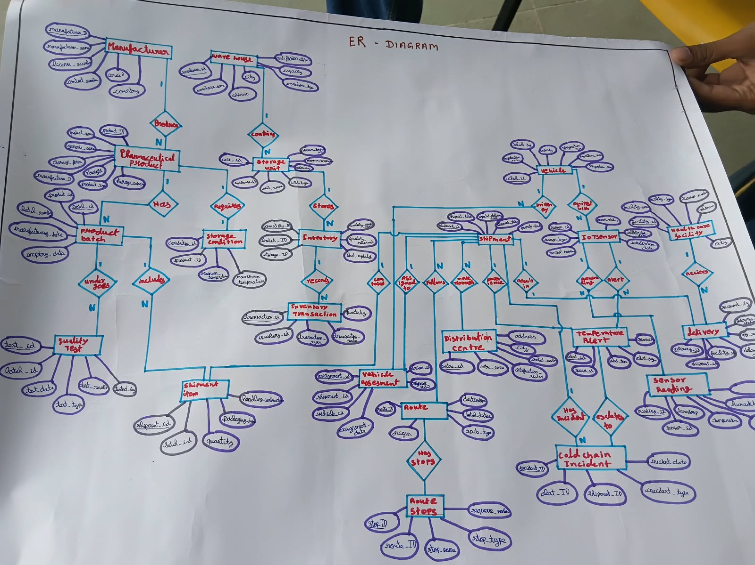
Figure 1. Team-prepared hand-drawn ER diagram for CryoTrack.

7.1 Major relationship summary
Entity / parent | Related entity | Cardinality | Implementation basis
MANUFACTURER | PHARMACEUTICAL_PRODUCT | One-to-many | MANUFACTURER_ID in PHARMACEUTICAL_PRODUCT
PHARMACEUTICAL_PRODUCT | PRODUCT_BATCH | One-to-many | PRODUCT_ID in PRODUCT_BATCH
PRODUCT_BATCH | QUALITY_TEST | One-to-many | BATCH_ID in QUALITY_TEST
PHARMACEUTICAL_PRODUCT | STORAGE_CONDITION | One-to-one | PRODUCT_ID is unique in STORAGE_CONDITION
WAREHOUSE | STORAGE_UNIT | One-to-many | WAREHOUSE_ID in STORAGE_UNIT
STORAGE_UNIT | INVENTORY | One-to-many | STORAGE_UNIT_ID in INVENTORY
PRODUCT_BATCH | INVENTORY | One-to-many | BATCH_ID in INVENTORY
INVENTORY | INVENTORY_TRANSACTION | One-to-many | INVENTORY_ID in INVENTORY_TRANSACTION
ROUTE | SHIPMENT | One-to-many | ROUTE_ID in SHIPMENT
ROUTE | ROUTE_STOP | One-to-many | ROUTE_ID in ROUTE_STOP
SHIPMENT | SHIPMENT_ITEM | One-to-many | SHIPMENT_ID in SHIPMENT_ITEM
PRODUCT_BATCH | SHIPMENT_ITEM | One-to-many | BATCH_ID in SHIPMENT_ITEM
VEHICLE | IOT_SENSOR | One-to-many | VEHICLE_ID in IOT_SENSOR
IOT_SENSOR | SENSOR_READING | One-to-many | SENSOR_ID in SENSOR_READING
IOT_SENSOR | TEMPERATURE_ALERT | One-to-many | SENSOR_ID in TEMPERATURE_ALERT
SHIPMENT | TEMPERATURE_ALERT | One-to-many | SHIPMENT_ID in TEMPERATURE_ALERT
TEMPERATURE_ALERT | COLD_CHAIN_INCIDENT | One-to-zero-or-one | ALERT_ID is unique in COLD_CHAIN_INCIDENT
HEALTHCARE_FACILITY | DELIVERY | One-to-many | FACILITY_ID in DELIVERY
SHIPMENT | DELIVERY | One-to-zero-or-one | SHIPMENT_ID is unique in DELIVERY
SHIPMENT / VEHICLE / DRIVER | VEHICLE_ASSIGNMENT | One-to-many per parent | Foreign keys in VEHICLE_ASSIGNMENT

Some conceptual references are polymorphic rather than ordinary foreign keys. SHIPMENT.ORIGIN_TYPE/ORIGIN_ID and DESTINATION_TYPE/DESTINATION_ID identify different kinds of locations. INVENTORY_TRANSACTION.REFERENCE_TYPE/REFERENCE_ID also uses a typed reference. These columns are not enforced by the ordinary foreign-key constraints listed in the DDL.

8. RELATIONAL SCHEMA
The following schema inventory is generated from the current database/schema.sql file. Each relation is shown with its column names and Oracle data types. PK identifies primary-key columns; FK indicates columns that participate in foreign-key constraints. DEFAULT values are included where declared in the DDL.

COLD_CHAIN_INCIDENT
Attribute | Oracle data type / declaration | Key role
INCIDENT_ID | NUMBER(*,0) | PK
ALERT_ID | NUMBER(*,0) | FK
SHIPMENT_ID | NUMBER(*,0) | FK
INCIDENT_TYPE | VARCHAR2(50) | —
INCIDENT_DATE | DATE | —
DESCRIPTION | VARCHAR2(500) | —
SEVERITY | VARCHAR2(20) | —
PRODUCT_IMPACT | VARCHAR2(300) | —
RESOLUTION_STATUS | VARCHAR2(30) | —
RESOLUTION_DATE | DATE | —
CORRECTIVE_ACTION | VARCHAR2(500) | —

DELIVERY
Attribute | Oracle data type / declaration | Key role
DELIVERY_ID | NUMBER(*,0) | PK
SHIPMENT_ID | NUMBER(*,0) | FK
FACILITY_ID | NUMBER(*,0) | FK
DELIVERY_DATE | DATE | —
RECEIVED_BY | VARCHAR2(100) | —
DELIVERY_STATUS | VARCHAR2(30) | —
QUANTITY_RECEIVED | NUMBER(*,0) DEFAULT 0 | —
QUANTITY_DAMAGED | NUMBER(*,0) DEFAULT 0 | —
PROOF_OF_DELIVERY | VARCHAR2(300) | —
REMARKS | VARCHAR2(500) | —

DISTRIBUTION_CENTER
Attribute | Oracle data type / declaration | Key role
DISTRIBUTION_CENTER_ID | NUMBER(*,0) | PK
CENTER_NAME | VARCHAR2(100) | —
ADDRESS | VARCHAR2(200) | —
CITY | VARCHAR2(50) | —
STATE | VARCHAR2(50) | —
CAPACITY | NUMBER(*,0) | —
CONTACT_NUMBER | VARCHAR2(20) | —
MANAGER_NAME | VARCHAR2(100) | —
CERTIFICATION_STATUS | VARCHAR2(30) | —

DRIVER
Attribute | Oracle data type / declaration | Key role
DRIVER_ID | NUMBER(*,0) | PK
DRIVER_NAME | VARCHAR2(100) | —
LICENSE_NUMBER | VARCHAR2(50) | —
PHONE | VARCHAR2(20) | —
LICENSE_EXPIRY | DATE | —
CERTIFICATION | VARCHAR2(100) | —
EMPLOYMENT_STATUS | VARCHAR2(30) | —

HEALTHCARE_FACILITY
Attribute | Oracle data type / declaration | Key role
FACILITY_ID | NUMBER(*,0) | PK
FACILITY_NAME | VARCHAR2(150) | —
FACILITY_TYPE | VARCHAR2(50) | —
LICENSE_NUMBER | VARCHAR2(50) | —
ADDRESS | VARCHAR2(200) | —
CITY | VARCHAR2(50) | —
STATE | VARCHAR2(50) | —
CONTACT_NUMBER | VARCHAR2(20) | —
STORAGE_CAPABILITY | VARCHAR2(100) | —
FACILITY_STATUS | VARCHAR2(30) | —

INVENTORY
Attribute | Oracle data type / declaration | Key role
INVENTORY_ID | NUMBER(*,0) | PK
BATCH_ID | NUMBER(*,0) | FK
STORAGE_UNIT_ID | NUMBER(*,0) | FK
QUANTITY_AVAILABLE | NUMBER(*,0) | —
QUANTITY_RESERVED | NUMBER(*,0) DEFAULT 0 | —
LAST_UPDATED | DATE DEFAULT SYSDATE | —
INVENTORY_STATUS | VARCHAR2(30) | —

INVENTORY_TRANSACTION
Attribute | Oracle data type / declaration | Key role
TRANSACTION_ID | NUMBER(*,0) | PK
INVENTORY_ID | NUMBER(*,0) | FK
TRANSACTION_TYPE | VARCHAR2(30) | —
QUANTITY | NUMBER(*,0) | —
TRANSACTION_DATE | DATE DEFAULT SYSDATE | —
REFERENCE_TYPE | VARCHAR2(30),REFERENCE_ID NUMBER(*,0) | —
PERFORMED_BY | VARCHAR2(100) | —
REMARKS | VARCHAR2(300) | —

IOT_SENSOR
Attribute | Oracle data type / declaration | Key role
SENSOR_ID | NUMBER(*,0) | PK
VEHICLE_ID | NUMBER(*,0) | FK
SENSOR_TYPE | VARCHAR2(50) | —
SERIAL_NUMBER | VARCHAR2(50) | —
MANUFACTURER | VARCHAR2(100) | —
INSTALLATION_DATE | DATE | —
CALIBRATION_DATE | DATE | —
CALIBRATION_EXPIRY | DATE | —
SENSOR_STATUS | VARCHAR2(30) | —
ACCURACY | NUMBER(5,2) | —

MANUFACTURER
Attribute | Oracle data type / declaration | Key role
MANUFACTURER_ID | NUMBER(*,0) | PK
MANUFACTURER_NAME | VARCHAR2(100) | —
LICENSE_NUMBER | VARCHAR2(50) | —
CONTACT_NUMBER | VARCHAR2(20) | —
EMAIL | VARCHAR2(100) | —
ADDRESS | VARCHAR2(200) | —
COUNTRY | VARCHAR2(50) | —
REGULATORY_AUTHORITY | VARCHAR2(100) | —

PHARMACEUTICAL_PRODUCT
Attribute | Oracle data type / declaration | Key role
PRODUCT_ID | NUMBER(*,0) | PK
MANUFACTURER_ID | NUMBER(*,0) | FK
PRODUCT_NAME | VARCHAR2(100) | —
GENERIC_NAME | VARCHAR2(100) | —
DOSAGE_FORM | VARCHAR2(50) | —
STRENGTH | VARCHAR2(50) | —
PRODUCT_TYPE | VARCHAR2(50) | —
STORAGE_CATEGORY | VARCHAR2(50) | —
SHELF_LIFE_DAYS | NUMBER(*,0) | —
REGULATORY_STATUS | VARCHAR2(30) | —

PRODUCT_BATCH
Attribute | Oracle data type / declaration | Key role
BATCH_ID | NUMBER(*,0) | PK
PRODUCT_ID | NUMBER(*,0) | FK
BATCH_NUMBER | VARCHAR2(50) | —
MANUFACTURING_DATE | DATE | —
EXPIRY_DATE | DATE | —
QUANTITY_PRODUCED | NUMBER(*,0) | —
BATCH_STATUS | VARCHAR2(30) | —
QUALITY_STATUS | VARCHAR2(30) | —

QUALITY_TEST
Attribute | Oracle data type / declaration | Key role
TEST_ID | NUMBER(*,0) | PK
BATCH_ID | NUMBER(*,0) | FK
TEST_DATE | DATE | —
TEST_TYPE | VARCHAR2(50) | —
TEST_RESULT | VARCHAR2(30) | —
TESTED_BY | VARCHAR2(100) | —
REMARKS | VARCHAR2(300) | —

ROUTE
Attribute | Oracle data type / declaration | Key role
ROUTE_ID | NUMBER(*,0) | PK
ORIGIN | VARCHAR2(150) | —
DESTINATION | VARCHAR2(150) | —
TOTAL_DISTANCE | NUMBER(10,2) | —
ESTIMATED_DURATION | NUMBER(*,0) | —
ROUTE_TYPE | VARCHAR2(50) | —
ROUTE_STATUS | VARCHAR2(30) | —

ROUTE_STOP
Attribute | Oracle data type / declaration | Key role
STOP_ID | NUMBER(*,0) | PK
ROUTE_ID | NUMBER(*,0) | FK
STOP_NAME | VARCHAR2(100) | —
STOP_TYPE | VARCHAR2(50) | —
SEQUENCE_NUMBER | NUMBER(*,0) | —
PLANNED_ARRIVAL | TIMESTAMP (6) | —
PLANNED_DEPARTURE | TIMESTAMP (6) | —
ACTUAL_ARRIVAL | TIMESTAMP (6) | —
ACTUAL_DEPARTURE | TIMESTAMP (6) | —

SENSOR_READING
Attribute | Oracle data type / declaration | Key role
READING_ID | NUMBER(*,0) | PK
SENSOR_ID | NUMBER(*,0) | FK
READING_TIMESTAMP | TIMESTAMP (6) | —
TEMPERATURE | NUMBER(5,2) | —
HUMIDITY | NUMBER(5,2) | —
LATITUDE | NUMBER(10,7) | —
LONGITUDE | NUMBER(10,7) | —
BATTERY_LEVEL | NUMBER(5,2) | —

SHIPMENT
Attribute | Oracle data type / declaration | Key role
SHIPMENT_ID | NUMBER(*,0) | PK
SHIPMENT_DATE | DATE | —
EXPECTED_DELIVERY_DATE | DATE | —
ACTUAL_DELIVERY_DATE | DATE | —
ORIGIN_TYPE | VARCHAR2(30) | —
ORIGIN_ID | NUMBER(*,0) | —
DESTINATION_TYPE | VARCHAR2(30) | —
DESTINATION_ID | NUMBER(*,0) | —
SHIPMENT_STATUS | VARCHAR2(30) | —
PRIORITY_LEVEL | VARCHAR2(20) | —
TOTAL_WEIGHT | NUMBER(10,2) | —
ROUTE_ID | NUMBER(*,0) | FK

SHIPMENT_ITEM
Attribute | Oracle data type / declaration | Key role
SHIPMENT_ID | NUMBER(*,0) | PK, FK
BATCH_ID | NUMBER(*,0) | PK, FK
QUANTITY | NUMBER(*,0) | —
PACKAGING_TYPE | VARCHAR2(50) | —
HANDLING_INSTRUCTIONS | VARCHAR2(300) | —

STORAGE_CONDITION
Attribute | Oracle data type / declaration | Key role
CONDITION_ID | NUMBER(*,0) | PK
PRODUCT_ID | NUMBER(*,0) | FK
MINIMUM_TEMPERATURE | NUMBER(5,2) | —
MAXIMUM_TEMPERATURE | NUMBER(5,2) | —
MINIMUM_HUMIDITY | NUMBER(5,2) | —
MAXIMUM_HUMIDITY | NUMBER(5,2) | —
LIGHT_SENSITIVITY | VARCHAR2(30) | —
STORAGE_INSTRUCTIONS | VARCHAR2(300) | —

STORAGE_UNIT
Attribute | Oracle data type / declaration | Key role
STORAGE_UNIT_ID | NUMBER(*,0) | PK
WAREHOUSE_ID | NUMBER(*,0) | FK
UNIT_NAME | VARCHAR2(100) | —
UNIT_TYPE | VARCHAR2(50) | —
MINIMUM_TEMPERATURE | NUMBER(5,2) | —
MAXIMUM_TEMPERATURE | NUMBER(5,2) | —
CAPACITY | NUMBER(*,0) | —
CURRENT_STATUS | VARCHAR2(30) | —
INSTALLATION_DATE | DATE | —

TEMPERATURE_ALERT
Attribute | Oracle data type / declaration | Key role
ALERT_ID | NUMBER(*,0) | PK
SENSOR_ID | NUMBER(*,0) | FK
SHIPMENT_ID | NUMBER(*,0) | FK
ALERT_TIME | TIMESTAMP (6) | —
ALERT_TYPE | VARCHAR2(50) | —
RECORDED_TEMPERATURE | NUMBER(5,2) | —
EXPECTED_MIN | NUMBER(5,2) | —
EXPECTED_MAX | NUMBER(5,2) | —
SEVERITY | VARCHAR2(20) | —
ALERT_STATUS | VARCHAR2(30) | —
ACKNOWLEDGED_TIME | TIMESTAMP (6) | —

VEHICLE
Attribute | Oracle data type / declaration | Key role
VEHICLE_ID | NUMBER(*,0) | PK
REGISTRATION_NUMBER | VARCHAR2(30) | —
VEHICLE_TYPE | VARCHAR2(50) | —
REFRIGERATION_TYPE | VARCHAR2(50) | —
TEMPERATURE_MIN | NUMBER(5,2) | —
TEMPERATURE_MAX | NUMBER(5,2) | —
CAPACITY | NUMBER(10,2) | —
VEHICLE_STATUS | VARCHAR2(30) | —
LAST_MAINTENANCE_DATE | DATE | —

VEHICLE_ASSIGNMENT
Attribute | Oracle data type / declaration | Key role
ASSIGNMENT_ID | NUMBER(*,0) | PK
SHIPMENT_ID | NUMBER(*,0) | FK
VEHICLE_ID | NUMBER(*,0) | FK
DRIVER_ID | NUMBER(*,0) | FK
ASSIGNMENT_DATE | DATE | —
START_TIME | TIMESTAMP (6) | —
END_TIME | TIMESTAMP (6) | —
ASSIGNMENT_STATUS | VARCHAR2(30) | —

WAREHOUSE
Attribute | Oracle data type / declaration | Key role
WAREHOUSE_ID | NUMBER(*,0) | PK
WAREHOUSE_NAME | VARCHAR2(100) | —
ADDRESS | VARCHAR2(200) | —
CITY | VARCHAR2(50) | —
STATE | VARCHAR2(50) | —
CAPACITY | NUMBER(*,0) | —
WAREHOUSE_TYPE | VARCHAR2(50) | —
CERTIFICATION_STATUS | VARCHAR2(30) | —
MANAGER_NAME | VARCHAR2(100) | —

9. KEYS AND INTEGRITY CONSTRAINTS

9.1 Primary keys
Table | Primary key
COLD_CHAIN_INCIDENT | INCIDENT_ID
DELIVERY | DELIVERY_ID
DISTRIBUTION_CENTER | DISTRIBUTION_CENTER_ID
DRIVER | DRIVER_ID
HEALTHCARE_FACILITY | FACILITY_ID
INVENTORY | INVENTORY_ID
INVENTORY_TRANSACTION | TRANSACTION_ID
IOT_SENSOR | SENSOR_ID
MANUFACTURER | MANUFACTURER_ID
PHARMACEUTICAL_PRODUCT | PRODUCT_ID
PRODUCT_BATCH | BATCH_ID
QUALITY_TEST | TEST_ID
ROUTE | ROUTE_ID
ROUTE_STOP | STOP_ID
SENSOR_READING | READING_ID
SHIPMENT | SHIPMENT_ID
SHIPMENT_ITEM | SHIPMENT_ID, BATCH_ID
STORAGE_CONDITION | CONDITION_ID
STORAGE_UNIT | STORAGE_UNIT_ID
TEMPERATURE_ALERT | ALERT_ID
VEHICLE | VEHICLE_ID
VEHICLE_ASSIGNMENT | ASSIGNMENT_ID
WAREHOUSE | WAREHOUSE_ID

9.2 Foreign-key constraints
Child table | Constraint name | Child column(s) | Referenced table | Referenced column(s)
COLD_CHAIN_INCIDENT | FK_INCIDENT_ALERT | ALERT_ID | TEMPERATURE_ALERT | ALERT_ID
COLD_CHAIN_INCIDENT | FK_INCIDENT_SHIPMENT | SHIPMENT_ID | SHIPMENT | SHIPMENT_ID
DELIVERY | FK_DELIVERY_SHIPMENT | SHIPMENT_ID | SHIPMENT | SHIPMENT_ID
DELIVERY | FK_DELIVERY_FACILITY | FACILITY_ID | HEALTHCARE_FACILITY | FACILITY_ID
INVENTORY | FK_INVENTORY_BATCH | BATCH_ID | PRODUCT_BATCH | BATCH_ID
INVENTORY | FK_INVENTORY_UNIT | STORAGE_UNIT_ID | STORAGE_UNIT | STORAGE_UNIT_ID
INVENTORY_TRANSACTION | FK_TRANSACTION_INVENTORY | INVENTORY_ID | INVENTORY | INVENTORY_ID
IOT_SENSOR | FK_SENSOR_VEHICLE | VEHICLE_ID | VEHICLE | VEHICLE_ID
PHARMACEUTICAL_PRODUCT | FK_PRODUCT_MANUFACTURER | MANUFACTURER_ID | MANUFACTURER | MANUFACTURER_ID
PRODUCT_BATCH | FK_BATCH_PRODUCT | PRODUCT_ID | PHARMACEUTICAL_PRODUCT | PRODUCT_ID
QUALITY_TEST | FK_TEST_BATCH | BATCH_ID | PRODUCT_BATCH | BATCH_ID
ROUTE_STOP | FK_STOP_ROUTE | ROUTE_ID | ROUTE | ROUTE_ID
SENSOR_READING | FK_READING_SENSOR | SENSOR_ID | IOT_SENSOR | SENSOR_ID
SHIPMENT | FK_SHIPMENT_ROUTE | ROUTE_ID | ROUTE | ROUTE_ID
SHIPMENT_ITEM | FK_ITEM_SHIPMENT | SHIPMENT_ID | SHIPMENT | SHIPMENT_ID
SHIPMENT_ITEM | FK_ITEM_BATCH | BATCH_ID | PRODUCT_BATCH | BATCH_ID
STORAGE_CONDITION | FK_CONDITION_PRODUCT | PRODUCT_ID | PHARMACEUTICAL_PRODUCT | PRODUCT_ID
STORAGE_UNIT | FK_UNIT_WAREHOUSE | WAREHOUSE_ID | WAREHOUSE | WAREHOUSE_ID
TEMPERATURE_ALERT | FK_ALERT_SENSOR | SENSOR_ID | IOT_SENSOR | SENSOR_ID
TEMPERATURE_ALERT | FK_ALERT_SHIPMENT | SHIPMENT_ID | SHIPMENT | SHIPMENT_ID
VEHICLE_ASSIGNMENT | FK_ASSIGN_SHIPMENT | SHIPMENT_ID | SHIPMENT | SHIPMENT_ID
VEHICLE_ASSIGNMENT | FK_ASSIGN_VEHICLE | VEHICLE_ID | VEHICLE | VEHICLE_ID
VEHICLE_ASSIGNMENT | FK_ASSIGN_DRIVER | DRIVER_ID | DRIVER | DRIVER_ID

The supplied schema.sql contains 23 CREATE TABLE definitions and 23 foreign-key constraint definitions.

9.3 Unique constraints
Table | Unique column(s)
COLD_CHAIN_INCIDENT | ALERT_ID
DELIVERY | SHIPMENT_ID
DRIVER | LICENSE_NUMBER
HEALTHCARE_FACILITY | LICENSE_NUMBER
IOT_SENSOR | SERIAL_NUMBER
MANUFACTURER | LICENSE_NUMBER
PRODUCT_BATCH | BATCH_NUMBER
ROUTE_STOP | ROUTE_ID, SEQUENCE_NUMBER
STORAGE_CONDITION | PRODUCT_ID
VEHICLE | REGISTRATION_NUMBER

Unique constraints prevent duplicate values in selected candidate-key fields. Examples include manufacturer licence number, driver licence number, healthcare-facility licence number, vehicle registration number, sensor serial number, product batch number, one storage-condition record per product, one delivery per shipment, one incident per alert, and unique route-stop sequence numbers within a route.

9.4 Referential integrity notes
Foreign keys ensure that child rows refer to existing parent rows for the relationships explicitly declared in schema.sql. The DDL does not declare ordinary foreign keys for the polymorphic origin/destination identifiers in SHIPMENT or the reference-type/reference-ID pair in INVENTORY_TRANSACTION. These require application-level validation or another explicit design mechanism.

10. FUNCTIONAL DEPENDENCIES AND NORMALIZATION
A functional dependency X → Y means that a value of attribute set X determines a value of attribute set Y. In each relation, the declared primary key determines the remaining non-key attributes. Where a unique constraint exists, its columns also provide a candidate key for the relation.
Relation | Representative primary-key functional dependency
COLD_CHAIN_INCIDENT | INCIDENT_ID → ALERT_ID, SHIPMENT_ID, INCIDENT_TYPE, INCIDENT_DATE, DESCRIPTION, SEVERITY, PRODUCT_IMPACT, RESOLUTION_STATUS, RESOLUTION_DATE, CORRECTIVE_ACTION
DELIVERY | DELIVERY_ID → SHIPMENT_ID, FACILITY_ID, DELIVERY_DATE, RECEIVED_BY, DELIVERY_STATUS, QUANTITY_RECEIVED, QUANTITY_DAMAGED, PROOF_OF_DELIVERY, REMARKS
DISTRIBUTION_CENTER | DISTRIBUTION_CENTER_ID → CENTER_NAME, ADDRESS, CITY, STATE, CAPACITY, CONTACT_NUMBER, MANAGER_NAME, CERTIFICATION_STATUS
DRIVER | DRIVER_ID → DRIVER_NAME, LICENSE_NUMBER, PHONE, LICENSE_EXPIRY, CERTIFICATION, EMPLOYMENT_STATUS
HEALTHCARE_FACILITY | FACILITY_ID → FACILITY_NAME, FACILITY_TYPE, LICENSE_NUMBER, ADDRESS, CITY, STATE, CONTACT_NUMBER, STORAGE_CAPABILITY, FACILITY_STATUS
INVENTORY | INVENTORY_ID → BATCH_ID, STORAGE_UNIT_ID, QUANTITY_AVAILABLE, QUANTITY_RESERVED, LAST_UPDATED, INVENTORY_STATUS
INVENTORY_TRANSACTION | TRANSACTION_ID → INVENTORY_ID, TRANSACTION_TYPE, QUANTITY, TRANSACTION_DATE, REFERENCE_TYPE, PERFORMED_BY, REMARKS
IOT_SENSOR | SENSOR_ID → VEHICLE_ID, SENSOR_TYPE, SERIAL_NUMBER, MANUFACTURER, INSTALLATION_DATE, CALIBRATION_DATE, CALIBRATION_EXPIRY, SENSOR_STATUS, ACCURACY
MANUFACTURER | MANUFACTURER_ID → MANUFACTURER_NAME, LICENSE_NUMBER, CONTACT_NUMBER, EMAIL, ADDRESS, COUNTRY, REGULATORY_AUTHORITY
PHARMACEUTICAL_PRODUCT | PRODUCT_ID → MANUFACTURER_ID, PRODUCT_NAME, GENERIC_NAME, DOSAGE_FORM, STRENGTH, PRODUCT_TYPE, STORAGE_CATEGORY, SHELF_LIFE_DAYS, REGULATORY_STATUS
PRODUCT_BATCH | BATCH_ID → PRODUCT_ID, BATCH_NUMBER, MANUFACTURING_DATE, EXPIRY_DATE, QUANTITY_PRODUCED, BATCH_STATUS, QUALITY_STATUS
QUALITY_TEST | TEST_ID → BATCH_ID, TEST_DATE, TEST_TYPE, TEST_RESULT, TESTED_BY, REMARKS
ROUTE | ROUTE_ID → ORIGIN, DESTINATION, TOTAL_DISTANCE, ESTIMATED_DURATION, ROUTE_TYPE, ROUTE_STATUS
ROUTE_STOP | STOP_ID → ROUTE_ID, STOP_NAME, STOP_TYPE, SEQUENCE_NUMBER, PLANNED_ARRIVAL, PLANNED_DEPARTURE, ACTUAL_ARRIVAL, ACTUAL_DEPARTURE
SENSOR_READING | READING_ID → SENSOR_ID, READING_TIMESTAMP, TEMPERATURE, HUMIDITY, LATITUDE, LONGITUDE, BATTERY_LEVEL
SHIPMENT | SHIPMENT_ID → SHIPMENT_DATE, EXPECTED_DELIVERY_DATE, ACTUAL_DELIVERY_DATE, ORIGIN_TYPE, ORIGIN_ID, DESTINATION_TYPE, DESTINATION_ID, SHIPMENT_STATUS, PRIORITY_LEVEL, TOTAL_WEIGHT, ROUTE_ID
SHIPMENT_ITEM | SHIPMENT_ID, BATCH_ID → QUANTITY, PACKAGING_TYPE, HANDLING_INSTRUCTIONS
STORAGE_CONDITION | CONDITION_ID → PRODUCT_ID, MINIMUM_TEMPERATURE, MAXIMUM_TEMPERATURE, MINIMUM_HUMIDITY, MAXIMUM_HUMIDITY, LIGHT_SENSITIVITY, STORAGE_INSTRUCTIONS
STORAGE_UNIT | STORAGE_UNIT_ID → WAREHOUSE_ID, UNIT_NAME, UNIT_TYPE, MINIMUM_TEMPERATURE, MAXIMUM_TEMPERATURE, CAPACITY, CURRENT_STATUS, INSTALLATION_DATE
TEMPERATURE_ALERT | ALERT_ID → SENSOR_ID, SHIPMENT_ID, ALERT_TIME, ALERT_TYPE, RECORDED_TEMPERATURE, EXPECTED_MIN, EXPECTED_MAX, SEVERITY, ALERT_STATUS, ACKNOWLEDGED_TIME
VEHICLE | VEHICLE_ID → REGISTRATION_NUMBER, VEHICLE_TYPE, REFRIGERATION_TYPE, TEMPERATURE_MIN, TEMPERATURE_MAX, CAPACITY, VEHICLE_STATUS, LAST_MAINTENANCE_DATE
VEHICLE_ASSIGNMENT | ASSIGNMENT_ID → SHIPMENT_ID, VEHICLE_ID, DRIVER_ID, ASSIGNMENT_DATE, START_TIME, END_TIME, ASSIGNMENT_STATUS
WAREHOUSE | WAREHOUSE_ID → WAREHOUSE_NAME, ADDRESS, CITY, STATE, CAPACITY, WAREHOUSE_TYPE, CERTIFICATION_STATUS, MANAGER_NAME

10.1 First Normal Form (1NF)
A relation is in 1NF when each attribute contains a single value from its domain and repeating groups are not stored inside a single row. CryoTrack stores separate sensor observations as rows in SENSOR_READING rather than keeping a list of readings in a vehicle record. Similarly, shipment products are represented through individual SHIPMENT_ITEM rows.

10.2 Second Normal Form (2NF)
A relation is in 2NF when it is in 1NF and every non-key attribute is fully dependent on the whole candidate key. Most CryoTrack relations use single-column primary keys, so partial dependency on a proper subset of the primary key does not arise. SHIPMENT_ITEM uses the composite primary key (SHIPMENT_ID, BATCH_ID). Its QUANTITY, PACKAGING_TYPE and HANDLING_INSTRUCTIONS describe the particular batch included in the particular shipment and are intended to depend on the complete pair.

10.3 Third Normal Form (3NF)
A relation is in 3NF when it is in 2NF and non-key attributes do not depend transitively on a candidate key through another non-key attribute. CryoTrack separates manufacturer data from product data: MANUFACTURER stores manufacturer details and PHARMACEUTICAL_PRODUCT references it through MANUFACTURER_ID. Product batches are stored in PRODUCT_BATCH and refer to PHARMACEUTICAL_PRODUCT. Warehouse data is separated from storage-unit data, and vehicle data is separated from sensor data. This reduces repeated descriptive information and helps avoid update anomalies.

10.4 Worked normalization example
Consider a hypothetical unnormalized shipment register containing Shipment_ID, Shipment_Date, Route_ID, Route_Origin, Route_Destination, Batch_ID, Batch_Number, Product_ID, Product_Name and Quantity. If one shipment contains multiple batches, the batch details repeat across shipment rows. The design decomposes this information into SHIPMENT, ROUTE, PRODUCT_BATCH, PHARMACEUTICAL_PRODUCT and SHIPMENT_ITEM. The shipment and batch relationship is stored in SHIPMENT_ITEM with a composite key, while route, product and batch descriptions are stored once in their respective relations.
Design stage | Illustrative structure | Reason
Unnormalized register | Shipment details repeated for each batch item | Repeated groups and duplicated descriptive fields
1NF | One shipment-batch item per row | Each row stores one shipment item
2NF | SHIPMENT and SHIPMENT_ITEM separated | Item attributes depend on the full shipment/batch key
3NF | ROUTE, PRODUCT and PRODUCT_BATCH separated | Route and product descriptions are stored with their own entities

10.5 Normalization conclusion
The schema is organized around entity-specific relations and declared primary/foreign keys, and is designed to satisfy at least 3NF for the modeled operational data. A formal proof for every possible business-rule dependency requires review of all candidate keys and domain dependencies; the primary-key dependencies shown here are representative, not a substitute for that complete proof.

11. IMPLEMENTATION DETAILS
Component | Project configuration
DBMS | Oracle Database 21c XE
Oracle schema | COLDCHAIN
Database service | XEPDB1
Backend | Python Flask
Oracle connectivity | Python oracledb
Authentication database | SQLite
Frontend | HTML, CSS and JavaScript
Configuration | Environment variables and local .env
Development environment | Visual Studio Code

11.1 Application implementation
The main application source files are app.py, auth.py, rbac.py and oracle_ops.py. app.py is the main Flask application. oracle_ops.py provides Oracle-facing operations. auth.py and rbac.py implement authentication and application-level access-control logic. create_user.py supports user provisioning, and test_db.py is available for database connectivity checking. The frontend is organized into templates/ and static/.

11.2 Role-based access control
Role | Responsibility area
Administrator | Administration and governance
Operations Manager | Operations management
Shipping & Fleet Operator | Shipping and fleet operations
Cold-Chain Monitoring Operator | Cold-chain monitoring
Inventory & Warehouse Operator | Inventory and warehousing
Quality & Compliance Operator | Quality and compliance
Delivery Operator | Deliveries and distribution
Viewer / Auditor | Audit and oversight

RBAC is implemented at the application layer through Flask authentication and permission checks. SQLite is used for authentication-related records; these roles should not be described as Oracle database users unless a separate Oracle user configuration exists.

11.3 Database implementation and sample data
The prepared sample_data.sql script is intended to generate 15 rows per table (345 intended rows) for a fresh demonstration schema. It has not been verified by execution against the current live database. The live COLDCHAIN schema was separately queried and returned 549 existing records; the sample-data script must not be blindly run against that database.

11.4 Setup and execution
- Install Oracle Database 21c XE and start the database service.
- Connect to the XEPDB1 service using the COLDCHAIN schema.
- For a fresh schema, review and execute database/schema.sql.
- Review sample_data.sql and execute it only against a clean demonstration schema.
- Create and activate a Python virtual environment.
- Install packages listed in requirements.txt.
- Configure local Oracle connection values and Flask secrets through a private .env file.
- Start the application with python app.py and open the local URL printed by Flask.
Never publish .env, database passwords, local SQLite files or virtual-environment folders to GitHub.

12. SQL OPERATIONS AND QUERY DEMONSTRATIONS
The project query set is designed to demonstrate retrieval and analysis across the cold-chain database. The examples below are grounded in the implemented table and column names from schema.sql. They should be run in the COLDCHAIN schema after confirming that the required data exists.

12.1 SELECT and filtering
Example: retrieve batches that expire within the next 180 days.
SELECT BATCH_ID, BATCH_NUMBER, EXPIRY_DATE, BATCH_STATUS
FROM PRODUCT_BATCH
WHERE EXPIRY_DATE BETWEEN SYSDATE AND SYSDATE + 180
ORDER BY EXPIRY_DATE;

12.2 JOIN operation
Example: display products together with their manufacturer names.
SELECT P.PRODUCT_ID, P.PRODUCT_NAME, M.MANUFACTURER_NAME
FROM PHARMACEUTICAL_PRODUCT P
JOIN MANUFACTURER M
ON M.MANUFACTURER_ID = P.MANUFACTURER_ID;

12.3 GROUP BY and aggregate functions
Example: calculate available inventory by warehouse.
SELECT W.WAREHOUSE_NAME, SUM(I.QUANTITY_AVAILABLE) AS TOTAL_AVAILABLE
FROM WAREHOUSE W
JOIN STORAGE_UNIT SU ON SU.WAREHOUSE_ID = W.WAREHOUSE_ID
JOIN INVENTORY I ON I.STORAGE_UNIT_ID = SU.STORAGE_UNIT_ID
GROUP BY W.WAREHOUSE_NAME;

12.4 HAVING
Example: show warehouses that contain more than one storage unit.
SELECT W.WAREHOUSE_NAME, COUNT(SU.STORAGE_UNIT_ID) AS UNIT_COUNT
FROM WAREHOUSE W
JOIN STORAGE_UNIT SU ON SU.WAREHOUSE_ID = W.WAREHOUSE_ID
GROUP BY W.WAREHOUSE_NAME
HAVING COUNT(SU.STORAGE_UNIT_ID) > 1;

12.5 Subquery
Example: retrieve products that have at least one batch.
SELECT P.PRODUCT_ID, P.PRODUCT_NAME
FROM PHARMACEUTICAL_PRODUCT P
WHERE EXISTS (
SELECT 1 FROM PRODUCT_BATCH B
WHERE B.PRODUCT_ID = P.PRODUCT_ID
);

12.6 Data dictionary queries
The Oracle data dictionary can be queried to inspect the schema's tables, constraints and indexes.
SELECT TABLE_NAME, CONSTRAINT_NAME, CONSTRAINT_TYPE, STATUS
FROM USER_CONSTRAINTS
ORDER BY TABLE_NAME, CONSTRAINT_TYPE;

12.7 DML and transaction evidence
INSERT, UPDATE and DELETE demonstrations should be performed with disposable test records or in a separate test schema. Use SAVEPOINT and ROLLBACK for reversible demonstrations. Do not update or delete existing operational records merely to obtain screenshots. Capture the actual SQL statement and its Oracle output in the final submission.

12.8 Executed SQL Query and Transaction Evidence
The following screenshots document SQL statements executed in the COLDCHAIN schema and their returned results. The evidence includes product/manufacturer retrieval, inventory and shipment joins, warehouse aggregation, GROUP BY with HAVING, a subquery, sensor-reading retrieval, and a reversible INSERT–UPDATE–DELETE transaction. The SQL*Plus output is reproduced as captured; clipped column headings in the terminal screenshots are not interpreted as additional values.
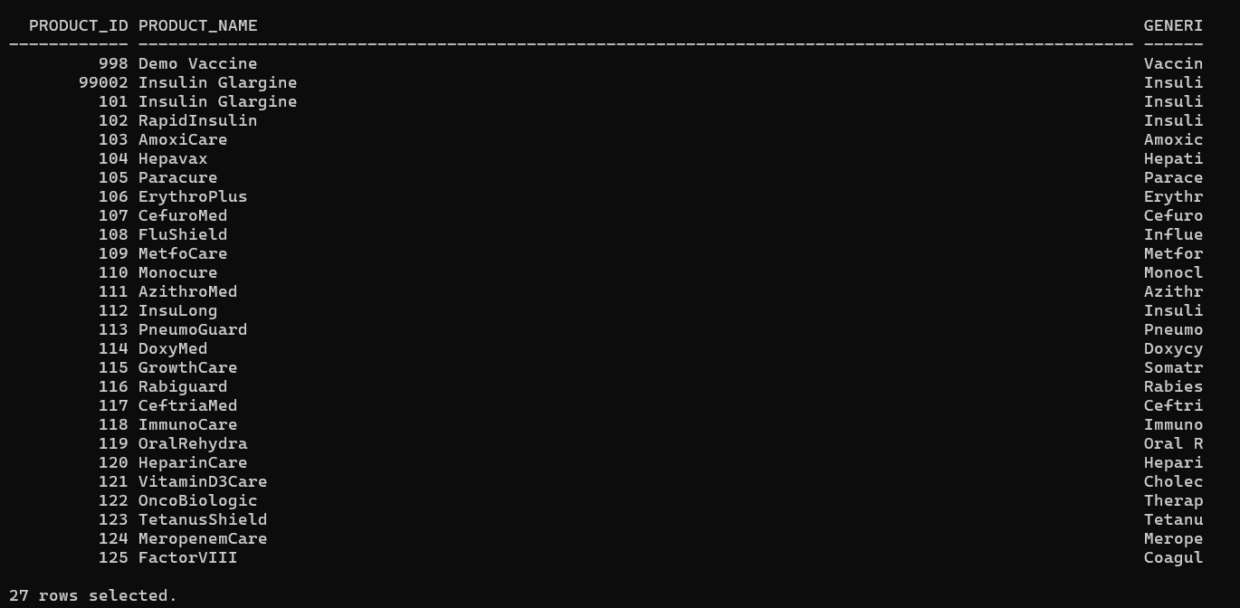
Figure 12.1. Product and manufacturer retrieval query; 27 product rows were returned.
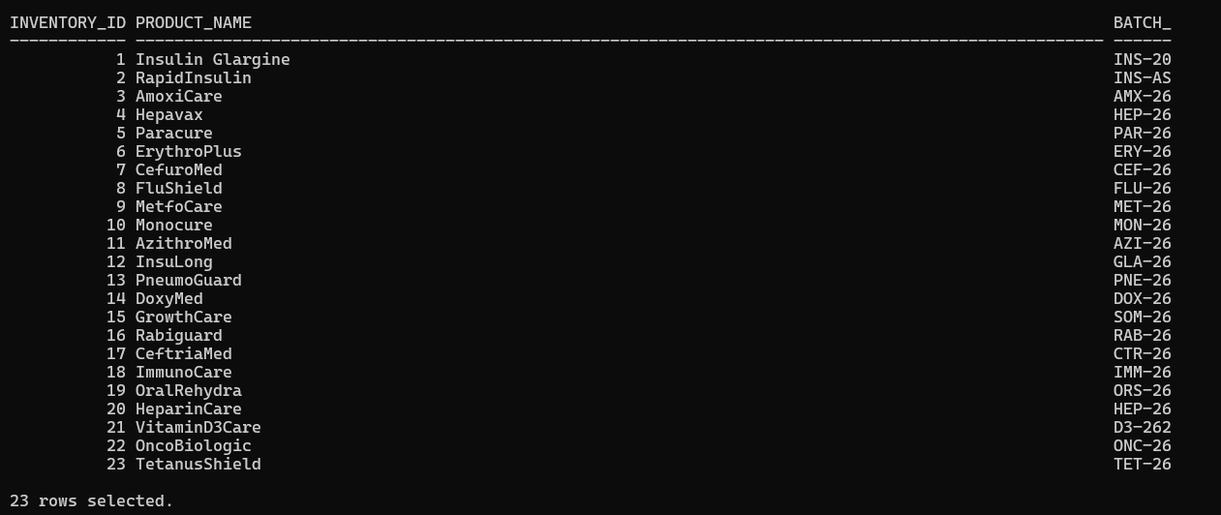
Figure 12.2. Inventory, batch and product join; 23 inventory rows were returned.
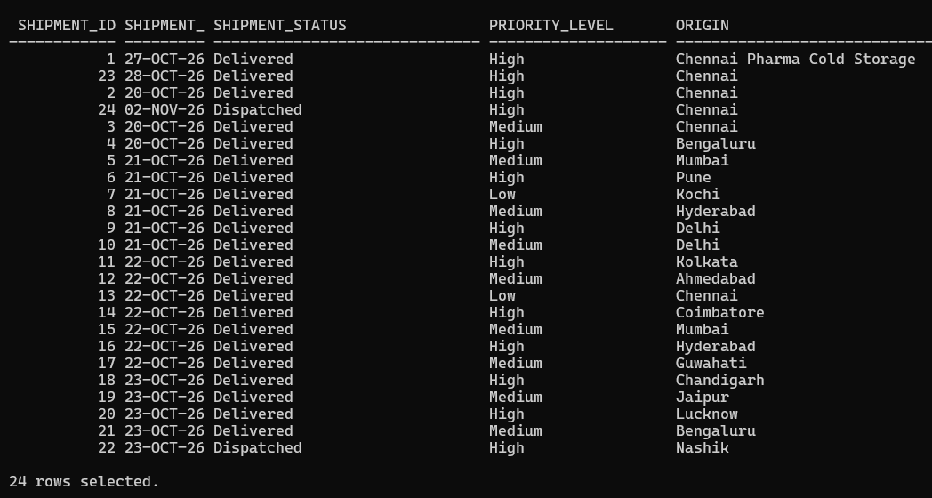
Figure 12.3. Shipment and route join; 24 shipment rows were returned.
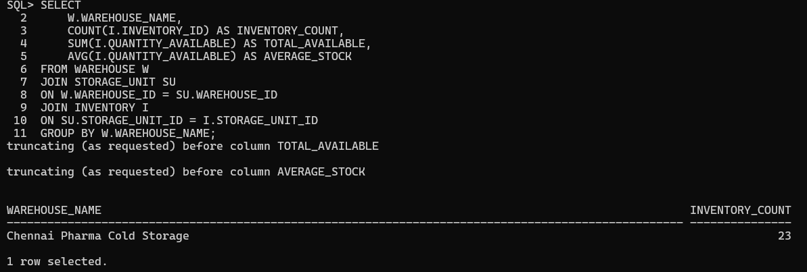
Figure 12.4. Warehouse inventory aggregation using COUNT, SUM and AVG; one warehouse group was returned. The terminal truncated some aggregate columns.
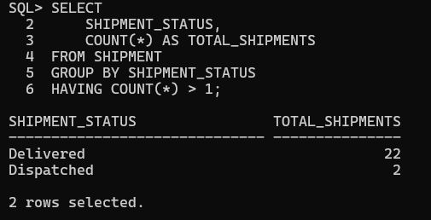
Figure 12.5. GROUP BY and HAVING query showing shipment counts: Delivered 22 and Dispatched 2.
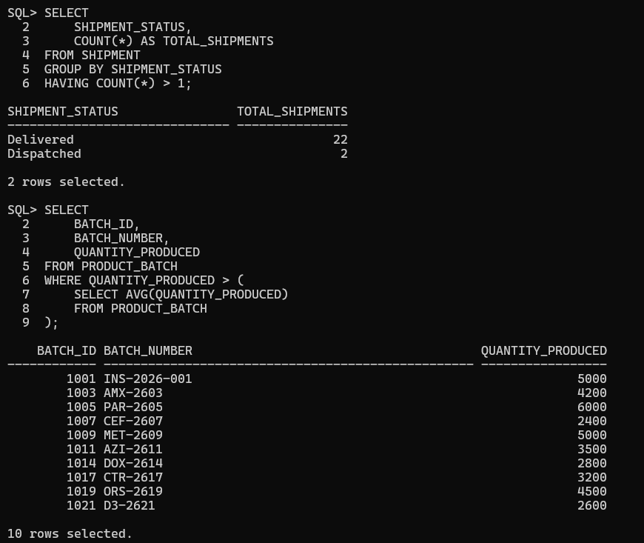
Figure 12.6. Subquery output showing 10 batches with production quantities above the overall average.
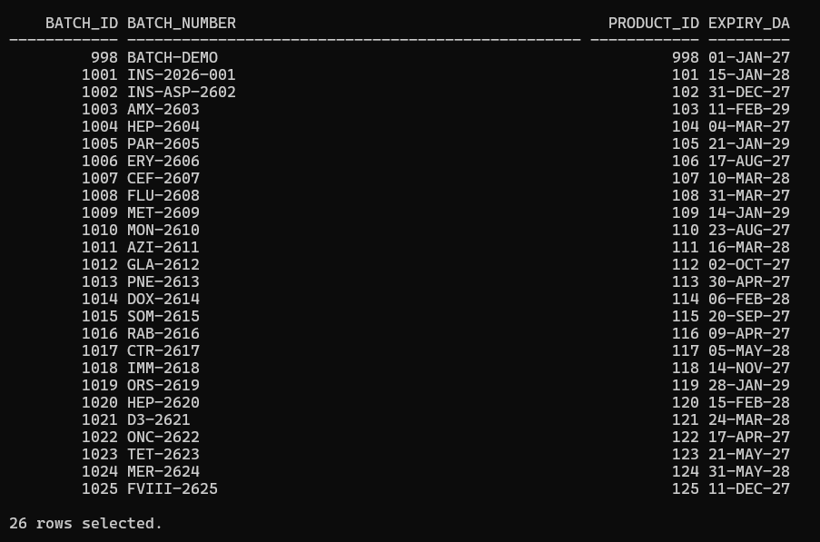
Figure 12.7. Product-batch listing output; 26 rows were returned.
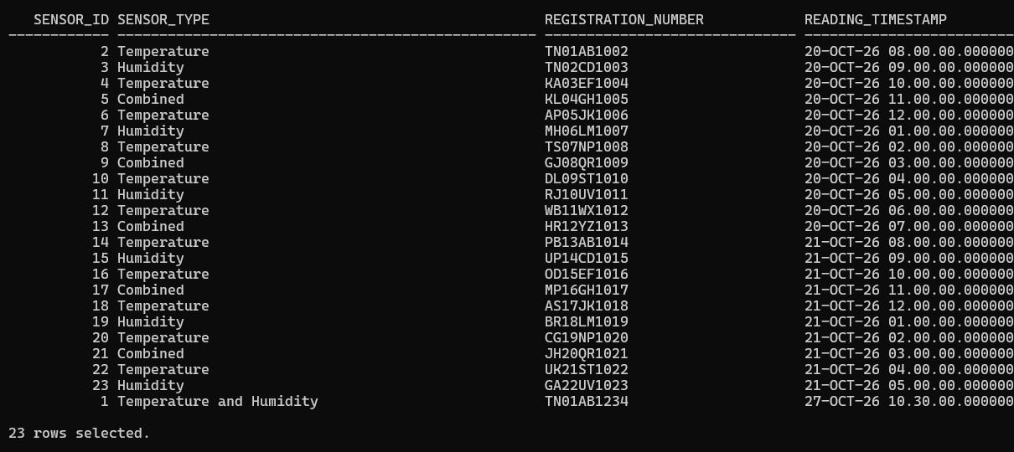
Figure 12.8. Sensor, vehicle and sensor-reading join; 23 reading rows were returned.
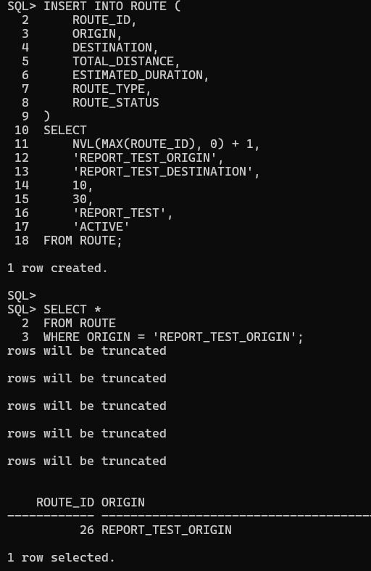
Figure 12.9. INSERT demonstration; one temporary route row was created and retrieved.
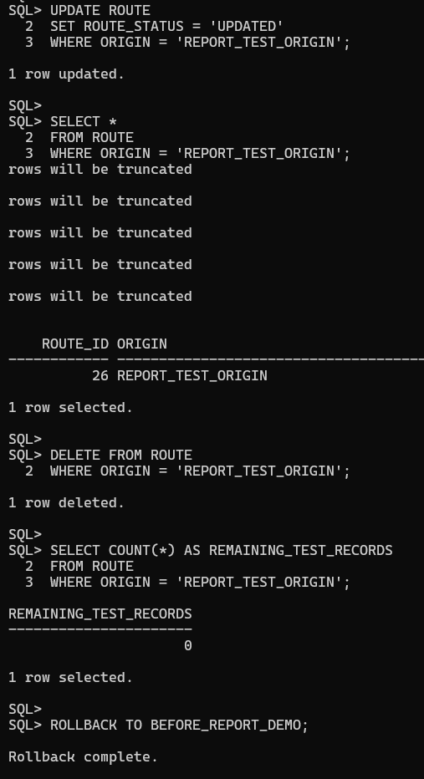
Figure 12.10. UPDATE and DELETE demonstrations; the temporary row was updated and then deleted. The remaining-row count was zero.
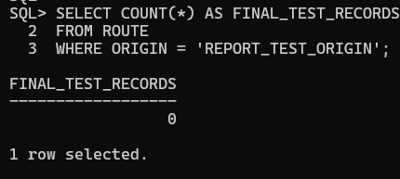
Figure 12.11. Transaction rollback verification; the final temporary-record count was zero.

13. APPLICATION MODULES AND SCREENSHOT EVIDENCE
The following screenshots are taken from the uploaded CryoTrack project folder. Each figure is included as visual evidence of the corresponding interface. Captions describe the visible screen and do not imply that every possible CRUD operation has been independently tested.

13.1 Login page
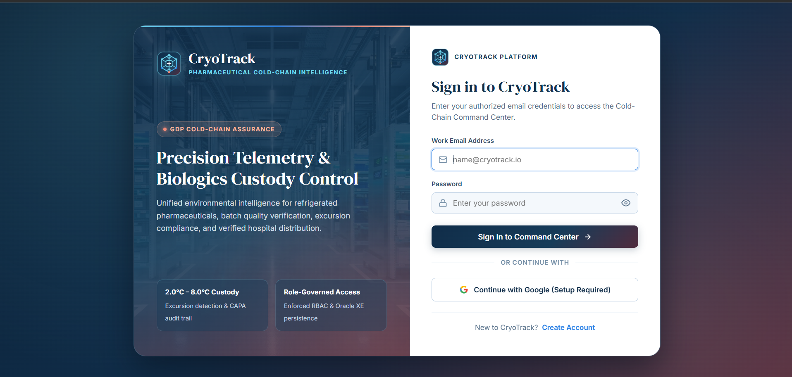
Figure 2. Authentication interface (01_login.png).

13.2 Dashboard
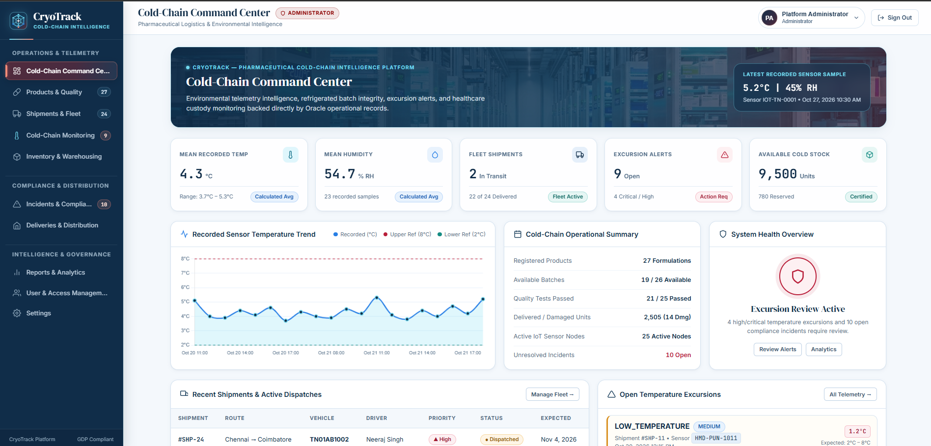
Figure 3. Main operational overview (02_dashboard.png).

13.3 Inventory
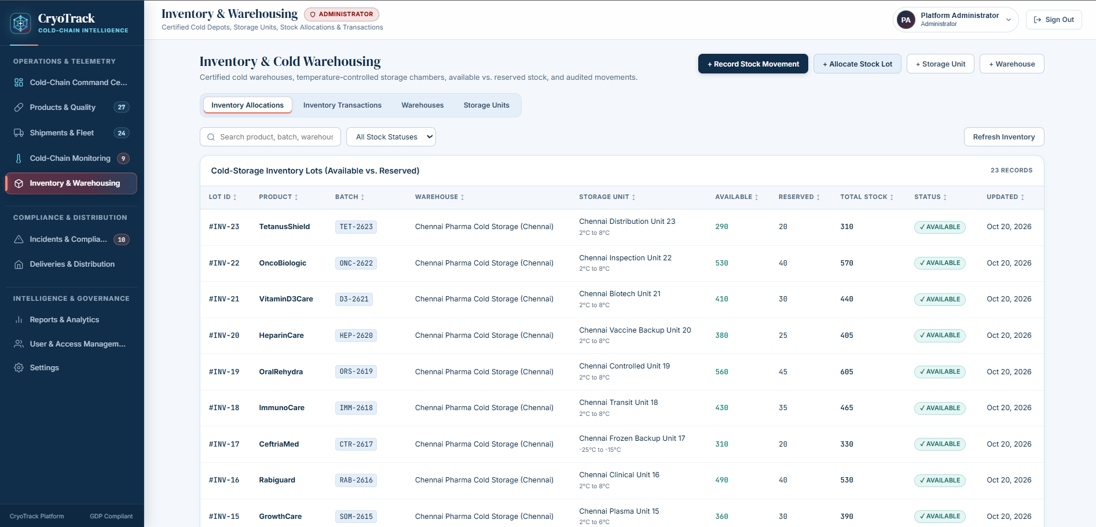
Figure 4. Inventory and warehouse interface (03_inventory.png).

13.4 Shipments
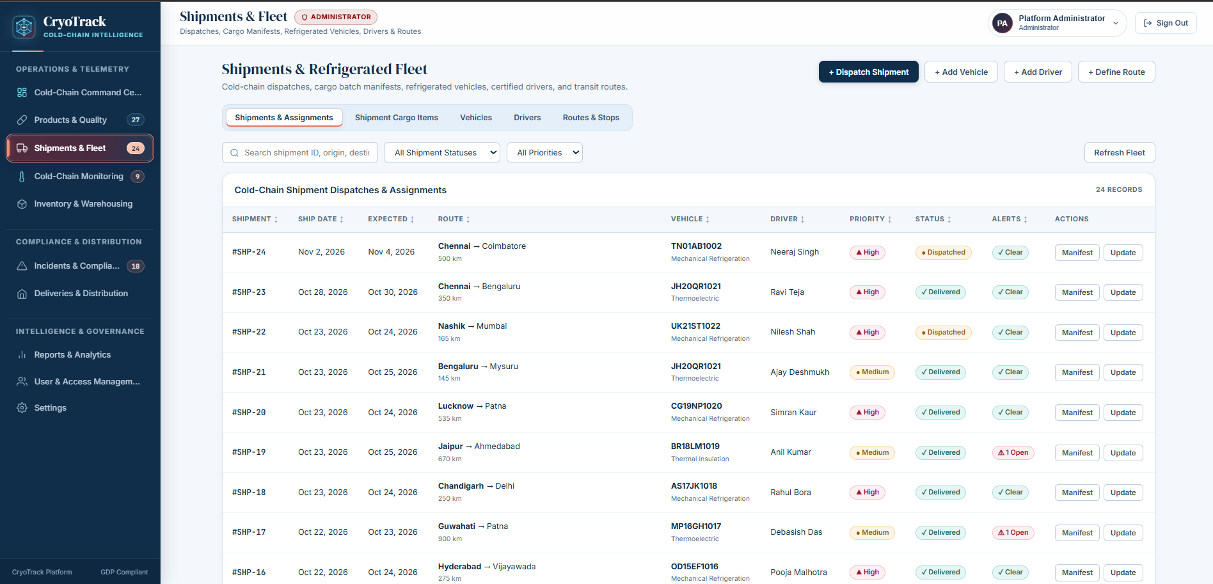
Figure 5. Shipment management interface (04_shipments.png).

13.5 Temperature monitoring
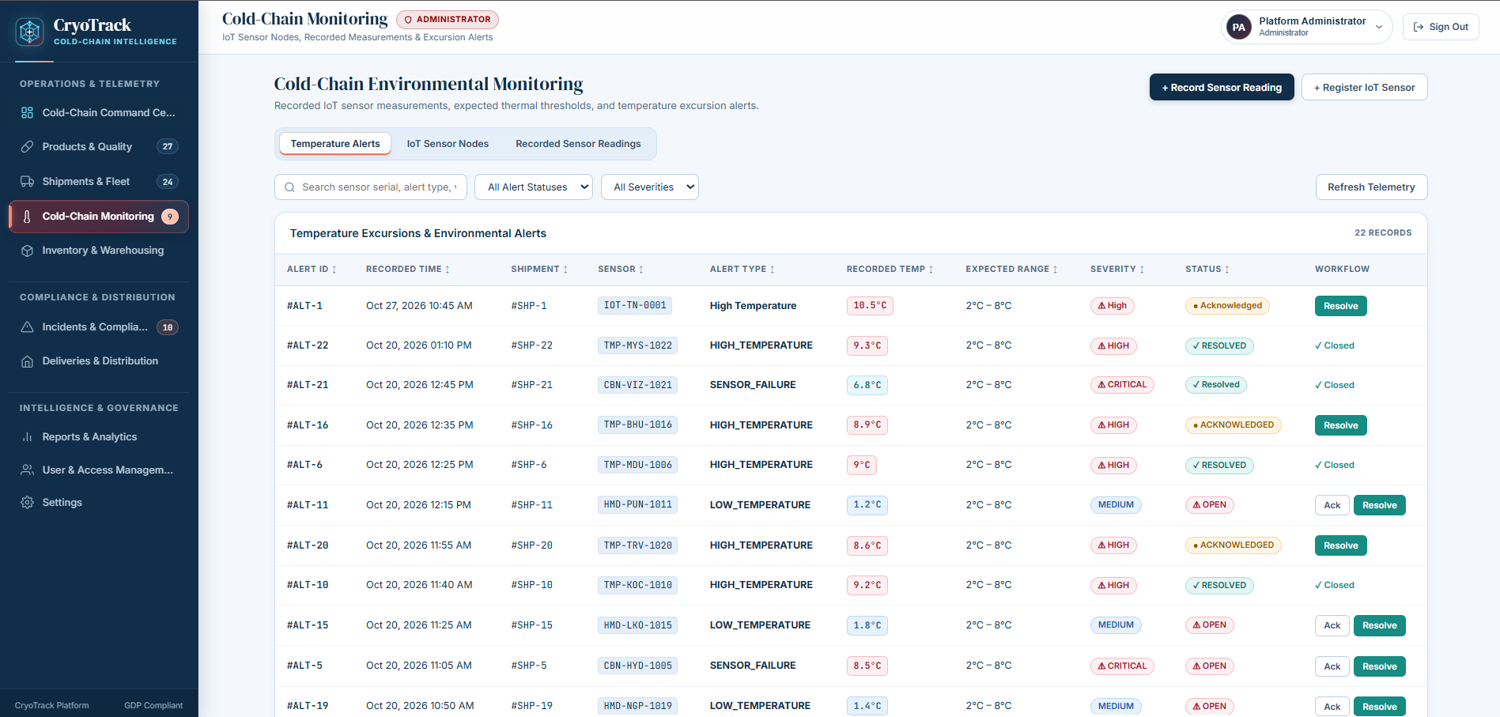
Figure 6. Temperature and sensor monitoring interface (05_temperature.png).

13.6 Alerts
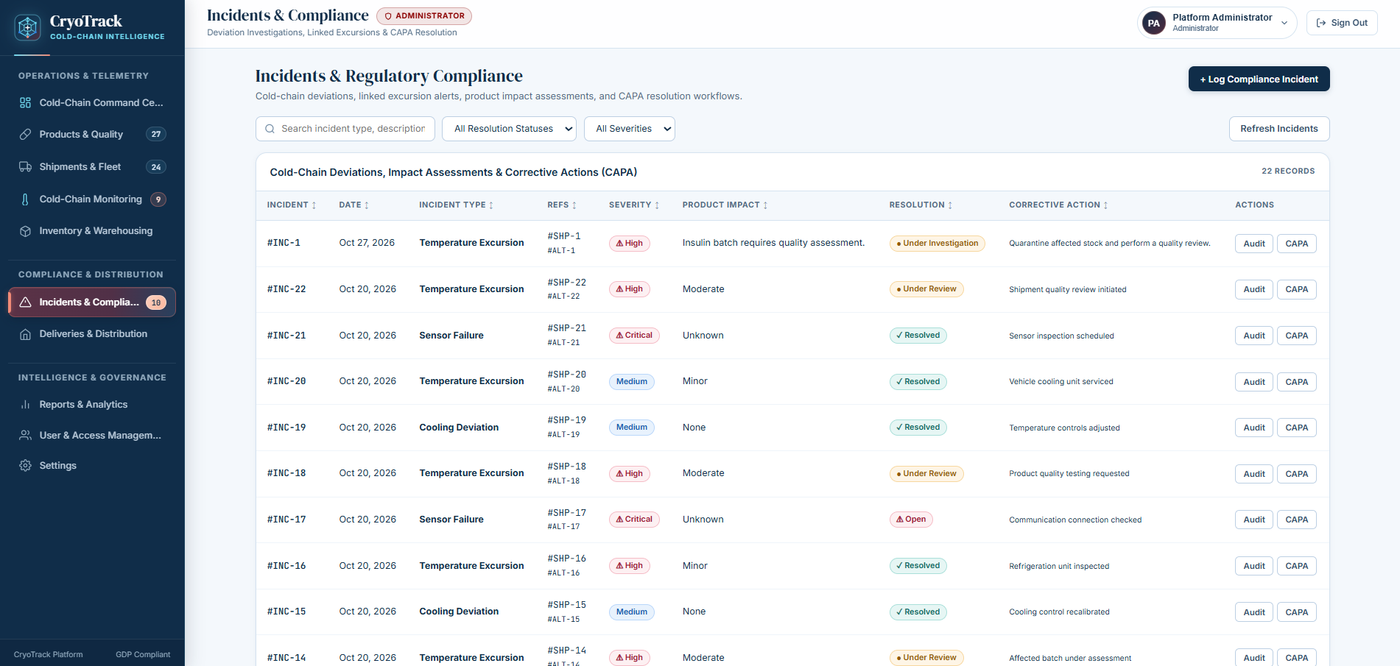
Figure 7. Temperature alert interface (06_alerts.png).

13.7 Products
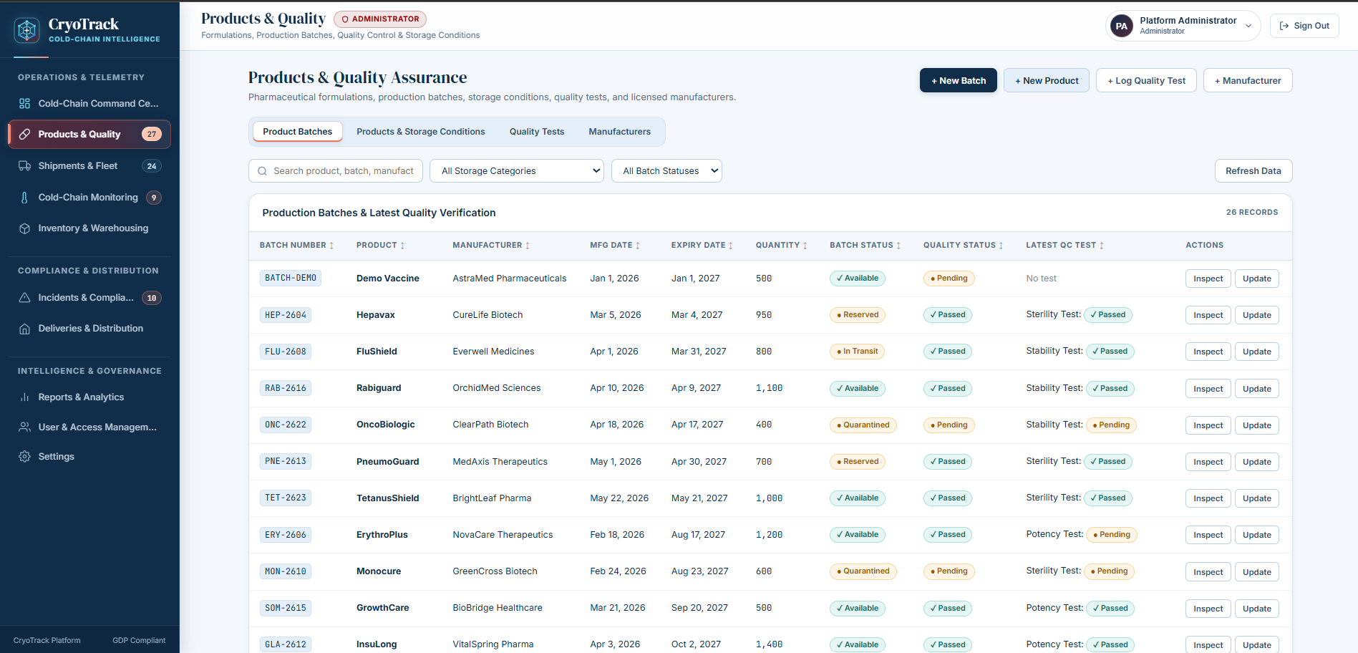
Figure 8. Pharmaceutical product interface (07_products.png).

13.8 Database
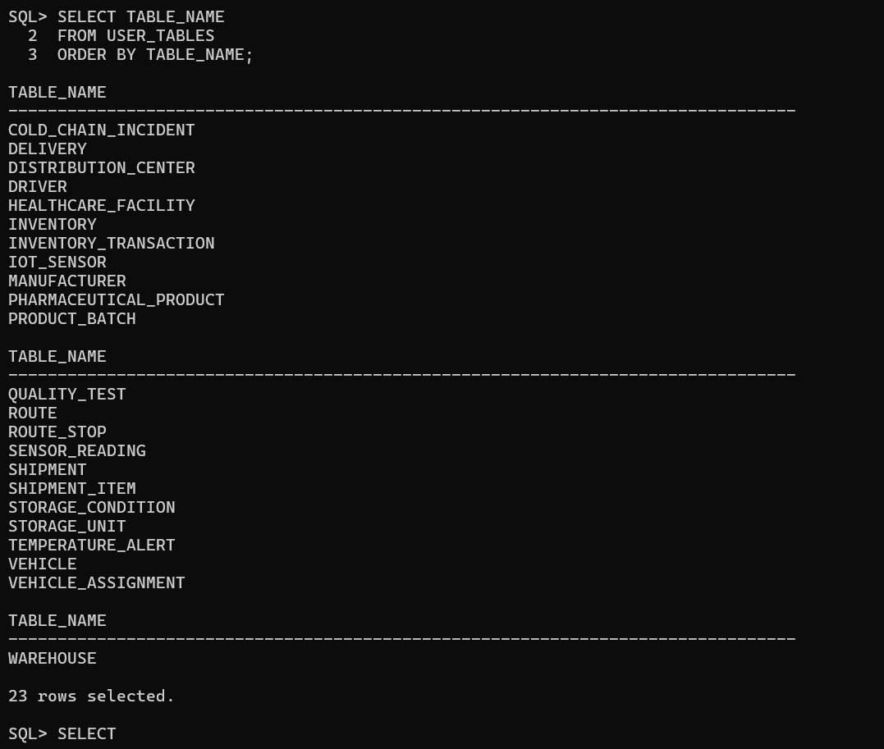
Figure 9. Database-related evidence (08_database.png).

13.9 Users
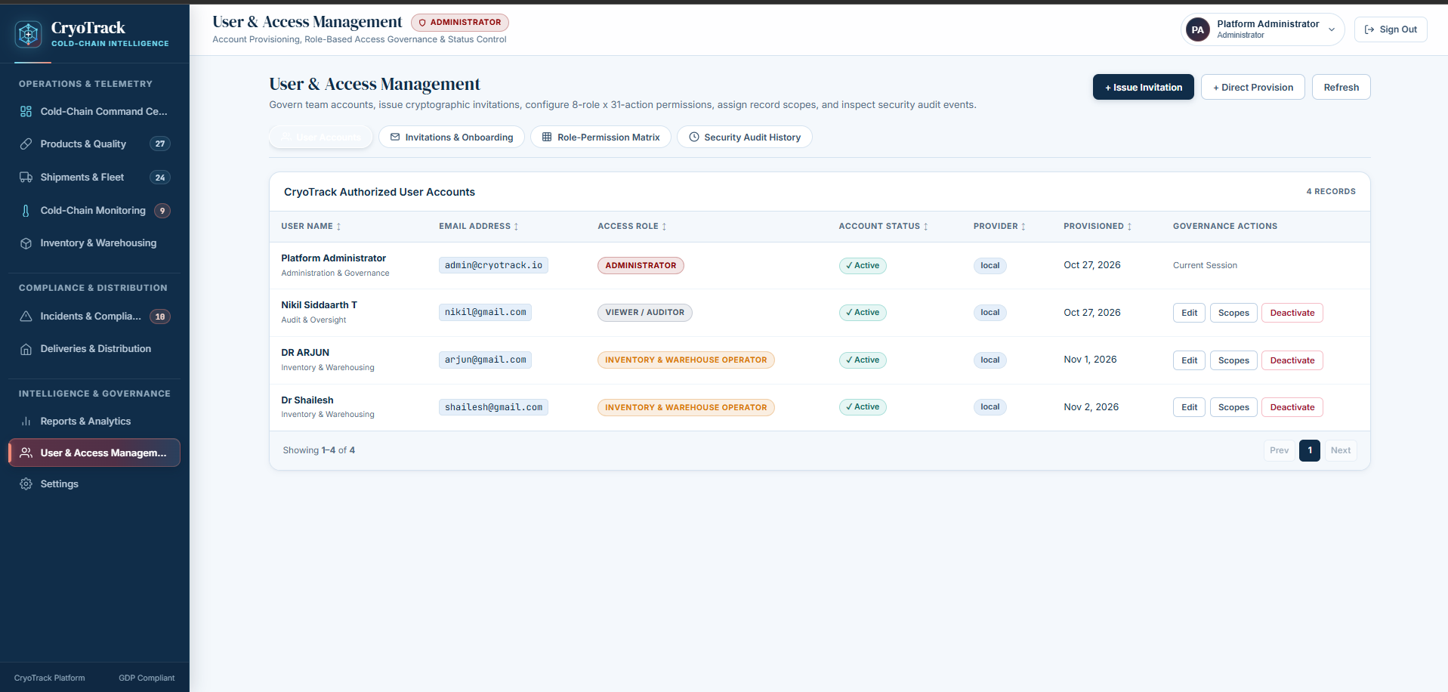
Figure 10. User and access management interface (09_users.png).

13.10 Reports
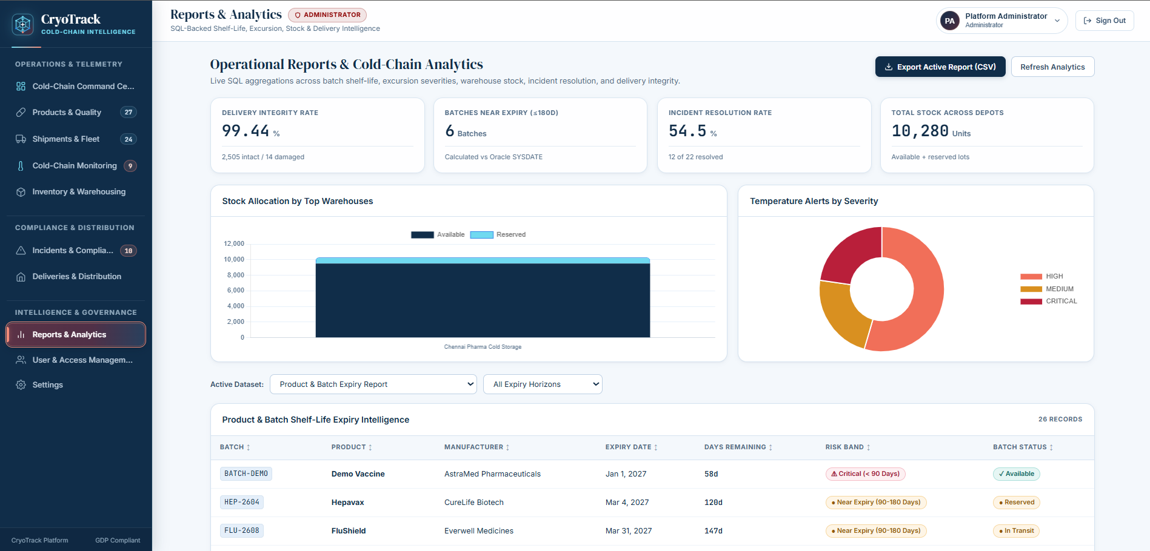
Figure 11. Reporting interface (10_reports.png).

13.11 Settings
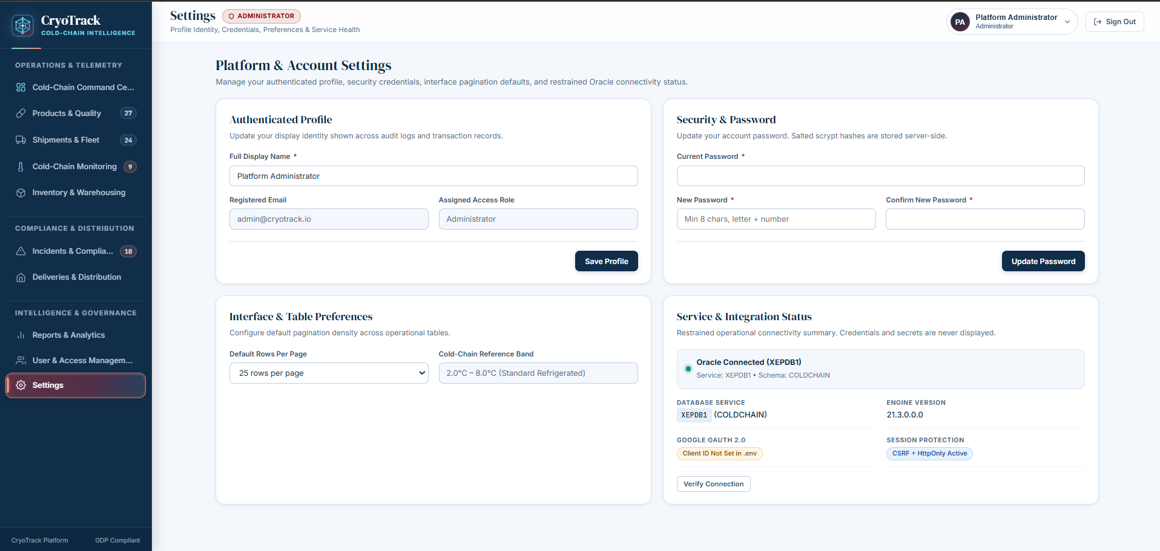
Figure 12. Application settings interface (11_settings.png).

14. TESTING STRATEGY AND RESULTS
Testing should verify the web application, database connectivity, access control, data retrieval and integrity behavior. The uploaded project contains test_db.py as a database connectivity utility. The table below is a test plan; actual outcomes are intentionally left unclaimed until the team executes each test and records evidence.
Test ID | Test scenario | Expected result | Actual result / evidence
TC01 | Valid login | User is authenticated and dashboard is displayed | Record after execution
TC02 | Invalid login | Login is rejected with an appropriate message | Record after execution
TC03 | Role-restricted module | Access is controlled by assigned role/permission | Record after execution
TC04 | Product retrieval | Product records are displayed | Record after execution
TC05 | Inventory retrieval | Inventory records are displayed | Record after execution
TC06 | Shipment retrieval | Shipment details are displayed | Record after execution
TC07 | Sensor reading retrieval | Sensor readings are displayed | Record after execution
TC08 | Temperature alert retrieval | Alert records are displayed | Record after execution
TC09 | Oracle connectivity | Connectivity utility reports a successful connection | Record after execution
TC10 | Invalid foreign-key reference | Oracle rejects the invalid reference | Record after execution
TC11 | Duplicate unique value | Oracle rejects a duplicate unique-key value | Record after execution
TC12 | Reversible transaction | ROLLBACK restores the pre-test state | Record after execution

14.1 Test execution record
After executing the cases, replace each 'Record after execution' entry with the observed result, date, tester and screenshot reference. Attach SQL Developer/SQL*Plus output for database tests and browser screenshots for application tests. Do not mark a case as Passed without execution evidence.

14.2 Verified Oracle Database Results
The SQL*Plus USER_CONSTRAINTS queries returned 56 enabled constraints in total: 23 primary keys, 23 foreign keys and 10 unique constraints. The grouped query displayed three constraint categories, and the separate COUNT(*) query confirmed the total of 56. The foreign-key relationship query returned 23 rows. These are observed database results.
Table 14.1. Row counts returned by Oracle for each table
Table name | Observed rows
COLD_CHAIN_INCIDENT | 22
DELIVERY | 21
DISTRIBUTION_CENTER | 24
DRIVER | 24
HEALTHCARE_FACILITY | 22
INVENTORY | 23
INVENTORY_TRANSACTION | 22
IOT_SENSOR | 25
MANUFACTURER | 25
PHARMACEUTICAL_PRODUCT | 27
PRODUCT_BATCH | 26
QUALITY_TEST | 25
ROUTE | 25
ROUTE_STOP | 23
SENSOR_READING | 23
SHIPMENT | 24
SHIPMENT_ITEM | 24
STORAGE_CONDITION | 25
STORAGE_UNIT | 24
TEMPERATURE_ALERT | 22
VEHICLE | 25
VEHICLE_ASSIGNMENT | 23
WAREHOUSE | 25
Total observed records: 549.
Table 14.2. Summary of enabled constraints
Constraint category | Count
Primary keys | 23
Foreign keys | 23
Unique constraints | 10
Total | 56
The detailed constraint listing showed all listed constraints as ENABLED. The foreign-key listing identifies the child and parent tables shown in Table 9.2; these relationships are reproduced below from the SQL*Plus output.
Table 14.3. Foreign-key relationships verified in Oracle
Child table | Constraint | Parent table
COLD_CHAIN_INCIDENT | FK_INCIDENT_SHIPMENT | SHIPMENT
COLD_CHAIN_INCIDENT | FK_INCIDENT_ALERT | TEMPERATURE_ALERT
DELIVERY | FK_DELIVERY_FACILITY | HEALTHCARE_FACILITY
DELIVERY | FK_DELIVERY_SHIPMENT | SHIPMENT
INVENTORY | FK_INVENTORY_BATCH | PRODUCT_BATCH
INVENTORY | FK_INVENTORY_UNIT | STORAGE_UNIT
INVENTORY_TRANSACTION | FK_TRANSACTION_INVENTORY | INVENTORY
IOT_SENSOR | FK_SENSOR_VEHICLE | VEHICLE
PHARMACEUTICAL_PRODUCT | FK_PRODUCT_MANUFACTURER | MANUFACTURER
PRODUCT_BATCH | FK_BATCH_PRODUCT | PHARMACEUTICAL_PRODUCT
QUALITY_TEST | FK_TEST_BATCH | PRODUCT_BATCH
ROUTE_STOP | FK_STOP_ROUTE | ROUTE
SENSOR_READING | FK_READING_SENSOR | IOT_SENSOR
SHIPMENT | FK_SHIPMENT_ROUTE | ROUTE
SHIPMENT_ITEM | FK_ITEM_BATCH | PRODUCT_BATCH
SHIPMENT_ITEM | FK_ITEM_SHIPMENT | SHIPMENT
STORAGE_CONDITION | FK_CONDITION_PRODUCT | PHARMACEUTICAL_PRODUCT
STORAGE_UNIT | FK_UNIT_WAREHOUSE | WAREHOUSE
TEMPERATURE_ALERT | FK_ALERT_SENSOR | IOT_SENSOR
TEMPERATURE_ALERT | FK_ALERT_SHIPMENT | SHIPMENT
VEHICLE_ASSIGNMENT | FK_ASSIGN_SHIPMENT | SHIPMENT
VEHICLE_ASSIGNMENT | FK_ASSIGN_VEHICLE | VEHICLE
VEHICLE_ASSIGNMENT | FK_ASSIGN_DRIVER | DRIVER
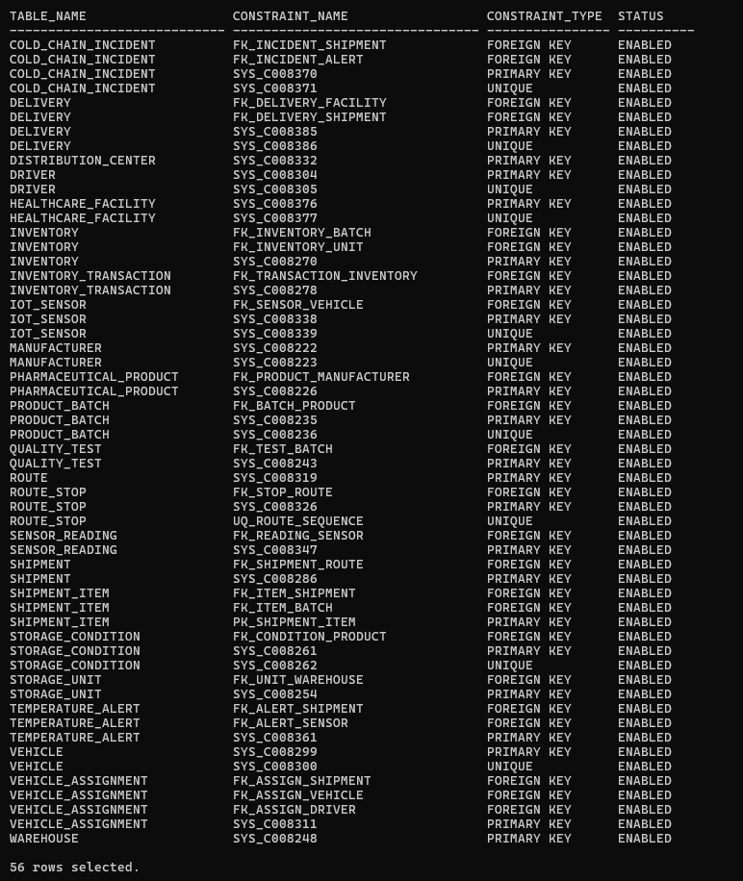
Figure 14.1. SQL*Plus output showing enabled primary-key, foreign-key and unique constraints.
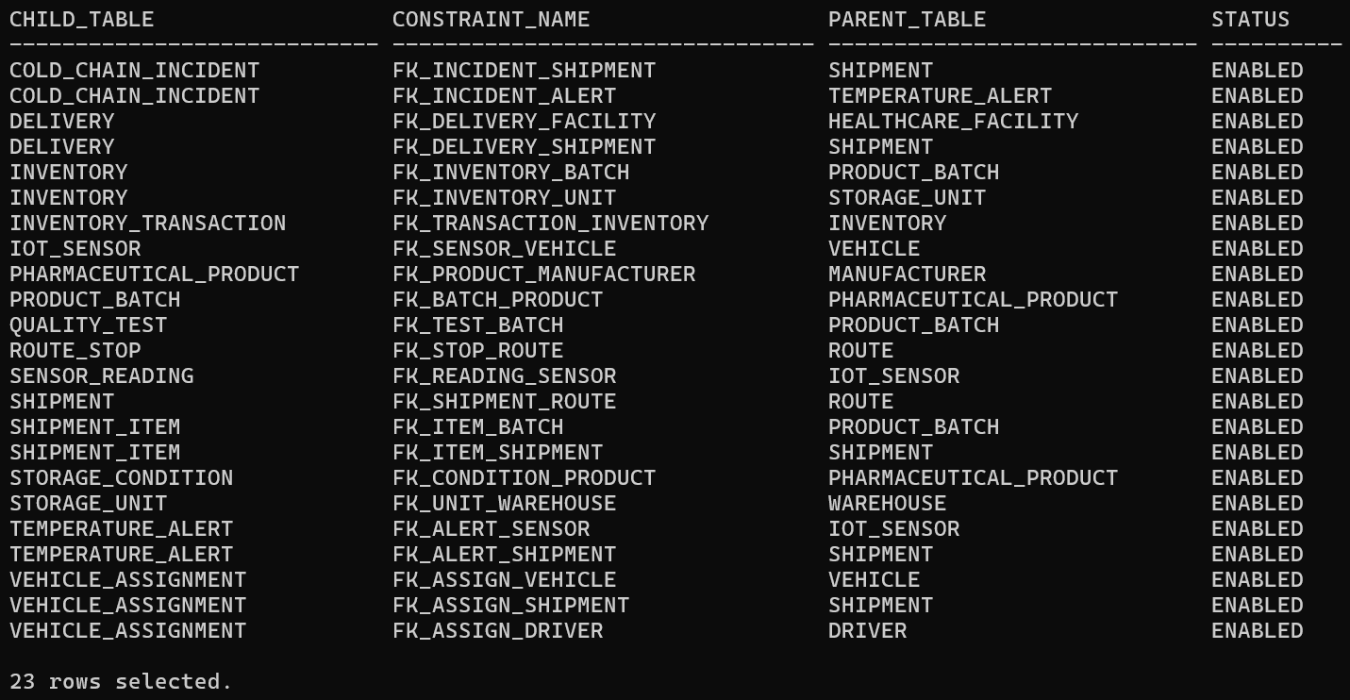
Figure 14.2. SQL*Plus output showing the 23 declared foreign-key relationships.

14.3 Index Information
The USER_INDEXES query returned 33 index entries. The displayed entries were reported as UNIQUE. These include indexes associated with primary-key and unique constraints, including Oracle-generated SYS_C... index names and explicitly named indexes such as UQ_ROUTE_SEQUENCE and PK_SHIPMENT_ITEM. The output does not establish that 33 manually created performance indexes exist.
Figure 14.3. Oracle USER_INDEXES output showing 33 unique index entries.
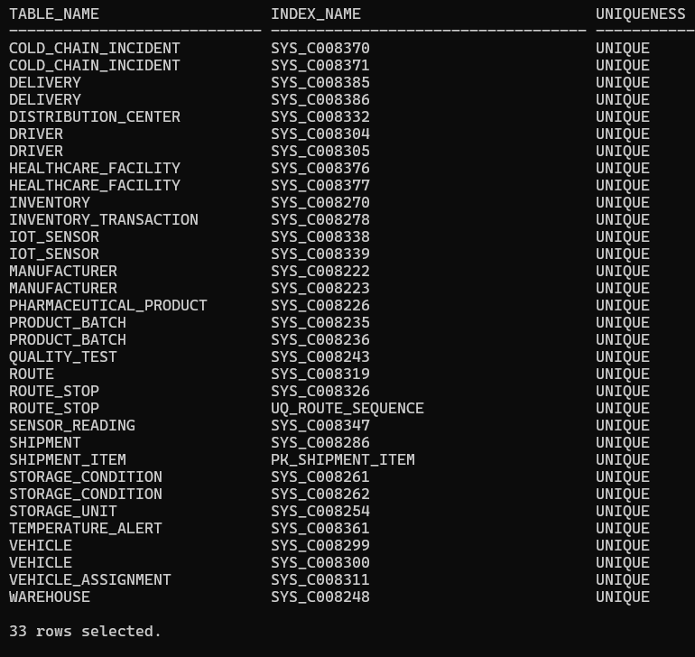
Figure 14.4. SQL*Plus verification of 23 primary keys, 23 foreign keys, 10 unique constraints and 56 total constraints.
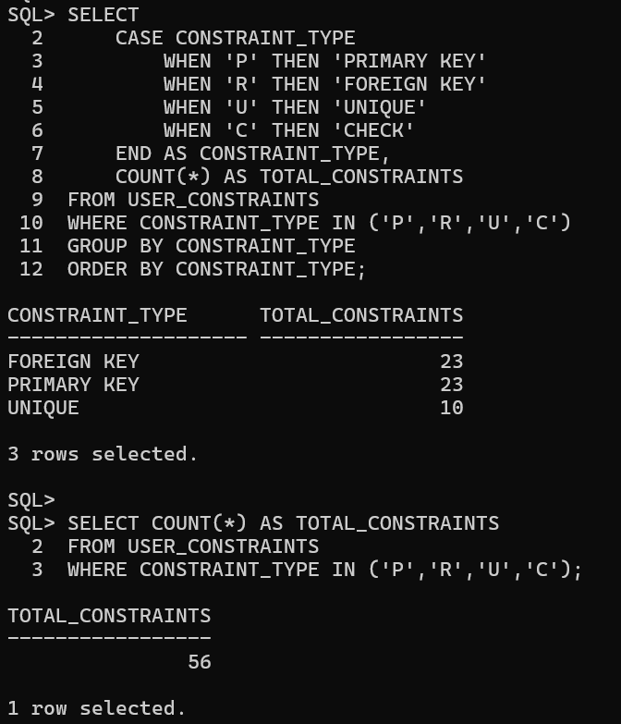

15. CONCLUSION
CryoTrack brings important pharmaceutical cold-chain records into a connected relational database and web application. The Oracle schema organizes product, batch, quality, storage, inventory, shipment, route, fleet, sensor, alert, incident and delivery information across 23 tables. The Flask application provides the interface and operational workflows, while separate SQLite storage supports application authentication. The project demonstrates ER modelling, relational schema design, primary and foreign keys, SQL querying, database connectivity and role-based access control.

16. LIMITATIONS AND FUTURE ENHANCEMENTS

16.1 Limitations
- The application depends on the availability and correct configuration of Oracle Database.
- Live sensor acquisition depends on an external device or configured data source; stored readings alone do not prove live hardware integration.
- External regulatory, manufacturer and healthcare systems are not confirmed as integrated.
- Sample data is synthetic and intended for a clean demonstration schema.
- Test outcomes must be recorded after actual execution.

16.2 Future enhancements
- Integrate supported physical IoT sensors for continuous temperature and humidity collection.
- Add configurable notifications for critical temperature excursions.
- Expand automated tests for CRUD operations, role permissions and invalid inputs.
- Add audit and traceability reports for product batches and shipment history.

- Add backup, recovery and deployment instructions for reproducible setup.

17. TEAM CONTRIBUTIONS

17.1 NIKIL SIDDAARTH T – 25BCE5373
Database Architecture and Backend Development
- Project planning and requirement analysis.
- Oracle XE database architecture and relational schema planning.
- Design of the 23-table database structure and relationships.
- Flask–Oracle connectivity and backend development.
- API implementation, integration and database validation.

17.2 PRAVEEN V – 25BCE5413
Frontend and Application Design
- CryoTrack website interface and visual design.
- Dashboard, sidebar and navigation structure.
- Data tables, forms and interactive components.
- Frontend–backend API integration.
- Presentation of application workflows.

17.3 SHAILESH K – 25BCE5707
Database Operations, Modules and Security
- SQL DDL/DML implementation across the 23 tables.
- Primary keys, foreign keys, integrity constraints and SQL operations.
- Complex queries, joins, subqueries and aggregate functions.
- Inventory, shipment and IoT monitoring workflows.
- Authentication, RBAC and department-specific permissions.
- Functional verification, debugging and documentation.

18. REFERENCES
[1] Oracle Corporation, Oracle Database 21c Documentation. https://docs.oracle.com/en/database/oracle/oracle-database/21/
[2] Oracle Corporation, Oracle Database SQL Language Reference. https://docs.oracle.com/en/database/oracle/oracle-database/21/sqlrf/
[3] Pallets Projects, Flask Documentation. https://flask.palletsprojects.com/
[4] Python Software Foundation, Python Documentation. https://docs.python.org/3/
[5] Python-oracledb Documentation. https://python-oracledb.readthedocs.io/
[6] VIT Chennai, BACSE202 Database Management Systems Digital Assignment Guidelines, 2026–2027.

APPENDIX A – SETUP AND SUBMISSION INFORMATION
Item | Location / instruction
Oracle DDL | database/schema.sql
Demonstration seed data | database/sample_data.sql – fresh schema only, review before execution
SQL query set | database/queries.sql
Application screenshots | screenshots/
Test connectivity utility | test_db.py
Python dependencies | requirements.txt
GitHub repository | [Insert final repository URL]
YouTube demonstration | [Insert 3–5 minute demonstration URL]

Before publishing, exclude .env, .venv, instance/ local database files, secrets and backup files. Keep .env.example only if it contains placeholders rather than real credentials.

