**KICKSTARTER OBESRVATIONS AND LIMITATIONS**

***What are three conclusions we can make about Kickstarter campaigns given the provided data?***

1. *US has most startups seeking funds followed by GB and these countries have the highest success rates as well.*

*Top 3 categories/ sub categories having the best success rates in US are*

1. *Music—Indie rock/rock*
2. *Film & Video – Documentary*
3. *Theater- Plays*

*Top 2 catgeories with best success rates in GB are*

1. *Music – rock and electronic music*
2. *Theater - Plays*

**Success percentage of startups in different countries. Fig shows US tops the list**

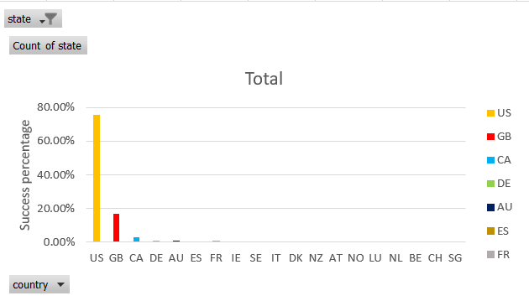

**Top performing categories in US**

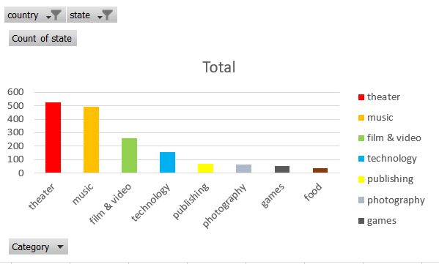

**Top performing categories in GB**

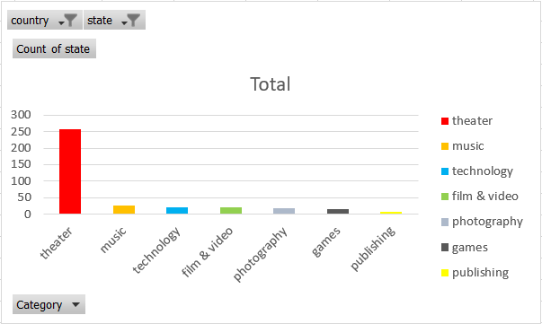

**We also see that majority of the startups are around Theater, music and technology**

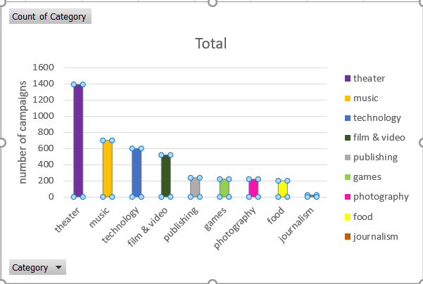

1. *Music and film videos are seeing a decline in success rate, while theater, games technology and photography are gaining more interest, hence you see more backers for these categories in the recent years*

**Success rates of different categories over years**

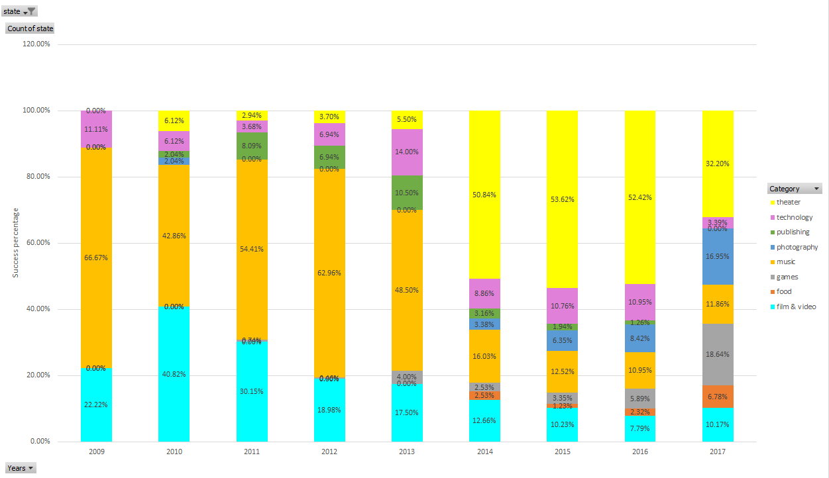

**Number of backers for each category over years.**

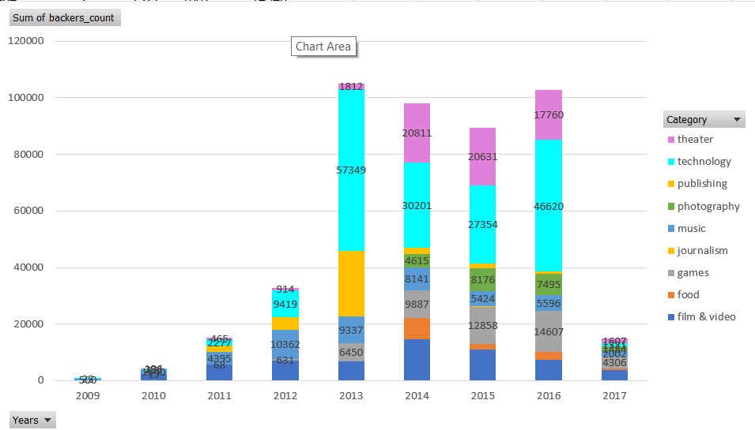

**Amount pledged by backers for different categories over years. Figure shows that Technology, game and theater are backing more money in the recent years**

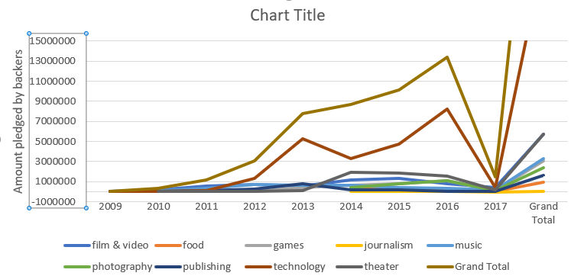

***What are some other possible tables/graphs that we could create?***

**A pie chart could be used to show state percentages of fundraising startups. Figure shows, a little over half of startups have been successful in the campaign**

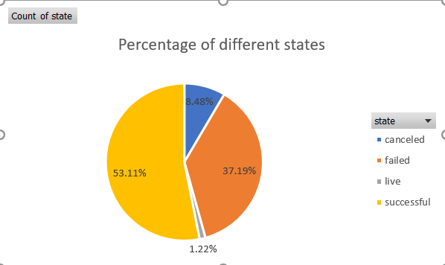

1. *A scatter plot on goal VS pledged shows, for successful startups amount pledged is greater than the goal set in most cases.While the ones that failed/canceled have a lower amount pledged*

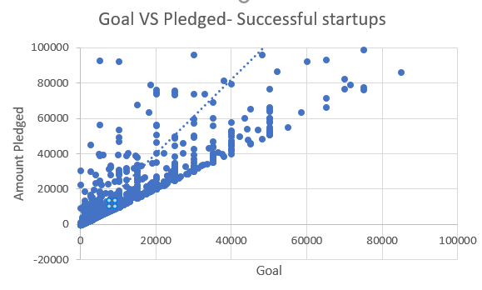

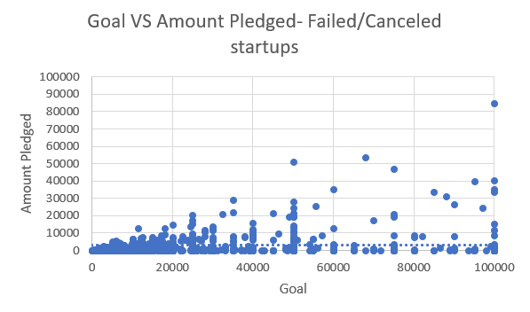

1. *Binning the goals into different buckests like below shows that Success is on the higher side for fund raising companies that have goals in the range of 1000-5000*

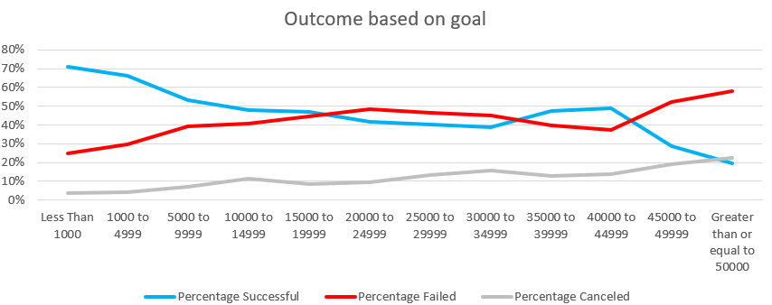

***Limitations***

**The dataset is more biased towards US startups**

**Dataset does not have equal representation from all categories. Ex Journalism**

**More attributes needed to conclusively find factors related to successful startups.**