**Multiple year stock Data**

Greatest Percentage Increase for 2016 is SD with increase of 11675%

Greatest Percentage Decrease for 2016 is DYN.W with decrease of -91.49%

Greatest Percentage Increase for 2015 is ARR with increase of 491.3%

Greatest Percentage Decrease for 2015 is KMI.W with decrease of -98.59%

Greatest Percentage Increase for 2014 is DM with increase of 5581.16%

Greatest Percentage Decrease for 2014 is CBO with decrease of -95.73%

It is observed that BAC ticker was traded the most in all 3 years.

2016 Data

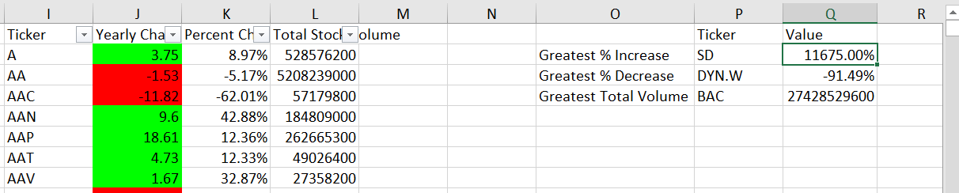

2015 Data

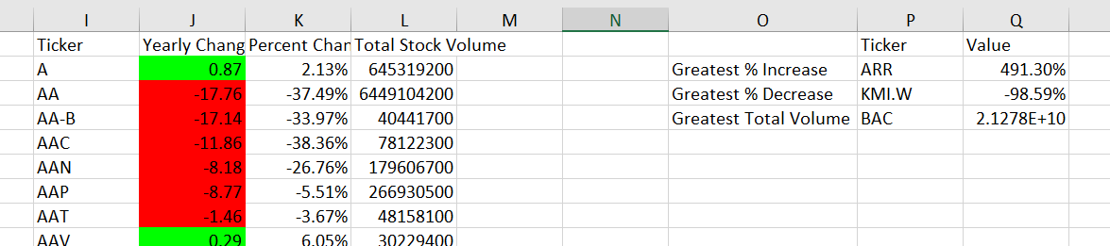

2014 data

