Nikhila Elizabeth Shaji
CS-B
Roll No-61

OOSE Assignment
Selenium Testing

Introduction:-
Selenium is a free (open-source) automated testing framework used to validate web applications across different browsers and platforms. Selenium can be easily deployed on platforms such as Windows, Linux, Solaris and Macintosh. Moreover, it supports OS (Operating System) for mobile applications like iOS, windows mobile and android. Selenium test scripts can be coded in any of the supported programming languages like C#, Java, Perl, PHP, Python and Ruby and can be run directly in most modern web browsers such as Internet Explorer, Mozilla Firefox, Google Chrome and Safari.

Aim:-To automate and test a website using Selenium

Installation:-
- Install python3 from python.org
- Install pip3
- For installing selenium, execute the line pip3 install selenium in terminal
- Install the webdiver. For Firefox, install gekodriver in YOUR PATH and install it from https://github.com/mozilla/geckodriver/releases

Website to be tested:-
- http://thedemosite.co.uk/addauser.php – It is the registration page which is automate and tested using selenium by providing the username and password. After registration, the username and password is stored into the database and displayed in the website.
- http://thedemosite.co.uk/login.php- It is the login page. This is tested by selenium by providing the username and password. Upon giving correct username and password, it will show login success otherwise it will show login failed.

Conclusion:-
Website is succesfully automated and tested using selenium

Test Script
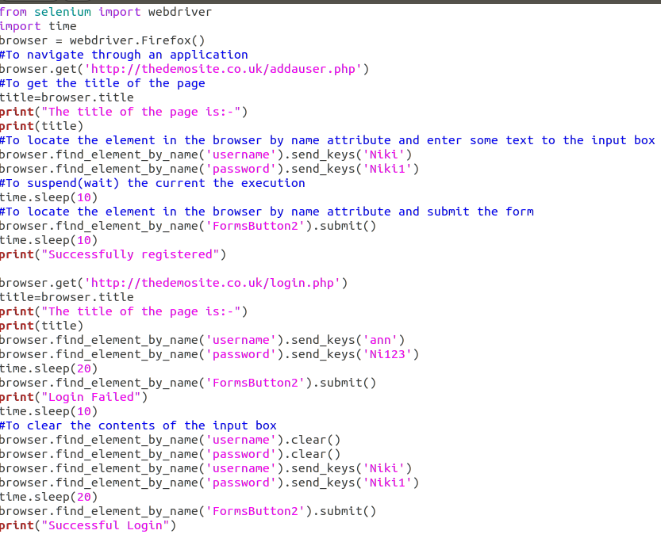

Output

Terminal

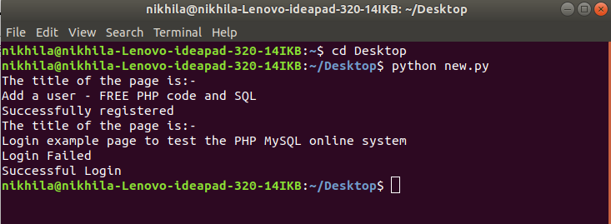

Registration
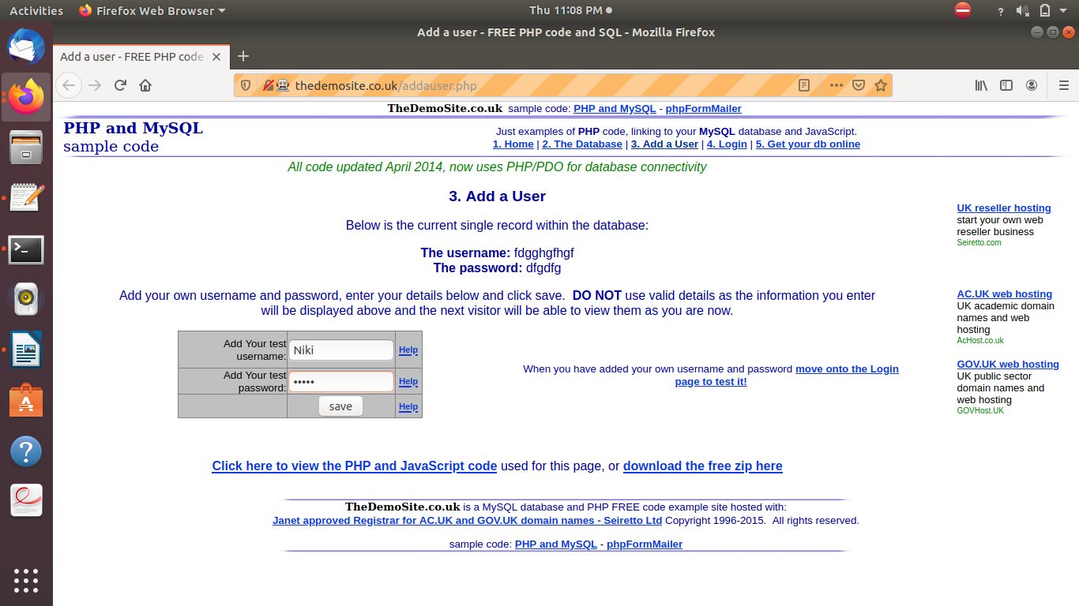
After Registeration

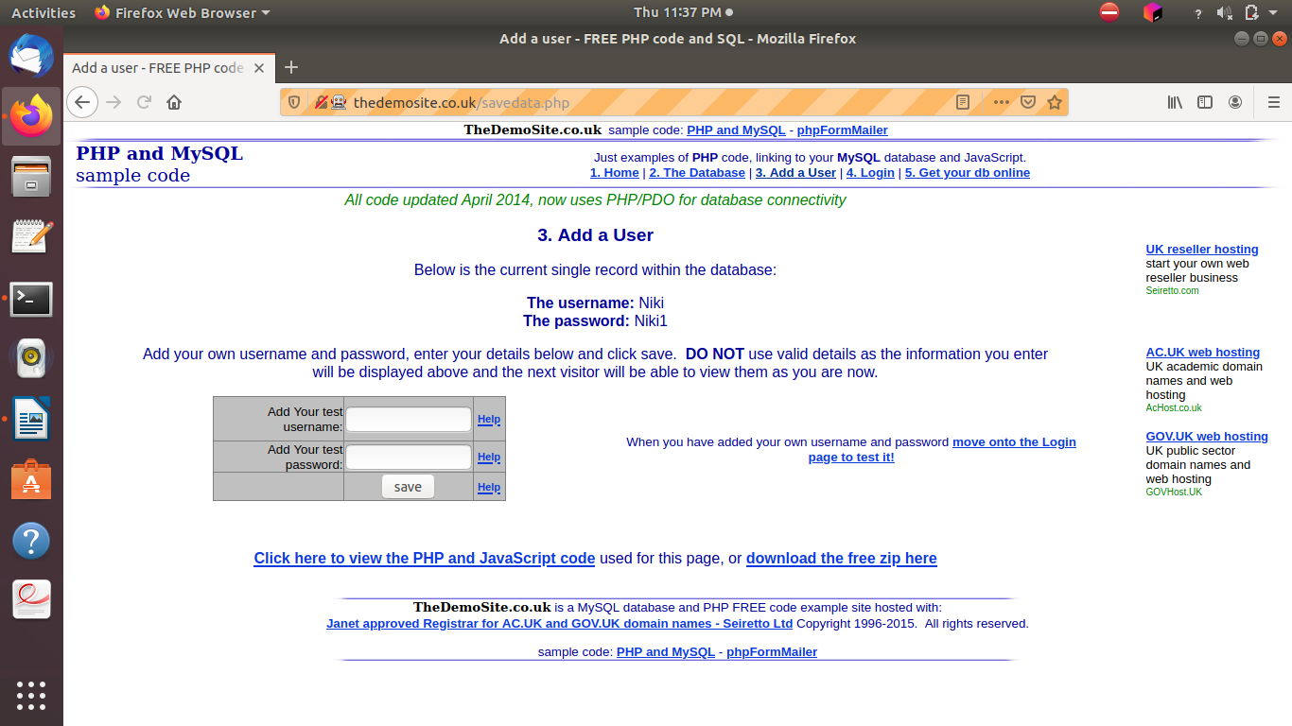

Logging with incorrect username and password

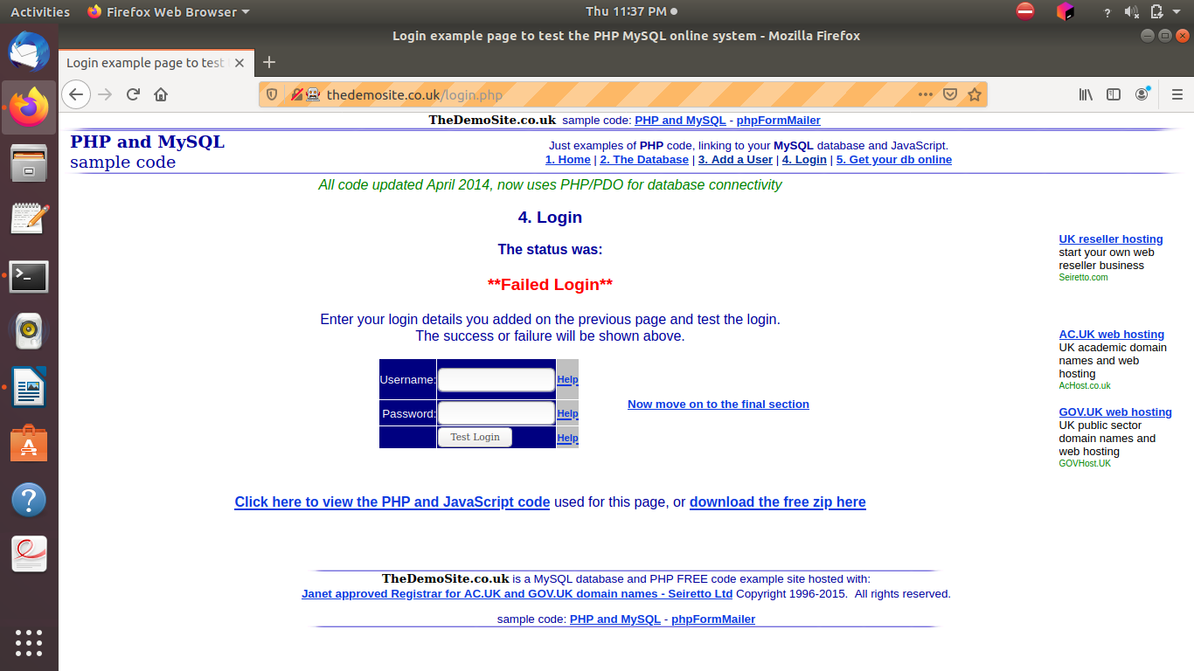
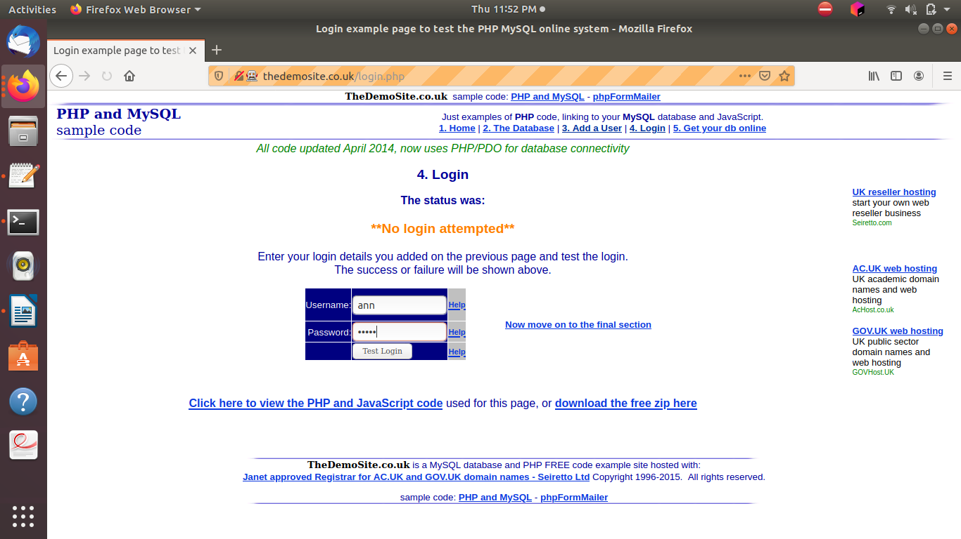

Logging with correct username and password

