WSDL SI_ETD_mailOUTService.wsdl
targetnamespace: | http://aeroflot.ru/xml.etd

services | bindings | porttypes | messages | types
SI_ETD_mailOUTService | SI_ETD_mailOUTBinding | SI_ETD_mailOUT | p2.Mail | Mail

service SI_ETD_mailOUTService
diagram
ports | HTTP_Port  binding p1:SI_ETD_mailOUTBinding  extensibility <soap:address location="http://mlk-sap-pod.msk.aeroflot.ru:50000/XISOAPAdapter/MessageServlet?senderParty=&amp;senderService=ETD&amp;receiverParty=&amp;receiverService=&amp;interface=SI_ETD_mailOUT&amp;interfaceNamespace=http%3A%2F%2Faeroflot.ru%2Fxml.etd" xmlns:soap="http://schemas.xmlsoap.org/wsdl/soap/"/>
source | <wsdl:service name="SI_ETD_mailOUTService">  <wsdl:port name="HTTP_Port" binding="p1:SI_ETD_mailOUTBinding">  <soap:address location="http://mlk-sap-pop.msk.aeroflot.ru:50100/XISOAPAdapter/MessageServlet?senderParty=&amp;senderService=ETD&amp;receiverParty=&amp;receiverService=&amp;interface=SI_ETD_mailOUT&amp;interfaceNamespace=http%3A%2F%2Faeroflot.ru%2Fxml.etd" xmlns:soap="http://schemas.xmlsoap.org/wsdl/soap/"/>  </wsdl:port>  </wsdl:service>

binding SI_ETD_mailOUTBinding
diagram | 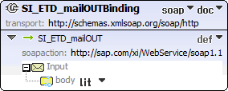
type | p1:SI_ETD_mailOUT
extensibility | <soap:binding style="document" transport="http://schemas.xmlsoap.org/soap/http" xmlns:soap="http://schemas.xmlsoap.org/wsdl/soap/"/>
operations | SI_ETD_mailOUT  extensibility <soap:operation soapAction="http://sap.com/xi/WebService/soap1.1" xmlns:soap="http://schemas.xmlsoap.org/wsdl/soap/"/>  input <soap:body use="literal" xmlns:soap="http://schemas.xmlsoap.org/wsdl/soap/"/>  output
used by | Port HTTP_Port in Service SI_ETD_mailOUTService
source | <wsdl:binding name="SI_ETD_mailOUTBinding" type="p1:SI_ETD_mailOUT">  <soap:binding style="document" transport="http://schemas.xmlsoap.org/soap/http" xmlns:soap="http://schemas.xmlsoap.org/wsdl/soap/"/>  <wsdl:operation name="SI_ETD_mailOUT">  <soap:operation soapAction="http://sap.com/xi/WebService/soap1.1" xmlns:soap="http://schemas.xmlsoap.org/wsdl/soap/"/>  <wsdl:input>  <soap:body use="literal" xmlns:soap="http://schemas.xmlsoap.org/wsdl/soap/"/>  </wsdl:input>  </wsdl:operation>  </wsdl:binding>

porttype SI_ETD_mailOUT

diagram | 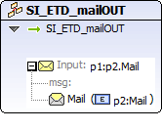
operations | SI_ETD_mailOUT  input p1:p2.Mail
used by | binding SI_ETD_mailOUTBinding
source | <wsdl:portType name="SI_ETD_mailOUT">  <wsdl:documentation/>  <wsdl:operation name="SI_ETD_mailOUT">  <wsdl:documentation/>  <wsp:Policy>  <wsp:PolicyReference URI="#OP_SI_ETD_mailOUT"/>  </wsp:Policy>  <wsdl:input message="p1:p2.Mail"/>  </wsdl:operation>  </wsdl:portType>

message p2.Mail

parts | Mail  element p2:Mail
used by | Operation SI_ETD_mailOUT in PortType SI_ETD_mailOUT
source | <wsdl:message name="p2.Mail">  <wsdl:documentation/>  <wsdl:part name="Mail" element="p2:Mail"/>  </wsdl:message>
Mail element |  | 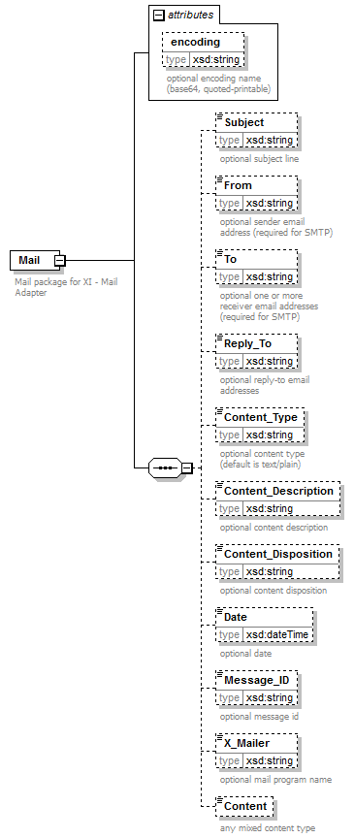
namespace |  | http://sap.com/xi/XI/Mail/30
properties |  | content complex
children |  | Subject From To Reply_To Content_Type Content_Description Content_Disposition Date Message_ID X_Mailer Content
attributes |  | Name Type Use Default Fixed annotation  encoding xsd:string documentation optional encoding name (base64, quoted-printable)
annotation |  | documentation  Mail package for XI - Mail Adapter
source |  | <xsd:element name="Mail">  <xsd:annotation>  <xsd:documentation>Mail package for XI - Mail Adapter</xsd:documentation>  </xsd:annotation>  <xsd:complexType>  <xsd:sequence>  <xsd:element name="Subject" type="xsd:string" minOccurs="0">  <xsd:annotation>  <xsd:documentation>optional subject line</xsd:documentation>  </xsd:annotation>  </xsd:element>  <xsd:element name="From" type="xsd:string" minOccurs="0">  <xsd:annotation>  <xsd:documentation>optional sender email address (required for SMTP)</xsd:documentation>  </xsd:annotation>  </xsd:element>  <xsd:element name="To" type="xsd:string" minOccurs="0">  <xsd:annotation>  <xsd:documentation>optional one or more receiver email addresses (required for SMTP)</xsd:documentation>  </xsd:annotation>  </xsd:element>  <xsd:element name="Reply_To" type="xsd:string" minOccurs="0">  <xsd:annotation>  <xsd:documentation>optional reply-to email addresses</xsd:documentation>  </xsd:annotation>  </xsd:element>  <xsd:element name="Content_Type" type="xsd:string" minOccurs="0">  <xsd:annotation>  <xsd:documentation>optional content type (default is text/plain)</xsd:documentation>  </xsd:annotation>  </xsd:element>  <xsd:element name="Content_Description" type="xsd:string" minOccurs="0">  <xsd:annotation>  <xsd:documentation>optional content description</xsd:documentation>  </xsd:annotation>  </xsd:element>  <xsd:element name="Content_Disposition" type="xsd:string" minOccurs="0">  <xsd:annotation>  <xsd:documentation>optional content disposition</xsd:documentation>  </xsd:annotation>  </xsd:element>  <xsd:element name="Date" type="xsd:dateTime" minOccurs="0">  <xsd:annotation>  <xsd:documentation>optional date</xsd:documentation>  </xsd:annotation>  </xsd:element>  <xsd:element name="Message_ID" type="xsd:string" minOccurs="0">  <xsd:annotation>  <xsd:documentation>optional message id</xsd:documentation>  </xsd:annotation>  </xsd:element>  <xsd:element name="X_Mailer" type="xsd:string" minOccurs="0">  <xsd:annotation>  <xsd:documentation>optional mail program name</xsd:documentation>  </xsd:annotation>  </xsd:element>  <xsd:element name="Content" minOccurs="0">  <xsd:annotation>  <xsd:documentation>any mixed content type</xsd:documentation>  </xsd:annotation>  </xsd:element>  </xsd:sequence>  <xsd:attribute name="encoding" type="xsd:string">  <xsd:annotation>  <xsd:documentation>optional encoding name (base64, quoted-printable)</xsd:documentation>  </xsd:annotation>  </xsd:attribute>  </xsd:complexType>  </xsd:element>

