

A00258753

Nikit Vaswani

Table of Contents

INTRODUCTION 3

SCREENSHOTS 3

GUI before Insertion 3

After insertion 4

After Update 4

After Deletion 5

SQL QUERIES: 5

Creating the table 5

Inserting into the table 5

Updating the Table 6

Deleting a row 6

Conclusion 6

# INTRODUCTION

This project is based on Valet Parking to store the information related to the cars that are parked in the parking. This application makes it easier to maintain the system of car parking. It saves some important information at the time a car is parked like id, owner name, car number and the area at which it is parked. This project has 2 sides to it one is the server side which creates a server using which the project is able to perform certain functions like get, put, post and delete. And the other side which runs on server side and uses it HSQL database in order to manipulate the database. It uses an XMLPullParser which translates the data using getter and setter methods.

# SCREENSHOTS

## GUI before Insertion

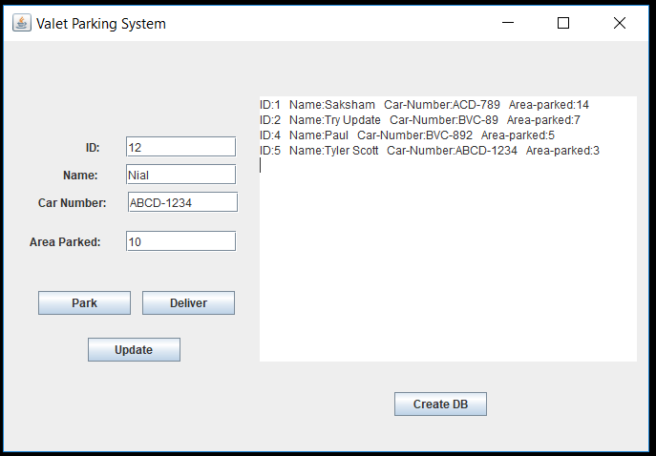

## After insertion

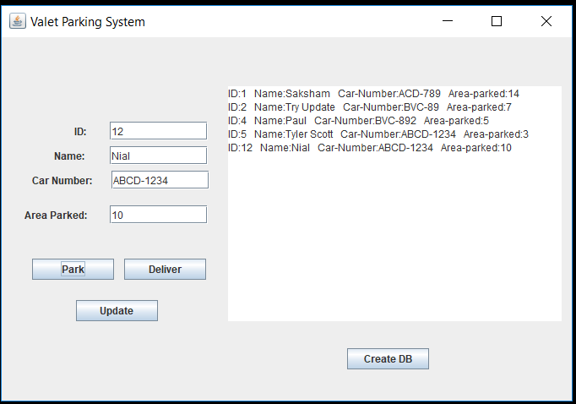

## After Update

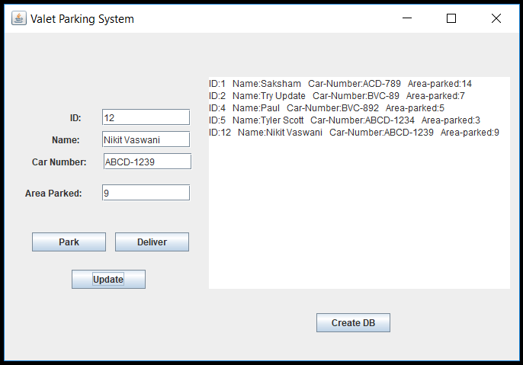

## After Deletion

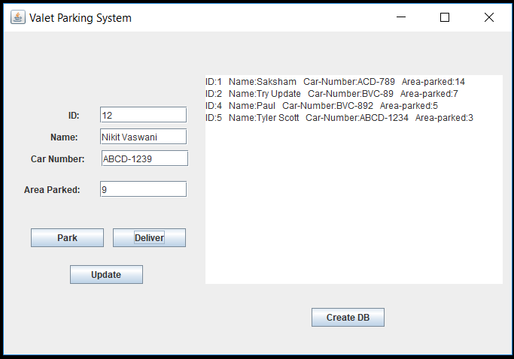

# SQL QUERIES:

## Creating the table

CREATE TABLE car(

id integer identity,

name varchar(30) not null,

numb varchar(30) not null,

area integer not null);

## Inserting into the table

INSERT INTO "PUBLIC"."CAR"

("ID", "NAME", "NUMB", "AREA" )

VALUES (1 , ' NIKIT VASWANI, 'XYZ-0989', 2);

## Updating the Table

UPDATE CAR

SET ID = 1, NAME = “NIKIT”, NUMB=”ABC-123”, AREA=4

WHERE ID = 1;

## Deleting a row

DELETE FROM "PUBLIC"."CAR" WHERE ID = 1;

# Conclusion

This project has completed all the necessary requirements of having both client and server-side applications. The client-side application of the project uses XMLPullParser to show the results at the GUI. And all the data that both these applications manipulate works on the HSQLDB. I had a great experience developing the project it was a great revision of all the labs that we worked on. I would love work on similar projects in the near future.