JDBC Assignment

Nikit Vaswani

A00258753

# What can it be used for? What Information it gives to user?

I think that this application can be used by Olympics committee to apply CRUD (Create, read, update & Delete) operations. It can be very useful to maintain the record for athletes who participate in the Olympics. It also creates a csv file using java and shows the required output in csv file. It tells the user all that the necessary information about the athlete who has won a medal in the Olympic games.

# GUI

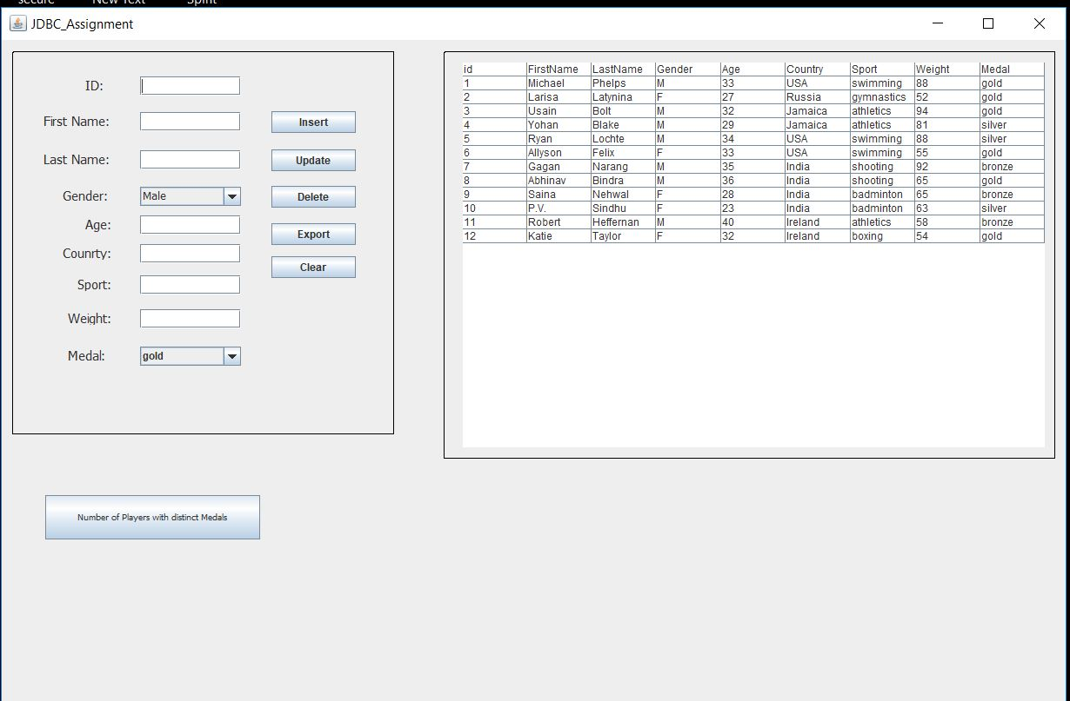

# TRIGGER

## To Insert all the deleted Values

# 

## To Convert input to lower case values

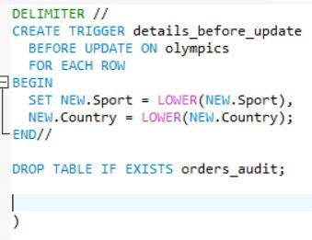

# Extra Features

I have learned to create and implement two different types of triggers. One of the triggers converts the elements that are added as a country or sport it converts them into lower case and then stores them inside the table. The second trigger inserts all the values that are deleted from the Olympics table into a new table.

I have also learned to create a csv file using java. I have also learned to use stored procedures using which I exported some data in the csv file.

# Benefits of the System:

* It Exports the data from the table to a csv file.
* It allows the user to manipulate the table using the JDBC Application.

# Conclusion

I think it was a very interesting project and has helped me learn a lot. I have learned about triggers, stored procedure and saving the data into a csv file. I would like to do similar projects in the near future to help me grow more as a Software Engineer. I will also be using the knowledge that I have gained from this project into my other projects.