REPORT

(Assignment-1)

A00258753

Nikit Vaswani

## Working of AJAX :-

‘Creating an Instance’ - An instance is created so that we can make changes using this instance.

function getHTTPObject() {

var xhr = false;

if(window.XMLHttpRequest){

xhr = new XMLHttpRequest();

}

else if(window.ActiveXOBject){

try{

xhr=new ActiveXObject("Msxml2.XMLHTTP");

}catch(e){

xhr=false;

}

}

return xhr;

}

‘Using the instance that was created earlier’

function grabFile(value) {

var file;

var city="";

city = document.getElementById("city").value;

if(city==""){

city = "Athlone";

}

file = "https://api.openweathermap.org/data/2.5/forecast/daily?q="+city+"&mode=xml&units=metric&cnt=7&appid=9de243494c0b295cca9337e1e96b00e2";

var request = getHTTPObject(); //Here we returning the instance and saving it in the variable

if (request){

request.onreadystatechange= function() { //when there is change in the state of instance

weat (request); we call this function

};

request.open("GET", file, true);

request.send(null);

}

}

‘The function that we called’

function weat(request) {

if(request.readyState==4){ //Checking if the instance is ready

if(request.status==200||request.status==304){ //Checking if the instance returns correctly and

var data = request.responseXML; everything is working fine

var name = data.getElementsByTagName('name')[0].firstChild.nodeValue;

var con = data.getElementsByTagName('country')[0].firstChild.nodeValue;

//fetching dates

var date1 = data.getElementsByTagName('time')[0].attributes.getNamedItem('day').nodeValue;

var date2 = data.getElementsByTagName('time')[1].attributes.getNamedItem('day').nodeValue;

var date3 = data.getElementsByTagName('time')[2].attributes.getNamedItem('day').nodeValue;

var date4 = data.getElementsByTagName('time')[3].attributes.getNamedItem('day').nodeValue;

var date5 = data.getElementsByTagName('time')[4].attributes.getNamedItem('day').nodeValue;

var date6 = data.getElementsByTagName('time')[5].attributes.getNamedItem('day').nodeValue;

var date7 = data.getElementsByTagName('time')[6].attributes.getNamedItem('day').nodeValue;

//fetching min temp

var min1 = data.getElementsByTagName('temperature')[0].attributes.getNamedItem('min').nodeValue;

var min2 = data.getElementsByTagName('temperature')[1].attributes.getNamedItem('min').nodeValue;

var min3 = data.getElementsByTagName('temperature')[2].attributes.getNamedItem('min').nodeValue;

var min4 = data.getElementsByTagName('temperature')[3].attributes.getNamedItem('min').nodeValue;

var min5 = data.getElementsByTagName('temperature')[4].attributes.getNamedItem('min').nodeValue;

var min6 = data.getElementsByTagName('temperature')[5].attributes.getNamedItem('min').nodeValue;

var min7 = data.getElementsByTagName('temperature')[6].attributes.getNamedItem('min').nodeValue;

//fetching max temp

var max1 = data.getElementsByTagName('temperature')[0].attributes.getNamedItem('max').nodeValue;

var max2 = data.getElementsByTagName('temperature')[1].attributes.getNamedItem('max').nodeValue;

var max3 = data.getElementsByTagName('temperature')[2].attributes.getNamedItem('max').nodeValue;

var max4 = data.getElementsByTagName('temperature')[3].attributes.getNamedItem('max').nodeValue;

var max5 = data.getElementsByTagName('temperature')[4].attributes.getNamedItem('max').nodeValue;

var max6 = data.getElementsByTagName('temperature')[5].attributes.getNamedItem('max').nodeValue;

var max7 = data.getElementsByTagName('temperature')[6].attributes.getNamedItem('max').nodeValue;

console.log(date1 );

//using these values to create a line chart

var ctx = document.getElementById('myChart').getContext('2d');

var myChart = new Chart(ctx, {

type: 'line',

data: {

labels: [date1, date2, date3, date4,date5, date6, date7],

datasets: [{

label: 'Max Temp(°C)',

data: [max1,max2, max3, max4, max5, max6, max7],

backgroundColor: "rgba(153,255,51,0.4)"

// backgroundColor: "Red"

}, {

label: 'Min Temp(°C)',

data: [min1, min2, min3, min4, min5,min6, min7],

backgroundColor: "rgba(255,153,0,0.4)"

// backgroundColor: "Blue"

}]

}

});

console.log(request.responseText);

}

}

else if(request.status==404){ //Checking if received an incorrect response

alert("City not found!!Please provide correct name."); from the instance then we alert the user

}

}

Above mentioned method and other similar methods are used in the assignment

## ASSIGNMENTS SCREEN-SHORTS:-

‘Home Page of the website’

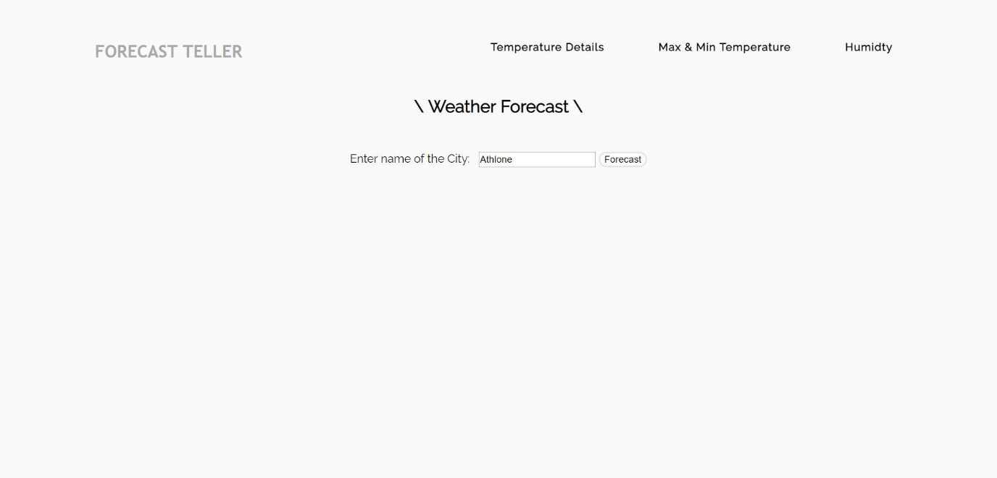

‘On click of forecast button in the temperature details section of the web-page’

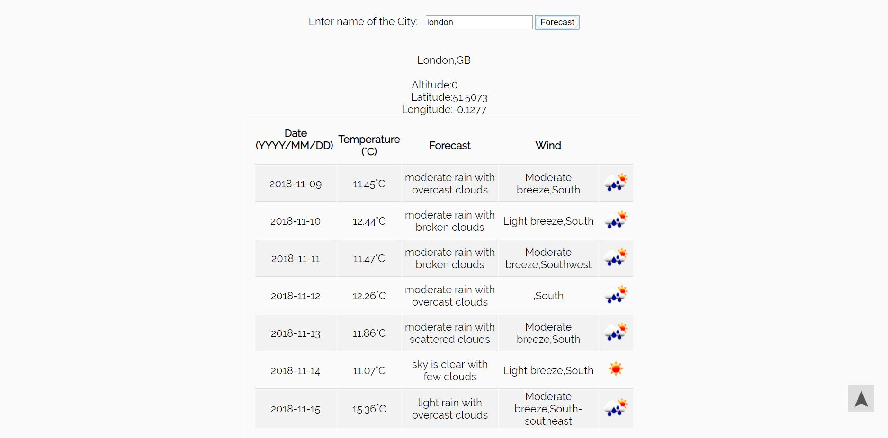

‘On click of forecast button in the Max & Min Temperature section of the web-page’

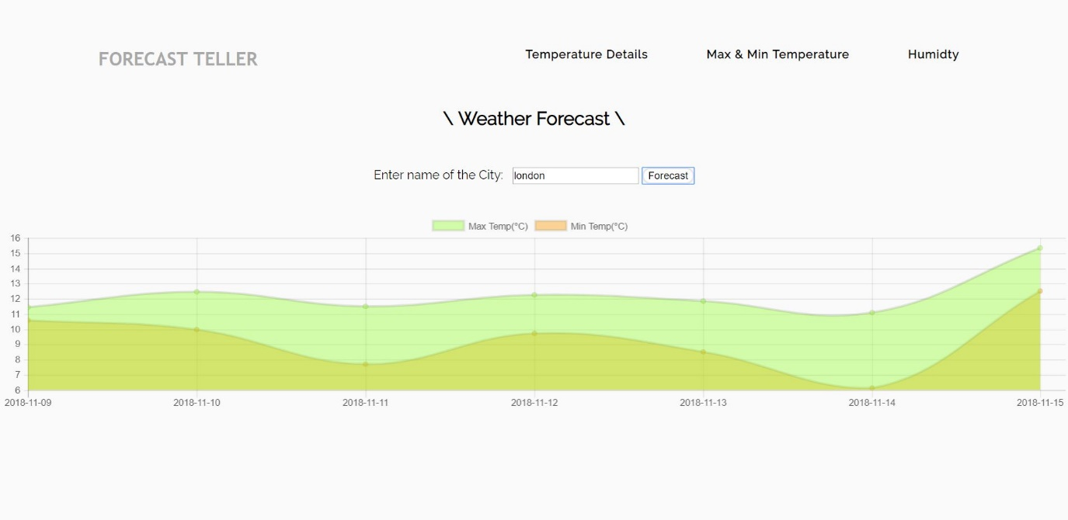

‘On click of forecast button in the Humidity section of the web-page’

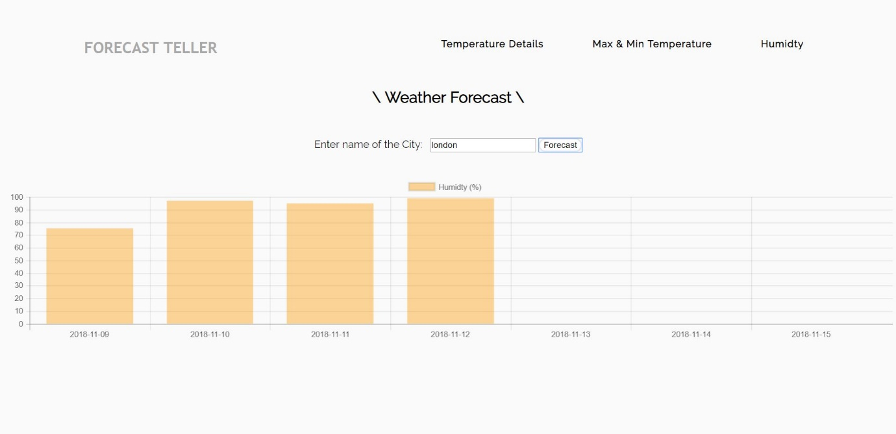

## Interesting Features of the Assignment:-

Scroll to Top when the user scrolls below for more information a button appears on the bottom-right of the screen and when user clicks on this button it scrolls to the top of the page.

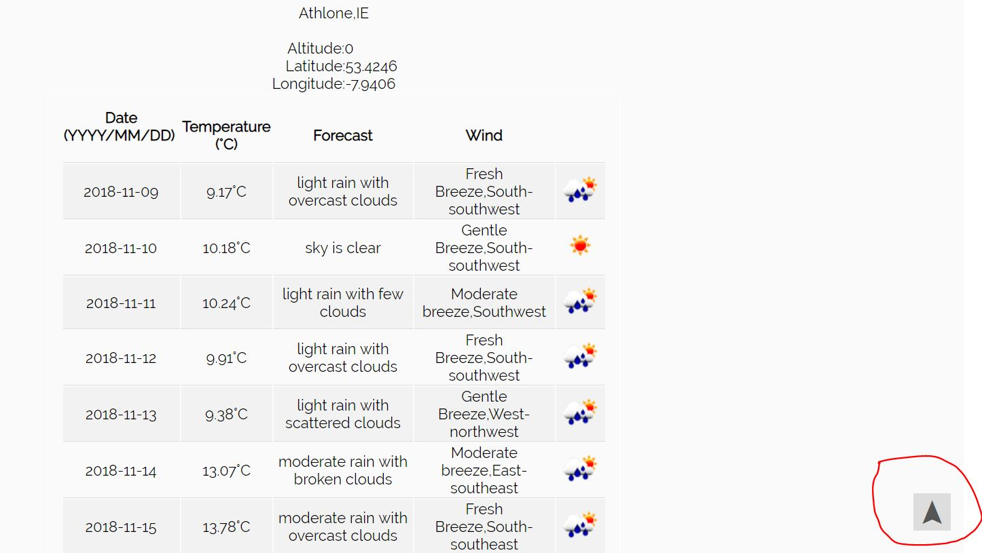

Fetching Images Directly from the web page: <img src='http://openweathermap.org/img/w/"+i1+".png'>

Where i1 = data.getElementsByTagName('symbol')[0].attributes.getNamedItem('var').nodeValue;

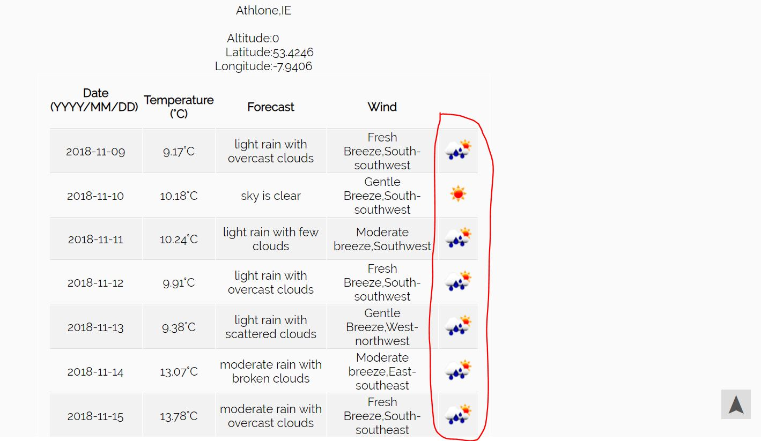

On Hover of the Temperature Details, Max & Min Temperature and Humidity we get “\” 2 of these around them below is an Image where User have hovered over Temperature Details.

