**Non-E-Lab Questions-**

**Unit 2-**

**Q6: Triangle**

Algorithm:

Step 1: Start the program

Step 2: Take the 3 sides from user and store in 3 variables a, b, c

Step 3: If a is equal to b and b is equal to c then its Equilateral

Step 4: If a is not equal to b and b is not equal to c and c is not equal to a then it’s a Scalene Triangle

Step 5: If above condition doesn’t match then it’s an Isosceles Triangle.

Step 6: Stop

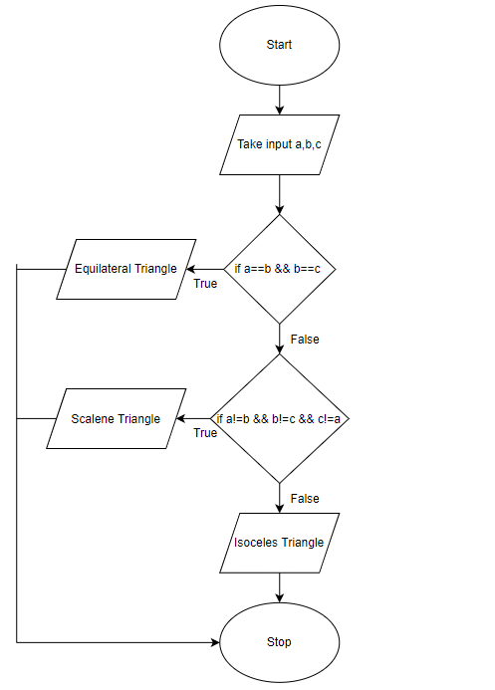Flowchart:

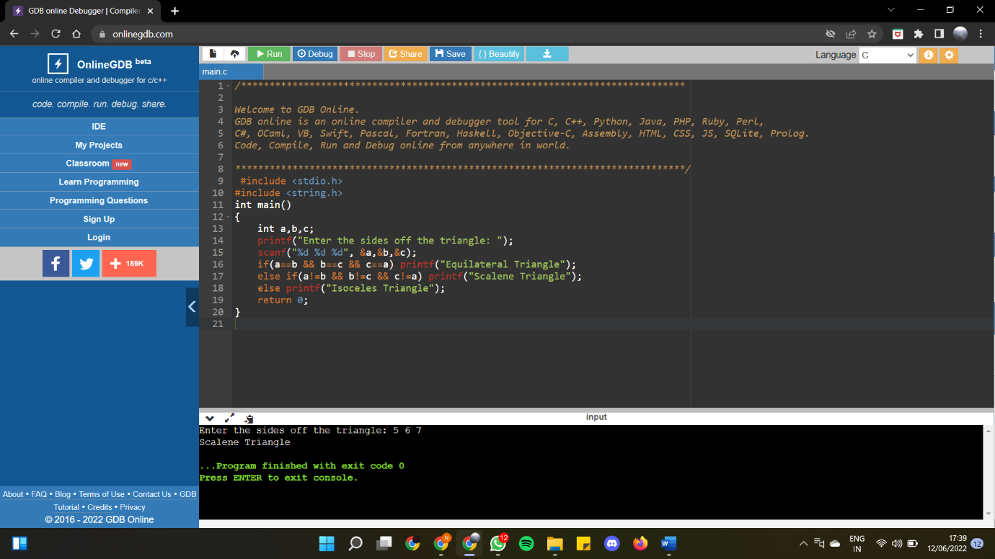

**Unit 3-**

**Q3: John and Peter word game**

Algorithm:

Step 1: Start the program

Step 2: Assign variable i to 1 and char c to ‘a’

Step 3: Run a loop based on the condition if i is not zero.

Step 4: Take input from John and Peter turn wise by checking odd and even value of i.

Step 5: If first character of the input word matches with c then assign c the last character of the input word and increment i.

Step 6: If it doesn’t match then the word entered was wrong. Assign i to 0 to falsify the loop condition, to terminate it.

Step 7: Stop

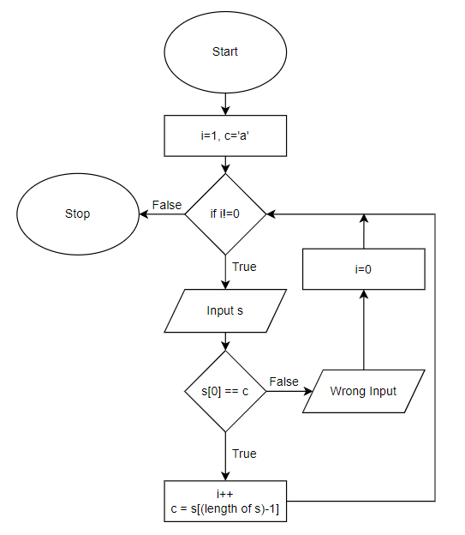Flowchart:

