Студент: Пермяков Н.А.
Группа: М8О-208Б-19
Номер по списку: 24

«СИСТЕМЫ ПРОГРАММИРОВАНИЯ»
Курсовая работа 2021.
Часть 1.

Вариант грамматики:j24

Чтобы получить 4, до 12:00 24.05.2021 пришлите отчет
по ДОПОЛНИТЕЛЬНОМУ заданию.
После оператора вызова БУЛЕВСКОЙ функции поместите комментарий с именем ее прототипа в Микролиспе.
Например, pier_Q( ...)/*pier?*/

Продемонстрируйте на контрольной задаче coin21.
В начало отчете по КР1 вставьте текст этого задания, скриншот трансляции, скриншот запуска в С++, распечатку ИЗМЕНЕННЫХ продукций.
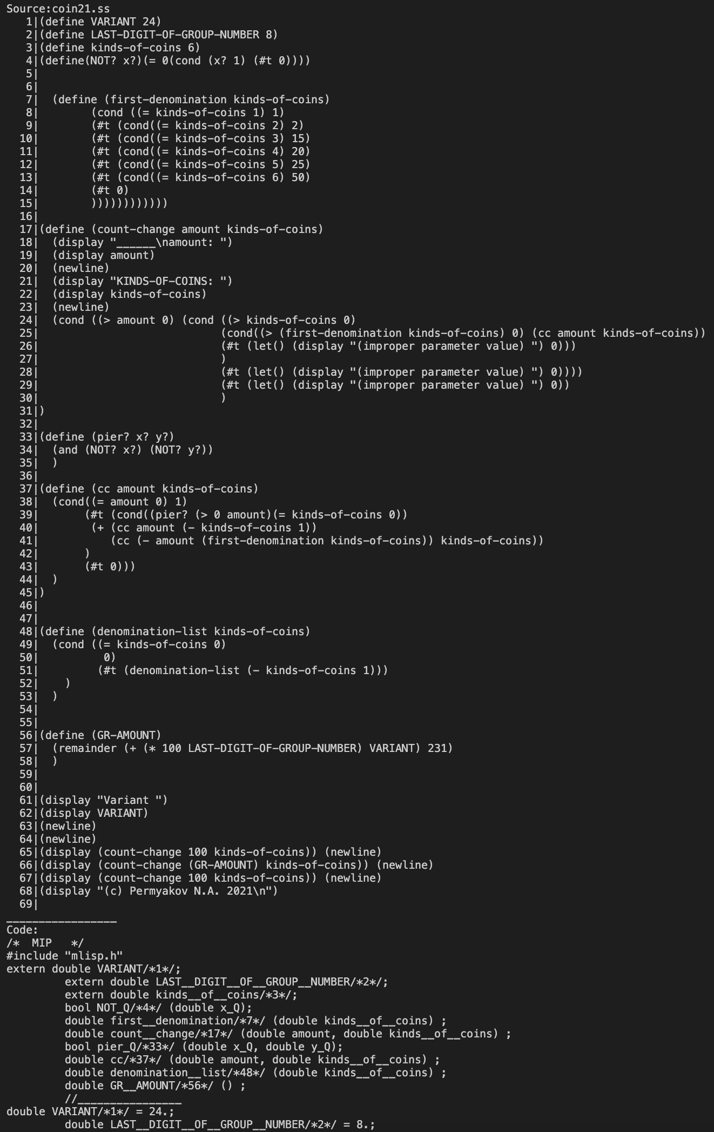

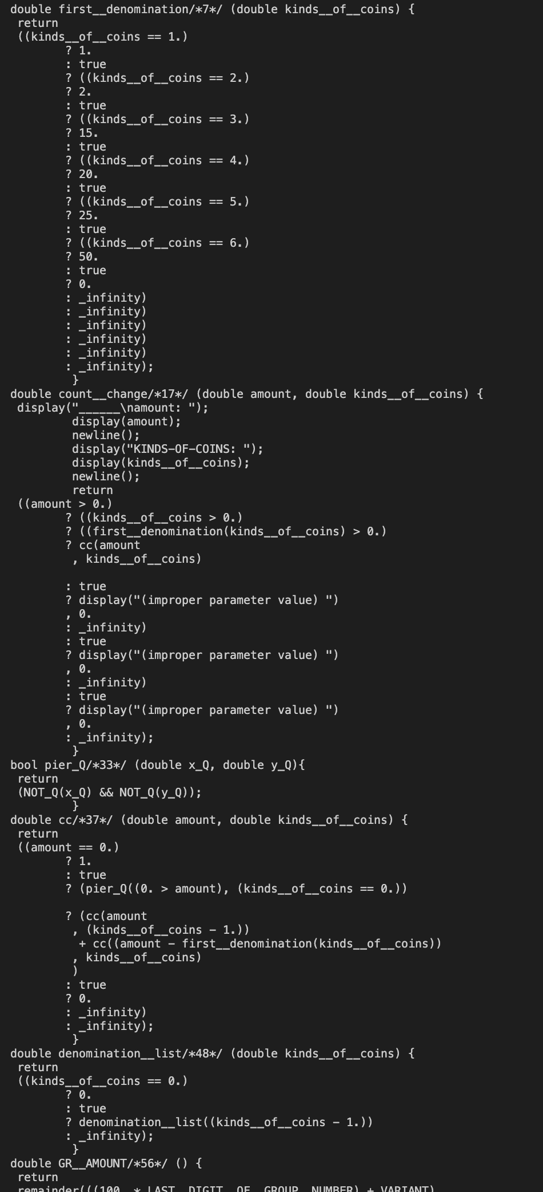
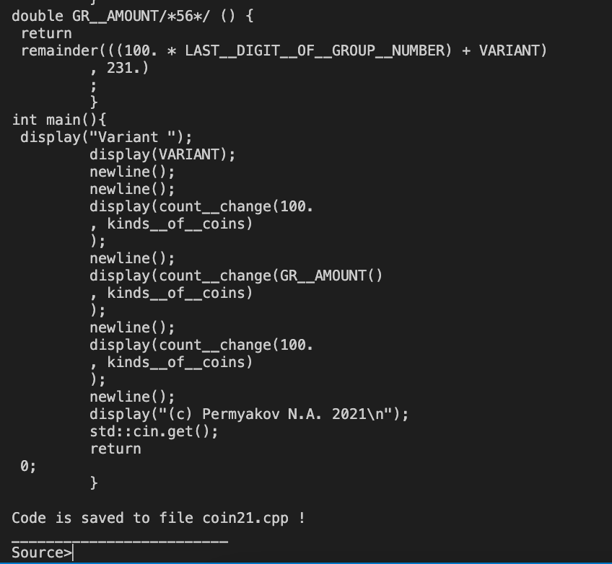

int tCG::p35() /* #t */ { // BOOL -> $bool
S1->obj = (S1->name == "#t" ? "true" : "false");
return 0;
}

Контрольная задача №1 – zeller.

Полный скриншот трансляции без трассировки (крупный белый шрифт на ярком черном фоне).
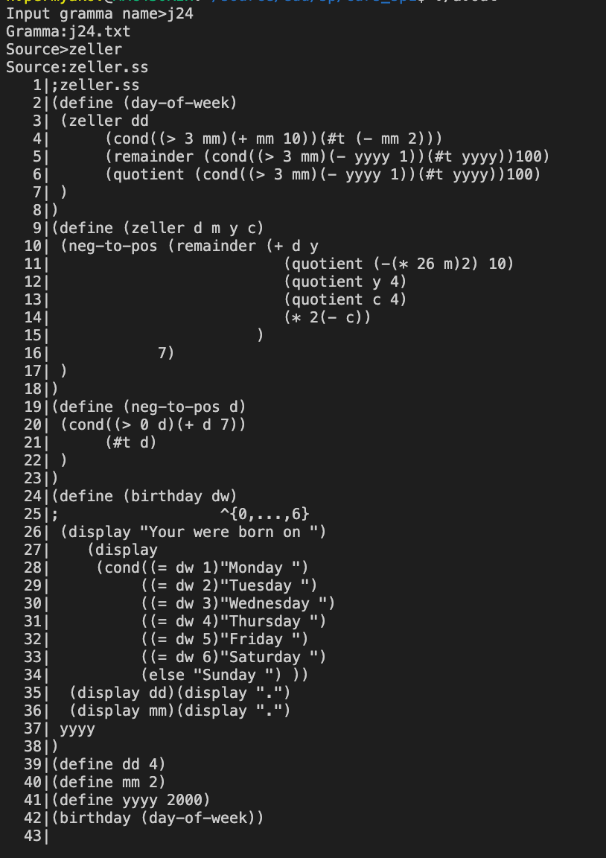
>
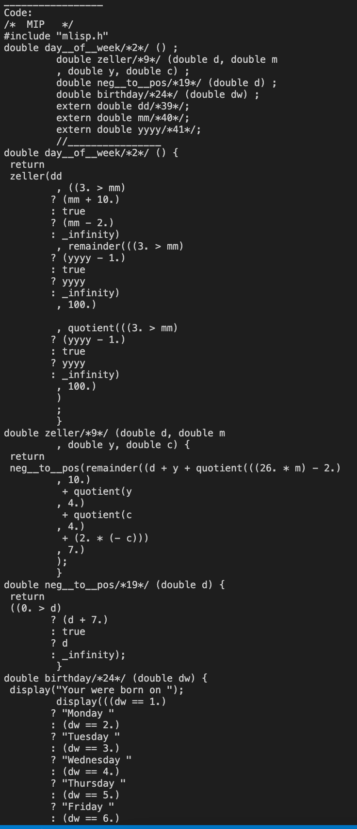

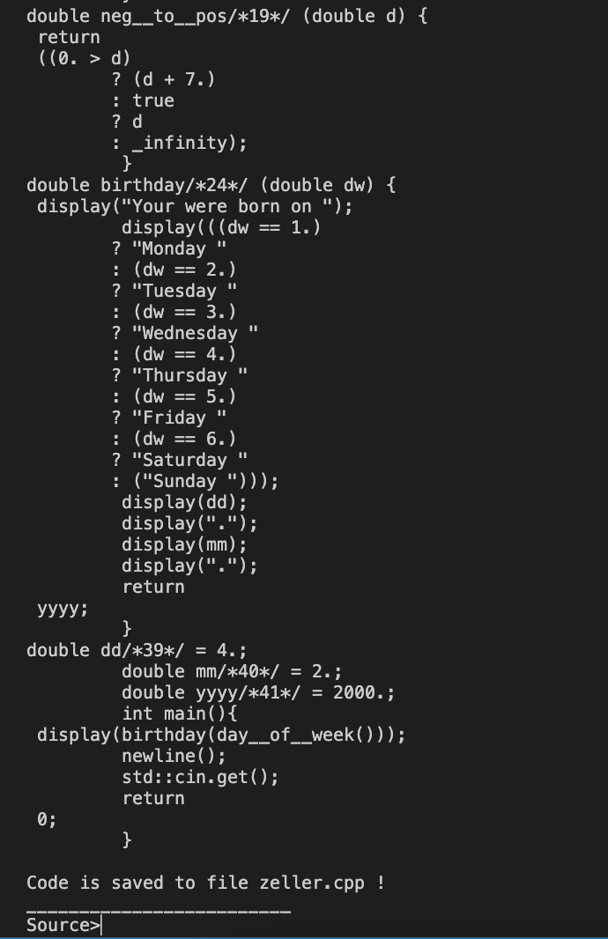
Распечатка файла zeller.cpp .
>/* MIP */
#include "mlisp.h"
double day__of__week/*2*/ () ;
double zeller/*9*/ (double d, double m
, double y, double c) ;
double neg__to__pos/*19*/ (double d) ;
double birthday/*24*/ (double dw) ;
extern double dd/*39*/;
extern double mm/*40*/;
extern double yyyy/*41*/;
//________________
double day__of__week/*2*/ () {
return
zeller(dd
, ((3. > mm)
? (mm + 10.)
: true
? (mm - 2.)
: _infinity)
, remainder(((3. > mm)
? (yyyy - 1.)
: true
? yyyy
: _infinity)
, 100.)

, quotient(((3. > mm)
? (yyyy - 1.)
: true
? yyyy
: _infinity)
, 100.)
)
;
}
double zeller/*9*/ (double d, double m
, double y, double c) {
return
neg__to__pos(remainder((d + y + quotient(((26. * m) - 2.)
, 10.)
+ quotient(y
, 4.)
+ quotient(c
, 4.)
+ (2. * (- c)))
, 7.)
);
}
double neg__to__pos/*19*/ (double d) {
return
((0. > d)
? (d + 7.)
: true
? d
: _infinity);
}
double birthday/*24*/ (double dw) {
display("Your were born on ");
display(((dw == 1.)
? "Monday "
: (dw == 2.)
? "Tuesday "
: (dw == 3.)
? "Wednesday "
: (dw == 4.)
? "Thursday "
: (dw == 5.)
? "Friday "
: (dw == 6.)
? "Saturday "
: ("Sunday ")));
display(dd);
display(".");
display(mm);
display(".");
return
yyyy;
}
double dd/*39*/ = 4.;
double mm/*40*/ = 2.;
double yyyy/*41*/ = 2000.;
int main(){
display(birthday(day__of__week()));
newline();
std::cin.get();
return
0;
}

Скриншот запуска задачи на С++.
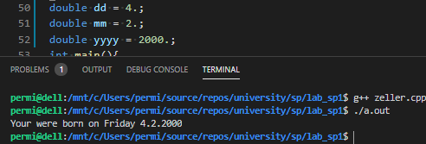
>

Контрольная задача №2 – golden21.

Полный скриншот трансляции без трассировки (крупный белый шрифт на ярком черном фоне).
>
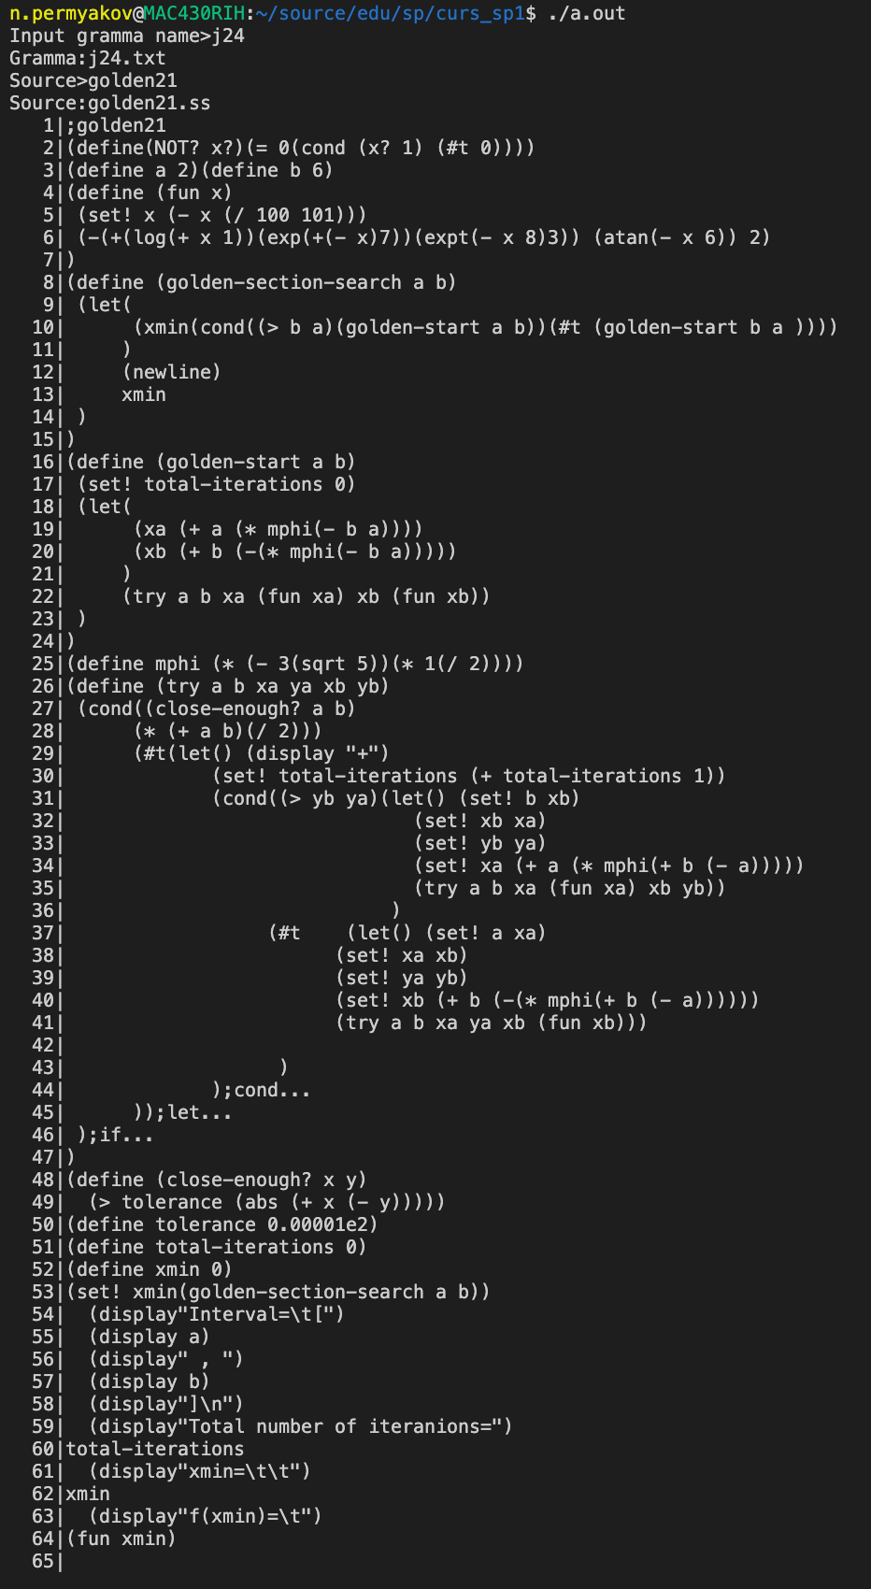

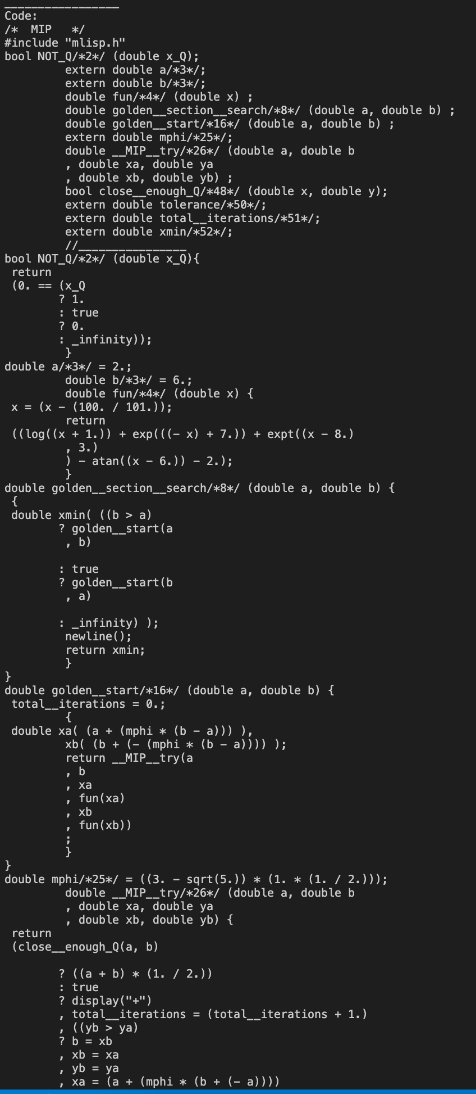
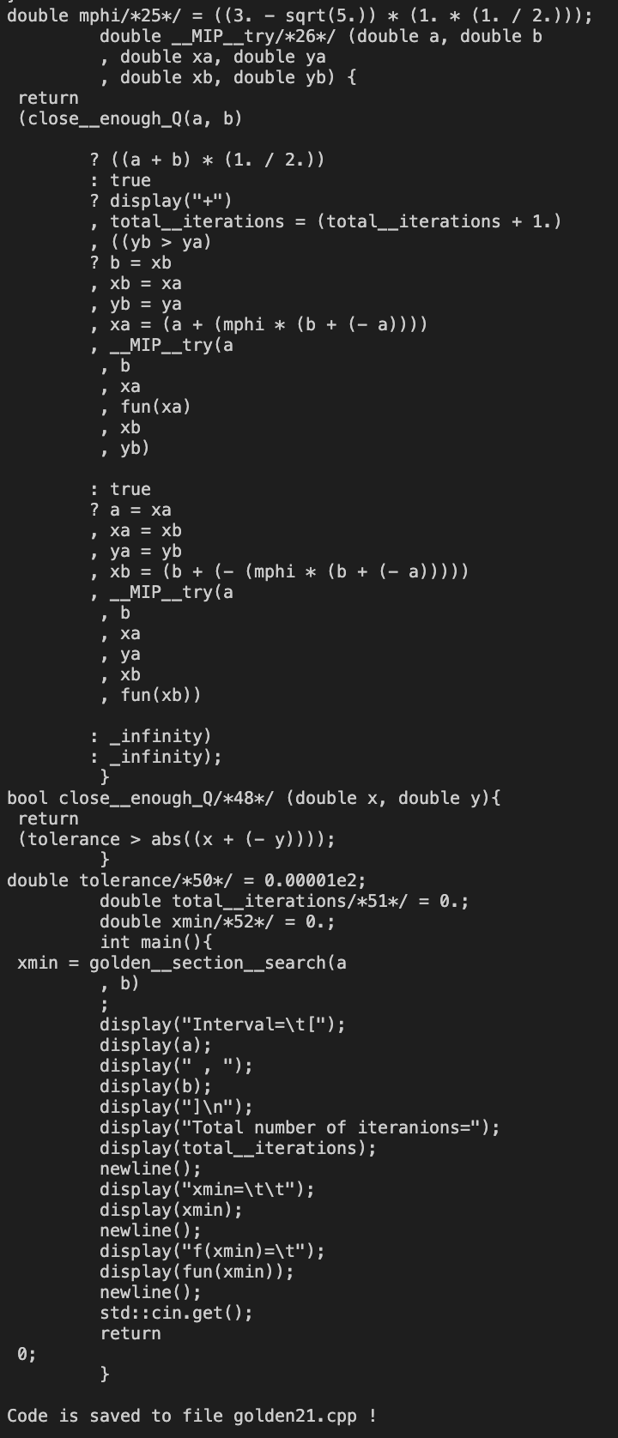

Распечатка файла golden21.cpp .
>/* MIP */
#include "mlisp.h"
bool NOT_Q/*2*/ (double x_Q);
extern double a/*3*/;
extern double b/*3*/;
double fun/*4*/ (double x) ;
double golden__section__search/*8*/ (double a, double b) ;
double golden__start/*16*/ (double a, double b) ;
extern double mphi/*25*/;
double __MIP__try/*26*/ (double a, double b
, double xa, double ya
, double xb, double yb) ;
bool close__enough_Q/*48*/ (double x, double y);
extern double tolerance/*50*/;
extern double total__iterations/*51*/;
extern double xmin/*52*/;
//________________
bool NOT_Q/*2*/ (double x_Q){
return
(0. == (x_Q
? 1.
: true
? 0.
: _infinity));
}
double a/*3*/ = 2.;
double b/*3*/ = 6.;
double fun/*4*/ (double x) {
x = (x - (100. / 101.));
return
((log((x + 1.)) + exp(((- x) + 7.)) + expt((x - 8.)
, 3.)
) - atan((x - 6.)) - 2.);
}
double golden__section__search/*8*/ (double a, double b) {
{
double xmin( ((b > a)
? golden__start(a
, b)

: true
? golden__start(b
, a)

: _infinity) );
newline();
return xmin;
}
}
double golden__start/*16*/ (double a, double b) {
total__iterations = 0.;
{
double xa( (a + (mphi * (b - a))) ),
xb( (b + (- (mphi * (b - a)))) );
return __MIP__try(a
, b
, xa
, fun(xa)
, xb
, fun(xb))
;
}
}
double mphi/*25*/ = ((3. - sqrt(5.)) * (1. * (1. / 2.)));
double __MIP__try/*26*/ (double a, double b
, double xa, double ya
, double xb, double yb) {
return
(close__enough_Q(a, b)

? ((a + b) * (1. / 2.))
: true
? display("+")
, total__iterations = (total__iterations + 1.)
, ((yb > ya)
? b = xb
, xb = xa
, yb = ya
, xa = (a + (mphi * (b + (- a))))
, __MIP__try(a
, b
, xa
, fun(xa)
, xb
, yb)

: true
? a = xa
, xa = xb
, ya = yb
, xb = (b + (- (mphi * (b + (- a)))))
, __MIP__try(a
, b
, xa
, ya
, xb
, fun(xb))

: _infinity)
: _infinity);
}
bool close__enough_Q/*48*/ (double x, double y){
return
(tolerance > abs((x + (- y))));
}
double tolerance/*50*/ = 0.00001e2;
double total__iterations/*51*/ = 0.;
double xmin/*52*/ = 0.;
int main(){
xmin = golden__section__search(a
, b)
;
display("Interval=\t[");
display(a);
display(" , ");
display(b);
display("]\n");
display("Total number of iteranions=");
display(total__iterations);
newline();
display("xmin=\t\t");
display(xmin);
newline();
display("f(xmin)=\t");
display(fun(xmin));
newline();
std::cin.get();
return
0;
}

Скриншот запуска задачи на С++.
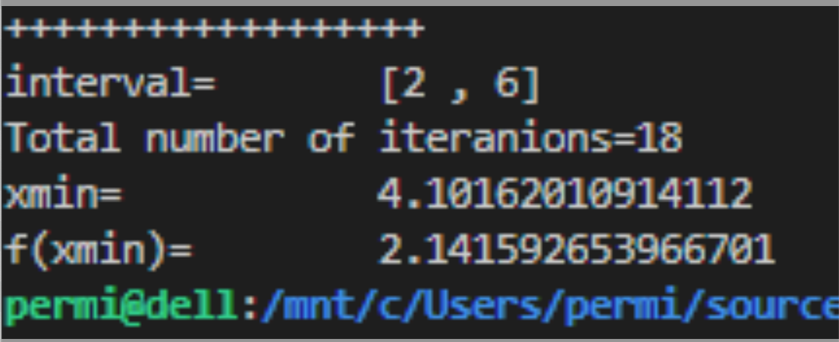
>

Контрольная задача №3 – coin21.

Полный скриншот трансляции без трассировки (крупный белый шрифт на ярком черном фоне).
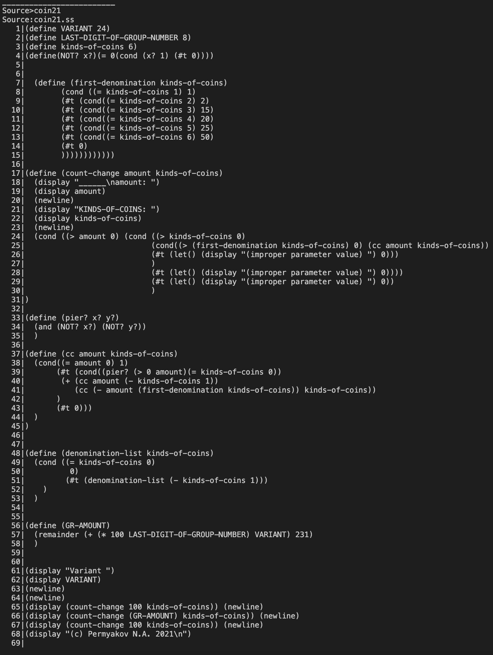
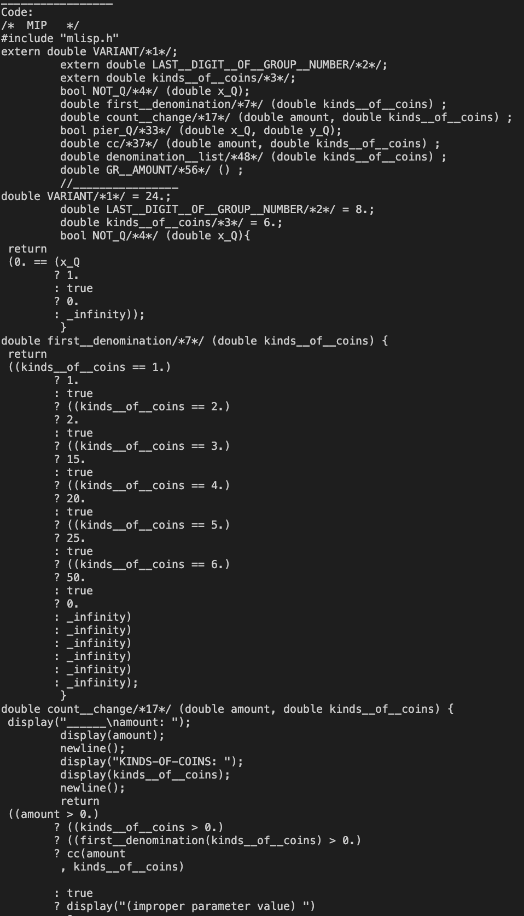
>
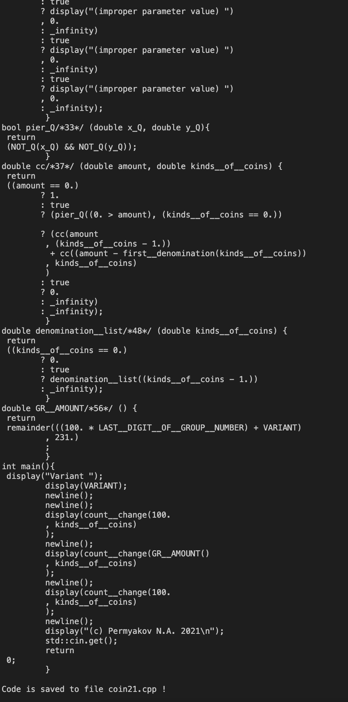

Распечатка файла coin21.cpp .
>/* MIP */
#include "mlisp.h"
extern double VARIANT/*1*/;
extern double LAST__DIGIT__OF__GROUP__NUMBER/*2*/;
extern double kinds__of__coins/*3*/;
bool NOT_Q/*4*/ (double x_Q);
double first__denomination/*7*/ (double kinds__of__coins) ;
double count__change/*17*/ (double amount, double kinds__of__coins) ;
bool pier_Q/*33*/ (double x_Q, double y_Q);
double cc/*37*/ (double amount, double kinds__of__coins) ;
double denomination__list/*48*/ (double kinds__of__coins) ;
double GR__AMOUNT/*56*/ () ;
//________________
double VARIANT/*1*/ = 24.;
double LAST__DIGIT__OF__GROUP__NUMBER/*2*/ = 8.;
double kinds__of__coins/*3*/ = 6.;
bool NOT_Q/*4*/ (double x_Q){
return
(0. == (x_Q
? 1.
: true
? 0.
: _infinity));
}
double first__denomination/*7*/ (double kinds__of__coins) {
return
((kinds__of__coins == 1.)
? 1.
: true
? ((kinds__of__coins == 2.)
? 2.
: true
? ((kinds__of__coins == 3.)
? 15.
: true
? ((kinds__of__coins == 4.)
? 20.
: true
? ((kinds__of__coins == 5.)
? 25.
: true
? ((kinds__of__coins == 6.)
? 50.
: true
? 0.
: _infinity)
: _infinity)
: _infinity)
: _infinity)
: _infinity)
: _infinity);
}
double count__change/*17*/ (double amount, double kinds__of__coins) {
display("______\namount: ");
display(amount);
newline();
display("KINDS-OF-COINS: ");
display(kinds__of__coins);
newline();
return
((amount > 0.)
? ((kinds__of__coins > 0.)
? ((first__denomination(kinds__of__coins) > 0.)
? cc(amount
, kinds__of__coins)

: true
? display("(improper parameter value) ")
, 0.
: _infinity)
: true
? display("(improper parameter value) ")
, 0.
: _infinity)
: true
? display("(improper parameter value) ")
, 0.
: _infinity);
}
bool pier_Q/*33*/ (double x_Q, double y_Q){
return
(NOT_Q(x_Q) && NOT_Q(y_Q));
}
double cc/*37*/ (double amount, double kinds__of__coins) {
return
((amount == 0.)
? 1.
: true
? (pier_Q((0. > amount), (kinds__of__coins == 0.))

? (cc(amount
, (kinds__of__coins - 1.))
+ cc((amount - first__denomination(kinds__of__coins))
, kinds__of__coins)
)
: true
? 0.
: _infinity)
: _infinity);
}
double denomination__list/*48*/ (double kinds__of__coins) {
return
((kinds__of__coins == 0.)
? 0.
: true
? denomination__list((kinds__of__coins - 1.))
: _infinity);
}
double GR__AMOUNT/*56*/ () {
return
remainder(((100. * LAST__DIGIT__OF__GROUP__NUMBER) + VARIANT)
, 231.)
;
}
int main(){
display("Variant ");
display(VARIANT);
newline();
newline();
display(count__change(100.
, kinds__of__coins)
);
newline();
display(count__change(GR__AMOUNT()
, kinds__of__coins)
);
newline();
display(count__change(100.
, kinds__of__coins)
);
newline();
display("(c) Permyakov N.A. 2021\n");
std::cin.get();
return
0;
}

Скриншот запуска задачи на С++.
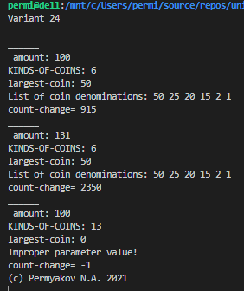
>

Распечатка файла code-gen.cpp.
>
/* $j24 */
#include "code-gen.h"
using namespace std;
void tCG::init(){declarations.clear();
Authentication = "MIP";
}

int tCG::p01(){ // S -> PROG
string header ="/* " + Authentication +" */\n";
header += "#include \"mlisp.h\"\n";
header += declarations;
header += "//________________ \n";
S1->obj = header + S1->obj;
return 0;
}

int tCG::p02(){ // PROG -> CALCS
S1->obj = "int main(){\n " + S1->obj + "std::cin.get();\n\t return\n 0;\n\t }\n";
return 0;
}

int tCG::p03(){ // PROG -> DEFS
S1->obj += "int main(){\n "
"display(\"No calculations!\");\n\t newline();\n\t "
"std::cin.get();\n\t return\n 0;\n\t }\n";
return 0;
}

int tCG::p04(){ // PROG -> DEFS CALCS
S1->obj += "int main(){\n " + S2->obj + "std::cin.get();\n\t return\n 0;\n\t }\n";
return 0;
}

int tCG::p05(){ // E -> $id
S1->obj = decor(S1->name);
return 0;
}

int tCG::p06(){ // E -> $int
S1->obj = S1->name + ".";
return 0;
}

int tCG::p07(){ // E -> $dec
S1->obj = S1->name;
return 0;
}

int tCG::p08(){ // E -> AREX
return 0;
}

int tCG::p09(){ // E -> COND
return 0;
}

int tCG::p10(){ // E -> EASYLET
return 0;
}

int tCG::p11(){ // E -> CPROC
return 0;
}

int tCG::p12(){ // EASYLET -> HEASYL E )
if(S1->count != 0){
S1->obj +=S2->obj + ";\n\t";
}
S1->obj +=S2->obj;
++(S1->count);
return 0;
}

int tCG::p13(){ // HEASYL -> ( let ( )
return 0;
}

int tCG::p14(){ // HEASYL -> HEASYL INTER
S1->obj += S2->obj + "\n\t, ";
return 0;
}

int tCG::p15(){ // AREX -> HAREX E )
if (S1->name == "/" && S1->count == 0) {
S1->obj = "(1. " + S1->obj + " " + S2->obj + ")";
}
else {
S1->obj = "(" + S1->obj + " " + S2->obj + ")";
}
return 0;
}

int tCG::p16(){ // HAREX -> ( AROP
S1->obj = S2->obj;
S1->name = S2->name;
return 0;
}

int tCG::p17(){ // HAREX -> HAREX E
if (S1->count == 0)
S1->obj = S2->obj + " " + S1->name;
else
S1->obj = S1->obj + " " + S2->obj + " " + S1->name;
++S1->count;
return 0;
}

int tCG::p18(){ // AROP -> +
S1->obj = S1->name;
return 0;
}

int tCG::p19(){ // AROP -> -
S1->obj = S1->name;
return 0;
}

int tCG::p20(){ // AROP -> *
S1->obj = S1->name;
return 0;
}

int tCG::p21(){ // AROP -> /
S1->obj = S1->name;
return 0;
}

int tCG::p22(){ // CPROC -> HCPROC )
S1->obj += ")";
if (S1->count >= 2) {
S1->obj += "\n\t ";
}
return 0;
}

int tCG::p23(){ // HCPROC -> ( $id
S1->obj = decor(S2->name) + "(";
return 0;
}

int tCG::p24(){ // HCPROC -> HCPROC E
if (S1->count) {
S1->obj += "\n\t , ";
}
S1->obj += S2->obj;
++S1->count;
return 0;
}

int tCG::p25(){ // COND -> ( cond BRANCHES )
S1->obj = "(" + S3->obj + "_infinity)";
return 0;
}

int tCG::p26(){ // BRANCHES -> CLAUS CLAUS
S1->obj += S2->obj;
return 0;
}

int tCG::p27(){ // CLAUS -> ( BOOL E )
S1->obj += S2->obj + "\n\t? " + S3->obj + "\n\t: ";
return 0;
}

int tCG::p28(){ // STR -> $str
S1->obj = S1->name;
return 0;
}

int tCG::p29(){ // STR -> SCOND
return 0;
}

int tCG::p30(){ // SCOND -> ( cond SBRANCHES )
S1->obj = "(" + S3->obj + ")";
return 0;
}

int tCG::p31(){ // SBRANCHES -> SELSE
return 0;
}

int tCG::p32(){ // SBRANCHES -> SCLAUS SBRANCHES
S1->obj += S2->obj;
return 0;
}

int tCG::p33(){ // SCLAUS -> ( BOOL STR )
S1->obj += S2->obj + "\n\t? " + S3->obj + "\n\t: ";
return 0;
}

int tCG::p34(){ // SELSE -> ( else STR )
S1->obj += "(" + S3->obj + ")";
return 0;
}

int tCG::p35(){ // BOOL -> $bool
S1->obj = (S1->name == "#t" ? "true" : "false");
return 0;
}

int tCG::p36(){ // BOOL -> $idq
S1->obj = decor(S1->name);
return 0;
}

int tCG::p37(){ // BOOL -> REL
return 0;
}

int tCG::p38(){ // BOOL -> AND
return 0;
}

int tCG::p39(){ // BOOL -> CPRED
return 0;
}

int tCG::p40(){ // CPRED -> HCPRED )
S1->obj += ")";
if (S1->count >= 2) {
S1->obj += "\n\t ";
}
return 0;
}

int tCG::p41(){ // HCPRED -> ( $idq
S1->obj = decor(S2->name) + "(";
return 0;
}

int tCG::p42(){ // HCPRED -> HCPRED ARG
if (S1->count) {
S1->obj += S1->count % 2 ? ", " : "\n\t , ";
}
S1->obj += S2->obj;
++S1->count;
return 0;
}

int tCG::p43(){ // ARG -> E
return 0;
}

int tCG::p44(){ // ARG -> BOOL
return 0;
}

int tCG::p45(){ // REL -> ( = E E )
S1->obj = "(" + S3->obj + " == " + S4->obj + ")";
return 0;
}

int tCG::p46(){ // REL -> ( > E E )
S1->obj = "(" + S3->obj + " > " + S4->obj + ")";
return 0;
}

int tCG::p47(){ // AND -> HAND BOOL )
S1->obj = "(" + S1->obj + S2->obj + ")";
return 0;
}

int tCG::p48(){ // HAND -> ( and
return 0;
}

int tCG::p49(){ // HAND -> HAND BOOL
S1->obj += S2->obj + " && ";
return 0;
}

int tCG::p50(){ // SET -> HSET E )
S1->obj += S2->obj;
return 0;
}

int tCG::p51(){ // HSET -> ( set! $id
S1->obj = decor(S3->name) + " = ";
return 0;
}

int tCG::p52(){ // DISPSET -> ( display E )
S1->obj = "display(" + S3->obj + ")";
return 0;
}

int tCG::p53(){ // DISPSET -> ( display BOOL )
S1->obj = "display(" + S3->obj + ")";
return 0;
}

int tCG::p54(){ // DISPSET -> ( display STR )
S1->obj = "display(" + S3->obj + ")";
return 0;
}

int tCG::p55(){ // DISPSET -> ( newline )
S1->obj = "newline()";
return 0;
}

int tCG::p56(){ // DISPSET -> SET
return 0;
}

int tCG::p57(){ // INTER -> DISPSET
return 0;
}

int tCG::p58(){ // INTER -> E
return 0;
}

int tCG::p59(){ // CALCS -> CALC
return 0;
}

int tCG::p60(){ // CALCS -> CALCS CALC
S1->obj += S2->obj;
return 0;
}

int tCG::p61(){ // CALC -> E
S1->obj = "display(" + S1->obj + ");\n\t newline();\n\t ";
return 0;
}

int tCG::p62(){ // CALC -> BOOL
S1->obj = "display(" + S1->obj + ");\n\t newline();\n\t ";
return 0;
}

int tCG::p63(){ // CALC -> STR
S1->obj = "display(" + S1->obj + ");\n\t newline();\n\t ";
return 0;
}

int tCG::p64(){ // CALC -> DISPSET
S1->obj += ";\n\t ";
return 0;
}

int tCG::p65(){ // DEFS -> DEF
return 0;
}

int tCG::p66(){ // DEFS -> DEFS DEF
S1->obj += S2->obj;
return 0;
}

int tCG::p67(){ // DEF -> PRED
return 0;
}

int tCG::p68(){ // DEF -> VAR
return 0;
}

int tCG::p69(){ // DEF -> PROC
return 0;
}

int tCG::p70(){ // PRED -> HPRED BOOL )
S1->obj += "return\n " + S2->obj + ";\n\t }\n";
return 0;
}

int tCG::p71(){ // HPRED -> PDPAR )
S1->obj += ")";
declarations += S1->obj + ";\n\t ";
S1->obj += "{\n ";
return 0;
}

int tCG::p72(){ // PDPAR -> ( define ( $idq
S1->obj = "bool " + decor(S4->name) + "/*" + S4->line + "*/ (";
S1->count = 0;
return 0;
}

int tCG::p73(){ // PDPAR -> PDPAR $idq
if (S1->count) {
S1->obj += S1->count % 2 ? ", " : "\n\t , ";
}
S1->obj += "double " + decor(S2->name);
++S1->count;
return 0;
}

int tCG::p74(){ // PDPAR -> PDPAR $id
if (S1->count) {
S1->obj += S1->count % 2 ? ", " : "\n\t , ";
}
S1->obj += "double " + decor(S2->name);
++S1->count;
return 0;
}

int tCG::p75(){ // VAR -> VARDCL E )
declarations += "extern double " + S1->obj + "/*" + S1->line + "*/;\n\t ";
S1->obj = "double " + S1->obj + "/*" + S1->line + "*/ = " + S2->obj + ";\n\t ";
return 0;
}

int tCG::p76(){ // VARDCL -> ( define $id
S1->obj = decor(S3->name);
return 0;
}

int tCG::p77(){ // PROC -> HPROC BLOCK )
S1->obj += S2->obj + "}\n";
return 0;
}

int tCG::p78(){ // PROC -> HPROC E )
S1->obj += "return\n " + S2->obj + ";\n\t }\n";
return 0;
}

int tCG::p79(){ // HPROC -> PCPAR )
S1->obj += ") ";
declarations += S1->obj + ";\n\t ";
S1->obj += "{\n ";
return 0;
}

int tCG::p80(){ // HPROC -> HPROC INTER
S1->obj += S2->obj + ";\n\t ";
return 0;
}

int tCG::p81(){ // PCPAR -> ( define ( $id
S1->obj = "double " + decor(S4->name) + "/*" + S4->line + "*/ (";
S1->count = 0;
S1->name = S4->name;
return 0;
}

int tCG::p82(){ // PCPAR -> PCPAR $id
if (S1->count) {
S1->obj += S1->count % 2 ? ", " : "\n\t , ";
}
S1->obj += "double " + decor(S2->name);
++S1->count;
return 0;
}

int tCG::p83(){ // BLOCK -> HBLOCK E )
S1->obj += "return " + S2->obj +";\n\t }\n";
return 0;
}

int tCG::p84(){ // HBLOCK -> BLVAR )
S1->obj += ";\n\t ";
return 0;
}

int tCG::p85(){ // HBLOCK -> HBLOCK INTER
S1->obj += S2->obj + ";\n\t ";
return 0;
}

int tCG::p86(){ // BLVAR -> ( let ( LOCDEF
S1->obj += "{\n double " + S4->obj;
return 0;
}

int tCG::p87(){ // BLVAR -> BLVAR LOCDEF
S1->obj += ",\n\t " + S2->obj;
return 0;
}

int tCG::p88(){ // LOCDEF -> ( $id E )
S1->obj += decor(S2->name) + "( " + S3->obj + " )";
return 0;
}

