**BMS COLLEGE OF ENGINEERING**

**(Autonomous College under VTU)**

**MASTER OF COMPUTER APPLICATIONS**



**REPORT ON:**

Advance Web Programming

**SUBMITTED BY:**

**Ananya Arya : 1BM19MCA03**

**K P Swathi : 1BM19MCA20**

**Birajdar Nikita Shivaji :1BM19MCA29**

**UNDER THE GUIDANCE OF:**

**Padmapriya V**

**ACKNOWLEDGMENT**

We heartily acknowledge **Padmapriya V mam,**for providing us with this opportunity and for supporting throughout our Endeavour. We take this opportunity to express our special gratitude to our course instructor, **Padmapriya v** mam, who has always been supportive and has guided us in completing our report. We are very much thankful for the immense help and moral support.

**Ananya arya**

**Kp swathi**

**Birajdar Nikita Shivaji**

**CONTENTS**

|  |  |
| --- | --- |
| **SL.NO** | **TITLE** |
|  | **Ideation-phase-1** |
|  | **Ideation-phase-2** |
|  | **Ideation-phase-3** |

IDEATION PHASE – I

**TITLE: “STUDENT MART “**

**INTRODUCTION:**

Studentmart is basically a web Application which focuses only on BMSCE students,

Students generally who stay in PG or hostels face trouble in selling their old books and furniture& like study table and mattresses while vacating their pg/hostel .

sites like OLX and QUIKR are generally for commercial use and it & hard to find visibility and buyers for students.

So, student mart can be very helpful for final Students who want to sell/donate their books or furniture & to their junior’s by directly contacting them without any hassle instead of posting on multiple what’s app group they have to just post on a single platform any interested junior can see the request and contact the seller student. Since it focuses only on BMSCE students there will be no delivery charges the buyer can directly take its items from college/PG (buyers).

**EXPECTED LIST OF FEATURE:**

1. User can buy the products.

2. User can sell the products .

3. User can donate books or any other products.

4. User can view the products.

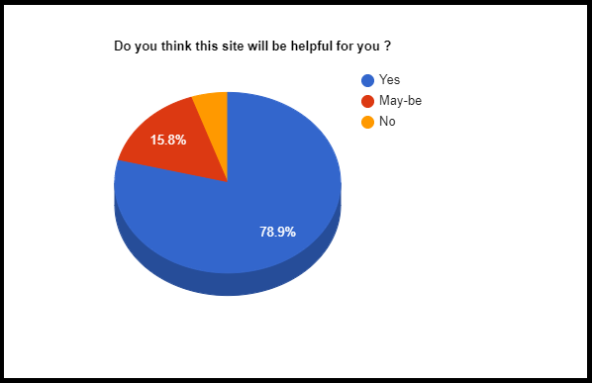**MARKET SURVEY:**

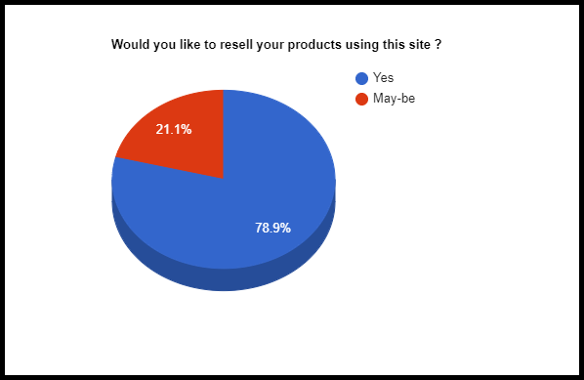

IDEATION PHASE - II (WIREFRAME)

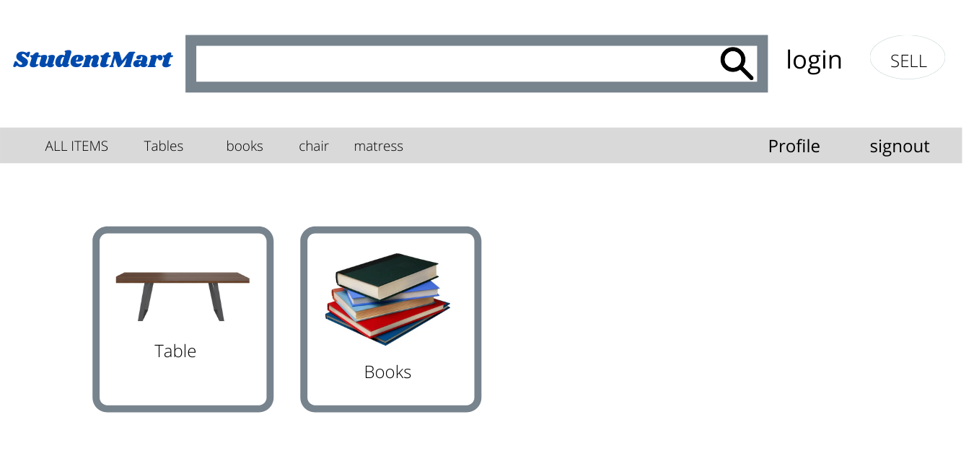

**Fig1:studentmart_homepage**

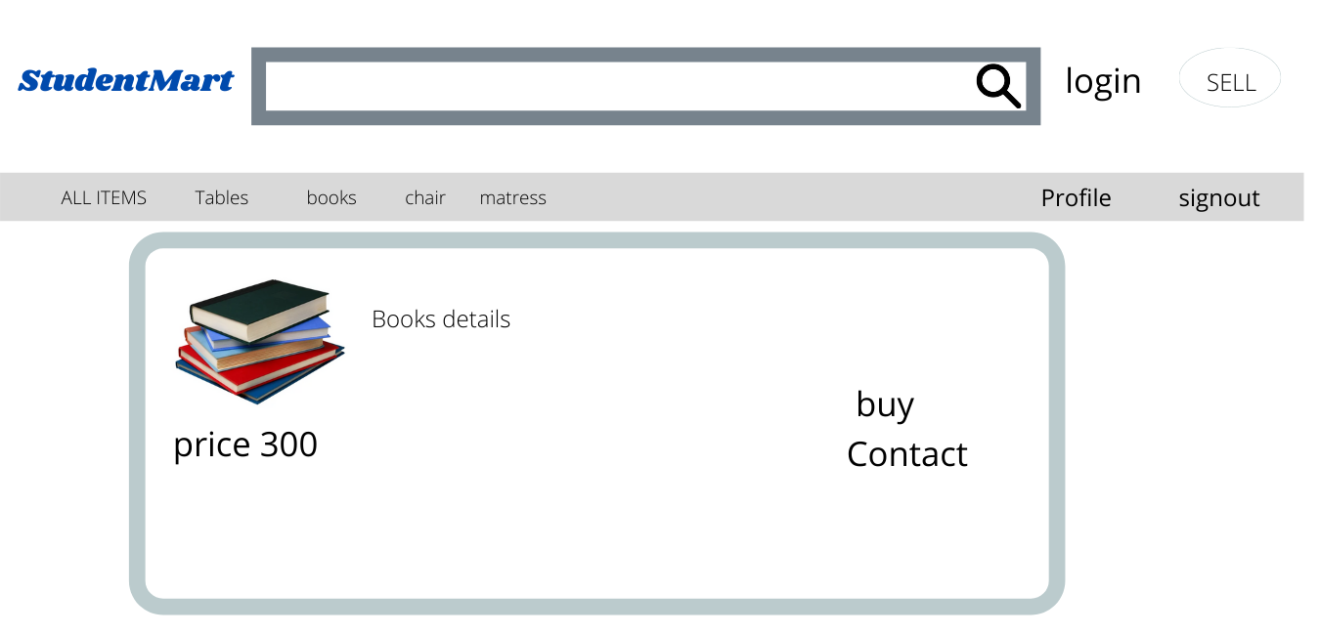

**Fig2:studentmart_productdetails**

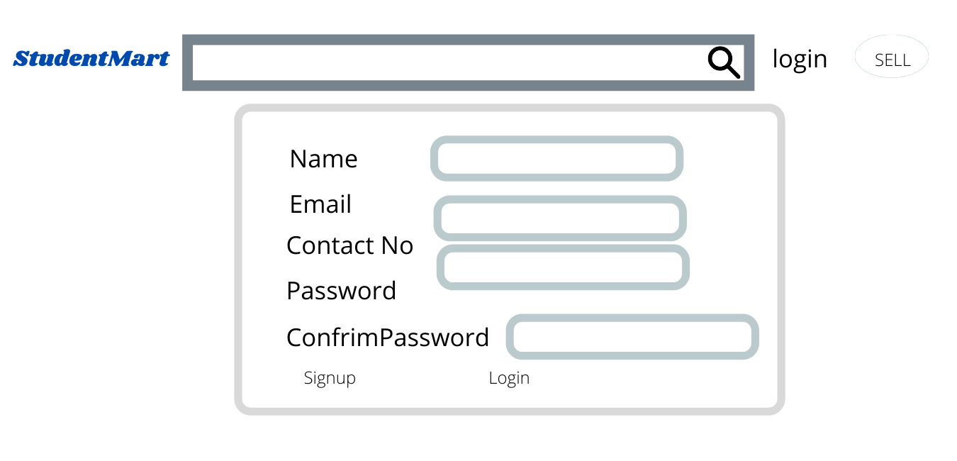

**Fig3:studentmart_signuppage**

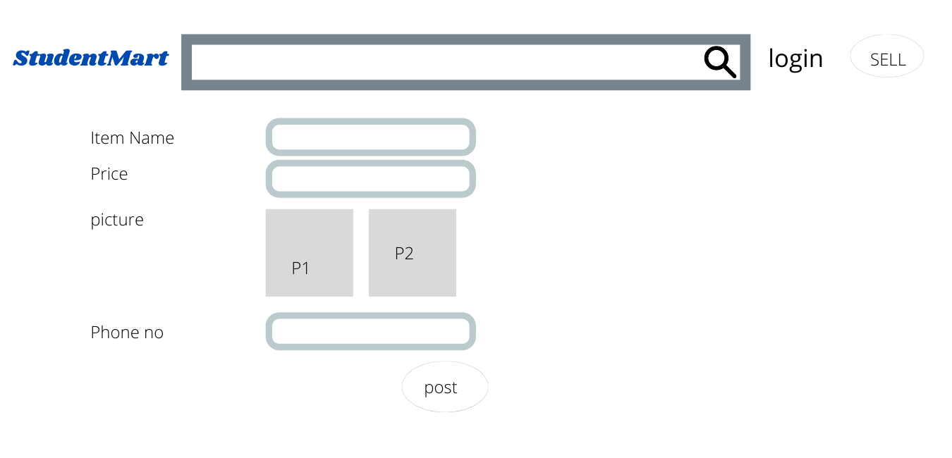

**Fig4:studentmart_productupload**

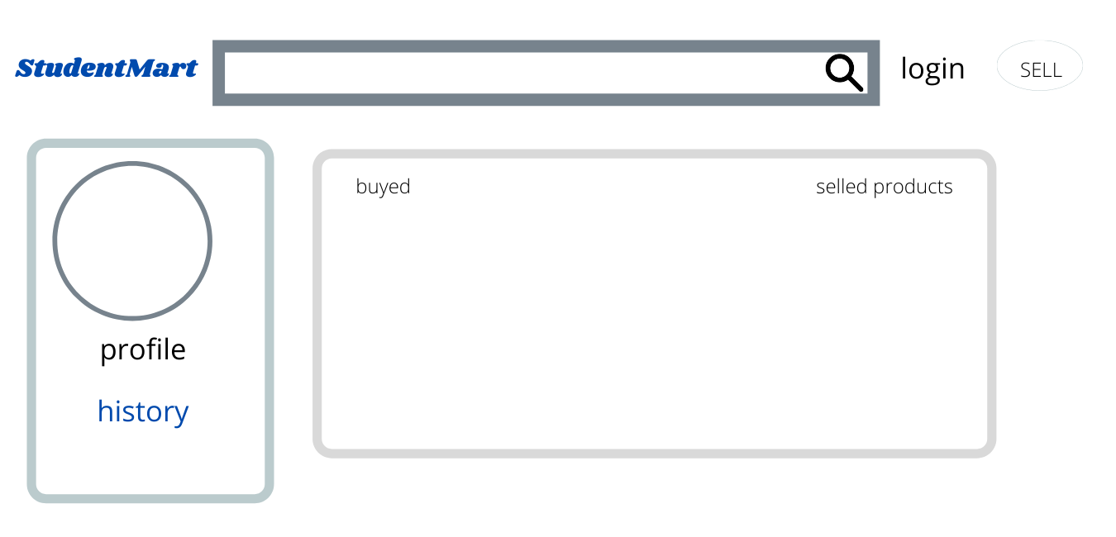

**Fig5:sudentmart_profilepage**

IDEATION PHASE - III (Screen Shots)

**Admin Dashboard**

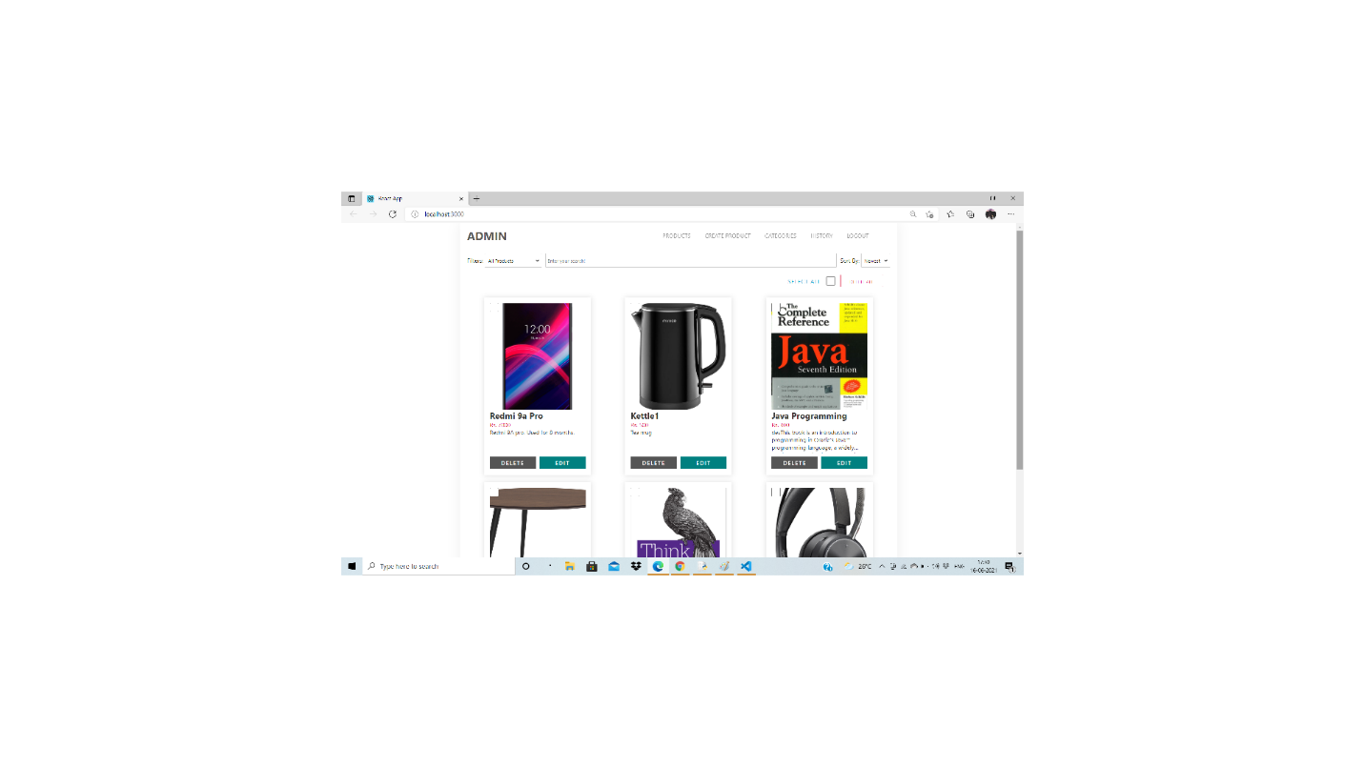

**Create Product :**

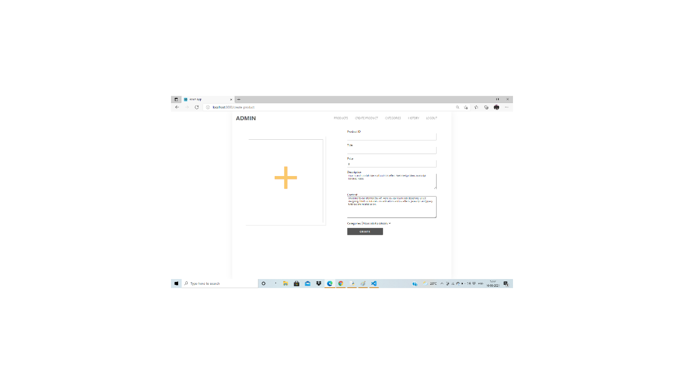

**Create Category**

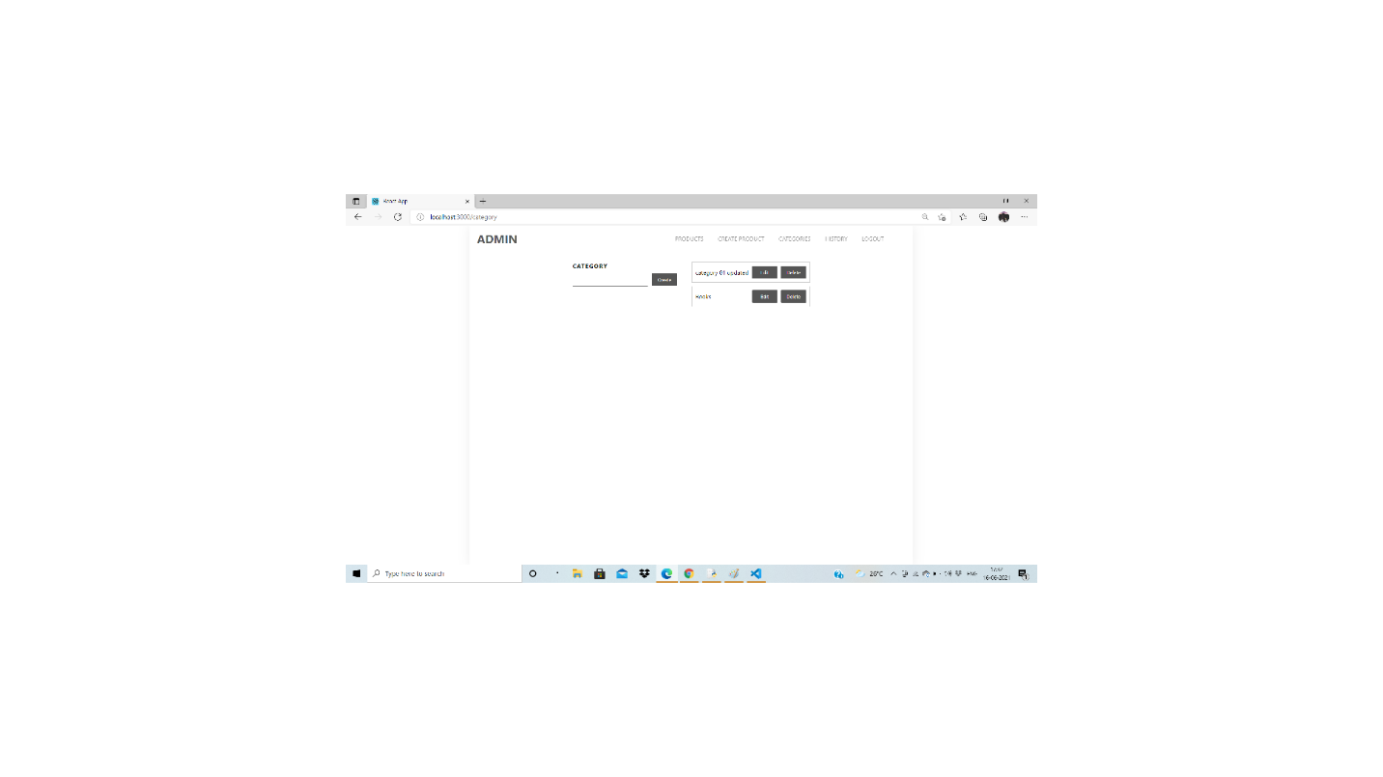

**Student Mart :**

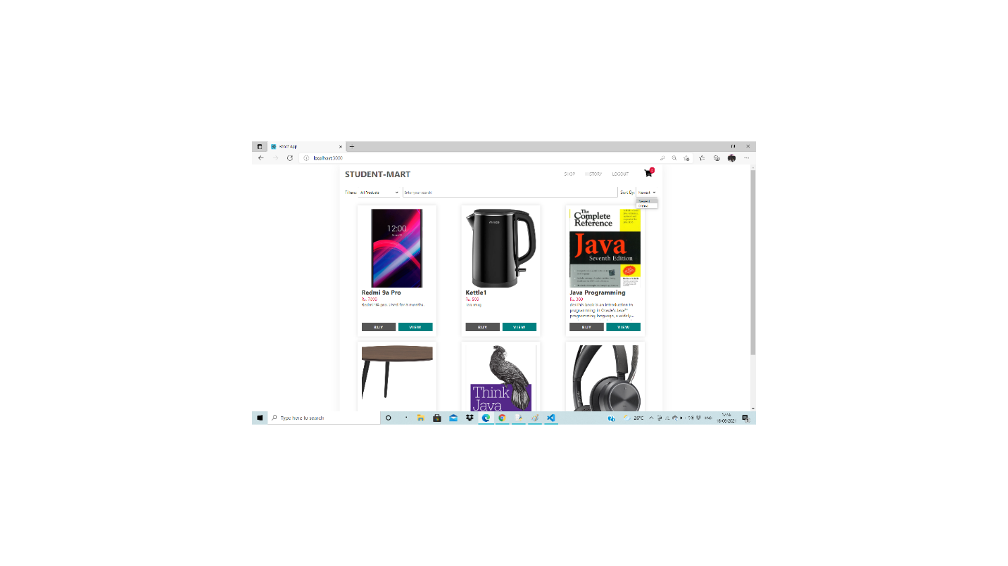

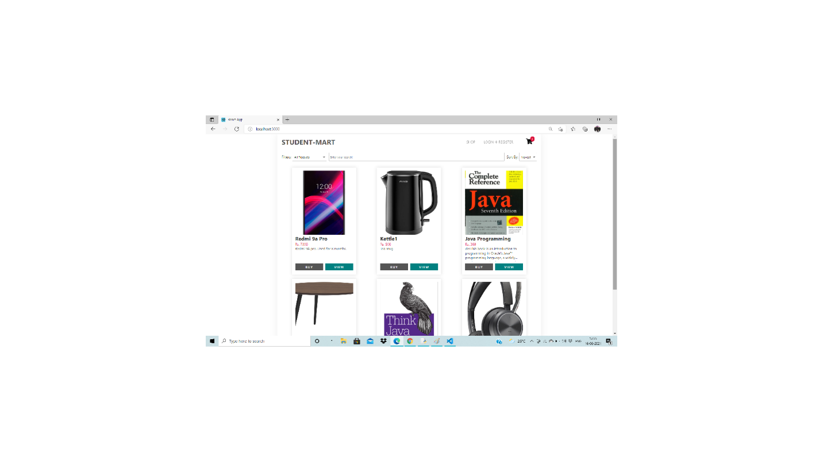

**History:**

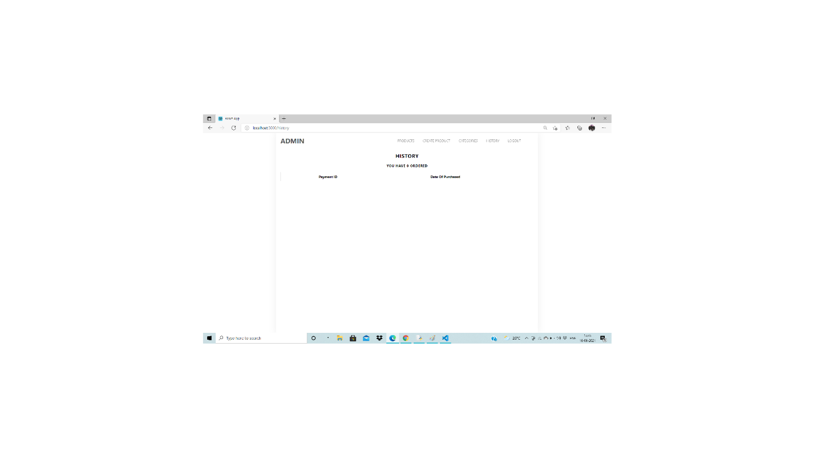

**Database:**

