**AWT LAB-TASK(03-09)**

Task: Nodejs using MySQL database

Tools: XAMPP MySQL server , MySQL-workbench and vs code

Code:

// npm install mysql and npm i express

const express =require('express')

const mysql=require('mysql')

const app=express()

//Create DB connection

//Create Database

//Create Table

//Insert Record

//Display Record => SELECT * from studentInfo

const connection = mysql.createConnection({

    host: 'localhost',

    user:'root',

    password:'',

    database:'University'

});

connection.connect((err)=>{

    if(err) throw err;

    console.log("Connected successfully to MySql server")

});

//db-create => create Database

app.get("/db-create", (req,res)=>{

    const dbquery="CREATE DATABASE IF NOT EXISTS University";

    connection.query(dbquery,(err,result)=>{

        if(err) throw err;

        console.log("Database created successfully",result)

    })

});

//db-table => Create Table in University DB

app.get("/db-table", (req,res)=>{

    const dbtable=`CREATE TABLE IF NOT EXISTS studentInfo(

        studentID varchar(10) NOT NULL,

        fname varchar(50) NOT NULL,

        lname varchar(50) NOT NULL,

        mobileNo varchar(15) NOT NULL,

        PRIMARY KEY (studentID))`

        // SHOW DATABASES => List the available DB from MySql server

    // connection.query("USE University",(err,result)=>{ // "Select Database"

    //     if(err) throw err;

        connection.query(dbtable,(err,result)=>{

            if(err) throw err;

            console.log("Table created successfully",result)

        });

    // });

});

//db-insert => Insert Record into studentInfo Table

app.get("/db-insert", (req,res)=>{

    const dbInsert=`INSERT INTO studentInfo

    (studentID,fname,lname,mobileNo)

    VALUES ('102','Mrugendra','Rahevar','123456789'),

    ('103','Martin','Parmar','123456789'),

    ('104','Vraj','Shah','123456789')`;

    connection.query(dbInsert,(err,result)=>{

        if(err) throw err;

        console.log(`Total affected ROWS: ${result['affectedRows']}`)

    })

});

app.get("/db-display", (req,res)=>{

    const dbdisplay=`SELECT * FROM studentInfo`

    connection.query(dbdisplay,(err,rows)=>{

        if(err) throw err;

        console.log('Data received');

        console.log(rows);

        console.log('------------------------------------')

        console.log(`Data : \n

        studentId \tfirstname \tlastname \tmobileno \n`);

        for (let index = 0; index < rows.length; index++) {

            let id = rows[index].studentID;

            let fname = rows[index].fname;

            let lname = rows[index].lname;

            let mobileNo = rows[index].mobileNo;

        console.log(`

        ${id} \t\t ${fname} \t ${lname} \t ${mobileNo} \n `);

        }

        })

});

app.listen(3000,()=>{

    console.log("Server is running on port number 3000")

})

Output:

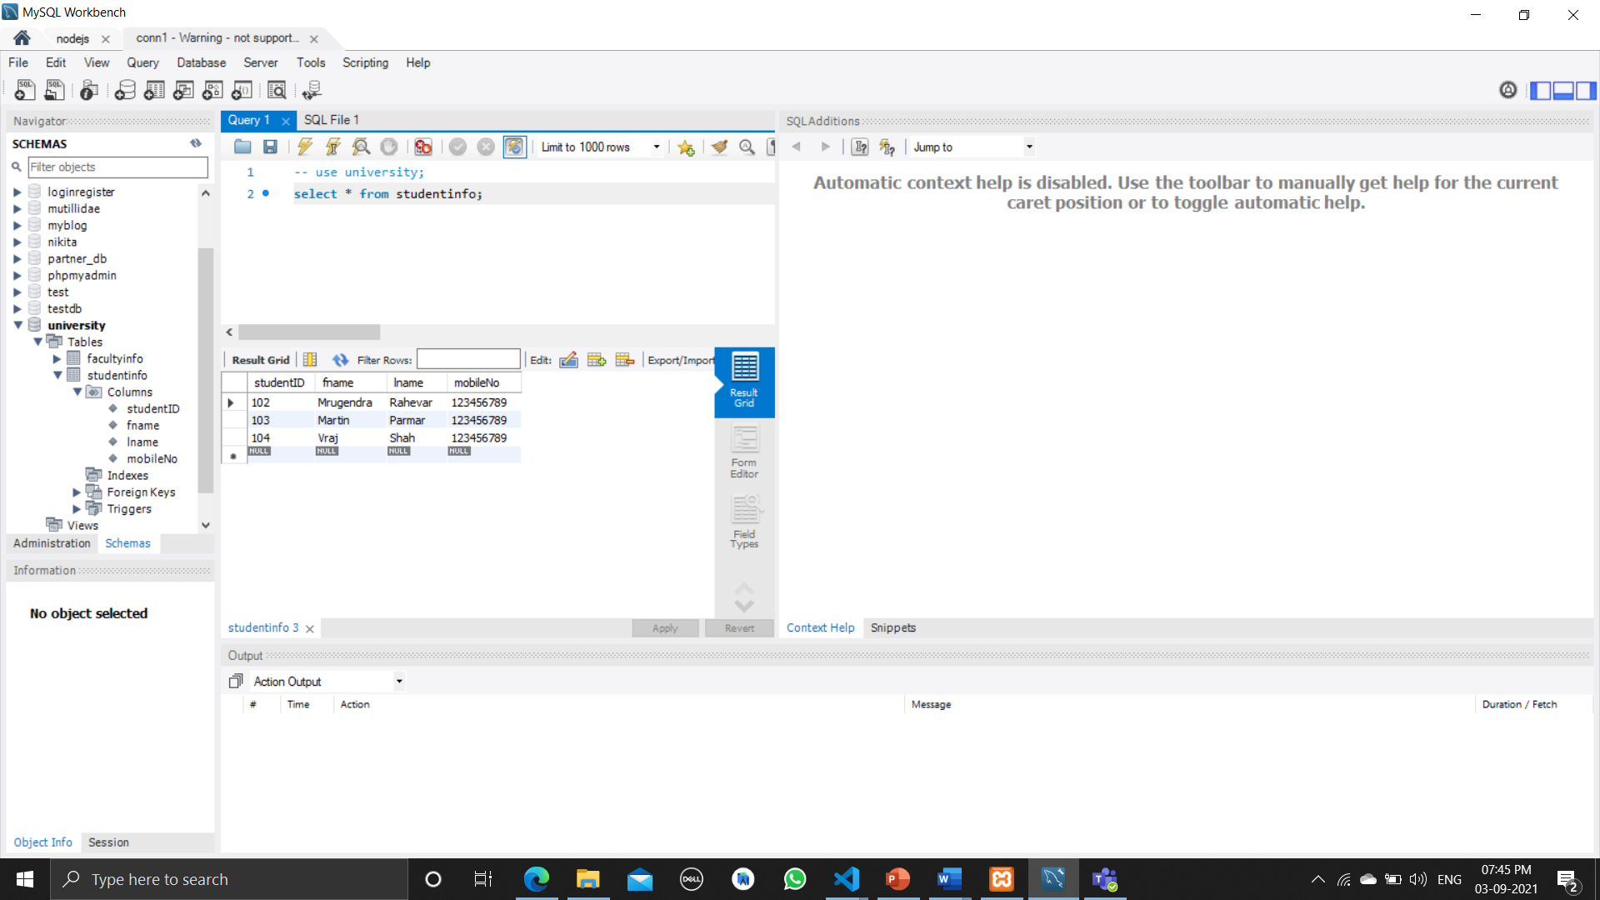

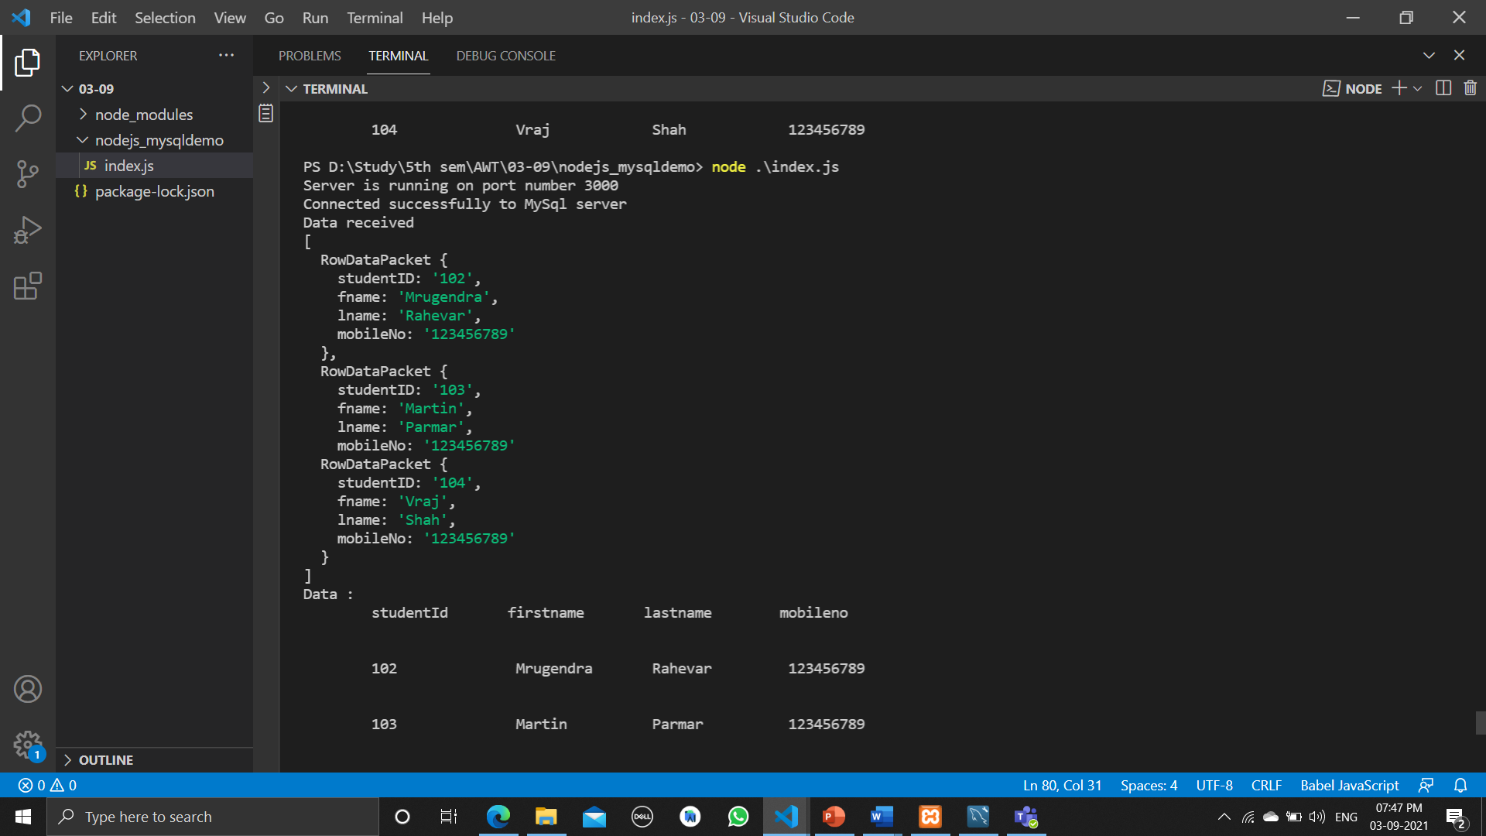

Data in tabular form

