Application performance Monitor

An Internship Report
Submitted in Partial Fulfillment for the Award of
M.Tech in Information Technology

By

Nikita Shah
MT2013141

To



International Institute of Information Technology
Bangalore – 560100

June 2015

CERTIFICATE

This is to certify that the internship report titled ‘Application Performance Monitor’ submitted by ‘Nikita Shah’ (MT2013141) is a bonafide work carried out under my/our supervision at ‘Hewlett−Packard (India) Software Operation Pte Ltd’ from January 8, 2015 to June 30, 2015, for a period of 5 Months & 22 Days in partial fulfillment of the M.Tech. Course of International Institute of Information Technology, Bangalore.

Her performance & conduct during the internship was satisfactory.

(Signature of the supervisor) Name of the Supervisor
Address.
(with seal)

Date:
Place:

Undertaking by the Student

I, Nikita Shah, hereby declare that the report of the internship program titled, “Application Performance Monitor” is prepared by me. I also confirm that, the report is only prepared for my academic requirement not for any other purposes.

Date:

______________________
Signature of the Student
(Roll Number)

ACKNOWLEDGEMENT

Internship is essentially a fresher’s first experience of the corporate world and is a golden opportunity for technology learning and self-development. I consider myself lucky and honored to be a part of Hewlett−Packard (India) Software Operation Pte Ltd as an intern.

The completion of this internship would not have been possible without helping hands from many. I would like to take this opportunity to thank them all.

I extend my sincere gratitude to Hewlett-Packard India Software Operation Pvt. Ltd. Bangalore, for providing me an opportunity to carry out the internship in organization. I would like to thank Mrs. Shalini Agarwal, Manager, Mr. Susanta Adhikary, Mentor, and the entire D-man team for their support and guidance throughout all of the project phases.

Last, but not the least, I would like to thank my peers and friends who provided me with valuable suggestions from time to time to improve my project.

Contents
ACKNOWLEDGEMENT iv
TABLE OF CONTENTS vi
LIST OF TABLES vii
LIST OF FIGURES viii
ABSTRACT ix
1. INTRODUCTION TO PERFORMANCE MONITOR 1
1.1 Motivation for the project: 1
1.2 Problem Statement: 1
1.3 Objective of the project 2
1.4 Scope 2
1.5 Methodology Adopted 2
1.6 Organization of report 3
2. REQUIREMENTS 4
2.1 User Characteristics 4
2.2 Functionality Requirements 4
2.3 Performance Requirements 4
2.4 Software Requirements 5
2.5 Hardware Requirements 5
3. DESIGN AND IMPLEMENTATION 6
3.1 Introduction 6
3.2 Design Considerations 6
3.3 Development methods 7
3.4 System Architecture 8
3.4.1 User Interface: 8
3.4.2 Performance Collection Component: 11
3.4.3 Persistence Component: 12
3.4.4 Analytics component: 14
3.4.5 Visuals Creation Component: 15
3.5 Flowchart 16
4 CONCLUSION AND FUTURE WORK 18
GLOSSARY 19
BIBLIOGRAPHIC REFERENCES 20

TABLE OF CONTENTS

Page No.

Acknowledgements iv

Table of Contents v

List of Tables (if applicable) vi

List of Figures (if applicable) vii

Abstract viii

1. INTRODUCTION 1

  - …….……………………… Pg. No.

  - …….……………………… Pg. No.

2. ……………………………………. Pg. No.

2.1 …………………………….. Pg. No.

Glossary Pg. No.

Bibliography Pg. No.

LIST OF TABLES

Table Number Title Page No.

2.1 --------------------

LIST OF FIGURES

Figure Number Title Page No.

3.1 --------------------

ABSTRACT

The project titled “Application Performance Monitor” monitors the resource usage (Memory, CPU, number of processes, page faults etc.) of any running application. It also has a history of resource usage persisted. This history coupled with real time data of resource usage proves to be a potential entry point for number of useful analysis. This foundation can be used to develop a recommendation system optionally with self-healing capabilities.

In general, a software appliance based in java, consists of many services. These are multi-threaded and are highly resource centric. If these are not controlled properly, will cause lead to performance bottleneck. This will have a cascading effect and the whole appliance could fail. The problem is absence of any way of preventing the above described scenario, there is no way to get notified before the performance bottle neck actually happens.

The approach taken is to solve this problem first in a reduced scope. User would be provided with a list of applications to choose from. Once the user’s choice is known, monitoring performance indexes (CPU usage, memory used, etc) will help benchmarking the activities thus getting an idea about its normal usage. Notifying the eco system about threshold breach will thus be possible so that proper actions could be taken. Analytics can be developed based on current and historical data of the collected metrics. These analytics can help in providing useful recommendations .Self-healing mechanisms could be thought of as a result of this analysis. Manual intervention can also be made highly beneficial by way of pinpointing the issue with greater accuracy. The performance key collection could be from OS, the hardware or any other third party tool available for it. The user could be provided with visuals in form of charts, alerts etc to improve available information reusability.

- INTRODUCTION TO PERFORMANCE MONITOR

Motivation for the project:
The motivation is to design a project that has flexible and predictive approach for troubleshooting and monitoring of the resources to resolve the errors in the system. Here we try to take a practical approach for monitoring the resource usage and dig in if necessary. Overall the solution proposed is to enable the analysis of the resource usage and provide recommendations for faster response to reported/unreported problem (would cause application failure if not recognized beforehand).
As an academic project with motivation of learning and exposing following technologies
• Resource Usage analysis
• Analytics engine
• Data Structures and Algorithms
• Java programming, JavaScript, JSP, Web programming
• Frameworks: Spring, Maven, REST

Problem Statement:
To provide in-depth analysis of the activity being performed within the federated/non-federated application via scientific analysis of various short/long lived activities and benchmarks the resource usage and the historical trend. This involves understanding the appliance activities initiated by resource manager and correlate with the existing performance benchmarking of the API/features.

Objective of the project
The project focuses mainly to come up with approach to monitor performance counter the various service within the application and analyze them to come up with recommendation to generate alert for degradation of performance based on the resource usage by the application.

Scope
This project will find its use in corporate environment where system administrator needs to analyze and evaluate the performance of a software/application troubleshoot the issue if any. Any corporate software could add benchmarking its performance and provision of recommendation before performance bottleneck to improve the usability of the corporate software/application tremendously.

Methodology Adopted
Application performance monitoring includes:
• The collection of live resource usage of an application/process (Sigar used for this purpose)
• Allow user to input specific parameters for the resource usage monitoring like application name, parameters to be monitored, time for the monitoring activity.
• Provide recommendation based on the analyzed information and knowledge base of known pattern.
• Store the resource usage in a MySQL database. Live resource usage data as well as historic data provided as input by user to be stored in a 3NF MySQL database.
• Zing charts are used to show visuals to the user (Live resource usage by a particular application is shown in a dynamic graph as well as a static graph is shown with all the resource usage information extracted from the MySql DB after taking into consideration the user input parameters.)

Organization of report
The report is organized into following sections: In chapter 1, Introduction to the subject matter where the concept of resource usage analysis is explained. It also talks about the motivation objective and scope of the project. In chapter 2, Concepts log analysis, the rule base system and learning algorithms used in the system are explained. Also a brief introduction of the environment is provided. In chapter 3, the flowchart, block diagram and the specifications associated with the log analyzer are discussed is discussed. In chapter 4, the implementation of the flowchart discussed in chapter 3 in java using Eclipse IDE is presented along the algorithm for the analysis In chapter 5, the testing done on the software has been discussed. Three kinds of testing have been done, Unit testing, Integration Testing and System Testing. In chapter 6, results of the project are presented. The results are shown through graphs. In chapter 7, the conclusion, limitations of the project and the further work are stated.
- REQUIREMENTS

2.1 User Characteristics
- User should be familiar with basic concepts of operating systems and various computer resources.
- User will interact with the system with the help of a web interface.
- User should be able to troubleshoot after the recommendation is provided.
- User must be capable of choosing appropriate parameters for monitoring the resource usage.

2.2 Functionality Requirements
- Accurate detection of all the processes running in the eco-system.
- Availability of live resource usage information for a particular application at any given (as long as the application is running.)
- Persistence of the usage information and ability to query on it in required format.
- Provision of visuals to the user to determine sudden spike in resource utilizations.
- Display of timely alerts, recommendations to avoid system failure in case of performance bottleneck.
- Recommendations to be backed by scientific analysis of historic data.
- Ability for user input of historic data as an input to be stored in the persistence layer.
- Generation of reports in forms other than static and dynamic charts (For example CSV values, excel dump, JSON dump etc. )

2.3 Performance Requirements
- Should be able to manage any type and number of process in the eco-system.
- Should be able to extract necessary information from os/software/third party tool.
- Should be able to work on all operating systems.
- Should be able to provide proper self-healing mechanisms.

2.4 Software Requirements
- Operating System: Windows NT 4.0, 2000 Pro/Server, 2003 Server, XP, Vista, 2008 Server, 7,Linux,Solaris,Mac
- Programming Tool: Eclipse IDE (Maven Plugin)
- Platform: Java 1.6 and above
- Other: Sigar, Zing charts, jQuery, Tomcat 6.0 onwards, Web browser

2.5 Hardware Requirements
- 1 GB RAM, 20GB HDD
- LAN/Internet connection to the server.
- Http network communication between user and the module.
- DESIGN AND IMPLEMENTATION

3.1 Introduction
The purpose of the design phase is to plan a solution of the problem specified by the requirement document. This phase is the first step in moving from the problem domain to the solution domain. The design of the system is perhaps the most critical factor affecting the quality of the software. Here we build the system Block diagram that will be helpful to understand the behavior of the system. Here we divide problem into modules. Data flow Diagrams show flow of data between/among modules.

3.2 Design Considerations
Java is powerful programming language. It has efficient high-level data structures and a simple but effective approach to object-oriented programming. It is easy to use and is therefore easy to write, compile, debug, and learn than other programming languages. This allows you to create modular programs and reusable code.
Sigar is an API available freely for download and can contributed to. It has an Apache License 2.0. This API provides the functionality of gathering System information and reporting the same. The specialty of this API is that it is OS independent (.dll’s and .so’s are provided for all OS.) Other alternatives included a PowerShell script wrapper around the perfmon utility provided in Windows operating system. The drawback of this approach was that it would have becomes OS specific. Sigar API handles all this very efficiently.
MySQL is the database chosen for the persistence layer. As the information to be persisted has a fixed structure, a relational database like MySQL suffices our needs completely.
The entire project is based on REST web services made available on the server. REST frame work makes it easy for us to introduce a new client later sometime in future without having to make any changes to the server side code at the backend. REST became the undisputable choice because of the very obvious advantages it offers over all its competitors.
Spring framework was chosen to develop this web-app/web-service as it makes the job of a developer very easy. Spring is highly scalable and provides easy integration with rest services.
Maven is chosen as the project management tool.

3.3 Development methods
The development method used in this software design is the modular development method. In this, the system is broken down into different modules, with a certain amount of dependency among them. The system is developed using the Bottom-up approach. The bottom-up approach is the piecing together of systems to give rise to grander systems, thus making the original systems sub-systems of the emergent system. In this approach the individual base elements of them are first specified in great detail. These elements are linked together to form larger subsystems, which in turn are linked, sometimes in many levels, until a complete top-level system is formed. This strategy often resembles a "seed" model, whereby beginning are small but eventually grow in complexity and completeness. Java- programming language has been used to develop the modules. Developing the application module by module takes the work of the developer as well as tester or analyzer easier.

3.4 System Architecture

Display all running processes
Charts, Graphs, Recommendations,
All other visuals

USER INTERFACE

User I/p: selected application and performance metrics to be measured

REST apis
Performance Collection Component
Visuals Creation Component

MySql 3NF database
Persistence Component
Analytics engine

User Interface:

3.4.1.1 Purpose:
The purpose of this component is to allow monitoring of the resources by any naïve user. Internal complex details are abstracted from the user through this User Interface thus making his interactions with the system smooth and easy.

Functionality:
- Allow selection of specific service to monitor.
- Allow selection of the performance counter and period to be monitored.
- Display of the entire performance matrix and its trend for certain period.
- Display of graph to be able to visualize the trend.
- Display of alert panel.
- Recommendation box for all recommendations to be displayed when appropriate.

Input, Output:
Input:
First a screen similar to the one shown below appears in-front of the user. The user is expected to enter the name of the process to be monitored here. User could just enter the application name or could copy paste from the list provided below.
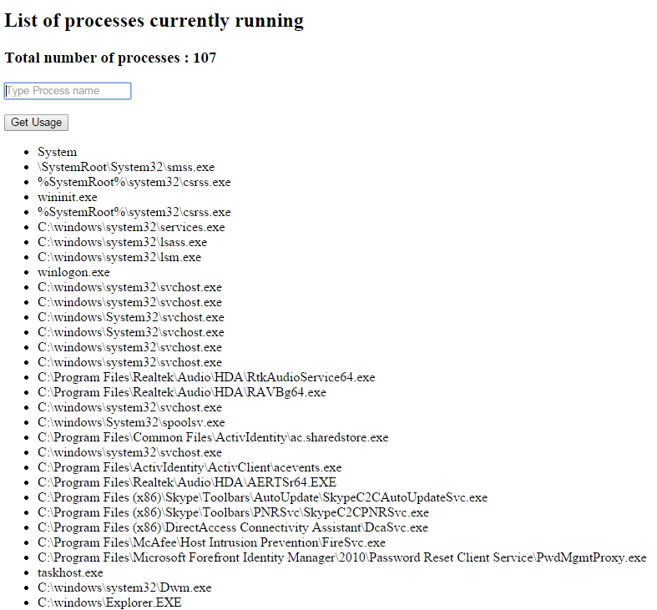

Output:
A live chart of the resource usage will then be shown to the use along with static charts if asked for. Recommendation window will follow if incase of resource usage spike. A sample diagram is shown below.
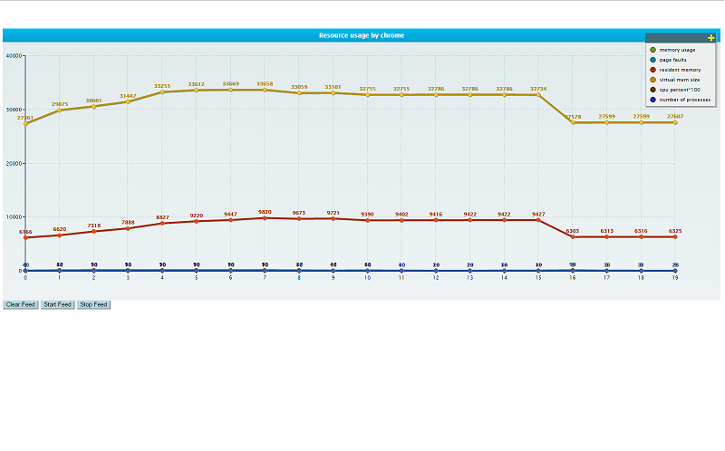

Implementation:
User Interface is implemented with the help of technologies like JSP, JavaScript, Ajax and spring is the framework used for implementation of the web-mvc architecture.

Performance Collection Component:

Purpose:
This component is responsible for collection of the performance metrics (CPU usage, memory usage etc.) of the running processes. This component is also responsible for providing information to the other modules and components when when required.

Functionality:
- Collection of performance metrics from the os/ hardware/ third party s/w without involving PID as, if the process restarts it gets a fresh new PID.
- Aggregation of metrics of all the processes of an application (say application chrome may have more than 1 instances (corresponding to number of tabs and number of windows)).Aggregate information as well as separate information should be captured.
- This component should be able to collect the metrics continuously and should be able to collect data on all platforms irrespective of OS being run on the machine. Also, this component should have a continuous communication with the persistence component to store this data.
- Should be able to interact with the visuals creation component, analytics engine and the persistence component to provide data to all these three components.
- It should be able to get a list of all processes running in the system and also performance metrics of them all (or sometimes just the one process entered by the user).

Input, Output
The input may come from the UI screen with a process name. The output in terms of usage characteristics of this process are to be forwarded to the visuals creation component and to the persistence component. Optionally analytics component may also ask PCC for this data. There is one scenario when there is no user input in this case, Performance Collection Component is expected to come up with list of all the processes currently running in the system and deliver this list to the User Interface. Output out of this component is a JSON form of the requested data.

Implementation:
We have used the SIGAR (System information gatherer and reporter) API as the core of our Performance Collection Component. This API provides os-dependent information in an independent way thus allowing us to write an application software which will run on almost all of the platforms. A different query language called PTQL is evolved and used in this API to make all process related queries independent of the process id. This component provides REST API services to the calling component. There is huge advantage of using REST like most of REST services run over HTTP protocol. Non-Restful technologies like SOAP
and WS-* have their own protocol stack and use HTTP only to tunnel through firewalls.
So, they don’t achieve the light-weight and scalability aspect associated with REST. Most of the REST queries used in this context are GET queries with very few POST queries.

Persistence Component:
3.4.3.1 Purpose:
This component is the persistence layer of the project. Persistence is necessary for any kind of analytics. Also, user is allowed to view resource usage data from past, to support this persistence becomes absolute essential.

Functionality:
- Interact with the MySQL database at the back end to perform CRUD operations in the database and to form and execute queries as per user/ other component requirement.
- Interact with Visuals Creation Component to provide statistics necessary for creation of the visuals after extracting from the database. This operation makes heavy use of query creation, query fire, result collection and structuring of the result for data consumption by the Visuals Creation Component.
- Interact with the Performance Collection Component continuously to persist all the resource usage data that has been captured by PCC currently.
- Analytics engine uses this component as part of its knowledge repository and as a base for all of its scientific analysis.

Input, Output:
Input to this component is generally an array list of objects of classes in the model of the mvc framework. These objects contain the data that needs to be persisted in the database.
Output form this component is again an array list of objects (POJOs) /JSON of the requested data after extraction from DB.

      - Implementation:
This component is a 3NF MySQL database. The currently captured data from the SIGAR API delivered by the PCC or any other historical data needs a formatted structure so that its persistence can be put to some use. This arrangements also helps us provide the functionality to the user to give process usage input independently. The schema of the implemented project is similar to the one shown below.

Table 1: Process Table.
ID(primary key)(System generated) | Name | Type | Cpu ID | Mem ID | i/0 | ……

Table 2: Thread Table
ID(primary key)(System generated) | Thread_id | Parent_Process_ID | CPU ID | MemID | …….

Table 3: CPU Info Table
ID(primary key)(System generated) | CPU Core Number | CPU frequency | ………….

Table 4: Memory Info table
ID(primary key)(System generated) | Shared Memory | Resident Memory | Size of memory | ………

Analytics component:

3.4.4.1 Purpose:
This component is responsible for benchmarking the resource usage of a process taking into account the usage patterns. This component would also be responsible for coming up with recommendation to avoid a system level crash due to performance bottleneck.

      - Functionality:
- To perform benchmarking of resource usage by mining all the available data on a particular process.
- Calculating the thresh hold value, such that values higher than thresh hold should be indicative of a potential performance bottle neck.
- Coming up with recommendations which may include degrading (lowering down) operations of a high resource consuming process/ termination of such process.

Input, Output:
      - Implementation:
These benchmarked values are to be revised periodically to reflect the application’s changed patterns in resource usage if any. The current usage of resources should be compared with these benchmarked values to recognize irregular patterns and come up with recommendation or self-healing actions if any.

Visuals Creation Component:

3.4.5.1 Purpose:
This goal of this component is to get data from other components and build up visuals from such data. Visuals would include live charts, static charts, alert boxes, recommendation boxes.

      - Functionality:
- To build visuals and interact with the User Interface component to successfully display these formed visuals. One of the major functions of this component is to continuously receive data from PCC and continuously update the live feed chart and then forward it UI component.
- To interact with other components like PCC, analytics component and persistence component to retrieve static and dynamic data for report generation.

Input, Output:
The input to this component is the data it asks for from all other components.
The output is the generated visuals in the form of charts which is communicated to the UI component.

      - Implementation:
This component makes use of Zing charts (a charting API available online in form of a JavaScript file) to create both dynamic (current usage statistics live feed data.) and static (historical usage patterns extracted from the database). This component is very vital for the application to achieve interactivity with the user. To achieve the live chart capability Ajax calls are made using java scripting library called jquery to the rest APIs made available by other components. The Ajax call has to be consume the returned JSON data in its success call back and add to the existing charts and repaint the chart on the UI.

3.5 Flowchart
It indicates the flow of control throughout the execution of the project through various components.
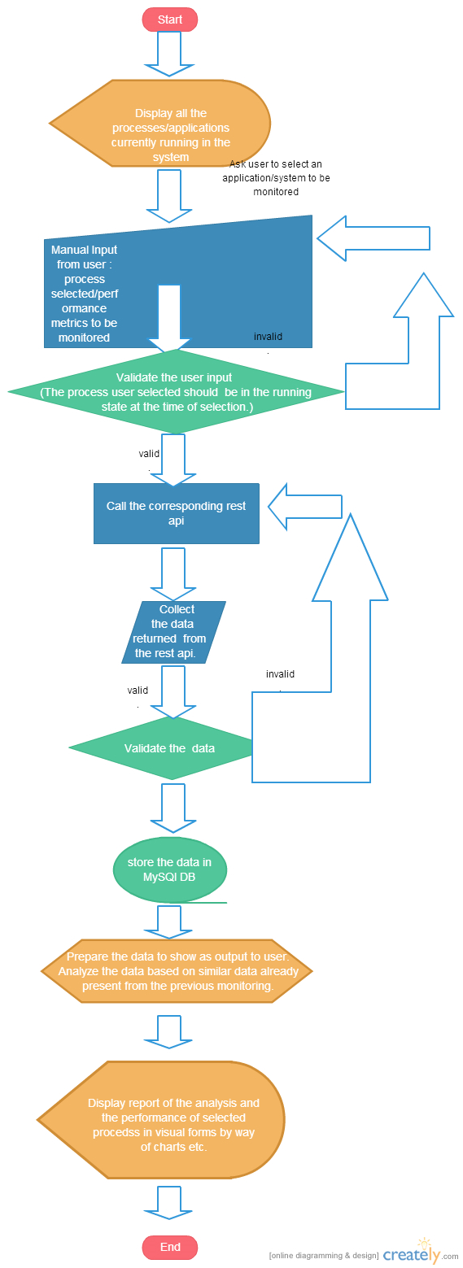

- CONCLUSION AND FUTURE WORK

Analyzing performance of any software application gives us tremendous insight into and control over the application. This project can be used as a POC for the same.
This project could be enhanced a lot in the future. In this project we are monitoring an application process running on the system. This same idea could be tweaked and improved to be embedded in any software application. Further, we could track any business level objectives performance. Say, for example we have a software application for order management system, an example of business level objective could be adding an item into the user’s cart. Rigorous usage of methods and techniques discussed in the project applied after appropriate improvements can help us closely monitor resource usage for this business level objective. Live resource usage monitor can help us avoid system crash due to many users bombarding the website. This will allow us to take some cautionary steps like redirecting the user hits to another URL, allowing only fixed number of users etc. The algorithms, methodologies used in the Analytics component can be improved continuously to make use of latest technologies and to make the performance monitor smarter.

GLOSSARY

BIBLIOGRAPHIC REFERENCES

