Supplementary Materials
Measurement of The Laminar Burning Velocity and Kinetics Study of The Importance of The Hydrogen Recovery Mechanism of Ammonia/Hydrogen/Air Premixed Flames
Gabriel J. Gotama^{a,b,c*}, Akihiro Hayakawaª, Ekenechukwu C. Okafor^{d}, Ryuhei Kanoshima^{a,e}, Masao Hayashi^{a,e}, Taku Kudoª, Hideaki Kobayashiª

ª Institute of Fluid Science, Tohoku University, 2-1-1 Katahira, Aoba-ku, Sendai, Miyagi 980-8577, Japan
^{b} School of Mechanical and Aerospace Engineering, Nanyang Technological University, 50 Nanyang Ave., Singapore 639798
^{c} Department of Aerospace and Geodesy, Technical University of Munich, Willy-Messerschmitt-Str. 1, Taufkirchen/Ottobrunn 82024, Munich, Germany
^{d} Fukushima Renewable Energy Institute, National Institute of Advanced Industrial Science and Technology (AIST), 2-2-9 Machiikedai, Koriyama, Fukushima 963-0298, Japan
^{e} Department of Aerospace Engineering, Tohoku University, 6-6-1 Aoba, Aramaki, Aoba-ku, Sendai, Miyagi 980-5879, Japan

*Corresponding author at: Department of Mechanical Engineering, The University of Melbourne, Parkville, Victoria 3010, Australia (ggotama@student.unimelb.edu.au)

- Sensitivity analysis of the laminar burning velocity using various mechanisms.
The sensitivity analysis includes reactions with the ten largest sensitivity coefficient from each equivalence ratio.
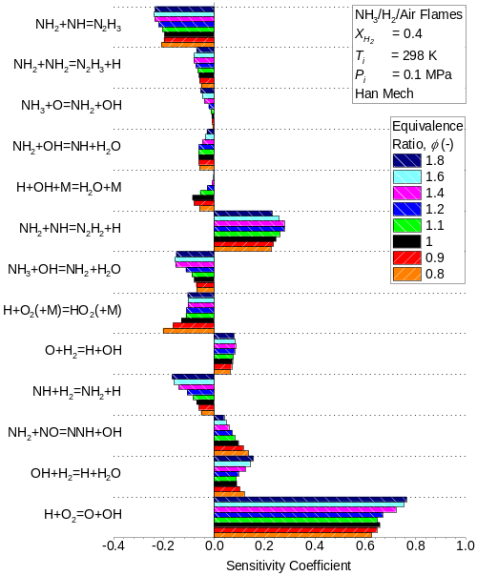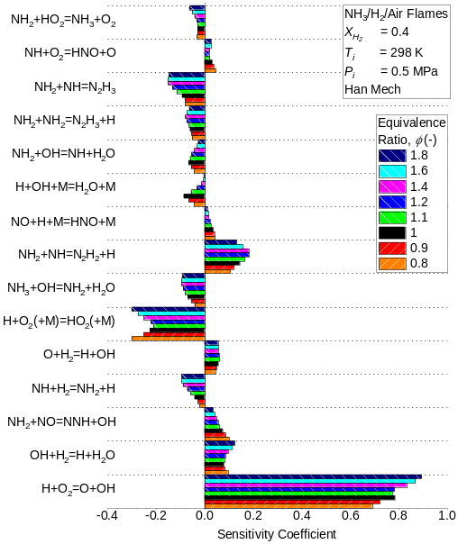
(a) (b)
Fig. S1. Sensitivity analysis of the unstretched laminar burning velocity for NH₃/H₂/Air premixed flames at X_{H2} = 0.4 under (a) 0.1 MPa and (b) 0.5 MPa using Han Mech [1].
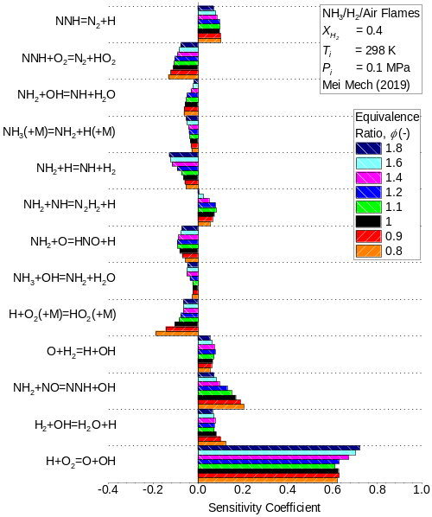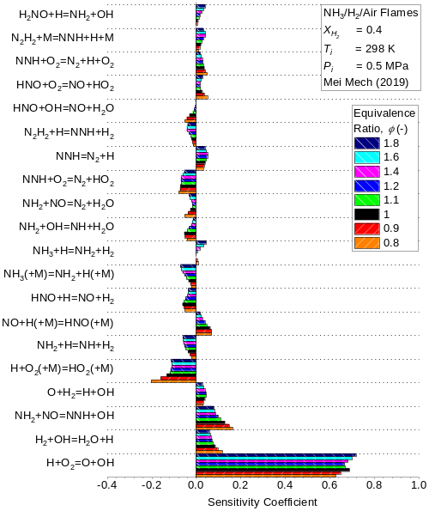
(a) (b)
Fig. S2. Sensitivity analysis of the unstretched laminar burning velocity for NH₃/H₂/Air premixed flames at X_{H2} = 0.4 under (a) 0.1 MPa and (b) 0.5 MPa using Mei Mech (2019) [2].
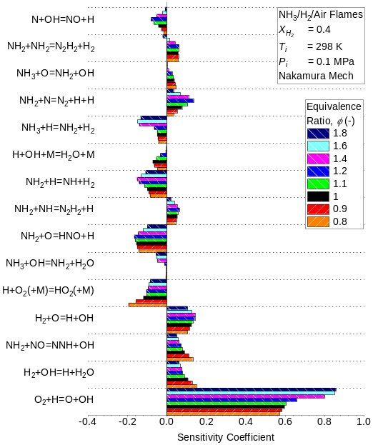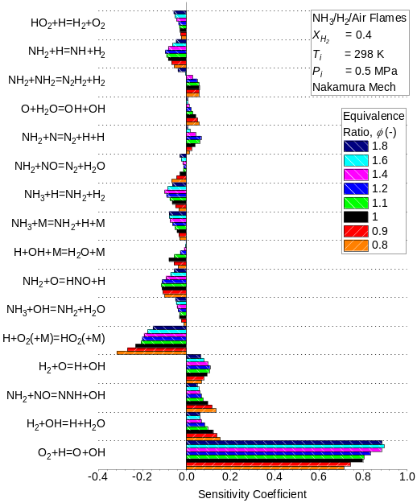
(a) (b)
Fig. S3. Sensitivity analysis of the unstretched laminar burning velocity for NH₃/H₂/Air premixed flames at X_{H2} = 0.4 under (a) 0.1 MPa and (b) 0.5 MPa using Nakamura Mech [3].

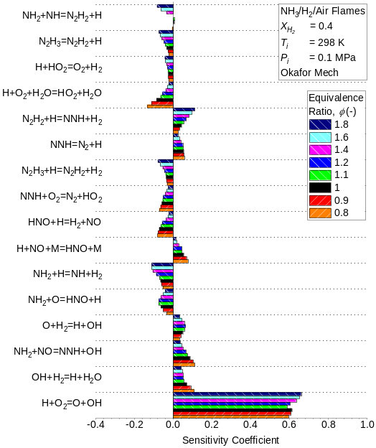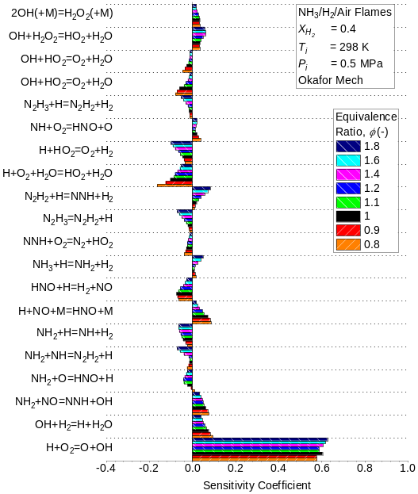
(a) (b)
Fig. S4. Sensitivity analysis of the unstretched laminar burning velocity for NH₃/H₂/Air premixed flames at X_{H2} = 0.4 under (a) 0.1 MPa and (b) 0.5 MPa using Okafor Mech [4].
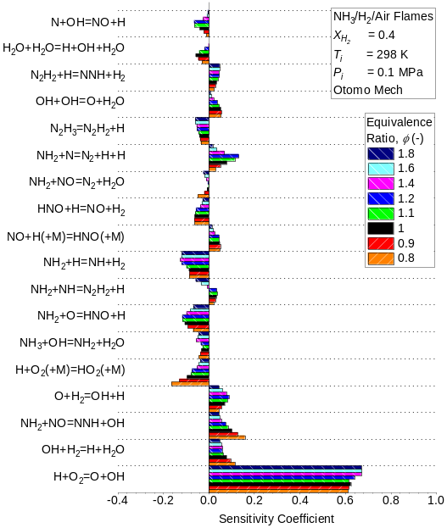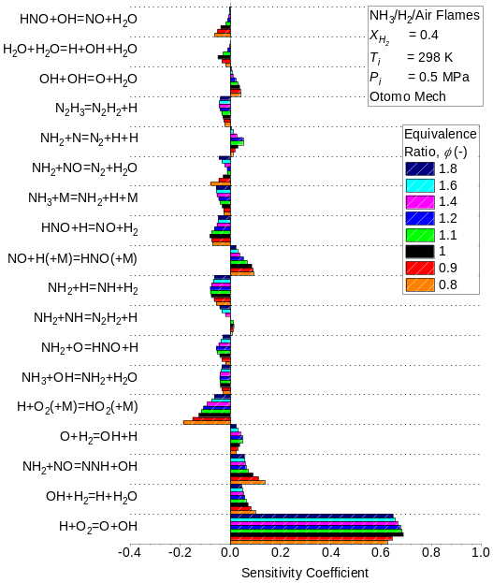
(a) (b)
Fig. S5. Sensitivity analysis of the unstretched laminar burning velocity for NH₃/H₂/Air premixed flames at X_{H2} = 0.4 under (a) 0.1 MPa and (b) 0.5 MPa using Otomo Mech [5].
- Details on the reactions with modified rate constant in the present mech
(1) NH₃ + OH = NH₂ + H₂O
It is the primary chain-branching reaction that decomposes NH₃ to NH₂ through H abstraction. Except for Okafor Mech (0.1 and 0.5 MPa) and Mei Mech at 0.5 MPa, all mechanisms used in the sensitivity analysis considered S_{L} to be sensitive to its reaction rate. Present Mech also includes this reaction in the sensitivity analysis (See Section 4.2 of the main text). Although the H abstraction of NH₃ also involves H and O as reactants, OH dominates this process. Nozari et al. [6] found that OH is responsible for more than 94% of NH₃ decomposition for pure NH₃ and NH₃/H₂ lean flames under high pressure and high temperature. The rate constant for the reaction was revised with the value proposed by Stagni et al. [50] that resulted in a faster reaction rate and reduced the overestimation of rich S_{L}.

(2) H + O₂(+M) = HO₂(+M)
It is responsible for most HO₂ formation and S_{L} is considered sensitive to its reaction rate by all mechanisms used in the sensitivity analysis except for Okafor Mech. Present Mech includes this reaction in the sensitivity analysis (See Section 4.2 of the main text). This reaction has a significant role in the kinetics at high pressure through its influence on the H radical that affect the H₂ decomposition/regeneration cycle (See Section 4.3 of the main text). The modification was done on the low-pressure limit, TROE, and the third body efficiency using similar value as Mei Mech (2019). The reaction rate for the low-pressure limit and the O₂ third body efficiency decreased while the TROE centering factor and the third body efficiency for H₂, H₂O, Ar, and He increased. The modification reduced the underestimation of lean S_{L}.

(3) H + HO₂ = H₂ + O₂
S_{L} is considered sensitive to its reaction rate through sensitivity analysis using Okafor Mech at 0.1 and 0.5 MPa and Nakamura Mech at 0.5 MPa. The reaction plays a role in the H₂ decomposition/regeneration cycle from its contribution to the H₂ regeneration (See Section 4.3 of the main text). The rate constant was revised with theoretical estimation proposed by Mousavipour et al. [7] that reduced overestimation of the rich S_{L}. Figure S6 shows reaction rate comparisons for H + HO₂ = H₂ + O₂ from various sources and those adopted in Present Mech and Han Mech [7–11]. The comparison includes rate constant suggested by Tsang and Hampson [9] from their review work, Hidaka et al. [10] through calculation from the rate constant of the reverse reaction, and Karkach and Osherov [11] from their theoretical calculation. The comparison shows that the rate constant adopted by Han Mech has lower reaction rate compared to the others. The rate constant adopted in the Present Mech has an intermediate reaction rate where it is lower than the one suggested by Karkach and Osherov [11] but higher than the one suggested by Tsang and Hampson [9].

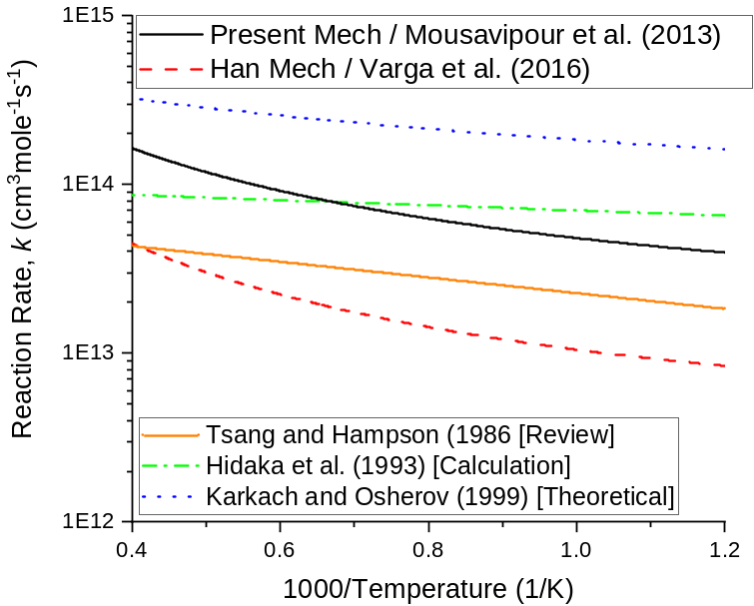
Fig. S6. Reaction rate comparison for H + HO₂ = H₂ + O₂ from various sources and those adopted in Present Mech and Han Mech.

(4) HNO + O₂ = NO + HO₂
Except for Han Mech, all reaction mechanisms used in the sensitivity analysis included it in their reaction data. Nevertheless, S_{L} is only considered sensitive to this reaction rate by Mei Mech (2019) at 0.5 MPa and Okafor Mech at 0.5 MPa. The reaction was added to improve the modelling of HNO decomposition to NO by providing an alternative path for HO₂ production. The rate constant suggested by Dean and Bozzelli [12] was adopted for this reaction and resulted in the reduced underprediction of lean S_{L}. A similar rate constant was used by Stagni et al. [13] in their reaction mechanism.

(5) HNO + OH = NO + H₂O
S_{L} is considered sensitive to this reaction rate through sensitivity analysis using Mei Mech (2019) and Otomo Mech. The rate constant was revised with the value proposed by Nguyen et al. [14]. A similar rate constant was used by Glarborg et al. [15] in their reaction mechanism. The revision brought a reduced reaction rate and diminished the role of OH radicals to convert HNO to NO. The revision resulted in the reduced underestimation for lean S_{L} with a larger effect at high pressure.

(6) NH + O₂ = HNO + O
S_{L} is considered sensitive to this reaction rate by Han Mech at 0.5 MPa and Okafor Mech at 0.5 MPa. It has a slight tendency to be more sensitive at lean condition. The rate constant was revised using value suggested by Baulch et al. [16] that decreased the reaction rate. The adoption reduced the predicted S_{L}, particularly for lean mixture, to balance the effect of revising other reactions’ rate constant for better prediction.

(7) NH₂ + N = N₂ + H + H
S_{L} is considered sensitive to this reaction rate by Nakamura Mech and Otomo Mech. The sensitivity was particularly high in a slightly rich condition (ϕ = 1.2). The reaction contributed to the production of N₂ through the H abstraction of NH₂. The new rate constant was adopted from Klaus [17], which was also used in the mechanism by Shrestha et al. (in 2018) [18] and Mei Mech (2019). The adoption reduced the reaction rate and decreased the S_{L} prediction for slightly rich mixture.

(8) NH₂ + NH₂ = N₂H₂ + H₂
S_{L} is considered sensitive to this reaction rate by Nakamura Mech at 0.1 and 0.5 MPa, and Present Mech at 0.1 MPa (See Section 4.2 of the main text). It describes one of the major formation paths of N₂H₂ through an identical bimolecular NH₂ reaction. It also has a role in the H₂ decomposition/regeneration cycle through its contribution in H₂ regeneration (See Section 4.3 of the main text). The new rate constant was adopted from Stothard et al. [19] and resulted in a faster reaction rate at low to intermediate temperature but slower after approximately 1700 K. It increased the predicted S_{L}, particularly for lean mixture. The change in the predicted S_{L} is significant at 0.1 MPa but negligible at 0.5 MPa.

(9) NH₂ + NO = NNH + OH (R₉), and
(10) NH₂ + NO = N₂ + H₂O (R₁₀)
S_{L} is considered sensitive to the reaction rate of R₉ by all mechanisms used in the sensitivity analysis, including Present Mech (See Section 4.2 of the main text). However, only Mei Mech (0.5 MPa), Nakamura Mech (0.5 MPa), Otomo Mech (0.1 and 0.5 MPa), and Okafor Mech (0.1 MPa) found S_{L} sensitives to the reaction rate of R₁₀. These two are the thermal De-NOx reactions and have been extensively investigated [20,21]. The revision brought an increased reaction rate for R₉ but reduced reaction rate for R₁₀. It increased the branching ratio, α = k₉ / (k₉ + k₁₀), that promoted O/H radical production, and the tendency of NH₂ to be converted into NO [15,20]. Due to the revision, the range of α in the effective thermal De-NOx temperature window (1100-1400 K) [15] is within 0.48-0.63. The new range of α is higher than the recommended limit of 0.508 for that temperature [22,23], with recent review work by Glarborg et al. [15] even suggested value of 0.3 – 0.4. However, the revision was proper for NH₃/H₂ flames as H₂ addition in NH₃ shifts the temperature window for thermal De-NOx towards lower temperature [24]. The adoption of the new rate constants for these reactions reduced S_{L} underestimation for lean flames.

(11) NH₂ + H(+M) = NH₃(+M)
Mei Mech and the Present Mech (See Section 4.2 of the main text) indicate that S_{L} is sensitive to its reaction rate. The reaction describes NH₃ regeneration from NH₂ that can affect the NH₃ decomposition. In the Present Mech, the rate constant suggested by Altinay and Macdonald [25] was adopted, which was also used by other mechanisms [15,18]. Adding this reaction resulted in considerable reduction in the overestimation of the rich S_{L}.

(12) NNH + O₂ = N₂ + HO₂
S_{L} is considered sensitive to the reaction rate by Mei Mech and Okafor Mech. It is a secondary path for NNH decomposition. This reaction reduces ammonia reactivity through the production of HO₂, a less reactive radical. It competes with the unimolecular reaction NNH = N₂ + H that also use NNH as reactant to produce H radical. The rate constant for this reaction was revised with the value proposed by Bozzelli and Dean [26] that slow down the reaction rate. The revision reduced the underestimation for lean S_{L}.

(13) OH + H₂ = H + H₂O
S_{L} is considered sensitive to its reaction rate by all mechanisms used in the sensitivity analysis. This reaction is important in the H₂ decomposition/regeneration cycle (See Section 4.3 of the main text) through its role in decomposing H₂ into H radical. It was attributed by Li et al. [27] to take part in the enhancement of the S_{L} with H₂ addition. In the Present Mech, the rate constant for this reaction was revised with the value proposed by Lam et al. [28]. A similar rate constant was used in Nakamura Mech. Figure S7 shows the reaction rate comparison for OH + H₂ = H + H₂O from various sources and those adopted in Present Mech and Han Mech [8,28–33]. In general, the rate constants adopted by Han Mech, Present Mech, and the one suggested by Nguyen et al. [33] from their theoretical work resulted in reaction rate that fits with the experimental measurements. Rate constant adopted in the Present Mech has slightly higher reaction rate at low to intermediate temperature but lower reaction rate at high temperature compared to the one adopted by Han Mech. The adoption of rate constant suggested by Lam et al. [28] in the Present Mech decreased the S_{L} prediction, particularly under lean and slightly rich conditions. It helps to balance the effect of revising other rate constants for better accuracy.
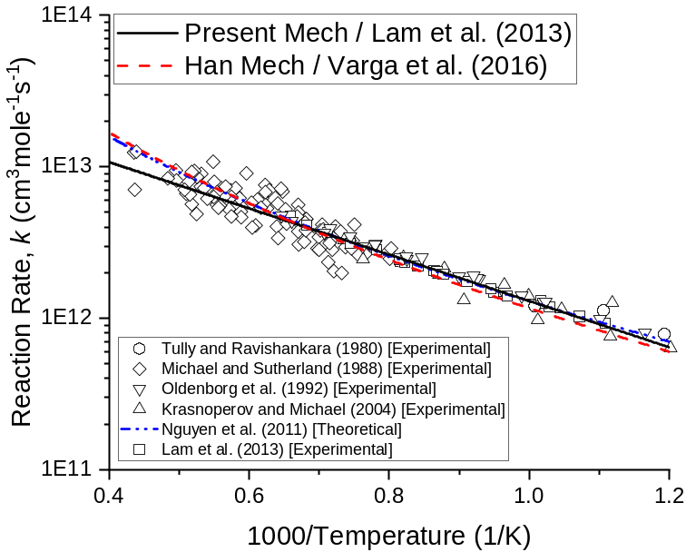
Fig. S7. Reaction rate comparison for OH + H₂ = H + H₂O from various sources and those adopted in Present Mech and Han Mech.
- Comparison for the predicted laminar burning velocity between the detailed Present Mech and the reduced Present Mech
As mentioned in the Section 3 of the main text, the Present Mech can be reduced to 26 species and 119 reactions by removing reactions involving HONO, HNOH, HON, HNO₂, HONO₂, and NO₃. According to Han et al. [1], the removal of those reaction has negligible effect on the S_{L} prediction. In order to prove this in the Present Mech, Fig. S8 shows the predicted S_{L} between the detailed Present Mech and the reduced Present Mech. As observed in the figure, the difference between the S_{L} predicted by the detailed and reduced Present Mech is negligible. It warrants the use of reduced Present Mech to lower the computational cost when used for flame modelling.

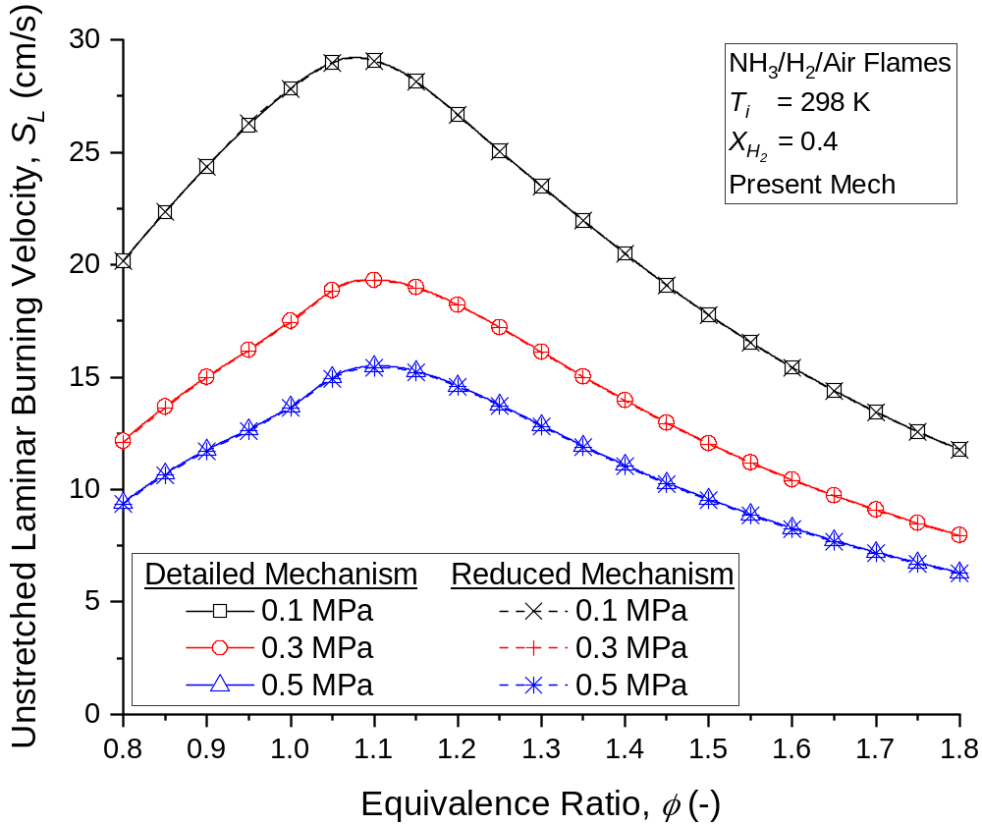
Fig. S8. Comparison of the predicted S_{L} for NH₃/H₂/Air premixed flames at X_{H2} = 0.4 between the detailed and reduced Present Mech.
- Experimental measurements of the laminar burning velocity and Markstein length for NH₃/H₂/Air premixed flames at X_{H2} = 0.4 and T_{i} = 298 K.

The reported uncertainty in this study was evaluated using two standard deviations. Please note that the reported measurements for lean flames at 0.5 MPa can be considered inaccurate as they were affected by the cellular instability effect.

0.1 MPa – Laminar burning velocity, S_{L}
Equivalence ratio, ϕ [-] | Non-linear S_{L} [cm/s] | Standard deviation for non-linear S_{L} [cm/s] | Linear S_{L} [cm/s] | Standard deviation for Linear S_{L} [cm/s]
0.8 | 20.56 | 0.49 | 21.66 | 0.41
0.9 | 25.30 | 0.3 | 25.83 | 0.28
1.0 | 29.03 | 0.43 | 29.11 | 0.44
1.1 | 30.28 | 0.26 | 30.39 | 0.31
1.2 | 27.10 | 0.32 | 27.56 | 0.35
1.4 | 19.68 | 0.11 | 20.78 | 0.13
1.6 | 14.91 | 0.21 | 16.69 | 0.45
1.8 | 10.84 | 0.09 | 15.85 | 1.53

0.5 MPa – Laminar burning velocity, S_{L}
Equivalence ratio, ϕ [-] | Non-linear S_{L} [cm/s] | Standard deviation for non-linear S_{L} [cm/s] | Linear S_{L} [cm/s] | Standard deviation for Linear S_{L} [cm/s]
0.8* | 11.73 | 0.48 | 11.79 | 0.45
0.9* | 13.64 | 0.35 | 13.69 | 0.33
1.0 | 14.41 | 0.16 | 14.46 | 0.14
1.1 | 14.96 | 0.15 | 14.96 | 0.14
1.2 | 13.76 | 0.08 | 13.77 | 0.09
1.4 | 10.36 | 0.04 | 10.40 | 0.05
1.6 | 7.57 | 0.09 | 7.65 | 0.14
1.8 | 5.56 | 0.04 | 5.75 | 0.08
*Can be considered inaccurate due to large cellular instability effect.

0.1 MPa – Burned gas Markstein length, L_{b}
Equivalence ratio, ϕ [-] | Non-linear L_{b} [mm] | Standard deviation for non-linear L_{b} [mm] | Linear L_{b} [mm] | Standard deviation for Linear L_{b} [mm]
0.8 | -2.635 | 0.215 | -1.477 | 0.066
0.9 | -1.251 | 0.149 | -0.867 | 0.075
1.0 | -0.480 | 0.035 | -0.421 | 0.027
1.1 | 0.363 | 0.071 | 0.424 | 0.101
1.2 | 0.916 | 0.033 | 1.257 | 0.059
1.4 | 1.326 | 0.023 | 2.334 | 0.044
1.6 | 1.696 | 0.029 | 3.820 | 0.198
1.8 | 2.247 | 0.033 | 9.893 | 1.910

0.5 MPa – Burned gas Markstein length, L_{b}
Equivalence ratio, ϕ [-] | Non-linear L_{b} [mm] | Standard deviation for non-linear L_{b} [mm] | Linear L_{b} [mm] | Standard deviation for Linear L_{b} [mm]
0.8* | -0.380 | 0.153 | -0.312 | 0.107
0.9* | -0.363 | 0.165 | -0.308 | 0.127
1.0 | -0.358 | 0.066 | -0.311 | 0.049
1.1 | -0.007 | 0.034 | -0.006 | 0.033
1.2 | 0.231 | 0.040 | 0.251 | 0.047
1.4 | 0.413 | 0.045 | 0.481 | 0.062
1.6 | 0.542 | 0.099 | 0.702 | 0.203
1.8 | 0.845 | 0.033 | 1.323 | 0.131
*Can be considered inaccurate due to large cellular instability effect.

- Assessing the performance of the Present Mech for NH₃/H₂/Air premixed flames at various conditions
Figure S9 shows the comparison between measured [34–37] and predicted S_{L} for NH₃/H₂/Air premixed flames at different pressure and X_{H2}. Figure S9a shows S_{L} comparison for NH₃/H₂/Air premixed flames with X_{H2} = 0.4 at 0.3 MPa and suggests that the Present Mech has accurate estimates despite developed using S_{L} measured at 0.1 and 0.5 MPa. It indicates that the flame kinetics are closely similar between 0.3 and 0.5 MPa. Figure S9b shows S_{L} comparison for NH₃/H₂/Air premixed flames with X_{H2} = 0.6 and suggests that the Present Mech has good agreement with measurements by Wang et al. [35] while Han Mech has close estimates with the measurements by Lhuillier et al. [37]. Since there are large discrepancies between the measurements at this condition, it cannot be determined whether the Present Mech is more accurate than Han Mech. Nevertheless, the comparisons in Fig. S11 indicate that the Present Mech can estimate the available S_{L} measurements for flames with intermediate X_{H2} at various pressures.
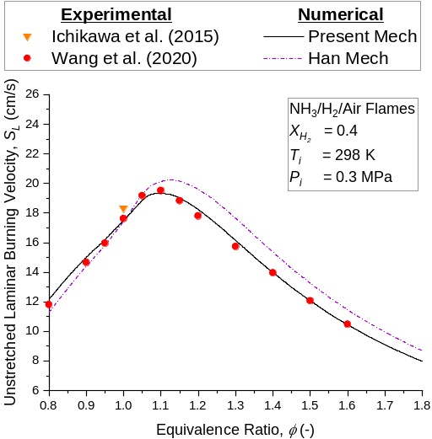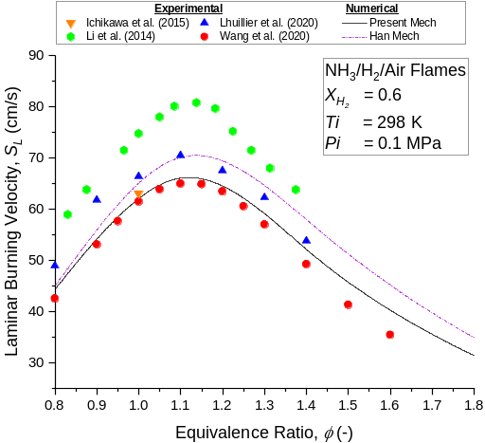
(a) (b)
Fig. S9. Unstretched laminar burning velocity of NH₃/H₂/Air premixed flames for various equivalence ratios with (a) X_{H2} = 0.4 at 0.3 MPa and (b) X_{H2} = 0.6 at 0.1 MPa.

Figure S10 shows S_{L} comparison of stoichiometry flames with various X_{H2} at 0.1 MPa (Fig. S10a) and 0.5 MPa (Fig. S10b). The comparison shows that both mechanisms have close prediction from X_{H2} = 0 to X_{H2} = 0.5 and fit with the experimental data [34–43]. At X_{H2} ≈ 0.5 and above, the predictions between the two mechanisms start to deviate with Han Mech predicting higher S_{L} than Present Mech. The accuracy of the mechanisms cannot be determined at X_{H2} ≈ 0.5 and above under 0.1 MPa, and for measurements under 0.5 MPa since S_{L} measurements are scarce.
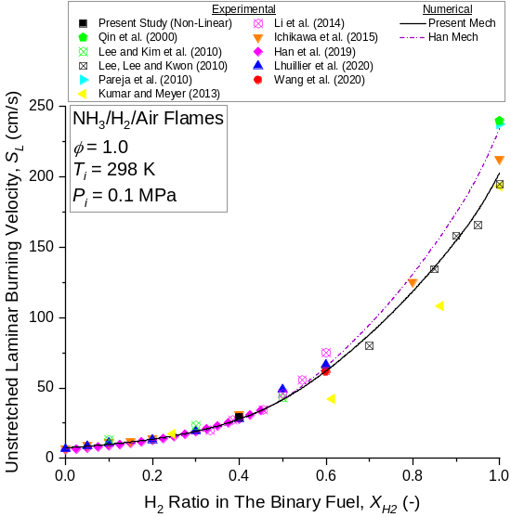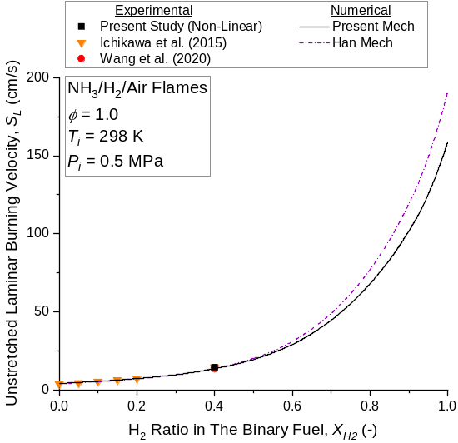
(a) (b)
Fig. S10. Unstretched laminar burning velocity of NH₃/H₂/Air premixed flames at various equivalence ratios and H₂ ratio in the binary fuel under (a) 0.1 MPa and (b) 0.5 MPa.

In order to further scrutinize the results shown in Fig. S10, S_{L} measurements and predictions for H₂/Air flames were compared and shown in Fig. S11. The comparison shows that both mechanisms can satisfactorily predict the measured S_{L} [34,38,40–42,44–46]. The lower S_{L} predictions from the Present Mech compared to Han Mech can be attributed to the modified rate constants for H₂ based reactions such as H + HO₂ = H₂ + O₂ and OH + H₂ = H + H₂O.

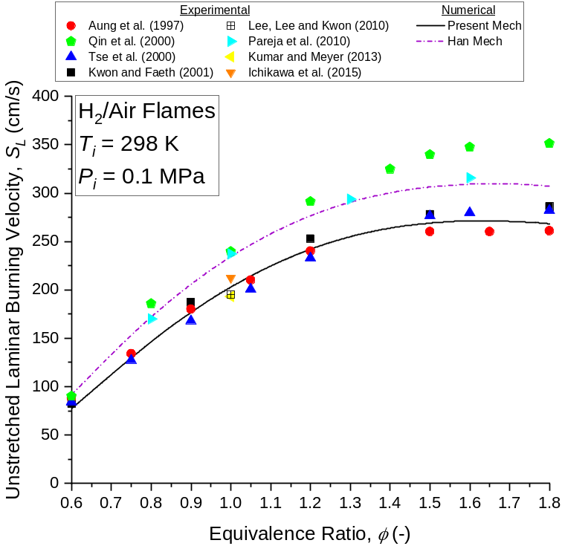
Fig. S11. Unstretched laminar Burning Velocity of H₂/Air premixed flames for various equivalence ratios under 0.1 MPa.

Figure. S12 shows comparison between experimental [2,47–49] and numerical S_{L} of NH₃/Air premixed flames. Comparison from Fig. S12 shows that the Present Mech overestimates lean S_{L} than Han Mech. At rich condition under 0.1 MPa, predictions from the Present Mech are slightly higher than Han Mech. The reason for the higher lean predictions from the Present Mech is the modifications of the rate constants for NH₃ based reactions, particularly those that increase the predicted lean S_{L}, as discussed in Section S.2.
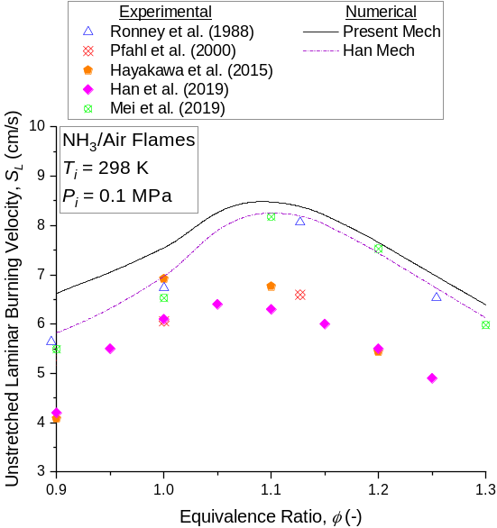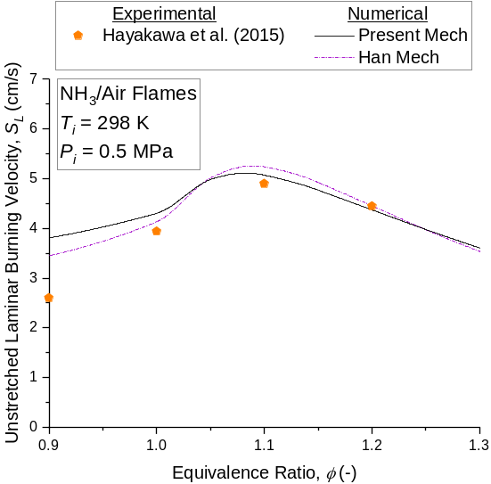
(a) (b)
Fig. S12. Unstretched laminar Burning Velocity of NH₃/Air premixed flames for various equivalence ratios under (a) 0.1 MPa and (b) 0.5 MPa.
- Properties of the mixtures for the theoretical evaluation of the Markstein length

Properties of the mixtures for the theoretical evaluation of the Markstein length at 0.1 MPa
Equivalence ratio, ϕ [-] | Unburnt density, ρ_{u} [kg/m³] | Burned gas density, ρ_{b} [kg/m³] | Adiabatic flame temperature, T_{b} [K] | Inner layer temperature, T⁰ [K] | Zeldovich number, Ze [-] | Effective Lewis number (volume), Le_{eff} (volume) [-] | Effective Lewis number (diffusion), Le_{eff} (diffusion) [-] | Thermal conductivity, λ [W/(mK)] | Specific heat capacity, c_{p} [J/(kg/K)] | Preheat zone thickness, δ_{l} [mm] | Theoretical Markstein length (volume), L_{bT} (volume) [mm] | Theoretical Markstein length (diffusion), L_{bT} (diffusion) [mm]
0.8 | 1.030 | 0.158 | 1955.581 | 1250.720 | 9.407 | 0.908 | 0.723 | 0.0334 | 1186.2 | 0.136 | 0.035 | -0.049
0.9 | 1.016 | 0.147 | 2079.345 | 1250.541 | 8.597 | 0.971 | 0.812 | 0.0341 | 1206 | 0.114 | 0.053 | -0.002
1.0 | 1.002 | 0.139 | 2172.704 | 1250.039 | 8.127 | 1.061 | 0.940 | 0.0348 | 1225.4 | 0.102 | 0.073 | 0.038
1.1 | 0.989 | 0.137 | 2143.970 | 1232.217 | 8.099 | 1.145 | 1.059 | 0.0355 | 1244.4 | 0.099 | 0.094 | 0.070
1.2 | 0.976 | 0.137 | 2081.691 | 1223.741 | 8.316 | 1.199 | 1.133 | 0.0361 | 1263.1 | 0.110 | 0.123 | 0.102
1.4 | 0.953 | 0.139 | 1960.434 | 1187.493 | 8.603 | 1.267 | 1.222 | 0.0373 | 1299.1 | 0.147 | 0.200 | 0.180
1.6 | 0.931 | 0.141 | 1849.446 | 1177.484 | 9.235 | 1.316 | 1.283 | 0.0385 | 1333.5 | 0.201 | 0.319 | 0.298
1.8 | 0.912 | 0.143 | 1748.336 | 1177.621 | 10.165 | 1.353 | 1.329 | 0.0395 | 1366.8 | 0.269 | 0.497 | 0.474

Properties of the mixtures for the theoretical evaluation of the Markstein length at 0.5 MPa
Equivalence ratio, ϕ [-] | Unburnt density, ρ_{u} [kg/m³] | Burned gas density, ρ_{b} [kg/m³] | Adiabatic flame temperature, T_{b} [K] | Inner layer temperature, T⁰ [K] | Zeldovich number, Ze [-] | Effective Lewis number (volume), Le_{eff} (volume) [-] | Effective Lewis number (diffusion), Le_{eff} (diffusion) [-] | Thermal conductivity, λ [W/(mK)] | Specific heat capacity, c_{p} [J/(kg/K)] | Preheat zone thickness, δ_{l} [mm] | Theoretical Markstein length (volume), L_{bT} (volume) [mm] | Theoretical Markstein length (diffusion), L_{bT} (diffusion) [mm]
0.8 | 5.151 | 0.791 | 1959.37 | 1380.841 | 11.48683 | 0.896 | 0.705 | 0.0334 | 1186.2 | 0.058 | 0.008 | -0.037
0.9 | 5.078 | 0.732 | 2087.80 | 1387.017 | 10.21598 | 0.961 | 0.797 | 0.0341 | 1206.0 | 0.047 | 0.019 | -0.008
1.0 | 5.009 | 0.687 | 2193.08 | 1379.664 | 9.319118 | 1.061 | 0.940 | 0.0348 | 1225.4 | 0.041 | 0.030 | 0.014
1.1 | 4.943 | 0.683 | 2151.27 | 1332.068 | 9.049142 | 1.151 | 1.067 | 0.0355 | 1244.4 | 0.037 | 0.038 | 0.028
1.2 | 4.881 | 0.686 | 2085.72 | 1310.488 | 9.224208 | 1.205 | 1.142 | 0.0361 | 1263.1 | 0.040 | 0.048 | 0.040
1.4 | 4.764 | 0.694 | 1962.18 | 1283.463 | 9.807842 | 1.275 | 1.234 | 0.0373 | 1299.1 | 0.054 | 0.082 | 0.074
1.6 | 4.657 | 0.704 | 1850.25 | 1274.478 | 10.78377 | 1.324 | 1.295 | 0.0385 | 1333.5 | 0.075 | 0.134 | 0.126
1.8 | 4.559 | 0.714 | 1748.71 | 1250.777 | 11.65384 | 1.359 | 1.337 | 0.0395 | 1366.8 | 0.101 | 0.207 | 0.198

References

[1] X. Han, Z. Wang, Y. He, Y. Zhu, K. Cen, Experimental and kinetic modeling study of laminar burning velocities of NH₃/syngas/air premixed flames, Combust. Flame 213 (2020) 1-13.
[2] B. Mei, X. Zhang, S. Ma, M. Cui, H. Guo, Z. Cao, Y. Li, Experimental and kinetic modeling investigation on the laminar flame propagation of ammonia under oxygen enrichment and elevated pressure conditions, Combust. Flame 210 (2019) 236-246.
[3] H. Nakamura, S. Hasegawa, T. Tezuka, Kinetic modeling of ammonia/air weak flames in a micro flow reactor with a controlled temperature profile, Combust. Flame 185 (2017) 16-27.
[4] E.C. Okafor, Y. Naito, S. Colson, A. Ichikawa, T. Kudo, A. Hayakawa, H. Kobayashi, Experimental and numerical study of the laminar burning velocity of CH₄-NH₃-air premixed flames, Combust. Flame 187 (2018) 185-198.
[5] J. Otomo, M. Koshi, T. Mitsumori, H. Iwasaki, K. Yamada, Chemical kinetic modeling of ammonia oxidation with improved reaction mechanism for ammonia/air and ammonia/hydrogen/air combustion, Int. J. Hydrogen Energy 43 (2018) 3004-3014.
[6] H. Nozari, A. Karabeyoğlu, Combustion characteristics of ammonia as a renewable energy source and development of reduced chemical mechanisms, 13th International Energy Conversion Engineering Conference (2015), AIAA 2015-3917.
[7] S.H. Mousavipour, V. Saheb, Theoretical study on the kinetic and mechanism of H + HO₂ reaction, Bull. Chem. Soc. Jpn. 80 (2007) 1901-1913.
[8] T. Varga, C. Olm, T. Nagy, I.G. Zsély, É. Valkó, R. Pálvölgyi, H.J. Curran, T. Turányi, Development of a joint hydrogen and syngas combustion mechanism based on an optimization approach, Int. J. Chem. Kinet. 48 (2016) 407–422.
[9] W. Tsang, R.F. Hampson, Chemical kinetic data base for combustion chemistry. Part I. Methane and related compounds, J. Phys. Chem. Ref. Data. 15 (1986) 1087–1279.
[10] Y. Hidaka, T. Taniguchi, H. Tanaka, T. Kamesawa, K. Inami, H. Kawano, Shock-tube study of CH2O pyrolysis and oxidation, Combust. Flame 92 (1993) 365–376.
[11] S.P. Karkach, V.I. Osherov, Ab initio analysis of the transition states on the lowest triplet H2O2 potential surface, J. Chem. Phys. 110 (1999) 11918–11927.
[12] A.M. Dean, J.W. Bozzelli, Combustion chemistry of nitrogen, in: W.C. Gardiner Jr. (Ed.), Gas-phase Combustion Chemistry, Springer Science+Business Media, New York, 2000, pp. 125-341.
[13] A. Stagni, C. Cavallotti, S. Arunthanayothin, Y. Song, O. Herbinet, F. Battin-Leclerc, T. Faravelli, An experimental, theoretical and kinetic-modeling study of the gas-phase oxidation of ammonia, React. Chem. Eng. 5 (2020) 696-711.
[14] H.M.T. Nguyen, S. Zhang, J. Peeters, T.N. Truong, M.T. Nguyen, Direct ab initio dynamics studies of the reactions of HNO with H and OH radicals, Chem. Phys. Lett. 388 (2004) 94-99.
[15] P. Glarborg, J.A. Miller, B. Ruscic, S.J. Klippenstein, Modeling nitrogen chemistry in combustion, Prog. Energy Combust. Sci. 67 (2018) 31-68.
[16] D.L. Baulch, M.J. Pilling, C.J. Cobos, R.A. Cox, C. Esser, P. Frank, T. Just, J.A. Kerr, J. Troe, R.W. Walker, J. Warnatz, Evaluated kinetic data for combustion modelling, J. Phys. Chem. Ref. Data 21 (1994) 411-734.
[17] P. Klaus, Entwicklung eines detaillierten Reaktionsmechanismus zur Modellierung der Bildung von Stickoxiden in Flammenfronten, Ph.D. Thesis, Ruprecht-Karls-Universität Heidelberg, Heidelberg, Germany, 1997.
[18] K.P. Shrestha, C. Lhuillier, A.A. Barbosa, P. Brequigny, F. Contino, C. Mounaïm-Rousselle, L. Seidel, F. Mauss, An experimental and modeling study of ammonia with enriched oxygen content and ammonia/hydrogen laminar flame speed at elevated pressure and temperature, Proc. Combust. Inst. 38 (2021) 2163–2174.
[19] N. Stothard, R. Humpfer, H.H. Grotheer, The multichannel reaction NH₂ + NH₂ at ambient temperature and low pressures, Chem. Phys. Lett. 240 (1995) 474-480.
[20] H. Kobayashi, A. Hayakawa, K.D.K.A. Somarathne, E.C. Okafor, Science and technology of ammonia combustion, Proc. Combust. Inst. 37 (2019) 109-133.
[21] X. He, B. Shu, D. Nascimento, K. Moshammer, M. Costa, R.X. Fernandes, Auto-ignition kinetics of ammonia and ammonia/hydrogen mixtures at intermediate temperatures and high pressures, Combust. Flame 206 (2019) 189-200.
[22] P. Glarborg, P.G. Kristensen, K. Dam-Johansen, J.A. Miller, Branching fraction of the NH2 + NO reaction between 1210 and 1370 K, J. Phys. Chem. A. 101 (1997) 3741–3745.
[23] J. Park, M.C. Lin, Laser-initiated NO reduction by NH3: Total rate constant and product branching ratio measurements for the NH2 + NO reaction, J. Phys. Chem. A. 101 (1997) 5–13.
[24] R.K. Lyon, Thermal DeNO_{x} Controlling nitrogen oxides emissions by a noncatalytic process, Environ. Sci. Technol. 21 (1987) 231-236.
[25] G. Altinay, R.G. Macdonald, Determination of the rate constants for the NH₂(X²B₁) + NH₂(X²B₁) and NH₂(X²B₁) + H recombination reactions in N₂ as a function of temperature and pressure, J. Phys. Chem. A 119 (2015) 7593-7610.
[26] J.W. Bozzelli, A.M. Dean, O + NNH: A possible new route for NO_{X} formation in flames, Int. J. Chem. Kinet. 27 (1995) 1097-1109.
[27] J. Li, H. Huang, N. Kobayashi, C. Wang, H. Yuan, Numerical study on laminar burning velocity and ignition delay time of ammonia flame with hydrogen addition, Energy 126 (2017) 796-809.
[28] K.Y. Lam, D.F. Davidson, R.K. Hanson, A shock tube study of H₂ + OH → H₂O + H using OH laser absorption, Int. J. Chem. Kinet. 45 (2013) 363-373.
[29] F.P. Tully, A.R. Ravishankara, Flash photolysis-resonance fluorescence kinetic study of the reactions OH + H2 → H2O + H and OH + CH4 → H2O + CH3 from 298 to 1020 K, J. Phys. Chem. 84 (1980) 3126–3130.
[30] J. V. Michael, J.W. Sutherland, Rate constant for the reaction of H with H2O and OH with H2 by the flash photolysis-shock tube technique over the temperature range 1246-2297 K, J. Phys. Chem. 92 (1988) 3853–3857.
[31] R.C. Oldenborg, G.W. Loge, D.M. Harradine, K.R. Winn, Kinetic study of the hydrogel + hydrogen reaction from 800 to 1550 K, J. Phys. Chem. 96 (1992) 8426–8430.
[32] L.N. Krasnoperov, J. V. Michael, Shock tube studies using a novel multipass absorption Cell: Rate constant results for OH + H2 and OH + C2H6, J. Phys. Chem. A. 108 (2004) 5643–5648.
[33] T.L. Nguyen, J.F. Stanton, J.R. Barker, Ab initio reaction rate constants computed using semiclassical transition-state theory: HO + H2 → H2O + H and isotopologues, J. Phys. Chem. A. 115 (2011) 5118–5126.
[34] A. Ichikawa, A. Hayakawa, Y. Kitagawa, K.D.K.A. Somarathne, T. Kudo, H. Kobayashi, Laminar burning velocity and Markstein length of ammonia/hydrogen/air premixed flames at elevated pressures, Int. J. Hydrogen Energy 40 (2015) 9570-9578.
[35] S. Wang, Z. Wang, A.M. Elbaz, X. Han, Y. He, M. Costa, A.A. Konnov, W.L. Roberts, Experimental study and kinetic analysis of the laminar burning velocity of NH₃/syngas/air, NH₃/CO/air and NH₃/H₂/air premixed flames at elevated pressures, Combust. Flame 221 (2020) 270-287.
[36] J. Li, H. Huang, N. Kobayashi, Z. He, Y. Nagai, Study on using hydrogen and ammonia as fuels: Combustion characteristics and NO_{x} formation, Int. J. Energy Res. 38 (2014) 1214-1223.
[37] C. Lhuillier, P. Brequigny, N. Lamoureux, F. Contino, C. Mounaïm-Rousselle, Experimental investigation on laminar burning velocities of ammonia/hydrogen/air mixtures at elevated temperatures, Fuel 263 (2020) 116653.
[38] X. Qin, H. Kobayashi, T. Niioka, Laminar burning velocity of hydrogen-air premixed flames at elevated pressure, Exp. Therm. Fluid Sci. 21 (2000) 58-63.
[39] J.H. Lee, J.H. Kim, J.H. Park, O.C. Kwon, Studies on properties of laminar premixed hydrogen-added ammonia/air flames for hydrogen production, Int. J. Hydrogen Energy 35 (2010) 1054-1064.
[40] J.H. Lee, S.I. Lee, O.C. Kwon, Effects of ammonia substitution on hydrogen/air flame propagation and emissions, Int. J. Hydrogen Energy 35 (2010) 11332-11341.
[41] J. Pareja, H.J. Burbano, Y. Ogami, Measurements of the laminar burning velocity of hydrogen-air premixed flames, Int. J. Hydrogen Energy 35 (2010) 1812-1818.
[42] P. Kumar, T.R. Meyer, Experimental and modeling study of chemical-kinetics mechanisms for H₂-NH₃-air mixtures in laminar premixed jet flames, Fuel 108 (2013) 166-176.
[43] X. Han, Z. Wang, M. Costa, Z. Sun, Y. He, K. Cen, Experimental and kinetic modeling study of laminar burning velocities of NH₃/air, NH₃/H₂/air, NH₃/CO/air and NH₃/CH₄/air premixed flames, Combust. Flame 206 (2019) 214-226.
[44] T. Aung, M.I. Hassan, G.M. Faeth, Flame stretch interactions of laminar premixed hydrogen/air flames at normal temperature and pressure, Combust. Flame 109 (1997) 1-24.
[45] S.D. Tse, D.L. Zhu, C.K. Law, Morphology and burning rates of expanding spherical flames in H₂/O₂/inert mixtures up to 60 atmospheres, Proc. Combust. Inst. 28 (2000) 1793-1800.
[46] O.C. Kwon, G.M. Faeth, Flame/stretch interactions of premixed hydrogen-fueled flames: Measurements and predictions, Combust. Flame 124 (2001) 590-610.
[47] P.D. Ronney, Effect of chemistry and transport properties on near-limit flames at microgravity, Combust. Sci. Technol. 59 (1988) 123-141.
[48] U.J. Pfahl, M.C. Ross, J.E. Shepherd, K.O. Pasamehmetoglu, C. Unal, Flammability limits, ignition energy, and flame speeds in H₂-CH₄-NH₃-N₂O-O₂-N₂ mixtures, Combust. Flame 123 (2000) 140-158.
[49] A. Hayakawa, T. Goto, R. Mimoto, Y. Arakawa, T. Kudo, H. Kobayashi, Laminar burning velocity and Markstein length of ammonia/air premixed flames at various pressures, Fuel 159 (2015) 98-106.

