БЕЛОРУССКИЙ ГОСУДАРСТВЕННЫЙ УНИВЕРСИТЕТ ИНФОРМАТИКИ И РАДИОЭЛЕКТРОНИКИ
Кафедра программного обеспечения информационных технологий

Факультет НиДО
Специальность ПОИТ

Контрольная работа № 1.1
по дисциплине
«Программное обеспечение встроенных систем»

Выполнил: Старостин Н.А.

Минск, 2022

Задание

“Светофор”
Напишите программу, управляющую тремя светофорами на T-образном перекрестке.
Машины с дороги A и B могут двигаться прямо или поворачивать направо. Машины с дороги C могут поворачивать налево и направо. Для каждого светофора имеется предопределенная последовательность цветов:

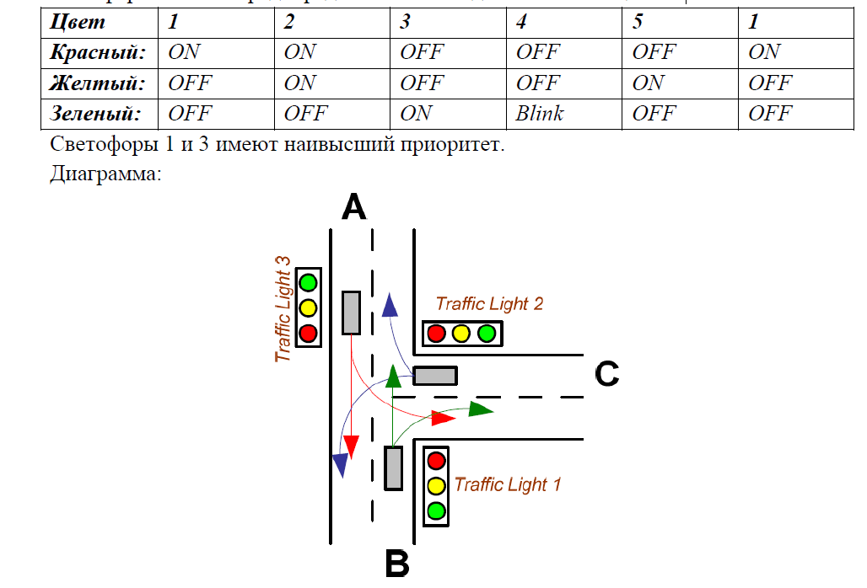
Схема устройства:
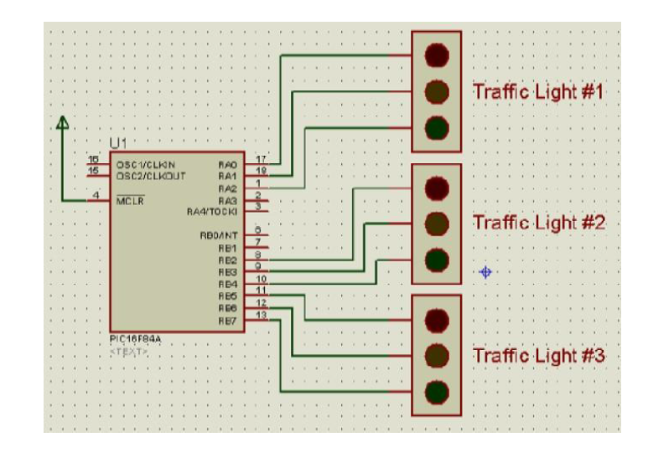

Решение
#include p16f84a.inc ; Include register definition file

delay1 equ 0x30
delay2 equ 0x31

;====================================================================
; VARIABLES
;====================================================================

;====================================================================
; RESET and INTERRUPT VECTORS
;====================================================================

; Reset Vector
RST code 0x0
goto Start

DELAY_SMALL:
BCF STATUS, RP0 ; Bank 0
MOVLW 0x4E
MOVWF delay1
MOVLW 0x20
MOVWF delay2
DELAY_SMALL_DELAY_LOOP_START:
DECFSZ delay1, 1
GOTO DELAY_SMALL_DELAY_LOOP_ADDITIONAL
DECFSZ delay2, 1
DELAY_SMALL_DELAY_LOOP_ADDITIONAL:
GOTO DELAY_SMALL_DELAY_LOOP_START
RETURN

DELAY:
BCF STATUS, RP0 ; Bank 0
MOVLW 0x4E
MOVWF delay1
MOVLW 0xC4
MOVWF delay2
DELAY_LOOP_START:
DECFSZ delay1, 1
GOTO DELAY_LOOP_ADDITIONAL
DECFSZ delay2, 1
DELAY_LOOP_ADDITIONAL:
GOTO DELAY_LOOP_START
RETURN
;====================================================================
; CODE SEGMENT
;====================================================================

ITERATE_TRAFFIC:
BCF STATUS, RP0
; all red
MOVLW b'00000001'
MOVWF PORTA
MOVLW b'00100100'
MOVWF PORTB
CALL DELAY

; red with yellow 1 and 3, 2 is red
MOVLW b'00000011'
MOVWF PORTA
MOVLW b'01100100'
MOVWF PORTB
CALL DELAY_SMALL

; green 1 and 3, 2 is red
MOVLW b'00000100'
MOVWF PORTA
MOVLW b'10000100'
MOVWF PORTB
CALL DELAY
CALL DELAY

; green 3, 1 is blinking, 2 is red
MOVLW b'00000000'
MOVWF PORTA
CALL DELAY_SMALL
MOVLW b'00000100'
MOVWF PORTA
CALL DELAY_SMALL

; green 3, 1 is yellow, 2 is red
MOVLW b'00000010'
MOVWF PORTA
MOVLW b'10000100'
MOVWF PORTB
CALL DELAY_SMALL

; green 3, 2 and 1 are red
MOVLW b'00000001'
MOVWF PORTA
MOVLW b'10000100'
MOVWF PORTB
CALL DELAY
CALL DELAY

; blink 3, 2 and 1 are red
MOVLW b'00000100'
MOVWF PORTB
CALL DELAY_SMALL
MOVLW b'10000100'
MOVWF PORTB
CALL DELAY_SMALL

; yellow 3, yellow and red 2, 1 is red
MOVLW b'01001100'
MOVWF PORTB
CALL DELAY_SMALL

; red 3, green 2, 1 is red
MOVLW b'00110000'
MOVWF PORTB
CALL DELAY
CALL DELAY

;blink 2, 3 is red, 1 is red
MOVLW b'00100000'
MOVWF PORTB
CALL DELAY_SMALL
MOVLW b'00110000'
MOVWF PORTB
CALL DELAY_SMALL

; yellow 2, 3 is red, 1 is yellow with red
MOVLW b'00000011'
MOVWF PORTA
MOVLW b'00101000'
MOVWF PORTB
CALL DELAY

; 2 and 3 are red, 1 is green
MOVLW b'00000100'
MOVWF PORTA
MOVLW b'00100100'
MOVWF PORTB
CALL DELAY
CALL DELAY

; blink 1, 2 and 3 are red
MOVLW b'00000000'
MOVWF PORTA
CALL DELAY_SMALL
MOVLW b'00000100'
MOVWF PORTA
CALL DELAY_SMALL

; 3 and 2 are red, 1 is yellow
MOVLW b'00000010'
MOVWF PORTA
CALL DELAY
; with next iteration initial state are all red
RETURN

PGM code
Start
BCF STATUS, RP0
CLRF PORTB
CLRF PORTA
BSF STATUS, RP0
CLRF TRISB
BSF TRISB, 0
CLRF TRISA
BCF STATUS, RP0

Loop
CALL ITERATE_TRAFFIC
goto Loop

;====================================================================
END

