Лабораторная работа №7
Тема: Отладка отдельных модулей программного проекта.
Организация обработки исключений.
Выполнил: Майсак Никита ПР 23/2
Цель: создать программный проект в среде Visual Studio на языке C#, реализовать организацию обработки исключений для обеспечения надежной работы приложения, а также разработать функционал для оформления предзаказов с использованием базы данных MS SQL Server.

Ход работы
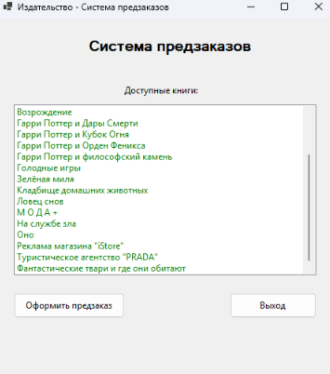
Рисунок 1 — Выбор книги
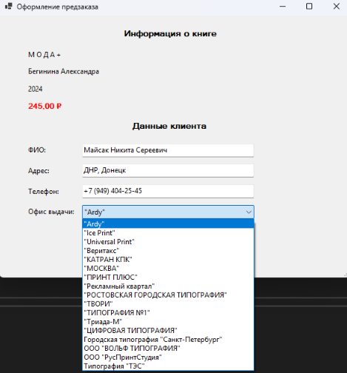
Рисунок 2 — Ввод данных клиента

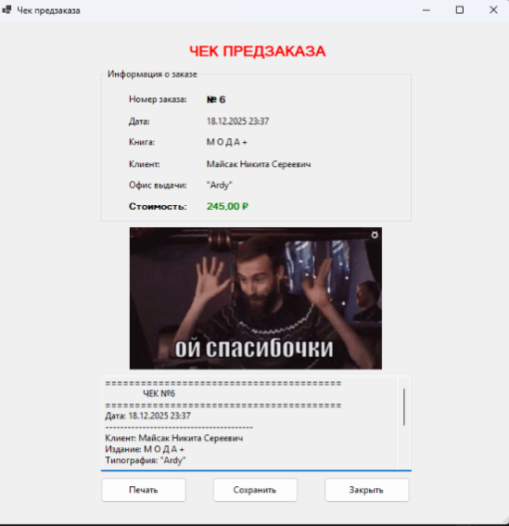
Рисунок 3 — Формирование чека
Листинг кода:
using System;
using Microsoft.Data.SqlClient;
using System.Collections.Generic;

namespace PR7
{
public class DatabaseHelper : IDisposable
{
private string connectionString = @"Data Source=DESKTOP-HKB5J94;Initial Catalog=publishing;Integrated Security=True;TrustServerCertificate=True;Connect Timeout=30";
public List<Book> GetBooks()
{
var books = new List<Book>();
try
{
using (var connection = new SqlConnection(connectionString))
{
connection.Open();
string query = @"
SELECT p.id_Publication, p.Name, p.Author,
a.Surname + ' ' + a.Name as AuthorName,
p.ReleaseYear, p.VolumeOfSheets, p.Circulation, p.Price
FROM Publications p
LEFT JOIN Authors a ON p.Author = a.id_Author
ORDER BY p.Name";

using (var command = new SqlCommand(query, connection))
using (var reader = command.ExecuteReader())
{
while (reader.Read())
{
books.Add(new Book
{
Id = (int)reader["id_Publication"],
Title = reader["Name"].ToString(),
AuthorId = reader["Author"] != DBNull.Value ? (int)reader["Author"] : 0,
AuthorName = reader["AuthorName"].ToString(),
ReleaseYear = (int)reader["ReleaseYear"],
Pages = (int)reader["VolumeOfSheets"],
Circulation = (int)reader["Circulation"],
Price = (decimal)reader["Price"]
});
}
}
}
}
catch (Exception ex)
{
throw new Exception($"Ошибка при загрузке книг: {ex.Message}");
}
return books;
}

public List<Office> GetOffices()
{
var offices = new List<Office>();
try
{
using (var connection = new SqlConnection(connectionString))
{
connection.Open();
string query = "SELECT id_Office, Office, Address, Phone FROM Offices ORDER BY Office";

using (var command = new SqlCommand(query, connection))
using (var reader = command.ExecuteReader())
{
while (reader.Read())
{
offices.Add(new Office
{
Id = (int)reader["id_Office"],
Name = reader["Office"].ToString(),
Address = reader["Address"].ToString(),
Phone = reader["Phone"].ToString()
});
}
}
}
}
catch (Exception ex)
{
throw new Exception($"Ошибка при загрузке офисов: {ex.Message}");
}
return offices;
}

public int CreateOrder(Order order)
{
try
{
using (var connection = new SqlConnection(connectionString))
{
connection.Open();
string query = @"
INSERT INTO Orders (Name, Type, Publication, Office, Customer,
DateOfAdmission, DateOfCompletion, Price)
VALUES (@Name, 1, @Publication, @Office, @Customer,
@DateOfAdmission, @DateOfCompletion, @Price);
SELECT SCOPE_IDENTITY();";

using (var command = new SqlCommand(query, connection))
{
command.Parameters.AddWithValue("@Name", order.OrderName);
command.Parameters.AddWithValue("@Publication", order.BookId);
command.Parameters.AddWithValue("@Office", order.OfficeId);
command.Parameters.AddWithValue("@Customer", order.CustomerId);
command.Parameters.AddWithValue("@DateOfAdmission", order.OrderDate);

if (order.CompletionDate.HasValue)
command.Parameters.AddWithValue("@DateOfCompletion", order.CompletionDate.Value);
else
command.Parameters.AddWithValue("@DateOfCompletion", DBNull.Value);

command.Parameters.AddWithValue("@Price", order.Price);

return Convert.ToInt32(command.ExecuteScalar());
}
}
}
catch (Exception ex)
{
throw new Exception($"Ошибка при создании заказа: {ex.Message}");
}
}

public int CreateCustomer(Customer customer)
{
try
{
using (var connection = new SqlConnection(connectionString))
{
connection.Open();
string query = @"
INSERT INTO Customers (Name, Type, Address, Phone)
VALUES (@Name, 1, @Address, @Phone);
SELECT SCOPE_IDENTITY();";

using (var command = new SqlCommand(query, connection))
{
command.Parameters.AddWithValue("@Name", customer.Name);
command.Parameters.AddWithValue("@Address",
string.IsNullOrEmpty(customer.Address) ? (object)DBNull.Value : customer.Address);
command.Parameters.AddWithValue("@Phone",
string.IsNullOrEmpty(customer.Phone) ? (object)DBNull.Value : customer.Phone);

return Convert.ToInt32(command.ExecuteScalar());
}
}
}
catch (Exception ex)
{
throw new Exception($"Ошибка при создании клиента: {ex.Message}");
}
}

public Order GetOrderDetails(int orderId)
{
try
{
using var connection = new SqlConnection(connectionString);
connection.Open();
string query = @"
SELECT o.id_Order, o.Name as OrderName, o.DateOfAdmission,
o.Price, p.Name as BookTitle, c.Name as CustomerName,
ofc.Office as OfficeName
FROM Orders o
LEFT JOIN Publications p ON o.Publication = p.id_Publication
LEFT JOIN Customers c ON o.Customer = c.id_Customer
LEFT JOIN Offices ofc ON o.Office = ofc.id_Office
WHERE o.id_Order = @OrderId";

using (var command = new SqlCommand(query, connection))
{
command.Parameters.AddWithValue("@OrderId", orderId);

using (var reader = command.ExecuteReader())
{
if (reader.Read())
{
return new Order
{
Id = (int)reader["id_Order"],
OrderName = reader["OrderName"].ToString(),
BookTitle = reader["BookTitle"].ToString(),
CustomerName = reader["CustomerName"].ToString(),
OfficeName = reader["OfficeName"].ToString(),
OrderDate = (DateTime)reader["DateOfAdmission"],
Price = (decimal)reader["Price"]
};
}
}
}
}
catch (Exception ex)
{
throw new Exception($"Ошибка при получении деталей заказа: {ex.Message}");
}
return null;
}

public bool TestConnection()
{
try
{
using (var connection = new SqlConnection(connectionString))
{
connection.Open();
return connection.State == System.Data.ConnectionState.Open;
}
}
catch (Exception ex)
{
Console.WriteLine($"Connection test failed: {ex.Message}");
return false;
}
}

public void Dispose()
{
// Очистка ресурсов при необходимости
}
}
}

using System;
using System.Windows.Forms;

namespace PR7
{
public partial class FormOrder : Form
{
private DatabaseHelper dbHelper;
private Book selectedBook;

public FormOrder(DatabaseHelper dbHelper, Book book)
{
InitializeComponent();
this.dbHelper = dbHelper;
this.selectedBook = book;

LoadOffices();
InitializeForm();
}

private void InitializeForm()
{
bookTitleLabel.Text = selectedBook.Title;
authorLabel.Text = selectedBook.AuthorName;
yearLabel.Text = selectedBook.ReleaseYear.ToString();
priceLabel.Text = $"{selectedBook.Price:C}";
}

private void LoadOffices()
{
try
{
var offices = dbHelper.GetOffices();
officeComboBox.DataSource = offices;
officeComboBox.DisplayMember = "Name";
officeComboBox.ValueMember = "Id";
}
catch (Exception ex)
{
MessageBox.Show($"Ошибка при загрузке офисов: {ex.Message}", "Ошибка",
MessageBoxButtons.OK, MessageBoxIcon.Error);
}
}

private void createOrderButton_Click(object sender, EventArgs e)
{
try
{
// Валидация данных
if (string.IsNullOrWhiteSpace(customerNameTextBox.Text))
{
MessageBox.Show("Введите ФИО клиента", "Внимание",
MessageBoxButtons.OK, MessageBoxIcon.Warning);
return;
}

if (officeComboBox.SelectedItem == null)
{
MessageBox.Show("Выберите офис", "Внимание",
MessageBoxButtons.OK, MessageBoxIcon.Warning);
return;
}

// Создаем клиента
var customer = new Customer
{
Name = customerNameTextBox.Text,
Address = addressTextBox.Text,
Phone = phoneTextBox.Text
};

// Сохраняем клиента в БД
int customerId = dbHelper.CreateCustomer(customer);

// Создаем заказ
var office = (Office)officeComboBox.SelectedItem;
var order = new Order
{
OrderName = $"Предзаказ: {selectedBook.Title}",
BookId = selectedBook.Id,
OfficeId = office.Id,
CustomerId = customerId,
OrderDate = DateTime.Now,
Price = selectedBook.Price
};

// Сохраняем заказ в БД
int orderId = dbHelper.CreateOrder(order);

// Показываем чек
var receiptForm = new FormReceipt(dbHelper, orderId);
receiptForm.ShowDialog();

MessageBox.Show("Заказ успешно оформлен!", "Успех",
MessageBoxButtons.OK, MessageBoxIcon.Information);

this.Close();
}
catch (Exception ex)
{
MessageBox.Show($"Ошибка при оформлении заказа: {ex.Message}", "Ошибка",
MessageBoxButtons.OK, MessageBoxIcon.Error);
}
}

private void cancelButton_Click(object sender, EventArgs e)
{
this.Close();
}

private void FormOrder_Load(object sender, EventArgs e)
{

}
}
}

using System;
using System.Windows.Forms;

namespace PR7
{
public partial class FormReceipt : Form
{
private DatabaseHelper dbHelper;
private int orderId;

public FormReceipt(DatabaseHelper dbHelper, int orderId)
{
InitializeComponent();
this.dbHelper = dbHelper;
this.orderId = orderId;

LoadReceiptData();
}

private void LoadReceiptData()
{
try
{
var order = dbHelper.GetOrderDetails(orderId);

if (order != null)
{
orderNumberLabel.Text = $"№ {order.Id}";
orderDateLabel.Text = order.OrderDate.ToString("dd.MM.yyyy HH:mm");
bookTitleLabel.Text = order.BookTitle;
customerNameLabel.Text = order.CustomerName;
officeLabel.Text = order.OfficeName;
priceLabel.Text = $"{order.Price:C}";

// Генерация текста для печати/сохранения
receiptTextBox.Text = GenerateReceiptText(order);
}
}
catch (Exception ex)
{
MessageBox.Show($"Ошибка при загрузке данных чека: {ex.Message}", "Ошибка",
MessageBoxButtons.OK, MessageBoxIcon.Error);
}
}

private string GenerateReceiptText(Order order)
{
return $"================================\n" +
$" ЧЕК ПРЕДЗАКАЗА\n" +
$"================================\n" +
$"Номер заказа: {order.Id}\n" +
$"Дата: {order.OrderDate:dd.MM.yyyy HH:mm}\n" +
$"================================\n" +
$"Книга: {order.BookTitle}\n" +
$"Клиент: {order.CustomerName}\n" +
$"Офис получения: {order.OfficeName}\n" +
$"================================\n" +
$"Стоимость: {order.Price:C}\n" +
$"================================\n" +
$"Спасибо за заказ!\n" +
$"Ожидайте уведомления о поступлении.";
}

private void printButton_Click(object sender, EventArgs e)
{
try
{
MessageBox.Show("Функция печати будет реализована позже", "Информация",
MessageBoxButtons.OK, MessageBoxIcon.Information);
}
catch (Exception ex)
{
MessageBox.Show($"Ошибка при печати: {ex.Message}", "Ошибка",
MessageBoxButtons.OK, MessageBoxIcon.Error);
}
}

private void saveButton_Click(object sender, EventArgs e)
{
try
{
SaveFileDialog saveDialog = new SaveFileDialog();
saveDialog.Filter = "Текстовые файлы (*.txt)|*.txt|Все файлы (*.*)|*.*";
saveDialog.Title = "Сохранить чек";
saveDialog.FileName = $"чек_заказа_{orderId}.txt";

if (saveDialog.ShowDialog() == DialogResult.OK)
{
System.IO.File.WriteAllText(saveDialog.FileName, receiptTextBox.Text);
MessageBox.Show("Чек успешно сохранен!", "Успех",
MessageBoxButtons.OK, MessageBoxIcon.Information);
}
}
catch (Exception ex)
{
MessageBox.Show($"Ошибка при сохранении: {ex.Message}", "Ошибка",
MessageBoxButtons.OK, MessageBoxIcon.Error);
}
}

private void closeButton_Click(object sender, EventArgs e)
{
this.Close();
}

private void receiptGroupBox_Enter(object sender, EventArgs e)
{

}
}
}

using Microsoft.Data.SqlClient;
using PR7;
using System.Windows.Forms;

namespace PR7
{
public partial class MainForm : Form
{
private DatabaseHelper dbHelper;

public MainForm()
{
InitializeComponent();
dbHelper = new DatabaseHelper();
LoadBooks();
TestConnection();
}

private void TestConnection()
{
try
{
if (dbHelper.TestConnection())
{
statusLabel.Text = "Подключено к базе данных";
statusLabel.ForeColor = System.Drawing.Color.Green;
}
else
{
statusLabel.Text = "Ошибка подключения к БД";
statusLabel.ForeColor = System.Drawing.Color.Red;
}
}
catch (Exception ex)
{
statusLabel.Text = $"Ошибка: {ex.Message}";
statusLabel.ForeColor = System.Drawing.Color.Red;
}
}

private void LoadBooks()
{
try
{
var books = dbHelper.GetBooks();
booksListBox.DataSource = books;
booksListBox.DisplayMember = "Title";
booksListBox.ValueMember = "Id";
}
catch (Exception ex)
{
MessageBox.Show($"Ошибка при загрузке книг: {ex.Message}", "Ошибка",
MessageBoxButtons.OK, MessageBoxIcon.Error);
}
}

private void createOrderButton_Click(object sender, EventArgs e)
{
if (booksListBox.SelectedItem == null)
{
MessageBox.Show("Выберите книгу для заказа", "Внимание",
MessageBoxButtons.OK, MessageBoxIcon.Warning);
return;
}

var selectedBook = (Book)booksListBox.SelectedItem;
var orderForm = new FormOrder(dbHelper, selectedBook);
orderForm.ShowDialog();
}

private void exitButton_Click(object sender, EventArgs e)
{
Application.Exit();
}

private void MainForm_Load(object sender, EventArgs e)
{

}
}
}

using System;
namespace PR7
{
public class Author
{
public int Id { get; set; }
public string Surname { get; set; }
public string Name { get; set; }
public string FullName => $"{Surname} {Name}";
}

public class Book
{
public int Id { get; set; }
public string Title { get; set; }
public int AuthorId { get; set; }
public string AuthorName { get; set; }
public int ReleaseYear { get; set; }
public int Pages { get; set; }
public int Circulation { get; set; }
public decimal Price { get; set; }
}

public class Customer
{
public int Id { get; set; }
public string Name { get; set; }
public string Address { get; set; }
public string Phone { get; set; }
public int Type { get; set; } = 1;
}

public class Office
{
public int Id { get; set; }
public string Name { get; set; }
public string Address { get; set; }
public string Phone { get; set; }
}

public class Order
{
public int Id { get; set; }
public string OrderName { get; set; }
public int BookId { get; set; }
public int OfficeId { get; set; }
public int CustomerId { get; set; }
public DateTime OrderDate { get; set; }
public DateTime? CompletionDate { get; set; }
public decimal Price { get; set; }

// Для отображения
public string BookTitle { get; set; }
public string CustomerName { get; set; }
public string OfficeName { get; set; }
}
}

using System;
namespace PR7
{
public class Author
{
public int Id { get; set; }
public string Surname { get; set; }
public string Name { get; set; }
public string FullName => $"{Surname} {Name}";
}

public class Book
{
public int Id { get; set; }
public string Title { get; set; }
public int AuthorId { get; set; }
public string AuthorName { get; set; }
public int ReleaseYear { get; set; }
public int Pages { get; set; }
public int Circulation { get; set; }
public decimal Price { get; set; }
}

public class Customer
{
public int Id { get; set; }
public string Name { get; set; }
public string Address { get; set; }
public string Phone { get; set; }
public int Type { get; set; } = 1;
}

public class Office
{
public int Id { get; set; }
public string Name { get; set; }
public string Address { get; set; }
public string Phone { get; set; }
}

public class Order
{
public int Id { get; set; }
public string OrderName { get; set; }
public int BookId { get; set; }
public int OfficeId { get; set; }
public int CustomerId { get; set; }
public DateTime OrderDate { get; set; }
public DateTime? CompletionDate { get; set; }
public decimal Price { get; set; }

// Для отображения
public string BookTitle { get; set; }
public string CustomerName { get; set; }
public string OfficeName { get; set; }
}
}

