The **Dynamic Systems Development technique (DSDM)** is an associate degree agile code development approach that provides a framework for building and maintaining systems. The DSDM philosophy is borrowed from a modified version of the sociologist principle—80 % of An application is often delivered in twenty percent of the time it’d desire deliver the entire (100 percent) application.

DSDM is An iterative code method within which every iteration follows the 80% rule that simply enough work is needed for every increment to facilitate movement to the following increment. The remaining detail is often completed later once a lot of business necessities are noted or changes are requested and accommodated.

The DSDM tool (www.dsdm.org) could be a worldwide cluster of member companies that put together tackle the role of “keeper” of the strategy. The pool has outlined AN [Agile Development Model](https://www.geeksforgeeks.org/software-engineering-agile-development-models/), known as the DSDM life cycle that defines 3 different unvarying cycles, preceded by 2 further life cycle activities:

1. **Feasibility Study:**  
   It establishes the essential business necessities and constraints related to the applying to be designed then assesses whether or not the application could be a viable candidate for the DSDM method.
2. **Business Study:**  
   It establishes the use and knowledge necessities that may permit the applying to supply business value; additionally, it is the essential application design and identifies the maintainability necessities for the applying.
3. **Functional Model Iteration:**  
   It produces a collection of progressive prototypes that demonstrate practicality for the client.  
   (Note: All DSDM prototypes are supposed to evolve into the deliverable application.) The intent throughout this unvarying cycle is to collect further necessities by eliciting feedback from users as they exercise the paradigm.
4. **Design and Build Iteration:**  
   It revisits prototypes designed throughout useful model iteration to make sure that everyone has been designed during a manner that may alter it to supply operational business price for finish users. In some cases, useful model iteration and style and build iteration occur at the same time.
5. **Implementation:**  
   It places the newest code increment (an “operationalized” prototype) into the operational surroundings. It ought to be noted that:
   * **(a)** the increment might not 100% complete or,
   * **(b)** changes are also requested because the increment is placed into place. In either case, DSDM development work continues by returning to the useful model iteration activity.

Below diagram describe the DSDM life cycle:

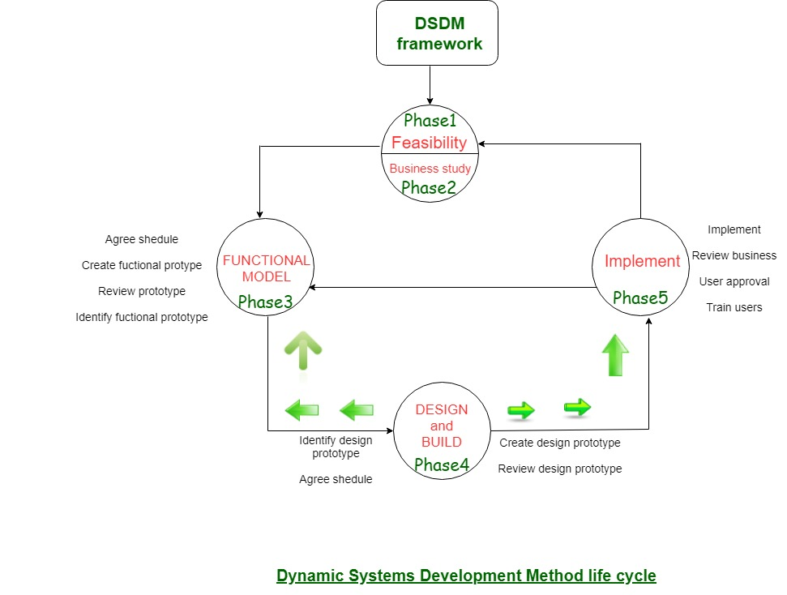

DSDM is often combined with XP to supply a mixed approach that defines a solid method model (the DSDM life cycle) with the barmy and bolt practices (XP) that are needed to create code increments.

additionally, the ASD ideas of collaboration and self-organizing groups are often tailored to a combined method model.

[Agile Methodology: What is Agile Model in Software Testing? (guru99.com)](https://www.guru99.com/agile-scrum-extreme-testing.html)