**Services App**

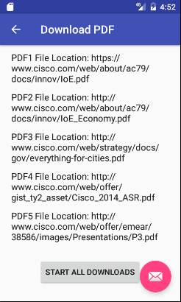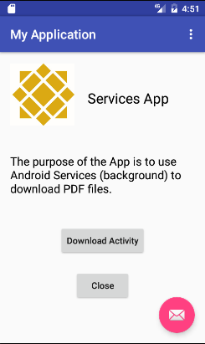

**Hardcoded PDF files location**

**Services App Main Activity**

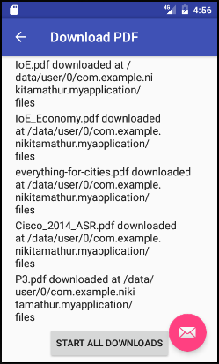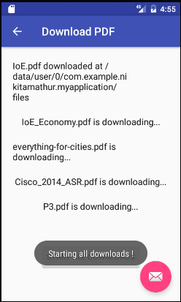

**All the PDF files starting to download**

**PDF files downloaded in the specified location**

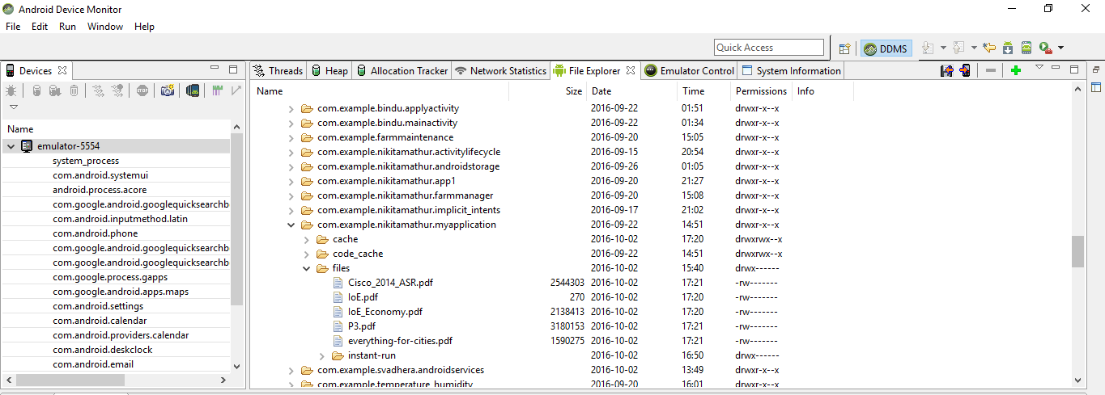

**Downloaded PDF files shown in the Android Device Monitor**