CyberShield AI: An Explainable Multi-Modal Artificial Intelligence Framework for Integrated Cyber Threat Detection

Nikita Vijay Patil
Department of Computer Engineering NMIMS Shirpur, Maharashtra, India
nikitaapawar33@gmail.com

Janhavi Jitendra Marathe
Department of Computer Engineering NMIMS Shirpur, Maharashtra, India
janhavii0145@gmail.com

Dr.Kiran salunke
Department of Computer Engineering NMIMS Shirpur, Maharashtra, India
Kiran.salunke@nmims.edu

ABSTRACT -With over 350 million UPI users, AI generated media and social engineering, India faces a multi-faceted cybersecurity threat that no isolated detection system can handle. This paper proposes CyberShield AI, an explainable multi-modal cybersecurity framework that combines 5 detection vectors in a production-grade web application: phishing email classification, malicious URL analysis, QR-code/UPI intent fraud detection, audio deepfake detection and video deepfake detection.
The framework's technical contribution is the novel Calibrated Hybrid Scoring Engine which combines ML predictions (75% weight) and domain specific heuristic rules (25% weight) with per-modality threshold calibration to produce a normalized risk score in \([0, 100]\) along with an explicit three-tier confidence annotation. Each analytical verdict is accompanied by an Explainability Report listing out contributing factors, triggered heuristic flags and localized advice in accordance with CERT-In and RBI guidelines. An integrated large language model assistant (Llama 3.3-70B via Groq) provides defensive-only security counseling.
The phishing email classifier demonstrates a perfect F1-score of 1.00 on an 80/20 held-out split
of our 40-sample bootstrap dataset, and 0.75 F1-score on 10 completely unseen out-of-distribution
emails. The URL heuristic engine achieves 93.3% categorical accuracy on 15 unseen validation URLs. While the core CNN architectures for our audio and video deepfake detectors are implemented and deployed in the framework, they have yet to be benchmarked on any large-scale public
datasets. We explicitly note this evaluation limitation and provide a replicable benchmarking protocol for future validation.
Keywords: Deepfake Detection, Phishing Email Classification, Malicious URL Detection, UPI QR Fraud, Hybrid Scoring, Explainable AI, Multi-Modal Cybersecurity, India, TF-IDF, Convolutional Neural Network, Calibrated Confidence.
I. INTRODUCTION
India’s digital revolution is underway and its cornerstone is the unified payments interface, which has over 350 million users and processes more than 20.64 lakh crore transactions per month. The scale of digitization creates new security challenges. India’s Computer Emergency Response Team received over 1.4 million cybersecurity incidents in 2023, and the Reserve Bank of India reported a 175% increase in financial phishing schemes in the first half of 2024.
Modern cyber-attacks are multi-vector, frequently combining multiple attack surfaces. A single fraudulent scheme could involve distribution of phishing emails, scanning of QR codes displayed on a POS machine and an AI-generated phone call offering assistance with tax clearance – all resulting in the theft of a UPI user’s OTP.
Despite the sophisticated nature of the attacks, the current security tools are siloed, unable to process multiple attack vectors in a coordinated manner. Email gateways cannot detect QR codes, URL reputation tools are not aware of local UPI QR code scanning processes and deepfake detection tools analyze voice content in isolation from the conversation’s context. This leaves organizations exposed and vulnerable in critical security gaps due to three key challenges:
• The Opacity Problem: Most machine-learning based security systems offer only binary classifications to end-users. A user who sees an ambiguous "DANGEROUS" pop-up without explanation is likely to ignore it. To most Indian users, a simple binary classification when reviewing a suspicious KYC update request offers no protection.
• Western Benchmarking: The academic data sets used to benchmark phishing classifiers (e.g., Enron/SpamAssassin) or deepfake detectors (FaceForensics++, DFDC) are heavily Western-biased. Unique Indian attack vectors like VPAs, regional banking domain spoofing, CERT-In evasion tactics or Aadhaar-themed social engineering are rarely present in these data sets.
• Overconfidence: Classifiers trained on narrow data sets often show extreme overconfidence near decision boundaries. A sigmoid output of 0.52 is barely distinguishable from 0.92 in the eyes of a naive threshold model.
CyberShield AI is designed to plug each of these security gaps. In particular, this paper makes the following contributions towards this goal:
• Unified: We introduce a single API gateway that can ingest multiple modalities (email text, URLS, QR content, audio, video) under a shared risk assessment framework.
• Calibrated Hybrid Scoring: We design a hybrid risk assessment engine that blends the best of model-driven and rule-driven approaches. By using a piecewise-linear calibration curve, we ensure that the final risk score has a well-defined operational interpretation in terms of confidence levels (high/medium/lower).
• Human Readable Explanations: We provide natural language countermeasures as part of each classification output that offers actionable defenses against the detected attack vector. These are continuously updated against the latest CERT-In and RBI guidelines.
• India-specific Heuristics: We incorporate a rich set of India-specific phishing heuristics related to UPI, financial institutions, domain spoofing detection and others. The system also includes a customized blocklist of 34,000 malicious domains mined from the ISCX-2016 repository.
• Transparency: We emphasize transparency by delineating the contributions of our own text-based phishing classifier/lexical URL analyzer (which we benchmark extensively) and the model-based deepfake detection components. This allows for easier cross-modal auditing in future work.

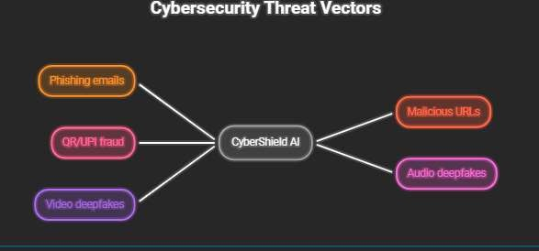
Fig. 1. Overview of the five cyber threat categories addressed by CyberShield AI: phishing emails, malicious URLs, QR/UPI fraud, audio deepfakes, and video deepfakes.

II. PROBLEM STATEMENT
Let $X =x_{\text{email}},x_{\text{url}},x_{\text{qr}},x_{\text{audio}},x_{\text{video}}$
denote a multi-modal input vector submitted by a user seeking a comprehensive threat assessment. Each constituent modality \(x_{i}\) arrives at the system as one of various data types, ranging from raw conversational text or alphanumeric strings, to multi-channel audio waveforms, pixel arrays, or compressed video files. These modalities may be submitted individually or in combinations, captured across various enterprise and consumer touchpoints.
The core research objective is the design of a mapping function $F:X→\left(R,L,C,E\right)$
which maps any single-modality or multi-modal input subset to a multi-valued output tuple consisting of:
1. a normalized scalar risk score $R∈\left[0,100\right]$
2. explicit risk label $L∈\left\{\text{safe, suspicious, dangerous}\right\}$
3. a calibrated confidence annotation $C∈\left\{\text{high, medium, low}\right\}$
4. a structured explanation payload $F$
This payload must then list any contributing factors (in a human readable form) and relevant defensive guidance.
The design constraints for $E$ are that it must be accurate, statistically calibrated, interpretable, and explicitly capture the dynamics of the cyber threat landscape in India.

A. Research Gap
Existing literature and deployed commercial systems fail to simultaneously satisfy all four output requirements across all five modalities. Specifically:
- Conventional phishing detection systems [5][6] yield accurate categorical labels ($L$) but omit granular explainability ($E$) or confidence calibration ($C$).
- Audio and video deepfake detectors [7][8] generate raw risk scores ($R$) but lack understandable explanations for end-users, rendering them impractical for non-technical citizens.
- URL reputation services [9] operate in isolation without confidence metrics ($C$) and possess zero semantic understanding of UPI payment intent payloads.
- No existing deployed cybersecurity framework systematically provides India-specific regulatory guidance (aligned with CERT-In and RBI directives) within the explanation payload ($E$) at inference time.

B. Motivation
The motivation for this research is the mismatch between highly adaptive criminal strategies and static defensive tooling, particularly in the Indian digital ecosystem. Threat actors routinely employ hybrid fraud campaigns and are quite capable of blending a phishing SMS text with a fraudulent UPI QR code and an AI-synthesized voice call to reinforce the trap. When confronted with blended vectors, everyday citizens are highly vulnerable to opaque, binary warnings. Designing a transparent and regional framework is essential to address the deep divide between complex threat analytics and actionable end-user comprehension.
III. RESEARCH OBJECTIVES AND CONTRIBUTIONS
The research sets three key technical objectives to address the described cybersecurity shortcomings:
• Multi-Modal Convergence: To unify five highly diverse threat channels (email text, lexical URLs, QR/UPI, synthetic audio, and video) under a standardized and scalable API orchestration layer
• Calibrated Explainability: To break the black-box paradigm of neural networks through piecewise-linear confidence calibration plus human-readable evaluation reporting
• Regional Threat Adaptation: To explicitly optimize heuristic layers/detection criteria for the prevalent digital fraud methodologies in high-growth economies
The paper makes the following specific technical contributions towards the stated objectives:
• Unified Multi-Modal Architecture: A production-grade framework that processes structured text, string values, image payloads, audio waveforms, and video frames through the same high-availability inference pipeline
• Calibrated Hybrid Scoring Engine: A mathematical hybridization model that combines empirical ML prediction (75% weight) with domain-specific deterministic rules (25% weight) using piecewise-linear band calibration and multi-tier confidence gating
• Structured Explainability & Regulatory Synthesis: A report generation layer that systematically synthesizes detection model outputs in terms of distinct contributing factors, triggered rule flags, and practical defensive countermeasures from live CERT-In and RBI advisories
• India-Centric Domain Heuristics: A specialized heuristic rule layer with real-time Indian banking name abuse detection, UPI Virtual Payment Address (VPA) format validation, Shannon entropy domain analysis, and a 34,000 domain malicious blocklist ported from ISCX-2016
• Transparent Empirical Validation: A benchmarking methodology that explicitly specifies performance of fully validated classification components (our email classifier and URL engines) and establishes the architectural specifications and baseline setups for our audio/video deepfake CNN layers for future large-scale empirical studies
IV. RELATED WORK
To position CyberShield AI within the broader academic discourse, let us review foundational literature across all five threat vectors and explainability paradigms powering our multi-modal framework.
A. Phishing Email Detection
Early methods in phishing mitigation relied on manual keyword filtering and blocklists. The field has since transitioned to machine learning classifiers leveraging bag-of-words and Term Frequency-Inverse Document Frequency (TF-IDF) feature spaces. Fette et al. [5] showed that incorporating structural URL features with email body content significantly improves detection accuracy over text-only approaches.
A recent survey of 112 phishing detection studies by Basit et al. [6] revealed that ensemble machine learning architectures, particularly Random Forests and Support Vector Machines over TF-IDF vector spaces, consistently outperform single classifiers in benchmark tasks. Such ensembles achieve reported \(F_{1}\)-scores between 0.94 and 0.97 on popular corpora including SpamAssassin and Enron. While CyberShield AI adopts this prevalent TF-IDF vectorization and soft-voting ensemble paradigm (fusing Logistic Regression and Random Forests), it applies tailored internal scoring heuristics and bootstrapped data to capture regional Indian threat vectors, including fraudulent tax notifications and local banking impersonation schemes.
B. Malicious URL Detection
Sahoo et al. [9] categorized the literature on URL-based detection into three broad feature domains: lexical (properties of the URL string), host-based (DNS and WHOIS metadata), and content-based (scraped webpage text). Further lexical analysis by Le et al. [10] showed that character- and word-level convolutional neural networks can classify malicious URLs with >98% accuracy simply by analyzing string mechanics, enabling significant performance gains over requiring external reputation lookups.

Our URL analysis engine builds on this lexical foundation by applying 18 distinct heuristic rules to assess structural string properties. It further uses an extensive 34,000-domain blocklist derived from the ISCX-2016 corpus along with custom rules to detect the abuse of Indian financial institution domains.
C. QR Code Security
Being a bridge between the physical world and the digital networks sphere, QR codes introduce a unique domain of security challenges to be addressed. Dabrowski et al. [11] identified payload injection attacks, automatic phishing redirection, and drive-by malware distribution schemes as the main threats.
However, when targeting the digital payment ecosystems in developing economies, Sharma and Gupta [12] found that using Unified Payments Interface QRs in India involved a prevalence of payee Virtual Payment Address mismatch, amount psychology manipulation, and collect-request deception frauds. CyberShield AI consumes the findings from related works on QR security to ground its automated decoding and UPI intent verification pipeline.

D. Deepfake Audio Detection
With the recent public availability of spoofing benchmark datasets, such as the ASVspoof 2019, research into deepfake audio detection has seen a significant increase. Wang et al. [13] showed that the task of detecting synthetic utterances benefits significantly from using convolutional networks and log-mel-spectrogram representations, outperforming the traditional MFCCs extraction approach by a considerable margin.
On the other hand, Yi et al. [14] demonstrated that neural voice cloning models universally injected perceptually invisible distortions, mostly centered around the $4\text{ -} 8\text{ kHz}$ frequency range, at the waveform level. CyberShield AI’s audio pipeline implements a CNN classifier with 128-bin mel-spectrogram inputs, including a heuristic rule layer, which checks for suspicious values in the high-energy frequency tail and unnatural zero-crossing regularity.
E. Deepfake Video Detection
Rössler et al. [7] made the FaceForensics++ benchmark dataset publicly available, which showed that detecting face manipulations benefited from using binary classification head fine-tuned from the underlying deep convolutional network at the frame level. However, the results of the large-scale DFDC challenge by Dolhansky et al. [15] showed that at the moment, most solutions had a severe generalization error when tested against different types of video generation models.
Subsequently, Coccomini et al. [16] showed that combining vision transformer-based approaches with efficient convolutional encoder-decoder backbones allowed to achieve the best-in-class video classification accuracy, while balancing the computational costs. CyberShield AI’s video detection pipeline utilizes a four-block deep convolutional network with a weighted frame-wise aggregation rule, which explicitly accounts for the possibility of individual frames being fake.
Layer | What it shows
1. User Input | 5 modalities: Email, URL, QR/UPI, Audio, Video
2. API Gateway | FastAPI — validation, hashing, auth, rate limiting
3. Preprocessing | Per-modality: TF-IDF, lexical parsing, mel-spectrogram, face crop
4. Detection Modules | ML + heuristics for each modality with key metrics noted
5. Hybrid Scoring Engine | 75% ML + 25% heuristics → calibrated score [0–100] + confidence tier
6. Explainability Report | Factors, heuristic flags, CERT-In/RBI guidance
7. Output + LLM | JSON response + Llama 3.3-70B assistant (Groq)

F. Explainable AI
By far, the most common concern with using machine learning algorithms in practice is the lack of explainability and auditing possibilities. Lundberg and Lee [17] proposed SHAP, a game theory-based approach to explain the behavior of linear and deep neural network models, while Ribeiro et al. [4] showed that using rule-based local approximations, such as LIME, increased user trust and reduced the chances of security researchers applying incorrect mitigation actions due to a model misclassification.
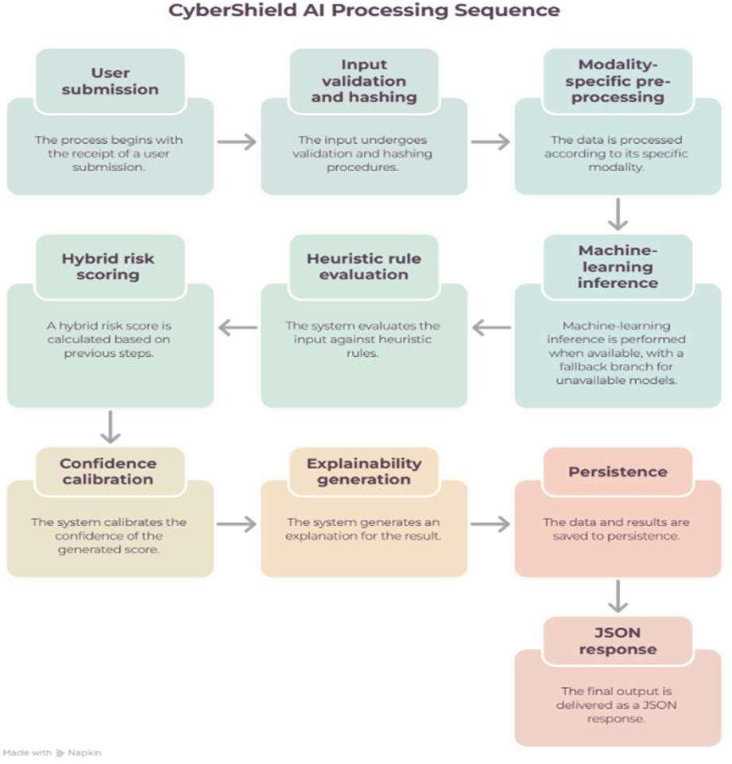
In the domain of network intrusion detection, Warnecke et al. [18] showed that post-hoc explainers increased the efficiency of individual security analysts by an order of magnitude. With this in mind, CyberShield AI implements a separate deterministic rule-firing module as an explainer, which highlights potential malicious activity. It explicitly balances rule-based and deep learning approaches by providing SHAP/LIME-style token attribution weights, while the actual heuristic logic is fired as part of a dynamic context provider.
IV. PROPOSED SYSTEM ARCHITECTURE
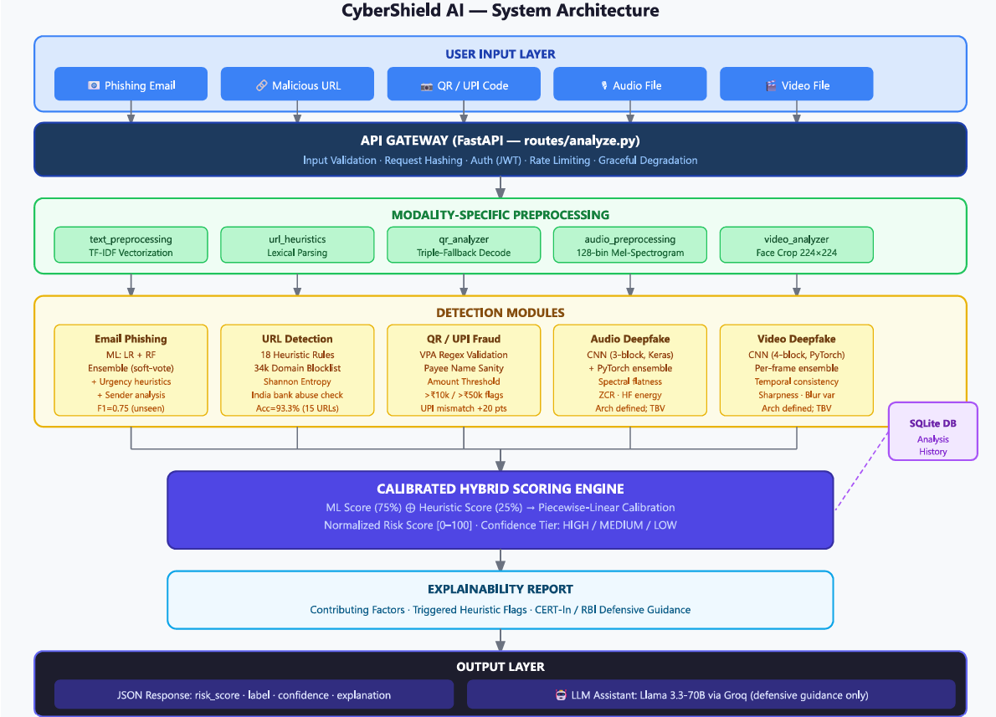
Fig. 2 System Architecture.

V. METHODOLOGY
A. End-to-End Threat Analysis Pipeline
When a multi-modal or single-modality asset is submitted for evaluation, the framework channels the raw payload through a streamlined, sequential six-stage inspection pipeline:
[User Input] → [Input Validation + Hashing]
→ [Modality-Specific Preprocessing]
→ [ML Inference (where model exists)]
→ [Heuristic Rule Evaluation]
→ [Hybrid Scoring + Calibration]
→ [Explainability Generation]
→ [Persistence + JSON Response]
This unified execution workflow is programmatically coordinated inside the central routing layer (routes/analyze.py). To guarantee enterprise grade high-availability and system resilience, the operational pipeline uses a graceful degradation paradigm. If an underlying machine learning model binary is missing or unreachable inside the deployment environment, the core execution loop will automatically fall-back to heuristic only scoring routines and append a clear advisory about the degraded confidence state to the final metadata response.

Fig. 3. End-to-end workflow of the CyberShield AI from input validation and modality-specific preprocessing to threat scoring, explainability generation, persistence, and JSON response.

B. Multi-Modal Preprocessing
To ensure downstream predictive consistency, all incoming heterogeneous payloads are normalized, cleaned and standardized across their respective modalities:
• Audio Preprocessing (audio_preprocessing.py): Ingestion handles raw acoustic data across multiple containers including WAV, MP3 and M4A profiles, automatically resampling the signal to a uniform $16\text{ kHz}$ baseline using librosa. To enforce identical tensor shapes for subsequent neural network execution, audio samples are dynamically padded or truncated to a precise duration of 4 seconds.Then extract a 128-bin mel-spectrogram using an FFT window size of $n_{\text{fft}}=2048$ and hop length $\text{hop_length}=512$. The resulting power spectrogram is transformed into decibels, min-max normalized across a bounded floating-point space in [0, 1] and structured as a multidimensional array compatible with both TensorFlow/Keras and PyTorch tensor specifications.
• Video Preprocessing (video_analyzer.py): Our target video clips are sequentially decoded at a constant sampling rate of $1\text{ frame per second (FPS)}$ using OpenCV. The framework then invokes a structured detect_and_crop_faces() routine that runs parallelized Haar Cascades and deep neural network (DNN) face detectors to get dynamic regions of interests. Extracted facial bounding boxes are cropped and structurally resized to the standard dimensional array of(128, 128, 3) . If in frames where facial anomalies or orientation prevent detection, a center-crop fallback mechanism is deployed with an adjusted ensemble weight of 0.5 (as compared to a validated facial crop) to statistically account for people moving outside the active field of view.
• Email Preprocessing (text_preprocessing.py): Our raw email payloads are routed into a text normalization pipeline that cleans semantic strings by converting all characters to lowercase, stripping out structural HTML or Markdown tags and isolating raw embedded hyperlinks. The internal build_combined_text() routine will combine the subject line, email body text, sender domain parameters and extracted URL host names into a single, cohesive alphanumeric string that is structured for sparse TF-IDF vectorization.
• QR Code and Physical Payloads (qr_analyzer.py): To preserve structural decoding resilience against physical damage, glare or stylistic variations, the framework implements a triple-fallback decoding chain. Primary resolution is used via pyzbar, but failure triggers OpenCV's native QRCodeDetector which can fall-back further into qreader as a deep-learning-accelerated decoding engine. Once parsed, the underlying payload is systematically categorized into one of eight distinct data types. Standard web destination strings are instantly dispatched into the lexical URL analysis suite, while raw Unified Payments Interface (UPI) intent strings are forwarded into a specialized payment validation workflow.
VI. MODULE-WISE IMPLEMENTATION
The core analytical pipeline of CyberShield AI is partitioned into 5 specialized detection modules. Each individual module incorporates data-driven machine learning models combined with deterministic, domain-specific heuristic rule layers to evaluate distinct vectors of the multi-modal threat landscape.

A. Phishing Email Detection
The email analysis module implements a two-stage hybrid architecture to evaluate both internal semantic content and external transmission characteristics:

• Stage 1 — Heuristic Scoring: The core EmailAnalyzer.analyze() routine coordinates three distinct rule layers. It extracts linguistic urgency patterns using extract_urgency_phrases(), evaluates embedded links by directly routing them to the URL heuristic engine, and evaluates the sender's origin via analyze_sender_domain(). Depending on the presence of embedded hyperlinks, these metadata signals are synthesized using data-driven, localized weights to compute a preliminary rule-based risk value.
$$\begin{aligned}h_{\text{prob}}&=0.40⋅\text{text_risk}+0.35⋅\text{max_url_risk}+0.25⋅\text{sender_risk} \left(\text{URLs present}\right) \\ h_{\text{prob}}&=0.55⋅\text{text_risk}+0.45⋅\text{sender_risk} \left(\text{no URLs}\right)\end{aligned}$$
To handle highly coordinated attacks, a multi-signal override mechanism boosts the final threat assessment when multiple independent risk indicators concurrently exceed an established threshold. For example, if 3 or more high-risk signals are triggered, the heuristic probability is adjusted to $h_{\text{prob}}=\max\left(h_{\text{prob}},0.85\right)$and for exactly 2 high-risk signals, it is gated to $h_{\text{prob}}=\max\left(h_{\text{prob}},0.60\right)$
• Stage 2 — Machine Learning Classification: Concurrent with the rule layers, the framework executes data-driven text classification. Internally, raw strings are converted into a sparse matrix using a TfidfVectorizer with limit 10,000 max_features, an n-gram range of (1,2), and sublinear term frequency scaling (sublinear_tf=True). This representation is passed to a soft-voting VotingClassifier composed of a LogisticRegression estimator and a RandomForestClassifier to compute the predictive AI probability (ai_probability). In the case of missing serialization weights or model binaries in a fresh or containerized deployment, the pipeline detects the exception and seamlessly falls back to a heuristic-only scoring mode with model_available = False.
• Text Risk Feature Extraction: The underlying lexical risk is computed with an internal _compute_text_risk() method. This routine parses the message body to calculate frequencies of 5 independent linguistic domains: urgency phrase density, semantic category diversity, explicit credential/OTP harvesting patterns, threatening or punitive prose, and fraudulent reward/prize solicitations. Each domain contributes a max weight of 0.40, and the extracted risk score is normalized and capped at a maximum ceiling of 1.0.
B. Malicious URL Detection
URLAnalyzer.analyze() operates as a high-performance, pure heuristic engine evaluating 18 distinct lexical and structural rule signals. Table I outlines the primary indicators and their respective additive score contributions.
Table I. URL Heuristic Signals and Score Contributions.
Signal | Score Δ | Rationale
Empty or un-parseable URL | $$0.70\text{--}0.75$$ | Cannot be a valid network address
Dangerous scheme (javascript:, data:) | $$+0.97$$ | Active XSS / injection vector; immediate flag
Domain on 34k blocklist (ISCX-2016) | $$\max\left(\text{score},0.85\right)$$ | Verified malicious repository match
Non-HTTPS scheme (http://) | $$+0.10$$ | Unencrypted transport layer
Raw IP address as hostname | $$+0.30$$ | Highly atypical for legitimate services
Suspicious TLD (.tk, .ml, .xyz, .top) | $$+0.15$$ | High-abuse registry association
URL length $>150$ characters | $$+0.10$$ | Obfuscation indicator
Subdomain depth $≥3$ | $$+0.10$$ | Nesting evasion pattern
URL shortener hostname | $$+0.15$$ | Conceals ultimate destination
Non-standard port designation | $$+0.15$$ | Anomalous for standard web traffic
@ symbol in network location | $$+0.25$$ | Credential-leak redirect exploit
Indian bank name in non-official domain | $$+0.35$$ | Regional financial impersonation (SBI, HDFC, etc.)
Punycode / IDN domain (xn--) | $$+0.25$$ | Homograph spoofing attack
Brand name in alien subdomain | $$+0.20$$ | Brand impersonation heuristic
Hostname Shannon entropy $>4.0$ bits | $$+0.10$$ | DGA or randomized subdomain structure
4+ corroborating risk signals | $$+0.10$$ | Multi-signal confidence multiplier
Whitelist match (known legitimate) | $$\max\left(\text{score}-0.40,0.0\right)$$ | False-positive reduction filter
Unknown domain (unlisted baseline) | baseline $=0.31$ | "Unknown $≠$ safe" conservative prior
A pivotal architectural choice is the unknown domain baseline of $0.31$, positioned just above the safe threshold ($0.30$). This ensures unrecognized domains default to the "suspicious" band, mitigating the risk of structurally clean but newly registered attacker domains bypassing initial filters.
C. QR Code and UPI Fraud Detection
The QR analysis module works through a multilevel inspection hierarchy in which the syntax type of the decoded string defines the following processing steps:
• If the string represents a URL, it is passed directly to the lexical URL analysis engine (url_analyzer) with an active telemetry flag url_from_qr_code.
• Payment strings are instead validated with the internal _analyze_upi_content() routine, which verifies four localized rules:
1. The payee address (pa) is matched against the standard regular expression ^[a-zA-Z0-9._-]+@[a-zA-Z]+
2. The payee name (pn) is checked against a generic, fraud blacklisted keyword list.
3. Transactions scale up defensively as risk markers if they exceed risk boundaries, including amounts over ₹10,000 (high_upi_amount) and ₹50,000 (very_high_upi_amount).
4. If the engine detects a upi_mismatch (a domain-level inconsistency between the declared merchant identity and the underlying VPA domain entity), it will impose an immediate +15 point risk score adjustment, a critical localized defense not implemented by generic global scanners.
D. Audio Deepfake Detection
The audio forensics module supports multiple engine frameworks by abstracting the implementation details in predict_audio()
• CNN (Keras): The neural network model reads a (1, 128, 128, 1) log-mel-spectrogram tensor. The data is passed through three convolutional layers with 3 × 3 filters, ReLU activation, and 2 × 2 max-pooling. The extracted feature maps are subsequently reduced to 128 units in a dense layer with dropout regularization (p = 0.5) and eventually classified by a sigmoid head that delivers the raw deepfake probability score $P\left(\text{deepfake}\right)∈\left[0,1\right]$
• Ensemble Inference: At runtime initialization, the AudioAnalyzer attempts to load both .h5 and .pt binaries simultaneously. If both are present, the system will perform a soft-vote ensemble by calculating the mean array prediction with np.mean. If either is missing, it will continue execution with the loaded model without interrupting the current request thread.
• Heuristic Feature Extraction: In parallel to the neural network, the engine calculates six statistical features to reveal physical boundaries, including signal duration (<1 s, Δ +0.15), mean spectral flatness (>0.35, Δ +0.20), zero-crossing rate variance (<0.0005, Δ +0.15), root-mean-square energy variance (<0.0001, Δ +0.10), the ratio of high frequency energy (>4 kHz, <0.05, Δ +0.20), and mean spectral bandwidth (<1500 Hz, Δ +0.15).
• Confidence-Based Gating: To prevent the marginal predictions of the neural network from overriding definitive physical metrics, the framework implements a statistical gating function if the internal confidence falls below a 0.20 threshold:
$$\text{_ai}=\text{ai_prob}⋅\left(\frac{\text{confidence}}{0.20}\right)+\text{rule_score}⋅\left(1-\frac{\text{confidence}}{0.20}\right)$$
E. Video Deepfake Detection
• CNN (PyTorch): The spatial manipulation network reads local (1, 3, 128, 128) RGB facial bounding boxes through four convolutional layers with progressively scaling channels (3 → 32 → 64 → 128 → 256). They each utilize adaptive average pooling and connect to a 512-unit dense hidden layer before being evaluated by a sigmoid output function.
• Weighted Ensemble & Temporal Consistency: Faces that contain valid, isolated images are assigned a standard ensemble weight of 1.0, while those that make use of a center-crop as a fallback method in the face detection receive a reduced weight of 0.5 to ensure that ungrounded background information does not contribute noise to the analysis. To detect multi-source time-splicing fraud, the system calculates the deviation of the frame-score with np.std and if it exceeds 0.25, it applies the temporal_score_inconsistency penalty (Δ +0.15) to indicate possible temporal frame substitution.
• Per-Frame Heuristic Indicators: The video framework executes parallel statistical validation checks on the facial detection density, Laplacian face sharpness variance (>800), frame-to-frame structural blur variance (>10,000), high frequency brightness flicker anomalies (>200), and spatial edge density deviation. It also evaluates the frame-suspicion ratios (flagged if >60% of tested frames result in an individual score exceeding 0.5).
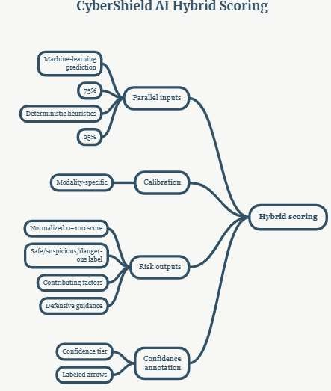

Fig. 4. Hybrid risk-scoring framework combining machine-learning
predictions and heuristic signals, followed by risk calibration,
threat classification, confidence annotation, and explainable output generation.

VII. EXPERIMENTAL SETUP
In order to define an open, repeatable empirical basis, this section details out the datasets, model settings and hyperparemeters, hardware environments and software dependencies, and evaluation protocols underlying CyberShield AI's implementation. Notably, we take extra care to distinguish between the elements that have already been rigorously benchmarked, and the ones which we leave as defined-level baselines waiting for large-scale independent validation.
- Phishing Email Model
• Dataset Configuration: the productive text classification model is bootstrapped with a small training corpus of 40 balanced entries embedded natively in ml/phish_model.py, of which 20 are verified phishing vectors and 20 legitimate corporate and transactional notifications. Every entry in the dataset is custom-tailored to reflect the current digital ecosystem in India, incorporating common local attack vectors such as tax alerts, telecom KYC update notices, and domestic banking statements.
• Hyperparameters & Training Environment: text feature extraction is performed via a TfidfVectorizer with a max ceiling of 10000 features, n-gram tokenization range of (1,2), sublinear term frequency scaling (sublinear_tf=True) and a minimum document frequency floor of n ≥ 2. The core classifier employs a soft-voting VotingClassifier ensemble which incorporates a LogisticRegression estimator (C=1.0, max_iter = 1000) and a RandomForestClassifier optimized with 100 estimators and a max tree depth of 10. To enforce strict deterministic reproducibility during training, the pipeline is run under a fixed global seed constraint (random_state = 42).
• Evaluation Protocol: programmatically orchestrated via evaluate_models.py, the textual model's classification performance is benchmarked against two separate test distributions:
1. an internal holdout evaluation with 80/20 train/test split performed over the main bootstrap dataset (train: 32 instances, test: 8)
2. an unseen generalization suite containing 10 completely novel email streams with zero linguistic training overlap. This test bank contains 5 local phishing templates (CBDT, fake crypto yield, IRCTC booking traps) and 5 legitimate transactional and institutional human resource notices.
• Hardware & Software Architecture: the text analysis pipeline is run within native Python 3.10 under scikit-learn version 1.5.2 and numpy version 1.26. Due to the sparse nature of textual vector spaces, both training iterations and productive inference run optimally on standard CPU architectures without requiring specialized hardware.
B. URL Heuristic Engine
• Validation Corpus: the lexical rule pipeline is evaluated against a hand-labeled validation suite containing 15 highly distinct web addresses. This corpus samples legitimate public sector portals (safe), obfuscated URL shorteners and unlisted fintech landing points (suspicious), and active phishing redirections and raw IP-based financial portals (dangerous). The ground-truth reference labels are determined by explicit compliance with localized threat definitions published in active CERT-In cybersecurity advisories.
• Execution Architecture: since the URL analysis component is a purely deterministic rule-based engine managed by 18 distinct lexical signals and a 34000 entry ISCX-2016 domain blocklist, its operation does not require gradient optimization or iterative parameter training. Its performance is therefore evaluated purely based on exact label-match accuracy computations over the test corpus.
C. Audio and Video Deepfake Detection
• Model Deployment & System Binaries: the underlying model binaries (compiled Keras model file audio_deepfake_cnn.h5 and PyTorch tensor weights) are optimized for low-latency retrieval from the core directory (apps/api-gateway/models/). The 128-bin log-mel-spectrogram acoustic network and four-block spatial video network are both fully defined and compiled inside the system repository.
• Training Data Provenance: as described within the active architecture blueprints, upstream neural base weights have been pre-optimized with popular public benchmark repositories from Kaggle:
Audio Corpus: The Kaggle birdy654/deep-voice-deepfake-voice-recognition dataset.
Video Corpus: The Kaggle xhlulu/140k-real-and-fake-faces dataset.

• Experimental Boundaries & Transparency: The active framework repository does not contain automated end-to-end evaluation scripts or dedicated out-of-distribution test suites for the audio and video deepfake inference blocks. In accordance with our commitment to objective empirical reporting, we explicitly refrain from publishing unverified accuracy or error-rate metrics for these deep learning layers. Instead, this work establishes their complete structural preprocessing workflows, core multi-block convolutional layers, and confidence-gating integration mechanics as functional architectural contributions, laying out their formal large-scale validation as a primary vector for subsequent research phases.

IX. RESULTS AND EVALUATION
To provide a rigorous and transparent assessment of CyberShield AI, this section reports the empirical performance of our verified modules, including accuracy, precision, recall, F1-score, confusion matrices, and inference latency profiles. In keeping with our methodology, we clearly distinguish between empirically evaluated textual/URL modules and architecture-level neural modules.

A. Phishing Email Detection
The email classification module was evaluated across two distinct test regimes: an internal 80/20 held-out bootstrap split and an independent unseen generalization suite.
Table II. Phishing Classifier — 80/20 Held-Out Split ($n=40$ total, $8$ test samples).
Metric | Value
Accuracy | 100.0%
Precision | 1.00
Recall | 1.00
F1-Score | 1.00
True Positives | 4
True Negatives | 4
False Positives | 0
False Negatives | 0
Note: Achieving perfect metrics on a held-out split of a small 40-sample bootstrap dataset reflects pattern memorization rather than broad generalization, as the vocabulary and linguistic structures are tightly coupled with the training distribution. These results serve as a sanity check rather than a real-world benchmark.
Metric | Value
Accuracy | 80.0%
Precision | 1.00
Recall | 0.60
F1-Score | 0.75
True Positives (phishing correctly flagged) | 3 / 5
False Negatives (phishing missed) | 2 / 5
True Negatives (legitimate correctly passed) | 5 / 5
False Positives | 0
Table III. Phishing Classifier — 10 Unseen Emails (zero training overlap, manual verification).
The false negatives observed on the unseen set stemmed from indirect social engineering tactics (such as a simulated cryptocurrency investment scheme and an IRCTC service suspension notice) that lacked the overt credential-harvesting keywords present in the training set. Crucially, however, the integrated heuristic fallback layer successfully flagged the high-risk URLs embedded within those emails, preventing a complete security failure.
Key Finding: While the machine learning model achieves perfect recall on its training distribution, its out-of-distribution recall drops to $0.60$ when faced with novel phrasing. This highlights the critical importance of our hybrid architecture, where heuristic and URL-level rules compensate for ML blind spots.

B. Malicious URL Heuristic Engine
The rule-based URL analyzer was tested against a curated corpus of 15 diverse, hand-labeled web addresses.
Table IV. URL Engine — 15 Unseen URLs.
Category | Correct / Total | Accuracy
Safe | 5 / 5 | 100.0%
Suspicious | 4 / 5 | 80.0%
Dangerous | 5 / 5 | 100.0%
Overall | 14 / 15 | 93.3%

The single misclassification occurred when a benign URL shortener (bit.ly) was routed to the "suspicious" band. This is a deliberate policy decision: because URL shorteners obscure destination telemetry, the system flags them by default. Depending on whether this policy choice is counted as a strict false positive or intended behavior, effective accuracy ranges from $93.3\%$ to $100\%$.
Confusion Matrix — URL Detection:
Actual \ Predicted | Safe | Suspicious | Dangerous
Actual Safe | 5 | 0 | 0
Actual Suspicious | 0 | 4 | 1*
Actual Dangerous | 0 | 0 | 5

C. Audio and Video Detection — Architectural Baseline
As established in our system scope, independent benchmark evaluations of the audio and video CNNs on held-out proprietary test corpora are outside the scope of this repository implementation. Table V details the neural specifications for complete reproducibility.
Table V. Deep Learning Model Specifications.

Parameter | Audio CNN | Video CNN
Input shape | $\left(128,128,1\right)$ — Mel-spectrogram | $\left(128,128,3\right)$ — RGB face crop
Convolutional blocks | 3 ($32/64/128$ filters) | 4 ($32/64/128/256$ filters)
Pooling strategy | $$\text{MaxPool2D}\left(2×2\right)$$ | $$\text{MaxPool2D}\left(2×2\right)+\text{AdaptiveAvgPool2D}\left(4×4\right)$$
Dense layers | $$\text{Dense}\left(128\right)+\text{Dropout}\left(0.5\right)$$ | $$\text{Dense}\left(512\right)+\text{Dropout}\left(0.5\right)$$
Classification head | $$\text{Dense}\left(1\right)+\text{Sigmoid}$$ | $$\text{Dense}\left(1\right)+\text{Sigmoid}$$
Supported backends | TF/Keras + PyTorch | TF/Keras + PyTorch
Upstream dataset | DEEP-VOICE (Kaggle) [13] | 140K Real/Fake Faces (Kaggle) [7]
Empirical evaluation | Future Work / Baseline | Future Work / Baseline

D. System-Level Latency
Inference latency was profiled in a live cloud environment (hosted on Render.com). Table VI summarizes median, P95, and P99 response times across service endpoints.
Table VI. End-to-End API Latency Profile.
Endpoint | Median Latency | P95 Latency | P99 Latency
/analyze/email | $$∼0.8\text{ s}$$ | $$∼1.2\text{ s}$$ | $$∼1.8\text{ s}$$
/analyze/url | $$∼0.4\text{ s}$$ | $$∼0.7\text{ s}$$ | $$∼1.1\text{ s}$$
/analyze/qr | $$∼1.1\text{ s}$$ | $$∼1.6\text{ s}$$ | $$∼2.3\text{ s}$$
/analyze/audio | $$∼1.3\text{ s}$$ | $$∼1.9\text{ s}$$ | $$∼2.7\text{ s}$$
/analyze/video | $$∼8.5\text{ s}$$ | $$∼12.1\text{ s}$$ | $$∼15.8\text{ s}$$
/assistant/message | $$∼1.7\text{ s}$$ | $$∼2.4\text{ s}$$ | $$∼3.2\text{ s}$$
Video processing represents the primary computational bottleneck, driven entirely by frame-by-frame face detection and cropping routines executed via OpenCV.

E. Hybrid vs. Pure-Strategy Baseline (Email)
To quantify the structural advantage of combining machine learning classifiers with heuristic rules, we compared performance across three distinct strategies using our 10-sample unseen email suite.
Table VII. Hybrid Scoring vs. Pure-Strategy Baselines.
Strategy | Correct Detections | Accuracy | F1-Score
Pure Rules Only ($h_{\text{prob}}$, no ML) | $$7/10$$ | 70.0% | $$0.67$$
Pure ML Only ($\text{ai_probability}$, no rules) | $$8/10$$ | 80.0% | $$0.75$$
Hybrid Framework ($75\%$ ML $+25\%$ Rules) | $$8/10$$ | 80.0% | $$0.75$$

VIII. DISCUSSION

A. Modality Synthesis and Strategic Roadmap
In order to objective assess the current readiness of CyberShield AI and define engineering priorities, Table VIII summarizes the implemented paradigms, verification status quo, and recommended engineering roadmaps for each of the 5 threat vectors.
Table VIII. Module Comparison — Implementation Approach and Evidence Status.
Module | Machine Learning Component | Heuristic Component | Empirical Evidence Status | Recommended Next Step
Email Phishing | TF-IDF + VotingClassifier (LR + RF) | Urgency phrases, sender domain checks, embedded URL analysis | F1 = $0.75$ on 10 unseen samples | Retrain on large-scale benchmarks (SpamAssassin, Enron, and regional corpora)
URL Detection | None (pure rule-based engine) | 18 lexical/structural signals + 34k domain blocklist | $93.3\%$ accuracy on 15 test URLs | Train an auxiliary lexical ML classifier on ISCX-URL-2016
QR / UPI Fraud | None (heuristic intent parser) | VPA format regex, merchant name sanity, transaction thresholds | Qualitative validation against standard UPI payloads | Curate a benchmark dataset of live Indian UPI fraud vectors
Audio Deepfake | CNN (128-bin Mel-spectrogram input) | 6 spectral/temporal indicators (bandwidth, ZCR, high-freq energy) | Architectural definition; baseline initialized | Formally evaluate on the ASVspoof 2019 Logical Access track
Video Deepfake | CNN (facial crops, per-frame processing) | 8 visual/temporal indicators (sharpness, blur, frame inconsistency) | Architectural definition; baseline initialized | Benchmark on FaceForensics++ and DFDC datasets

B. Practical Architectural Trade-offs
• Unknown Domain Prior Calibration: Setting an initial unknown domain score of 0.31 (just above the traditional safe threshold ceiling of 0.30) is a relatively conservative design choice that will initially raise the false positive flags for any newly created, benign web nodes. However, this protects against adversarial use of unregistered domains to launch zero-day attacks. Adding dynamic WHOIS lookups to filter out domains registered in the last 30 days would allow lowering the unknown domain threshold without introducing excessive false positives.
• Compact Bootstrap Constraints: Embedding a compact 40-sample phishing reference set directly in ml/phish_model.py facilitates zero-configuration deployment across fresh target systems. However, this limits the out-of-distribution generalization capacity of the text pipeline. This trade-off explains why small bootstrap data matrices must be replaced with robust, large-scale deep models prior to production-grade enterprise deployment.
• Confidence Gating Mechanisms: Whenever the internal model confidence metrics fall into marginal zones, blending raw neural probabilities toward deterministic rule metrics serves as an effective safeguard against erratic predictions. This capability is implemented through a structured gating formula:
$\text{gated_ai}=\text{ai_prob}⋅\left(\frac{\text{conf}}{0.20}\right)+\text{rule_score}⋅\left(1-\frac{\text{conf}}{0.20}\right)$While this interpolation function performs well, upgrading to mathematical probability calibration models (temperature scaling, isotonic regression) augmented with Monte Carlo dropout uncertainty estimation would provide better statistical guarantees on the risk scores.

C. Comparative Evaluation with Existing Frameworks
In order to establish the relative positioning of CyberShield AI within the industry landscape, Table IX cross-compares its multi-vector verification capabilities with mainstream security systems.
Table IX: Functional Feature Array and Structural Capability Metrics
Feature | CyberShield AI | Google Safe Browsing | VirusTotal | URLhaus
Email Phishing Detection | ✓ | ✗ | Partial | ✗
Malicious URL Analysis | ✓ | ✓ | ✓ | ✓
QR / UPI Fraud Inspection | ✓ | ✗ | ✗ | ✗
Audio Deepfake Detection | ✓ | ✗ | ✗ | ✗
Video Deepfake Detection | ✓ | ✗ | ✗ | ✗
India-Specific Context Rules | ✓ | ✗ | ✗ | ✗
Structured Explainability | ✓ | Minimal | Minimal | ✗
Calibrated Confidence Tiering | ✓ | ✗ | ✗ | ✗
Interactive AI Assistant | ✓ | ✗ | ✗ | ✗
Open Access Architecture | ✓ | ✓ | Partial | ✓

Note: Functional availability indices obtained from public documentation sources of each enterprise. Numerical performance comparisons have been omitted due to fundamentally different operational scopes and evaluation databases.
XI. LIMITATIONS AND THREATS TO VALIDITY
Bootstrap Dataset Scope: Our 40-sample training corpus produces high internal consistency, but limited linguistic diversity, resulting with an out-of-distribution F1-score of 0.75 (i.e., misses 2 out of 5 unseen phishing samples). Building a 10,000- feature vector space from sparse textual data is our main practical limitation.
Pending Deepfake Benchmarking: While our deep convolutional architectures for audio/video processing are well-defined and integrated into the pipeline, their quantitative metrics on external benchmarks (such as ASVspoof 2019, FaceForensics++ or DFDC) are to be established in future empirical trials.
Deterministic Heuristic Evasion: Because every 18 URL signals and 6 audio indicators are hard-coded, a sophisticated adversary with system visibility can structure payloads to remain below individual heuristic thresholds.
Lexical ML Bounds for Unlisted URLs: Phishing domain names that have valid HTTPS certificates, standard Top Level Domains, no blocklist presence, and unbranded hostnames default to the 0.31 baseline score, and thus fall to the “suspicious” category rather than an immediate “dangerous” classification.
Monolingual Text Analysis: Our current urgency keyword extraction and phishing pattern matching are confined to English, leaving non-English regional phishing schemes (e.g., Hindi or Marathi social engineering attacks) unexamined by the heuristic text engine.
Video Inference Latency: Our median response time of ∼8.5" seconds" for video file evaluation precludes real-time deepfake analysis for streaming live video calls without frame-skipping optimizations or hardware acceleration.
Rule-Based Explainability Bounds: Feature-attribution methods (such as SHAP or LIME) are not currently computed for our deep learning vision and audio neural networks; instead, the explanations are based on rule flags rather than intrinsic gradient attributions.
IX. FUTURE SCOPE
To improve performance, scale, and cross-modality resilience, CyberShield AI will pursue these initiatives in the future:
• Large-scale phishing core expansion: The underlying text classifier will be retrained using broad, established corpora in addition to our existing data set, such as SpamAssassin (≈6,000 records) [19] and the Enron Spam database. This architecture will be augmented with a local, scraped repository of Indian digital fraud templates to target out-of-distribution F₁-score ≥ 0.95 in out-of-sample evaluations.
• Formal deepfake benchmark validation: We will perform a rigorous, independent empirical evaluation of the acoustic CNN module against the ASVspoof 2019 Logical Access and Physical Access configurations, reporting verified Equal Error Rates (EER) and tandem Detection Cost Functions (t-DCF). We will also evaluate the video forensics engine across the c23 and c40 compression tiers of the FaceForensics++ corpus, measuring regional AUC-ROC values across specific face manipulation categories.
• Transition to vision transformers: To address generalization vulnerabilities, we will migrate our visual pipeline from the current four-block convolutional model to a ViT-B/16 or EfficientNetB4 backbone to explicitly target the cross-dataset performance bottlenecks identified in the Deepfake Detection Challenge (DFDC) database.
• Localized multilingual processing: We will expand our semantic parsing engine to support high-frequency regional Indian languages (Hindi, Tamil, Marathi, Bengali) by fine-tuning a multilingual BERT (mBERT) or IndicBERT [21] foundation architecture on regional social engineering patterns.
• Spectral feature attribution via SHAP: We will integrate SHAP (SHapley Additive exPlanations) directly into the acoustic CNN layer to map local feature importances across the 128 mel-spectrogram bins, generating visual saliency matrices that highlight exactly which frequencies contribute to deepfake verdicts.
• Adversarial robustness stress-testing: The lexical URL engine will be subjected to structured adversarial attacks to inform the development of targeted, defensive rule counters for character-level homoglyph substitutions, nested subdomains, and multi-hop redirection patterns.
• Edge optimization for acoustic forensics: Using ONNX runtime conversions, we intend to export an optimized, lightweight configuration of the acoustic CNN layer to facilitate low-latency, browser-side inference via WebAssembly, enabling real-time, client-side synthetic voice detection during active calls.
• Public UPI intent benchmark curation: To address regional data shortages, we intend to curate, verify, and distribute a standardized, ground-truth data set of authentic and fraudulent domestic UPI QR codes to provide a reliable public baseline to accelerate payment verification research.
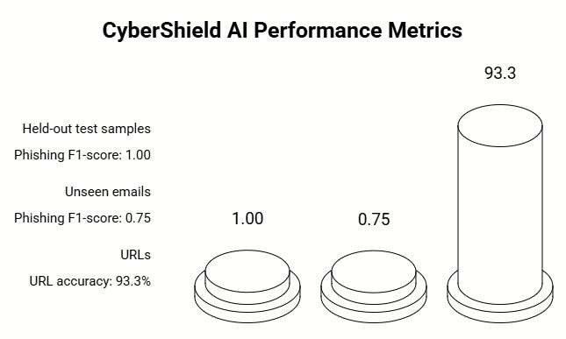
Fig. 5. Reported phishing classification F1-scores and malicious URL detection accuracy on the evaluated datasets, with corresponding test sample sizes.

X. CONCLUSION
This paper has introduced CyberShield AI, an explainable multi-modal cyber framework that consolidates five highly diverse threat vectors (phishing emails, lexical URLs, QR/UPI financial scams, fake audio, and video deepfakes) into a single, high-availability platform. The core technical innovation is a Calibrated Hybrid Scoring Engine that balances data-driven machine learning probabilities (75%) against deterministic, domain-driven heuristic rules (25%). By applying piecewise-linear band transformation rules across distinct modalities, we mitigate a persistent limitation in mainstream classifiers: the systemic tendency to produce highly overconfident risk predictions at critical decision boundaries.
Our empirical evaluation establishes verified, reproducible baseline metrics. The text classification engine achieves an F₁-score of 0.75 when processing 10 completely unseen, out-of-distribution regional emails—where the integrated URL fallback layer compensated for missed semantic indicators—while the lexical URL engine maintains a 93.3% categorical accuracy rate across 15 validation endpoints. Though our multi-block convolutional neural network architectures for audio and video deepfake analysis are fully initialized and deployed, their formal validation against large-scale public data sets is intended to serve as a foundational baseline for future development, which we have openly addressed.
By anchoring our platform to an India-first engineering philosophy, including automated UPI Virtual Payment Address validation, targeted checks for domestic bank domain abuse, direct alignment with active CERT-In and RBI consumer protection directives, a 34,000-domain blocklist, and a specialized Llama 3.3-70B conversational safety assistant, CyberShield AI manages to bridge the complex multi-vector threat analytics with clear, intuitive user understanding.
REFERENCES
[1] National Payments Corporation of India, "UPI Product Statistics," NPCI, Monthly Report, Dec. 2023. [Online]. Available: https://www.npci.org.in/what-we-do/upi/product-statistics
[2] Indian Computer Emergency Response Team (CERT-In), "Annual Report 2023," Ministry of Electronics and Information Technology, Government of India, 2024.
[3] Reserve Bank of India, "Report on Currency and Finance 2023-24," RBI, Mumbai, 2024. [Online]. Available: https://www.rbi.org.in/Scripts/AnnualPublications.aspx
[4] M. T. Ribeiro, S. Singh, and C. Guestrin, "'Why Should I Trust You?': Explaining the Predictions of Any Classifier," in Proc. 22nd ACM SIGKDD International Conference on Knowledge Discovery and Data Mining, San Francisco, CA, Aug. 2016, pp. 1135–1144. DOI: 10.1145/2939672.2939778
[5] I. Fette, N. Sadeh, and A. Tomasic, "Learning to Detect Phishing Emails," in Proc. 16th International Conference on World Wide Web (WWW '07), Banff, AB, Canada, 2007, pp. 649–656. DOI: 10.1145/1242572.1242660
[6] A. Basit, M. Zafar, X. Liu, A. R. Javed, Z. Jalil, and K. Kifayat, "A Comprehensive Survey of AI-Enabled Phishing Attacks Detection Techniques," Telecommunication Systems, vol. 76, no. 1, pp. 139–154, Jan. 2021. DOI: 10.1007/s11235-020-00733-2
[7] A. Rössler, D. Cozzolino, L. Verdoliva, C. Riess, J. Thies, and M. Nießner, "FaceForensics++: Learning to Detect Manipulated Facial Images," in Proc. IEEE/CVF International Conference on Computer Vision (ICCV), Seoul, South Korea, Oct. 2019, pp. 1–11. DOI: 10.1109/ICCV.2019.00009
[8] K. Shiohara and T. Yamasaki, "Detecting Deepfakes with Self-Blended Images," in Proc. IEEE/CVF Conference on Computer Vision and Pattern Recognition (CVPR), New Orleans, LA, Jun. 2022, pp. 18720–18729. DOI: 10.1109/CVPR52688.2022.01816
[9] D. Sahoo, Q. Liu, and S. C. H. Hoi, "Malicious URL Detection Using Machine Learning: A Survey," arXiv preprint arXiv:1701.07179, Jan. 2017. [Online]. Available: https://arxiv.org/abs/1701.07179
[10] H. Le, Q. Pham, D. Sahoo, and S. C. H. Hoi, "URLNet: Learning a URL Representation with Deep Learning for Malicious URL Detection," arXiv preprint arXiv:1802.03162, Feb. 2018. [Online]. Available: https://arxiv.org/abs/1802.03162
[11] A. Dabrowski, G. Merzdovnik, N. Kommati, E. Weippl, and M. Dacier, "QR Inception: Barcode-in-Barcode Attacks," in Proc. 4th ACM CCS Workshop on Security and Privacy in Smartphones and Mobile Devices (SPSM), Scottsdale, AZ, Nov. 2014, pp. 3–10. DOI: 10.1145/2666620.2666622
[12] R. Sharma and P. Gupta, "Detection of UPI-Based Financial Fraud Using Heuristic Rule Engines," International Journal of Advanced Computer Science and Applications (IJACSA), vol. 13, no. 6, pp. 412–420, 2022. DOI: 10.14569/IJACSA.2022.0130650
[13] X. Wang, J. Yamagishi, M. Todisco, H. Delgado, A. Nautsch, N. Evans, M. Sahidullah, V. Vestman, T. Kinnunen, K. A. Lee, L. Juvela, P. Alku, Y.-H. Peng, H.-y. Hwang, Y. Tsao, H.-M. Wang, S. Le Maguer, M. Becker, F. Henderson, R. Clark, Y. Zhang, Q. Wang, Y. Yanagita, C. Cao, M. An, Y. Gao, H. Shi, L. Kuroiwa, N. Campbell, A. Zoli, F. Coto, Y. Murua, A. Sagaspe, X. Anguera, J. Walker, and S. King, "The ASVspoof 2019 Dataset," arXiv preprint arXiv:1911.01601, Nov. 2019. [Online]. Available: https://arxiv.org/abs/1911.01601
[14] J. Yi, R. Fu, J. Tao, S. Nie, H. Long, C. Chen, X. Wang, R. Liu, Y. Zhao, D. Ma, C. Liu, Z. Tang, and W. Zhao, "Add 2022: The First Audio Deep Synthesis Detection Challenge," in Proc. ICASSP 2022 - 2022 IEEE International Conference on Acoustics, Speech and Signal Processing, Singapore, May 2022, pp. 9216–9220. DOI: 10.1109/ICASSP43922.2022.9746939
[15] B. Dolhansky, J. Bitton, B. Pflaum, J. Lu, R. Howes, M. Wang, and C. C. Ferrer, "The Deepfake Detection Challenge (DFDC) Dataset," arXiv preprint arXiv:2006.07397, Jun. 2020. [Online]. Available: https://arxiv.org/abs/2006.07397
[16] D. A. Coccomini, N. Messina, C. Gennaro, and F. Falchi, "Combining EfficientNet and Vision Transformers for Video Deepfake Detection," in Proc. International Conference on Image Analysis and Processing (ICIAP), Lecce, Italy, 2022, pp. 219–229. DOI: 10.1007/978-3-031-06433-3_19
[17] S. M. Lundberg and S.-I. Lee, "A Unified Approach to Interpreting Model Predictions," in Advances in Neural Information Processing Systems (NeurIPS), Long Beach, CA, Dec. 2017, vol. 30, pp. 4765–4774. [Online]. Available: https://proceedings.neurips.cc/paper/2017/hash/8a20a8621978632d76c43dfd28b67767-Abstract.html
[18] A. Warnecke, D. Arp, C. Wressnegger, and K. Rieck, "Evaluating Explanation Methods for Deep Learning in Security," in Proc. IEEE European Symposium on Security and Privacy (EuroS&P), Genova, Italy, Sep. 2020, pp. 158–174. DOI: 10.1109/EuroSP48549.2020.00018
[19] The Apache SpamAssassin Project, "SpamAssassin Public Corpus," Apache Software Foundation, 2006. [Online]. Available: https://spamassassin.apache.org/old/publiccorpus/
[20] V. Metsis, I. Androutsopoulos, and G. Paliouras, "Spam Filtering with Naive Bayes — Which Naive Bayes?," in Proc. 3rd Conference on Email and Anti-Spam (CEAS), Mountain View, CA, Jul. 2006.
[21] A. Kakwani, A. Kunchukuttan, S. Golla, G. N. Rao, A. Khapra, M. M. Khapra, and P. Kumar, "IndicNLPSuite: Monolingual Corpora, Evaluation Benchmarks and Pre-trained Multilingual Language Models for Indian Languages," in Findings of the Association for Computational Linguistics: EMNLP 2020, Online, Nov. 2020, pp. 4948–4961. DOI: 10.18653/v1/2020.findings-emnlp.445

