1] Data vizualiztion whithout pneumonia
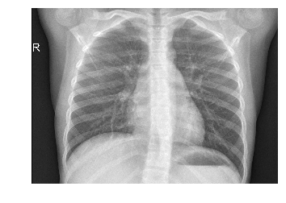

2] an X-ray of a patient diagnosed with pneumonia:
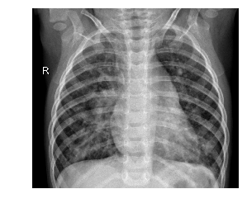

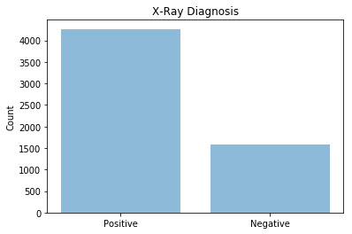
3]

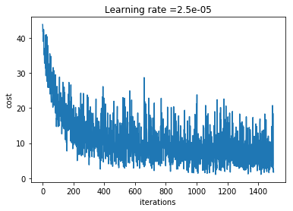
4] parameter has been optimized

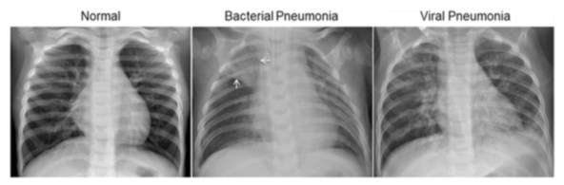
5]

6] Plot historygram

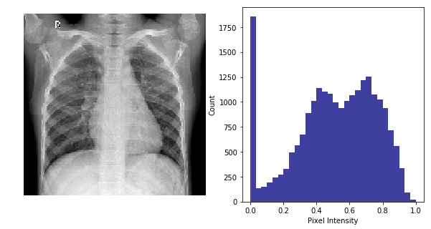

7] plotn three images

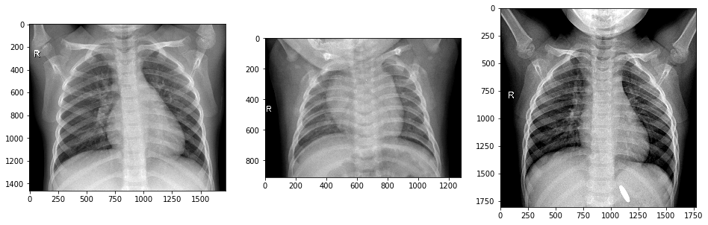

8] No pneumoina in this below images
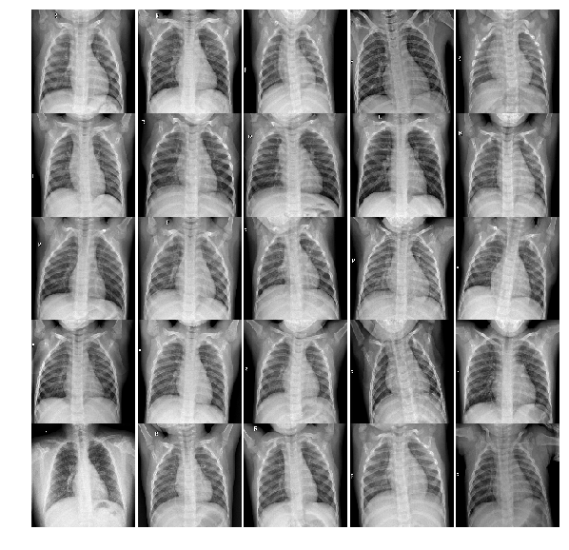

9] pneumonia in this below images

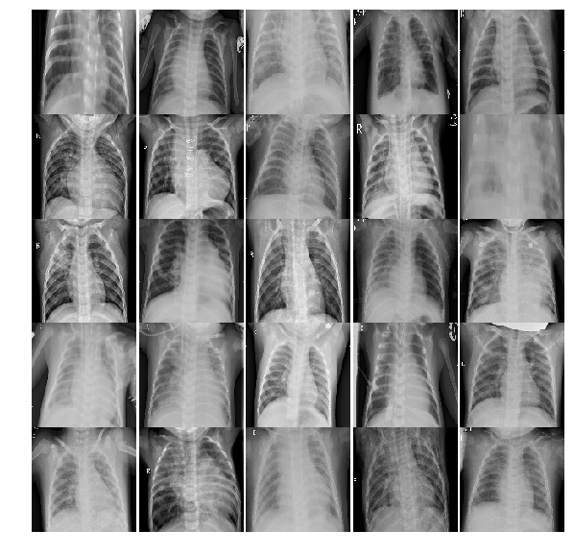

10]' No Pneumonia', 1: 'Yes Pneumonia'}

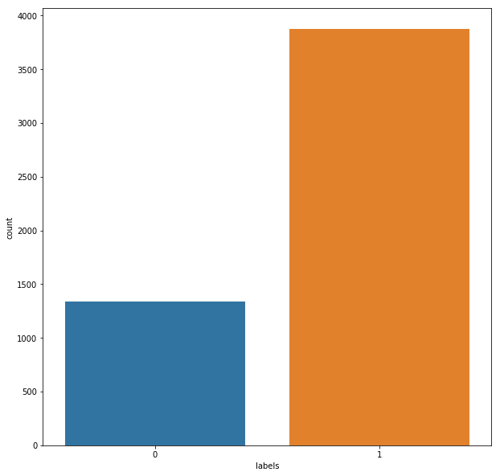

11] 'No Pneumonia', 1: 'Yes Pneumonia'

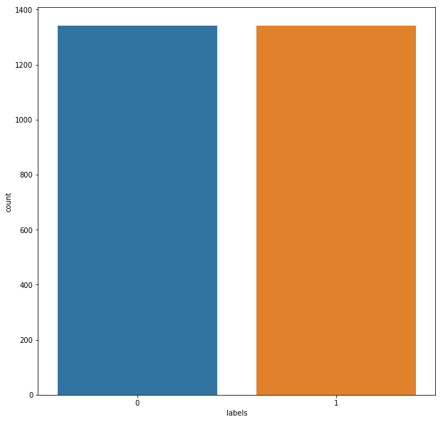

* OUTPUT SHAPES

Transfer learning w/ VGG16 Convolutional Network

pretrainedNetwork(X_trainRosReshaped, Y_trainRosHot, X_testRosReshaped, Y_testRosHot,pretrained_model_1,weight_path1,class_weight2,2,6,optimizer1,map_characters1)

Layer (type) Output Shape Param #
=================================================================
input_1 (InputLayer) (None, 150, 150, 3) 0
_________________________________________________________________
block1_conv1 (Conv2D) (None, 150, 150, 64) 1792
_________________________________________________________________
block1_conv2 (Conv2D) (None, 150, 150, 64) 36928
_________________________________________________________________
block1_pool (MaxPooling2D) (None, 75, 75, 64) 0
_________________________________________________________________
block2_conv1 (Conv2D) (None, 75, 75, 128) 73856
_________________________________________________________________
block2_conv2 (Conv2D) (None, 75, 75, 128) 147584
_________________________________________________________________
block2_pool (MaxPooling2D) (None, 37, 37, 128) 0
_________________________________________________________________
block3_conv1 (Conv2D) (None, 37, 37, 256) 295168
_________________________________________________________________
block3_conv2 (Conv2D) (None, 37, 37, 256) 590080
_________________________________________________________________
block3_conv3 (Conv2D) (None, 37, 37, 256) 590080
_________________________________________________________________
block3_pool (MaxPooling2D) (None, 18, 18, 256) 0
_________________________________________________________________
block4_conv1 (Conv2D) (None, 18, 18, 512) 1180160
_________________________________________________________________
block4_conv2 (Conv2D) (None, 18, 18, 512) 2359808
_________________________________________________________________
block4_conv3 (Conv2D) (None, 18, 18, 512) 2359808
_________________________________________________________________
block4_pool (MaxPooling2D) (None, 9, 9, 512) 0
_________________________________________________________________
block5_conv1 (Conv2D) (None, 9, 9, 512) 2359808
_________________________________________________________________
block5_conv2 (Conv2D) (None, 9, 9, 512) 2359808
_________________________________________________________________
block5_conv3 (Conv2D) (None, 9, 9, 512) 2359808
_________________________________________________________________
block5_pool (MaxPooling2D) (None, 4, 4, 512) 0
_________________________________________________________________
flatten_1 (Flatten) (None, 8192) 0
_________________________________________________________________
dense_1 (Dense) (None, 2) 16386
=================================================================
Total params: 14,731,074
Trainable params: 16,386
Non-trainable params: 14,714,688
_________________________________________________________________
Train on 2682 samples, validate on 468 samples
Epoch 1/6
2682/2682 [==============================] - 498s 186ms/step - loss: 0.4415 - acc: 0.8583 - val_loss: 0.4006 - val_acc: 0.8846
Epoch 2/6
2682/2682 [==============================] - 509s 190ms/step - loss: 0.2429 - acc: 0.9329 - val_loss: 0.3779 - val_acc: 0.8376
Epoch 3/6
2682/2682 [==============================] - 856s 319ms/step - loss: 0.1815 - acc: 0.9444 - val_loss: 0.3776 - val_acc: 0.8291
Epoch 4/6
2682/2682 [==============================] - 650s 242ms/step - loss: 0.1539 - acc: 0.9493 - val_loss: 0.3551 - val_acc: 0.8504
Epoch 5/6
2682/2682 [==============================] - 588s 219ms/step - loss: 0.1353 - acc: 0.9549 - val_loss: 0.3996 - val_acc: 0.8226
Epoch 6/6
2682/2682 [==============================] - 489s 182ms/step - loss: 0.1228 - acc: 0.9605 - val_loss: 0.3470 - val_acc: 0.8526

Keras CNN - accuracy: 0.8525641025641025

precision recall f1-score support

No Pneumonia 0.96 0.74 0.83 234
Yes Pneumonia 0.79 0.97 0.87 234

avg / total 0.87 0.85 0.85 468

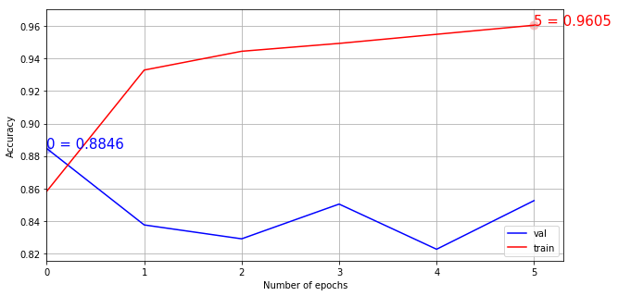

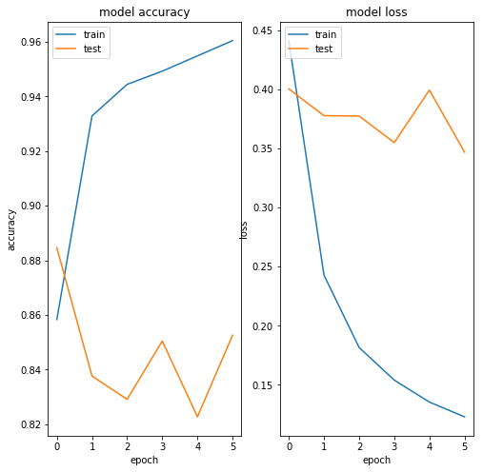

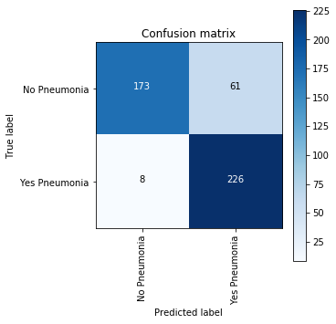

Transfer learning w/ InceptionV3 Convolutional Network

pretrainedNetwork(X_trainRosReshaped, Y_trainRosHot, X_testRosReshaped, Y_testRosHot,pretrained_model_2,weight_path2,class_weight2,2,6,optimizer1,map_characters1)

Layer (type) Output Shape Param #
=================================================================
input_1 (InputLayer) (None, 150, 150, 3) 0
_________________________________________________________________
block1_conv1 (Conv2D) (None, 150, 150, 64) 1792
_________________________________________________________________
block1_conv2 (Conv2D) (None, 150, 150, 64) 36928
_________________________________________________________________
block1_pool (MaxPooling2D) (None, 75, 75, 64) 0
_________________________________________________________________
block2_conv1 (Conv2D) (None, 75, 75, 128) 73856
_________________________________________________________________
block2_conv2 (Conv2D) (None, 75, 75, 128) 147584
_________________________________________________________________
block2_pool (MaxPooling2D) (None, 37, 37, 128) 0
_________________________________________________________________
block3_conv1 (Conv2D) (None, 37, 37, 256) 295168
_________________________________________________________________
block3_conv2 (Conv2D) (None, 37, 37, 256) 590080
_________________________________________________________________
block3_conv3 (Conv2D) (None, 37, 37, 256) 590080
_________________________________________________________________
block3_pool (MaxPooling2D) (None, 18, 18, 256) 0
_________________________________________________________________
block4_conv1 (Conv2D) (None, 18, 18, 512) 1180160
_________________________________________________________________
block4_conv2 (Conv2D) (None, 18, 18, 512) 2359808
_________________________________________________________________
block4_conv3 (Conv2D) (None, 18, 18, 512) 2359808
_________________________________________________________________
block4_pool (MaxPooling2D) (None, 9, 9, 512) 0
_________________________________________________________________
block5_conv1 (Conv2D) (None, 9, 9, 512) 2359808
_________________________________________________________________
block5_conv2 (Conv2D) (None, 9, 9, 512) 2359808
_________________________________________________________________
block5_conv3 (Conv2D) (None, 9, 9, 512) 2359808
_________________________________________________________________
block5_pool (MaxPooling2D) (None, 4, 4, 512) 0
_________________________________________________________________
flatten_2 (Flatten) (None, 8192) 0
_________________________________________________________________
dense_2 (Dense) (None, 2) 16386
=================================================================
Total params: 14,731,074
Trainable params: 16,386
Non-trainable params: 14,714,688
_________________________________________________________________
Train on 2682 samples, validate on 468 samples
Epoch 1/6
2682/2682 [==============================] - 501s 187ms/step - loss: 0.4229 - acc: 0.8840 - val_loss: 0.4445 - val_acc: 0.8077
Epoch 2/6
2682/2682 [==============================] - 505s 188ms/step - loss: 0.2351 - acc: 0.9370 - val_loss: 0.4205 - val_acc: 0.8013
Epoch 3/6
2682/2682 [==============================] - 517s 193ms/step - loss: 0.1778 - acc: 0.9471 - val_loss: 0.3925 - val_acc: 0.8162
Epoch 4/6
2682/2682 [==============================] - 503s 188ms/step - loss: 0.1491 - acc: 0.9534 - val_loss: 0.3752 - val_acc: 0.8248
Epoch 5/6
2682/2682 [==============================] - 507s 189ms/step - loss: 0.1324 - acc: 0.9590 - val_loss: 0.4975 - val_acc: 0.7756
Epoch 6/6
2682/2682 [==============================] - 501s 187ms/step - loss: 0.1215 - acc: 0.9627 - val_loss: 0.4616 - val_acc: 0.7970

Keras CNN - accuracy: 0.7970085470085471

precision recall f1-score support

No Pneumonia 0.97 0.61 0.75 234
Yes Pneumonia 0.72 0.98 0.83 234

avg / total 0.84 0.80 0.79 468

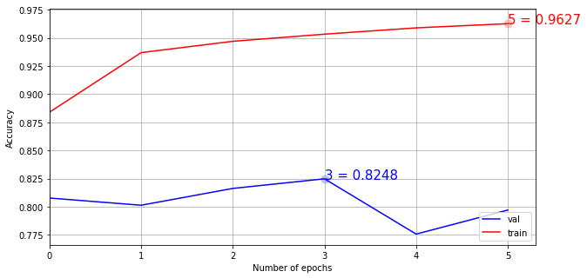

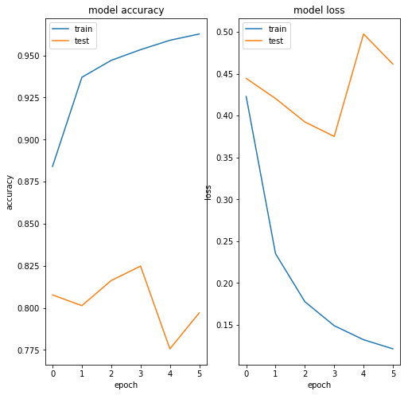

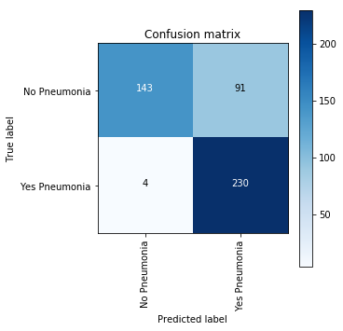

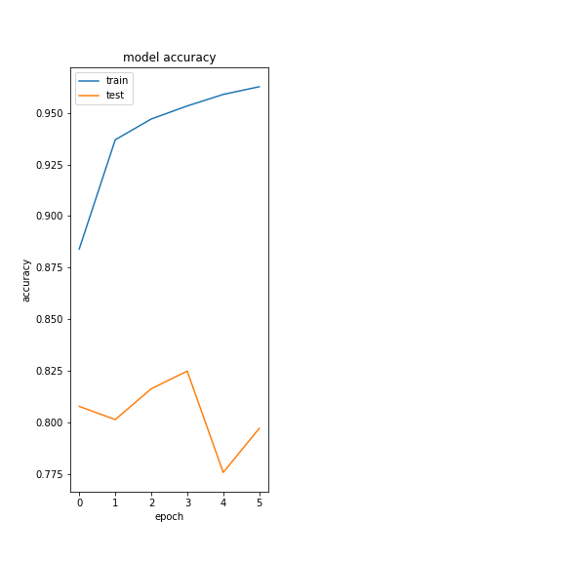
OUTPUT -

OUTPUT Vizualization

