**Learning Management System (LMS)**

**Description**:

* The Learning Management System is a software application designed to manage, deliver, and track educational courses and training programs efficiently. It facilitates communication between learners, instructors, and administrators while providing essential tools for assessment, certification, and course tracking.
* The LMS aims to streamline online education by offering a centralized platform for course management, learner engagement, payment processing, certification, and performance tracking. The system is designed for scalability and user-friendliness to cater to diverse educational needs.

**Introduction to the Domain**:

* Online learning platforms are transforming the educational landscape by providing flexible, accessible, and efficient ways for learners and educators to interact. With the increasing demand for remote education, an LMS is a vital tool for schools, universities, and corporate training programs.

**Problem Description**:  
The traditional methods of education management often result in inefficiencies and lack of scalability. Key challenges include:

1. Inefficient course management and tracking.
2. Limited learner-instructor interaction mechanisms.
3. Poor integration of assessment and certification processes.
4. Difficulty in managing diverse payment methods and tracking financial records.

**Visuals**:

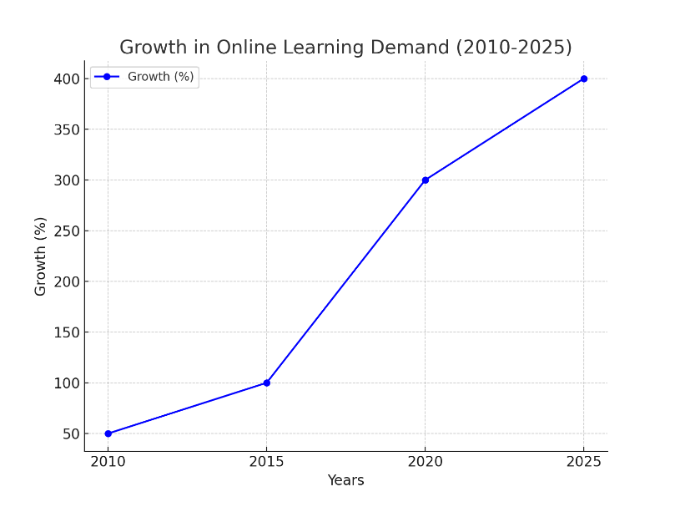

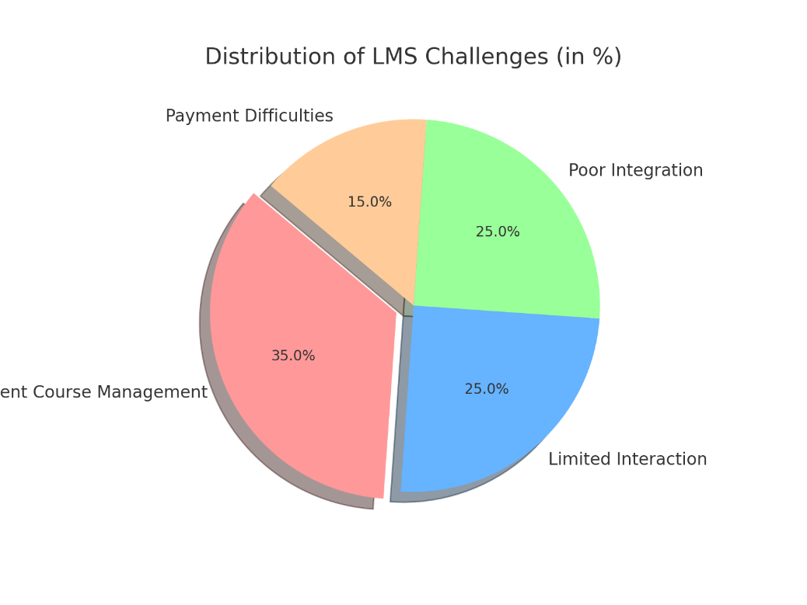

**Real-world Scenarios or Case Studies**:

* **Universities**:
  + Post-pandemic hybrid learning has made it challenging to manage in-person and online students simultaneously.
  + Example: A university handling 20,000 students manually struggled to organize online exams, resulting in delays and errors.
* **Corporate Training**:
  + Corporations face difficulties in tracking the progress and certifications of employees across departments.
  + Example: A large IT firm had issues with compliance training certifications, leading to audit failures.
* **Small Educational Institutes**:
  + Small institutes often lack the resources to adopt technology, leading to manual inefficiencies.
  + Example: Coaching centers manually managing course enrollments struggled during COVID-19 closures.
* **Freelance Instructors**:
  + Individual instructors face challenges in managing multiple students across platforms.
  + Example: A freelance language tutor managing payments and certifications for 200 students faced significant delays without a central system.

**Proposed Solution**

* Outline of the solution

**1.Inefficient course management and tracking**

* **Real-Time Progress Tracking:**  
  Use **real-time databases** (like Firebase or Socket.io) to update student progress dynamically.
* **Advanced Course Management Dashboard:**  
  Provide a user-friendly dashboard for instructors to create, update, and organize courses with minimal effort.
* **Reporting and Analytics:**  
  Implement **detailed analytics dashboards** that show attendance, quiz scores, completion rates, and overall engagement.

**2.Limited learner-instructor interaction mechanisms.**

* **Live Chat and Messaging System:**  
  Build an **in-app chat system** that allows real-time interaction between learners and instructors.
* **Discussion Forums:**  
  Implement a **community forum** where students can ask questions and instructors can moderate discussions.
* **Video Conferencing Integration:**  
  Integrate with tools like **Zoom**, **Microsoft Teams**, or **Twilio** for live classes.

**3.Poor integration of assessment and certification processes.**

* **Automated Assessment System:**  
  Implement a system for **quizzes, assignments, and exams** with automatic grading for objective questions.
* **Proctoring Mechanism:**  
  Add **proctoring tools** to monitor students during online exams to prevent cheating.
* **Certificate Generation:**  
  Automate the process of **certificate generation** upon course completion using templates.

**4.Difficulty in managing diverse payment methods and tracking financial records.**

* **Payment Gateway Integration:**  
  Integrate **popular payment gateways** like **Stripe**, **PayPal**, **Razorpay** to handle diverse payment methods.
* **Financial Dashboard:**  
  Provide a **financial management dashboard** for admins to track payments, generate invoices, and monitor revenue.
* How the solution directly addresses the problem
* **Payment Gateway Integration** allows users to pay using multiple methods, making the payment process flexible and user-friendly.
* **Subscription Management** helps track recurring payments, ensuring a steady revenue stream.
* **Financial Dashboard** provides admins with a clear view of all transactions, revenue, and pending payments.
* **Automated Invoicing** reduces manual work, ensures accuracy, and provides students with official payment records.
* **Scope:**
  + In-Scope

**1. A Fully Functional LMS Platform**

\***Key Features:**

*User-friendly interfaces for students, instructors, and administrators.

*Responsive design to work on various devices (desktop, tablet, mobile).

*Secure login and user authentication.

**2. User-Specific Dashboards**

\***For Students:**

*Dashboard displaying enrolled courses, progress tracking, and performance reports.

*Ability to access course materials, take quizzes, and submit assignments.

\***For Instructors:**

*Tools to create, upload, and manage course content (videos, notes, quizzes).

*Insights into student performance and activity tracking.

\***For Administrators:**

*Control panel to manage platform users, courses, and system settings.

*Data analytics for platform usage and performance monitoring.

**3. Course Management System**

*Features for creating and organizing courses with modules such as:

*Videos

*Documents (PDFs, slides)

*Quizzes and assignments

*Ability to schedule live classes or discussions.

**4. Quiz and Assessment Module**

*Features for instructors to create quizzes and exams.

*Students can take quizzes with automatic grading and feedback.

*Reporting for instructors on quiz results and overall student performance.

*Certificate generarion.

1. **Inbuilt code editor**

*To give student a better practice of coding.

*To solve coding question during quiz.

**6. AI Proctored Exam Feature (if added)**

*Real-time monitoring of students during exams to ensure academic integrity.

*Facial recognition, gaze tracking, and cheating detection.

**7.Live Support**

**\***Student can connect to instructor for any kind of help.

**8. Payment Gateway Integration**

*Students can pay for courses securely using integrated payment systems like Stripe or PayPal.

* + **Out-of-Scope**

### **Offline Functionality**

* **Out of Scope:** Full offline access to all course content and quizzes without an internet connection.
* **Reason:** While offline functionality can be a great feature, it may not be feasible in early stages due to complex syncing mechanisms required for offline access.

### **Third-Party Integrations**

* **Out of Scope:** Integration with external tools such as advanced analytics platforms, third-party video conferencing tools (e.g., Zoom, Teams), or specific external Learning Content Management Systems (LCMS).
* **Reason:** These integrations may require additional development efforts and third-party API considerations, which might be outside the scope.

### **Advanced Security Features**

* **Out of Scope:** Implementing advanced security features such as biometric authentication, encryption of every user interaction, or complex access control systems.
* **Reason:** While security is important, advanced features may be beyond the project’s initial scope due to the cost and complexity involved.

### **Social Learning Features**

* **Out of Scope:** Creating extensive social features such as forums, discussion boards, or advanced social networking functionality (e.g., student profiles, friend requests).
* **Reason:** These features require a whole set of additional features and are usually added once the core LMS functionality is established.

### **Complex User Roles and Permissions**

* **Out of Scope:** Highly complex user role management (e.g., allowing for detailed permissions for admins, instructors, students, and parents with granular access control).
* **Reason:** A basic LMS might have limited user roles (e.g., Admin, Instructor, Student), and more granular permissions can be added later.

### **Multi-Tenant SaaS LMS**

* **Description:** Creating a single LMS platform that can serve multiple organizations with separate branding and data privacy for each tenant.
* **Reason:** Multi-tenant architecture adds a lot of complexity in terms of data segregation, security, and customization.

### **Integration with Complex ERP Systems**

* **Description:** Integrating the LMS with enterprise resource planning (ERP) systems used by universities for managing finances, human resources, etc.
* **Reason:** ERP integrations are complex and require deep domain knowledge and custom API development for each ERP system.

**Objectives:**

The objective of the project in the video is to create a **Learning Management System (LMS)** that enhances online education by providing a platform where:

**Educators Can:**

* Create and manage courses with various modules like videos, quizzes, and assignments.
* Monitor student performance and provide feedback.
* Efficiently deliver educational content to a global audience.

**Students Can:**

* Enroll in courses, access learning materials, and track their progress.
* Take quizzes and exams to test their knowledge.
* Learn at their own pace with a user-friendly interface.

**Administrators Can:**

* Manage users (students and instructors).
* Oversee course content and platform functionality.
* Ensure smooth operation and enforce rules like access control and payment processing.
* The project aims to bridge the gap between educators and learners by leveraging modern web technologies to provide a seamless, interactive, and scalable e-learning platform. It promotes accessibility, flexibility, and personalized learning experiences.
  + Measurable and time-bound

**Development Timeline:**

* Complete the core LMS platform within **6 months**, including user interfaces for students, instructors, and admins.

**Course Creation Feature:**

* Enable **100% functional course management** (videos, documents, quizzes) by the end of **Month 3**.

**User Dashboards:**

* Launch **fully functional dashboards** for students, instructors, and admins by **Month 4**.

**Quiz and Assessment Module:**

* Implement **automated quiz grading** and **certificate generation** within **Month 5**.

**Payment Gateway Integration:**

* Ensure **secure payment processing** with **multiple gateways** (Stripe, PayPal) by the end of **Month 6**.

**User Engagement:**

* Achieve **at least 80% course completion rate** from enrolled students within the first **3 months of launch**.

**Live Support Feature:**

* Integrate **live chat support** by **Month 5** to enhance user engagement.

**Goal:** Deliver a fully functional, user-friendly LMS platform within **6 months**, focusing on scalability, security, and user engagement.

**Technology Stack**

* **Frontend:**

**React JS**: A popular JavaScript library for building user interfaces, React allows developers to create reusable UI components, manage state efficiently, and build dynamic web applications.

**Tailwind CSS**: A utility-first CSS framework that enables rapid UI development. It provides low-level utility classes to build custom designs without leaving the HTML, ensuring consistency and responsiveness across the application.

**Shadcn UI**: A UI component library that offers a collection of pre-built, accessible, and customizable components. Integrating Shadcn UI accelerates development by providing ready-to-use components that adhere to best practices in design and accessibility.

* **Backend:**

**Express.js**: A minimal and flexible Node.js web application framework that provides a robust set of features for web and mobile applications. In this project, Express.js is used to build the backend server, handle API requests, manage routing, and facilitate communication between the frontend and the database.

**Node.js** is the foundation for running the backend code. It provides the environment for **Express.js**, the web application framework used to build the server-side logic.

**API Creation**:  
The backend APIs (Application Programming Interfaces) are built using Node.js with Express.js. These APIs handle various functions such as:

* Fetching course data.
* Managing user authentication (e.g., login, registration).
* Storing and retrieving user progress data.
* Handling file uploads (e.g., course materials or user submissions).

**Middleware Integration**:  
Node.js allows the use of middleware functions in Express.js to:

* Parse incoming request bodies (e.g., using body-parser or built-in middleware).
* Handle cross-origin resource sharing (CORS) to allow requests from the React frontend.
* Implement security measures like validating JSON Web Tokens (JWT) for authentication.

**Database Communication**:  
Node.js facilitates interaction with **MongoDB** (NoSQL database) using libraries like **Mongoose**. It handles database queries asynchronously, ensuring non-blocking operations.

**For example:**

* Storing user details during registration.
* Fetching enrolled courses for a user.
* Saving user progress in lessons or quizzes.

**Database:**

**MongoDB**: A NoSQL database known for its scalability and flexibility. MongoDB stores data in JSON-like documents, making it a natural fit for JavaScript-based applications like those built with the MERN stack. In the LMS project, MongoDB is used to store user information, course content, progress tracking, and other relevant data.

· **OpenCV (Python):** Handles real-time video capture and processing.

· **TensorFlow or PyTorch:** Facilitates the development and deployment of deep learning models for behavior analysis.

· **CodeMirror:** A versatile text editor implemented in JavaScript for the browser. It provides a rich set of features for code editing, including syntax highlighting, customizable themes, and support for numerous programming languages. Integrating CodeMirror into the React application enables the development of a robust code editing interface.

· **Judge0:** An open-source online code execution system that supports multiple programming languages. It allows the code editor to execute and evaluate code written by users in real-time. By connecting the code editor to the Judge0 API, the application can compile and run code, providing immediate feedback to users.

**Tools:**

**VS Code** (or any code editor):

* A popular code editor with extensions for JavaScript, React, Node.js, etc.

**Git**:

* Version control system for tracking changes and collaborating on code.

**GitHub**:

* Repository hosting service for version control and collaboration.

**Postman** or **Insomnia**:

* Tools for testing APIs by sending HTTP requests to the backend.

**npm (Node Package Manager)**:

* For managing packages and dependencies.

**System Design/Architecture:**

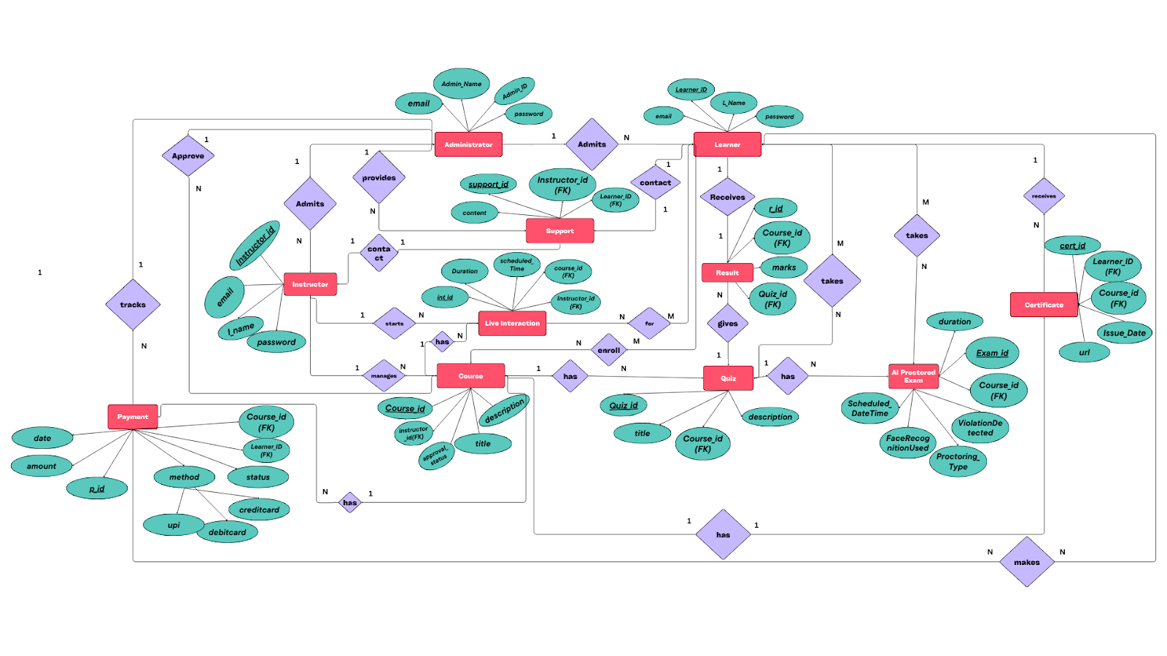

**ER Diagram Components and Their Explanation:**

**1. Administrator**

**Description:**  
 The system administrator oversees the platform's operation, manages instructors and learners, and ensures data integrity.

**Attributes:** AdminID, AdminName, Email, Password.

**Relationships**:

* + Approves instructors.
  + Admits learners into the system.

**2. Instructor**

* **Description**:  
   Instructors create and manage course content, quizzes, and live lectures. They are approved by administrators.
* **Attributes:** InstructorID, FName, LName, Email, Password.
* **Relationships:**
  + Manages courses.
  + Hosts live interactions for learners.

**3. Learner**

* **Description:**  
   Learners are the primary users who enroll in courses, participate in quizzes, live lectures, and receive certificates upon completion.
* **Attributes:** LearnerID, FName, LName, Email, Password.
* **Relationships:**
  + Takes courses.
  + Participates in quizzes and live interactions.
  + Receives certificates upon course completion.

**4. Course**

* **Description:**  
   Represents the central learning content created and managed by instructors.
* **Attributes:** CourseID, Title, Description.
* **Relationships:**
  + Managed by instructors.
  + Contains quizzes, AI proctored exams, and live interactions.
  + Is paid, requiring learners to make a payment to enroll.

**5. Quiz**

* **Description:**  
   Quizzes are assessments tied to specific courses to evaluate learner understanding.
* **Attributes:** QuizID, Title, Description, CourseID (FK).
* **Relationships**:
  + Belongs to a course.
  + Produces results for learners.

**6. AI Proctored Exam**

* **Description:** Advanced AI-enabled exams for ensuring fair assessment with features like face recognition and activity monitoring.
* **Attributes:** ExamID, ScheduledDateTime, Duration, FaceRecognitionUsed, ViolationDetected, ProctoringTool, CourseID (FK).
* **Relationships:**
  + Belongs to a course.

**7. Live Interaction**

* **Description:** Real-time live lectures and discussions hosted by instructors to engage learners.
* **Attributes:** InteractionID, ScheduledDateTime, Platform, Duration, Topic, MaxParticipants, AttendanceCount, CourseID (FK), InstructorID (FK).
* **Relationships:**
  + Associated with a specific course.
  + Hosted by an instructor.
  + Attended by learners.

**8. Feedback**

* **Description:** Allows learners to provide feedback on courses, quizzes, or live interactions for improvement.
* **Attributes:** FeedbackID, Rating, Comments, FeedbackType, FeedbackDate, LearnerID (FK), CourseID (FK).
* **Relationships:**
  + Learners give feedback for courses.

**9. Payment**

* **Description:** Handles financial transactions for learners to access paid courses.
* **Attributes:** PaymentID, Amount, Method (CreditCard/UPI), PaymentStatus, Date, CourseID (FK), LearnerID (FK).
* **Relationships:**
  + Made by learners for specific courses.

**10. Result**

* **Description:** Stores the outcomes of quizzes for learners, showing their performance.
* **Attributes:** ResultID, Marks, QuizID (FK), LearnerID (FK).
* **Relationships:**
  + Linked to quizzes taken by learners.

**11. Certificate**

* **Description:** Digital certificates issued to learners upon course completion.
* **Attributes:** CertID, IssueDate, URI, LearnerID (FK), CourseID (FK).
* **Relationships:**
  + Issued to learners for completed courses.

**Relationships Overview**

1. Administrator manages Instructor and admits Learners.
2. Instructor manages Courses and hosts Live Interactions.
3. Learner:
   * Enrolls in Courses, participates in Quizzes and Live Interactions.
   * Makes Payments to access courses.
   * Provides Feedback on courses.
   * Receives Certificates upon course completion.
4. Course contains Quizzes, AI Proctored Exams, and Live Interactions.
5. Quiz generates Results for learners.
6. Payment records course purchases.

**FLOWCHART:**

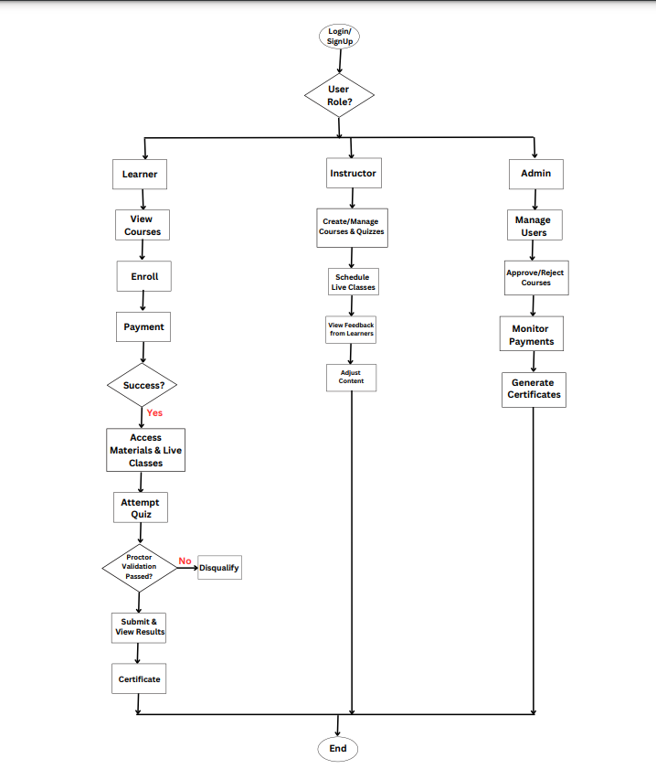

**Module Breakdown**

**1. User Management( Ayushi Mishra)**

* **Description:** This module handles the registration, login, and management of different user types: administrators, instructors, and learners. Administrators manage the overall system, instructors create and manage courses, and learners enroll in courses. The module ensures role-based access and user authentication.
* **Key Features:**
  + User registration and profile creation.
  + Login/logout functionality with secure password storage.
  + Role-based access control (e.g., only instructors can create quizzes, only admins can approve courses).

**2. Course Management(Swasti Jain)**

* **Description:** The Course Management module oversees the lifecycle of courses. It enables administrators or instructors to create, modify, and delete courses. Each course has details like title, description, and the instructor responsible for teaching it. Learners can browse available courses and enroll in them.
* **Key Features:**
  + Add/update/delete course details (title, description, duration).
  + Assign instructors to courses.
  + Track which learners are enrolled in which courses.

**3. Quiz Management(Niharika Thakur)**

* **Description:** This module is designed for creating quizzes associated with specific courses and tracking learner performance. Quizzes are authored by instructors and can contain a variety of questions to test learners' understanding of course content. Learners' quiz results are stored and can be accessed for performance evaluation.
* **Key Features:**
  + Create quizzes for courses with titles and descriptions.
  + Store and retrieve learner results for quizzes.
  + Generate analytics or insights on learner performance.

**4. Live Interaction (Live Classes)(Ayushi Mishra)**

* **Description:** This module enables real-time interactions between instructors and learners through live classes. Instructors can schedule live sessions, which learners can join at the specified time. It supports tracking session durations and allows learners to clarify doubts during the sessions.
* **Key Features:**
  + Schedule live classes with instructors.

**5. Support Module (Live Support)(Swasti Jain )**

* **Description:** The Support module allows learners to reach out for help through scheduled support sessions. Instructors or support staff can address learner queries related to course content, enrollment, or technical issues.
* **Key Features:**
  + Allow learners to contact support staff or instructors.
  + Facilitate scheduled support interactions.
  + Track and resolve learner issues effectively.

**6. Payment Module(Nikita Agarwal)**

* **Description:** The Payment module manages all transactions related to course enrollments. It supports multiple payment methods, such as credit/debit cards and UPI. It securely tracks payment details and links each payment to a specific learner and course.
* **Key Features:**
  + Process payments using secure methods.
  + Maintain a payment history with details like amount, date, and payment ID.
  + Link payments to specific courses and learners.

**7. Feedback Module (Niharika Thakur)**

* **Description:** The Feedback module collects feedback from learners about courses, instructors, and quizzes. This feedback is vital for improving course quality and ensuring learner satisfaction. It can be implemented as optional forms available after course completion or quiz submission.
* **Key Features:**
  + Allow learners to submit feedback on courses and instructors.
  + Aggregate feedback for reporting purposes.
  + Use feedback insights to enhance course content and teaching methods.

**8. AI Proctored Exam Module(Nikita Agarwal)**

* **Description:** This module integrates AI-based monitoring for exams, ensuring integrity and security during assessments. It uses technologies like facial recognition to authenticate learners and monitor their activities for any suspicious behavior. Violations are recorded and flagged for review.
* **Key Features:**
  + Authenticate learners using face recognition before starting exams.
  + Monitor learners during exams to detect cheating or other violations.
  + Record exam sessions for later review if required.

**9. Certification Module(Nikita Agarwal)**

* **Description:** The Certification module handles the generation and distribution of certificates upon course completion. It auto-generates certificates with unique URLs, linking them to specific learners and courses. Learners can download their certificates directly from their profiles.
* **Key Features:**
  + Generate certificates automatically upon course completion.
  + Include unique certificate URLs for validation purposes.
  + Allow learners to view and download their certificates.

**Hierarchical Diagram**

**Tabular Representation**

|  |  |  |  |
| --- | --- | --- | --- |
| **Module** | **Description** | **Entities Involved** | **Key Features** |
| **User Management** | **Manages administrators, instructors, and learners.** | **Administrator, Instructor, Learner** | **User creation, login, role-based access** |
| **Course Management** | **Handles course creation and management.** | **Course** | **Add/update/delete courses, assign instructors** |
| **Quiz Management** | **Manages quizzes and learner results.** | **Quiz, Result** | **Add quizzes, store results, evaluate learner performance** |
| **Live Interaction** | **Facilitates live classes between instructors and learners.** | **Live Interaction** | **Schedule classes** |
| **Support Module** | **Connects learners to instructors/support staff for queries.** | **Support** | **Schedule sessions, address learner queries** |
| **Payment Module** | **Processes payments for course enrollment.** | **Payment** | **Track payments, support multiple methods** |
| **Feedback Module** | **Collects feedback on courses, instructors, or quizzes (if added).** | **(Optional addition)** | **Submit/aggregate feedback** |
| **AI Proctored Exam Module** | **AI-enabled monitoring during exams.** | **AI Proctored Exam** | **Detect violations, authenticate learners using face recognition** |
| **Certification Module** | **Issues certificates to learners after course completion.** | **Certificate** | **Auto-generate certificates, provide download links** |

**Project Timeline:**

The timeline for the development of the Learning Management System (LMS) spans six months, divided into four phases: Planning, Development, Testing, and Deployment. Each phase includes specific tasks, milestones, and deadlines to ensure timely completion of the project.

**Phases and Timeline**

1. **Planning Phase (Month 1)**
   * **Duration:** 1 month
   * **Key Activities:**
     + Requirement gathering and analysis.
     + Stakeholder meetings and approval of project scope.
     + ER diagram creation and design.
     + Finalization of system architecture and technology stack.
   * **Milestones:**
     + Completion of project requirements and scope documentation.
     + Approval of system design and architecture.

**Deadline:** End of Month 1.

1. **Development Phase (Months 2-4)**
   * **Duration:** 3 months
   * **Key Activities:**
     + **Month 2:**
       - Backend development: Database design, API development.
       - Initial frontend development: Basic UI for admin, instructor, and learner.
     + **Month 3:**
       - Integration of core features: Courses, quizzes, certificates.
       - Implementation of payment gateway.
     + **Month 4:**
       - Advanced feature development: AI proctored exams, live interaction module, feedback system.
       - Integration of all modules and system-level functionality.
   * **Milestones:**
     + **Month 2:** Backend and database finalized; initial UI ready.
     + **Month 3:** Payment gateway and course modules completed.
     + **Month 4:** AI proctored exams and live interaction functionality integrated.

**Deadline:** End of Month 4.

1. **Testing Phase (Month 5)**
   * **Duration:** 1 month
   * **Key Activities:**
     + Unit testing for individual modules.
     + Integration testing to ensure modules work together seamlessly.
     + Performance testing for scalability and reliability.
     + User Acceptance Testing (UAT) with admin, instructor, and learner roles.
   * **Milestones:**
     + All modules tested and verified for functionality and performance.

**Deadline:** End of Month 5.

1. **Deployment Phase (Month 6)**
   * **Duration:** 1 month
   * **Key Activities:**
     + Deployment of the LMS system on a production server.
     + Monitoring and optimizing system performance.
     + Training and onboarding of users (admin, instructors, learners).
     + Feedback collection and implementation of final adjustments.
   * **Milestones:**
     + Successful deployment and handover of the project.

**Deadline:** End of Month 6.

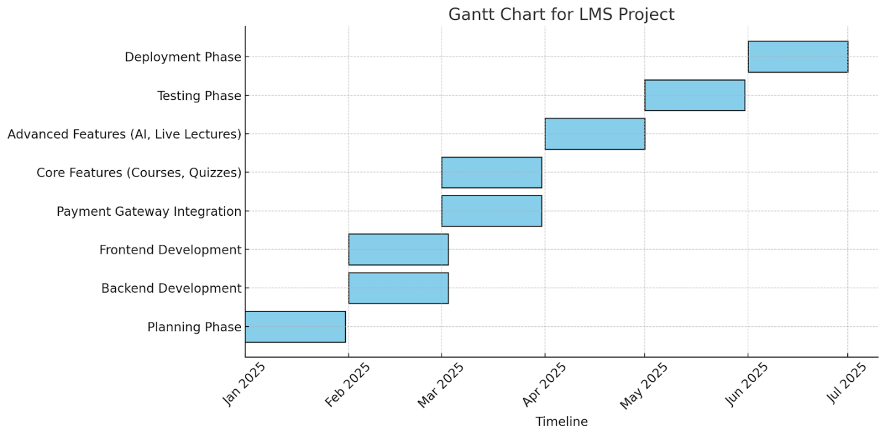

**Expected Outcomes: Key Benefits of the Software**

**1. Enhanced Learning Experience**

* **Interactive Learning:** The inclusion of live classes enables real-time interaction between learners and instructors, replicating a traditional classroom environment in a virtual space. Learners can ask questions, clarify doubts, and participate in discussions, enhancing engagement and comprehension.
* **24/7 Live Support:** A dedicated support system ensures that learners can resolve issues related to technical problems or course materials promptly, minimizing interruptions in their learning journey.
* **AI-Powered Proctored Exams:** AI-driven monitoring during assessments ensures fairness by detecting suspicious activities, such as multiple people in the camera frame or attempts to access unauthorized materials. This builds trust in the system for both learners and instructors.

**2. Seamless Administration**

* **Centralized User Management:** Administrators can oversee all aspects of the LMS, including managing users (learners and instructors), courses, quizzes, and certificates. This centralization reduces the complexity of handling various tasks separately.
* **Streamlined Course Approval:** Administrators have tools to quickly approve or reject course content submitted by instructors, ensuring the platform maintains high-quality standards.

**3. Increased Efficiency**

* **Course and Quiz Management:** Instructors can manage course content, create quizzes, and schedule exams through an intuitive interface. This reduces administrative overhead, allowing instructors to focus more on delivering quality education.
* **Integrated Payment System:** The platform includes multiple payment methods (UPI, credit card, debit card) for learners to enroll seamlessly. Payment tracking is automated, making fee collection hassle-free for administrators.
* **Instant Results and Feedback:** Learners receive quiz results and personalized feedback immediately, enabling them to identify strengths and areas for improvement.

**4. Personalized Learning**

* **Learner Progress Tracking:** The system tracks each learner's progress, including completed courses, earned certificates, quiz scores, and feedback. This allows learners to monitor their achievements and identify gaps in their learning.
* **Feedback Collection Mechanism:** Learners can submit feedback on courses and instructors. This ensures continuous improvement in course content and delivery.
* **Tailored Learning Paths:** Based on quiz performance and participation in live sessions, learners can receive recommendations for additional courses to enhance their skills further.

**5. Scalability**

* **Modular Design:** The LMS is designed with modularity in mind, allowing easy integration of new features like additional payment gateways, advanced analytics tools, or extended support options as the platform grows.
* **Multi-User Capability:** Whether it's a small group of learners or a large-scale educational institution, the platform can handle thousands of users simultaneously without compromising performance.
* **Future-Proofing with AI:** By integrating AI technologies for proctoring, learning analytics, and adaptive learning, the system remains relevant and competitive in an ever-evolving education technology landscape.

**6. Transparency and Security**

* **AI-Powered Monitoring for Exams:** The AI Proctoring feature ensures that exams are conducted in a fair and unbiased manner. It detects violations such as external device usage or unusual behavior and provides detailed reports to instructors and administrators.
* **Secure Transactions:** Payments made on the platform are encrypted and comply with industry security standards, ensuring data privacy and safe financial transactions.
* **Transparent Certification:** Learners can access their certificates through a secure URL, making it easy for them to share credentials with employers or institutions while maintaining authenticity.

**7. Cost-Effectiveness**

* **Reduced Operational Costs:** Automation of tasks such as user registration, course approval, certificate generation, and payment tracking reduces the need for manual intervention, saving administrative costs.
* **Affordable for Learners:** By minimizing the operational costs of running the platform, the LMS can offer affordable pricing plans for learners, increasing accessibility.

**8. Improved Learning Outcomes**

* **Gamified Quizzes:** Engaging and interactive quizzes make learning enjoyable while also helping learners retain knowledge better.
* **Data-Driven Insights:** Instructors and administrators can use learning analytics to assess learner performance and optimize teaching strategies.
* **Certificate of Achievement:** Learners receive verifiable certificates upon course completion, adding value to their resumes and professional profiles.

**Risks & Challenges**

**Potential Technical/Operational Risks**

1. **Technical Challenges:**
   * **Integration Issues:** Difficulty in integrating the payment gateway or AI proctoring systems with the LMS platform.
   * **Scalability Issues:** Performance may degrade with increasing users, courses, and live interactions.
   * **Data Security and Privacy:** Risks of data breaches or non-compliance with data protection regulations.
   * **System Downtime:** Unexpected server crashes affecting user access to the system.
2. **Operational Risks:**
   * **Limited Resources:** Insufficient team members or expertise in specific technical areas.
   * **Time Management:** Delays in meeting milestones or completing development phases.
   * **User Adoption:** Difficulty in onboarding users to the new system.
   * **Feedback Incorporation:** Challenges in addressing user feedback during development.
3. **AI-Specific Risks:**
   * **Proctoring Accuracy:** Errors in detecting violations during AI-proctored exams.
   * **Bias in AI Algorithms:** Potential bias in AI models affecting the fairness of evaluations.

**Risk Mitigation Plan**

1. **Technical Risk Mitigation:**
   * **Payment Gateway Integration:** We can conduct thorough research on well-documented APIs (e.g., Razorpay, PayPal) and perform rigorous testing.
   * **Scalability:** Optimize database queries and use techniques like database sharding or clustering to spread the load.
   * **Data Security:** Implement encryption (e.g., AES), regular vulnerability assessments, and compliance with GDPR or equivalent standards.
   * **Downtime:** Use load balancers and backup servers to ensure high availability and failover mechanisms.
2. **Operational Risk Mitigation:**
   * **Resource Planning:** Allocate tasks based on expertise and include buffer time for unexpected delays.
   * **Time Management:** Use project management tools (e.g., Jira, Trello) to track progress and deadlines.
   * **User Training:** Conduct webinars, tutorials, and live demos to facilitate smooth user onboarding.
   * **Feedback Loop:** Set up a feedback mechanism and prioritize changes based on impact and feasibility.
3. **AI Risk Mitigation:**
   * **Proctoring Accuracy:** Use pre-trained models and validate them with extensive test cases; add manual review options for flagged incidents.
   * **Bias Reduction:** Train AI models on diverse datasets and regularly evaluate their fairness and accuracy.

By proactively addressing these risks and employing the outlined mitigation strategies, the project can be delivered with reduced disruptions and improved success probability.

**Conclusion & Future Scope for the Learning Management System**

**Conclusion**

1. **Effective Learning Platform**:
   * The Learning Management System (LMS) serves as a **one-stop solution** for learners, instructors, and administrators. Its intuitive interface ensures that every user, regardless of technical proficiency, can navigate the platform with ease.
   * By integrating features like **live classes, live support**, and **AI-powered quizzes**, the platform delivers a **comprehensive learning ecosystem**, fostering both academic growth and skill development.
   * The seamless interaction between various user roles—administrators managing the system, instructors delivering knowledge, and learners engaging with the content—ensures an **enhanced and collaborative learning experience**.
2. **Enhanced Accessibility**:
   * The LMS is accessible 24/7, allowing learners to engage with **courses, quizzes, and certifications** at their convenience.
   * This flexibility empowers students from diverse locations and time zones to **access quality education anytime, anywhere**.
   * It addresses the modern need for **on-the-go learning**, making education a continuous and uninterrupted process.
   * Mobile and web compatibility further ensures that users can engage with the platform on their preferred devices, making it a **truly accessible and inclusive solution**.
3. **AI Integration**:
   * The incorporation of **AI proctored exams** ensures that assessments are conducted in a **fair and unbiased environment** by monitoring participants in real-time and detecting potential violations.
   * AI-driven **live interaction tools** facilitate a more engaging learning experience by providing **instant feedback** and enabling **adaptive learning paths** tailored to each learner’s needs.
   * This modern, tech-driven approach elevates the LMS beyond a traditional educational tool, positioning it as a **state-of-the-art solution** for online education.
4. **Scalable Solution**:
   * The platform is designed with scalability at its core, making it capable of **accommodating an increasing number of users, courses, and data volumes** as the institution grows.
   * Its modular design allows for easy integration of new features, ensuring the system remains **future-proof** and adaptable to evolving educational needs.
   * Whether for small institutions or large-scale universities, the LMS can seamlessly scale to meet demand, ensuring **long-term value and utility**.
5. **Secure and Reliable**:
   * **Data security** is a top priority, with advanced encryption protocols and strict access controls safeguarding sensitive information like user profiles, payment details, and exam results.
   * The platform is built on a robust architecture that ensures **high system uptime**, minimizing disruptions to learning and teaching activities.
   * Regular system updates and backups ensure that the platform remains **stable, secure, and compliant with industry standards**, offering users peace of mind and confidence in the system.

**Future Scope**

**1. Advanced Personalization**

* **AI-Driven Learning Paths**: Adaptive learning modules based on individual performance and preferences.
* **Gamification**: Engaging elements like badges, leaderboards, and interactive challenges to boost motivation.

**2. Scalability**

* **Global Access**: Expanding to support multilingual interfaces and diverse learning needs.
* **Cloud Scaling**: Enhanced cloud architecture to manage increasing user data and simultaneous users seamlessly.

**3. Improved AI Features**

* **Sentiment Analysis**: Analyze learner feedback and engagement levels in real-time.
* **Proctoring Enhancements**: Use advanced AI models for fraud detection and activity monitoring during exams.

**4. Comprehensive Analytics**

* **Data-Driven Insights**: Provide administrators with dashboards showing learner progress, engagement rates, and course effectiveness.
* **Predictive Analytics**: Forecast learner success and identify areas requiring intervention.

**5. Seamless Collaboration Tools**

* **Group Projects**: Enable team-based assignments with integrated communication tools.
* **Discussion Forums**: Foster community learning through moderated topic discussions.

**6. Offline Access**

* **Downloadable Content**: Allow learners to access course materials offline through mobile apps.
* **Progress Syncing**: Automatically update progress once back online.