Blogger

Snapshots of the blogger website:

\* If the user is not logged in, he can only be a reader

\* Front page

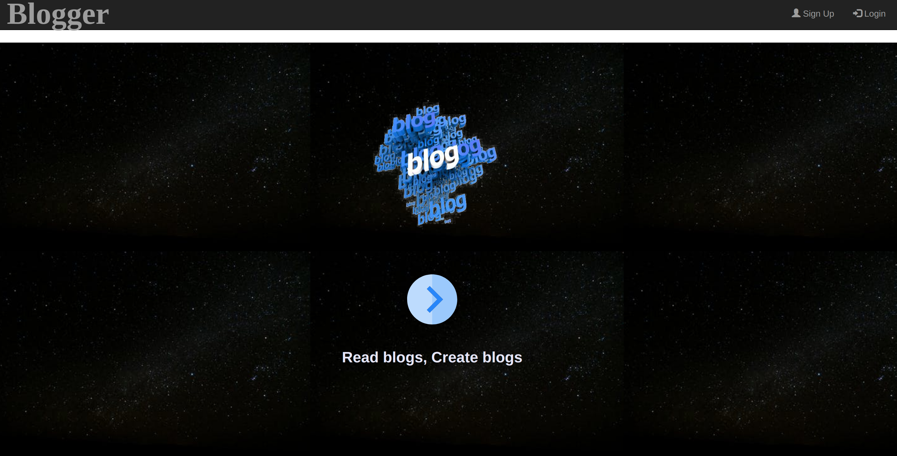

\*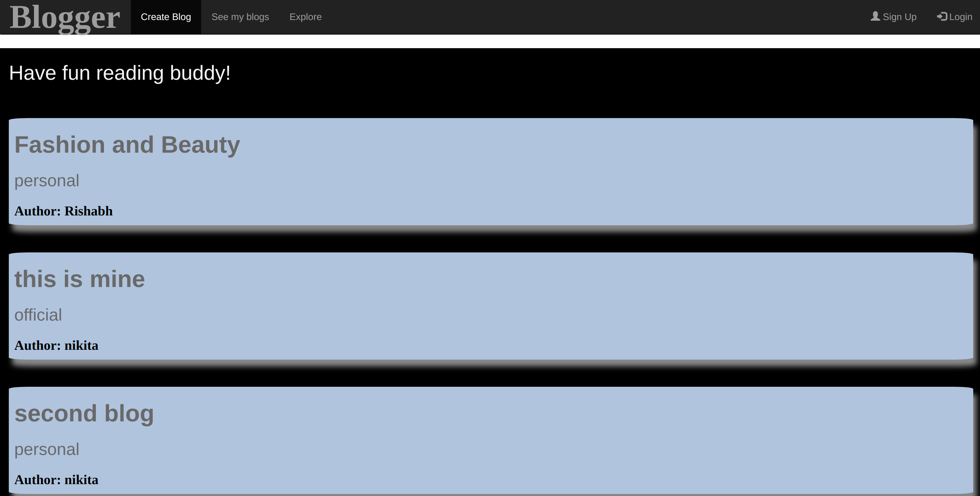 Explore all blogs to read

\*Show chosen blog to read

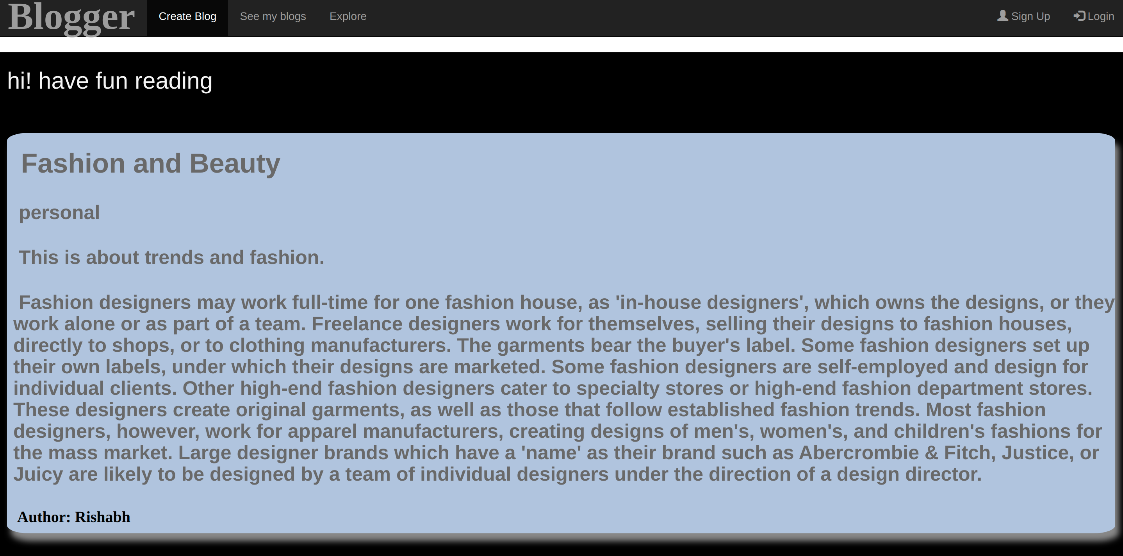

\* If you try to access anything beyond the reader’s role

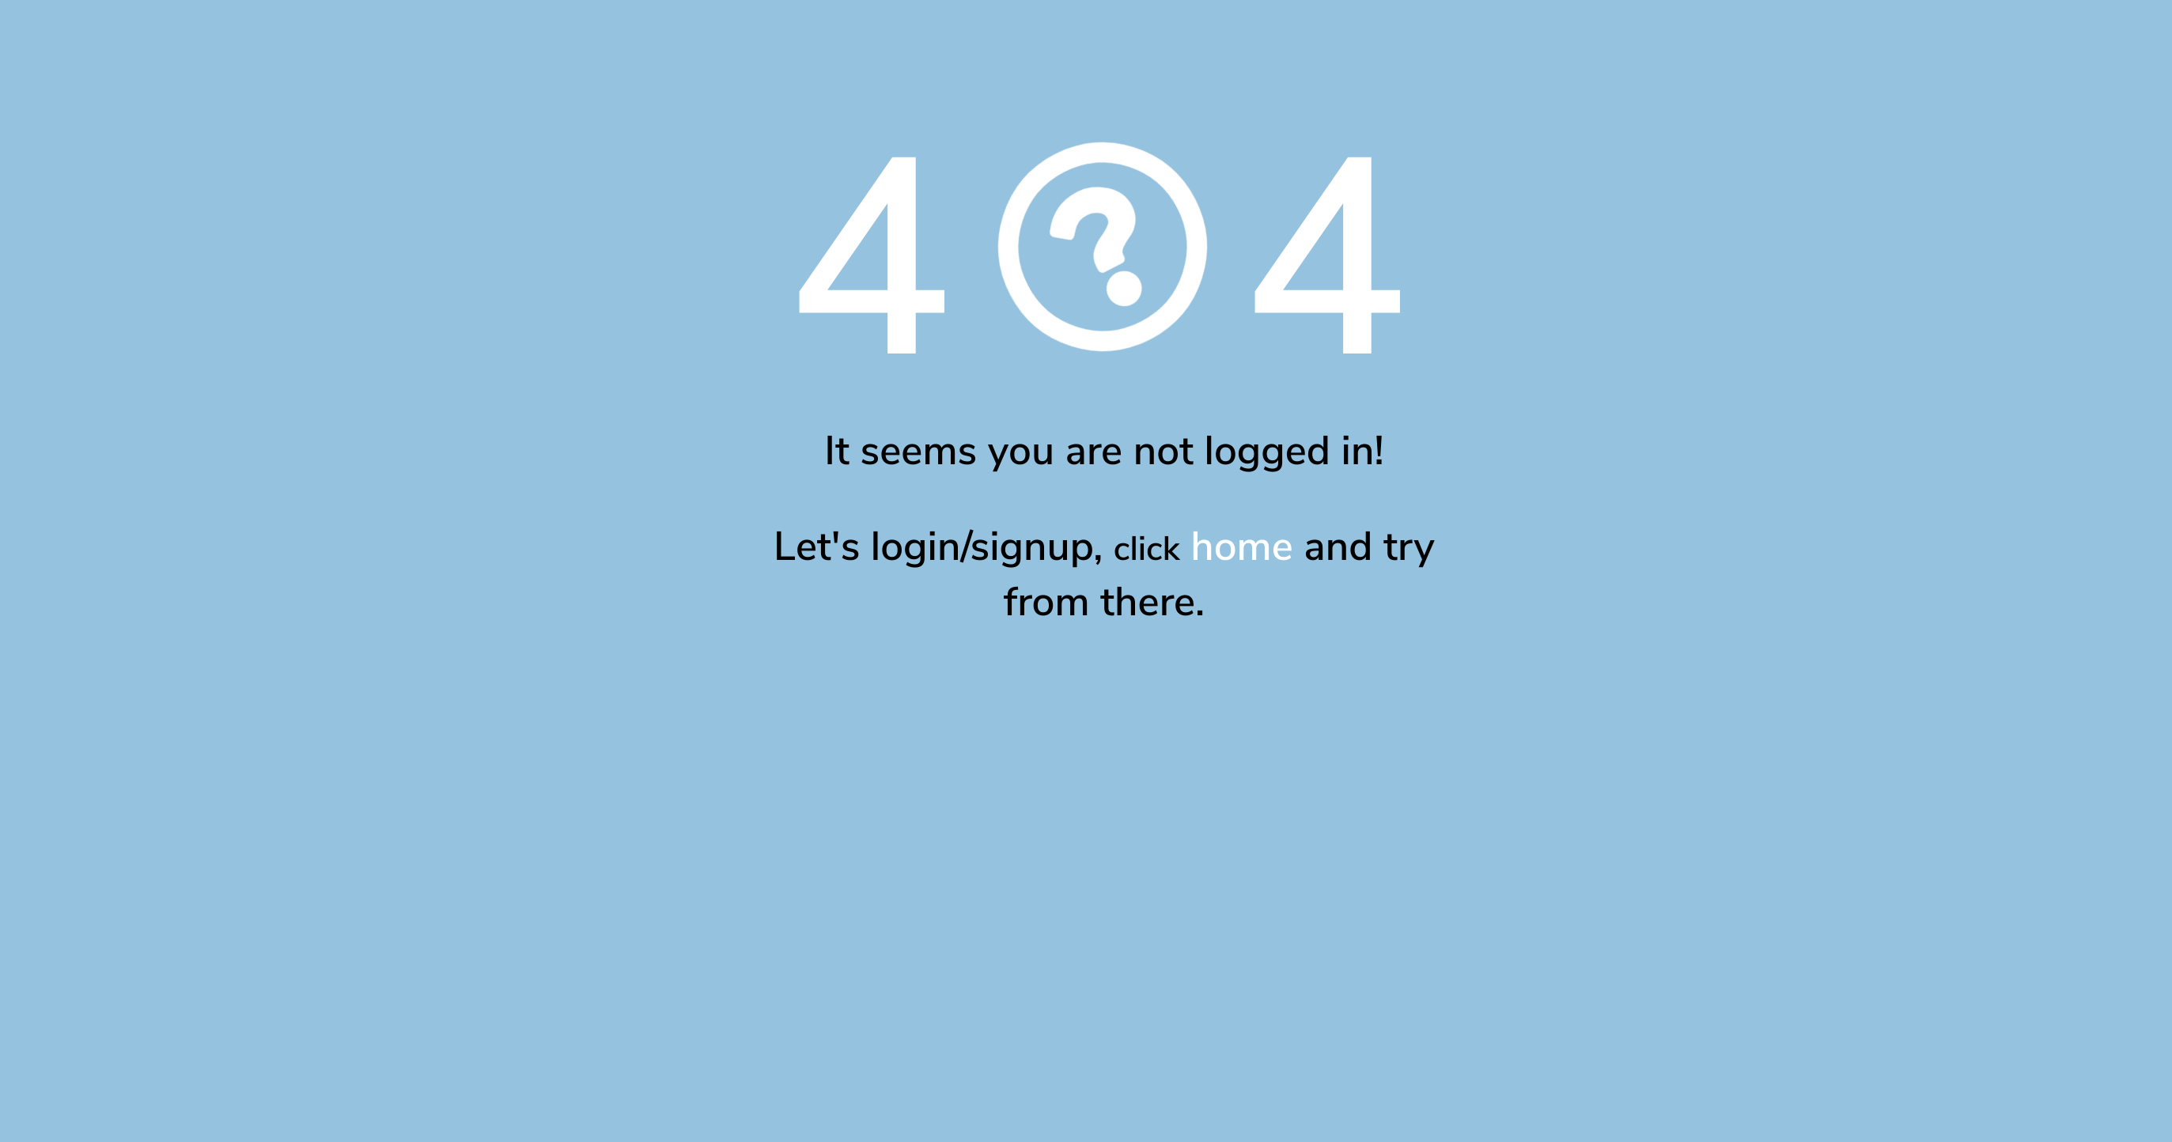

\* If the user is logged in, he can be a reader as well as blogger

\* When you signup

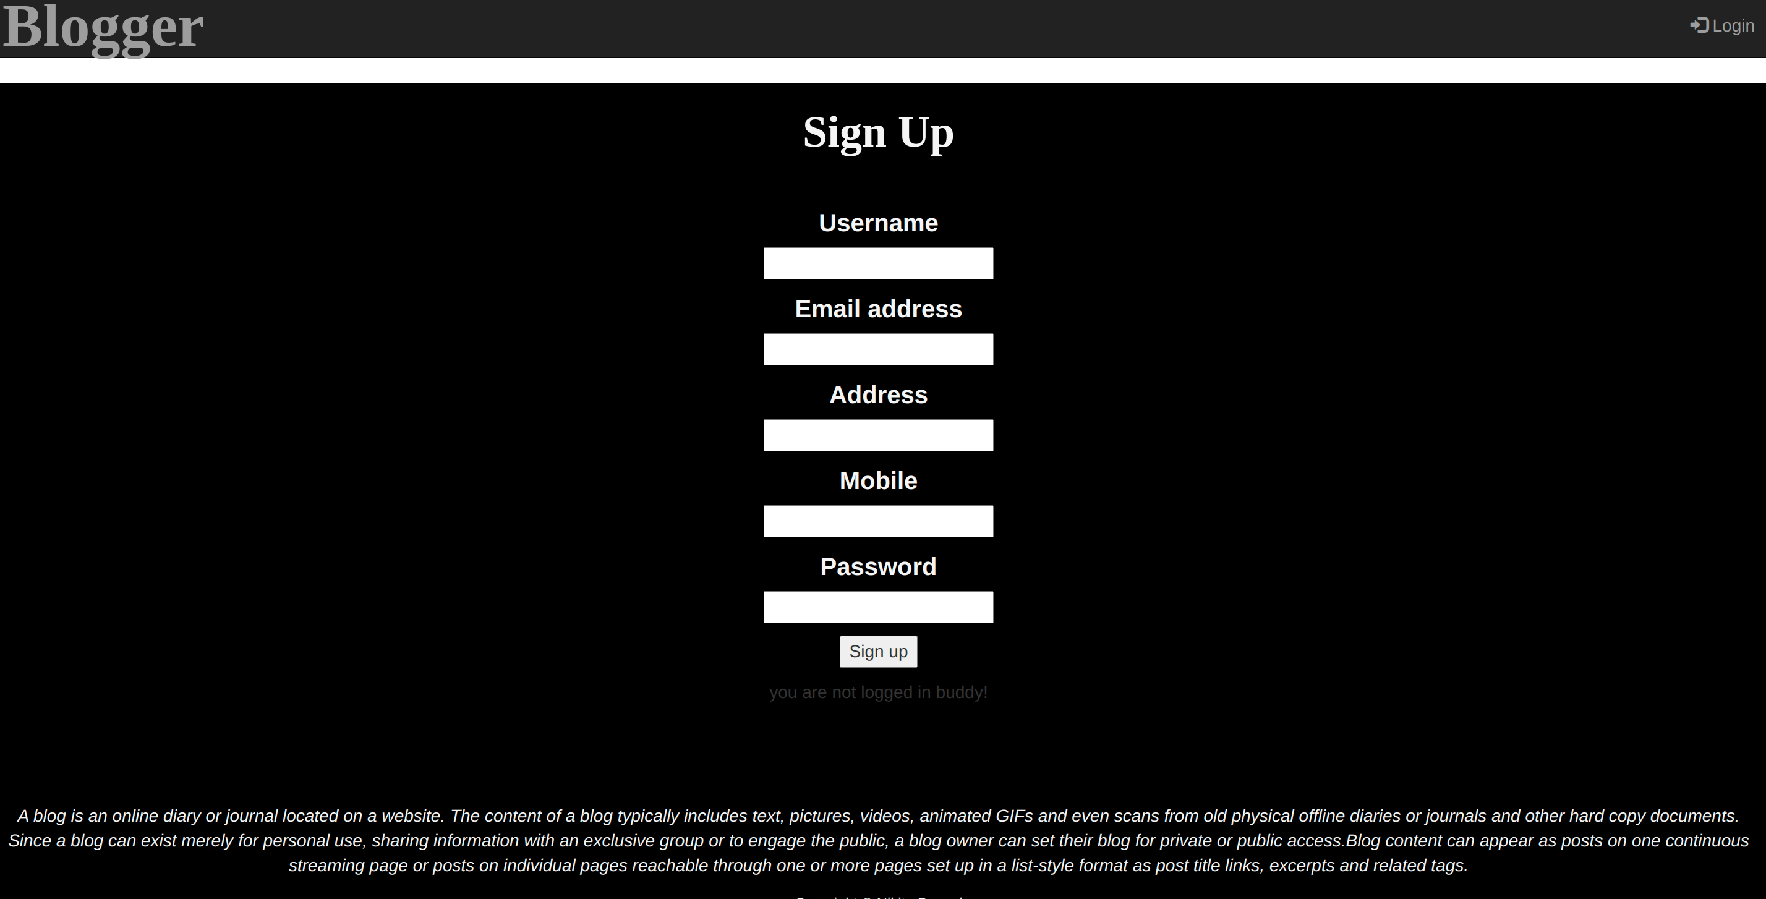

\* When you login

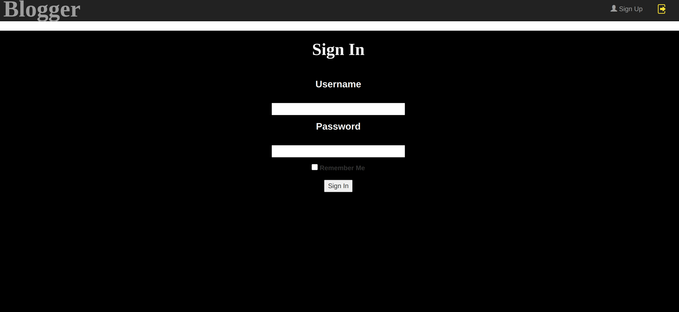

\* When u click to see your blogs

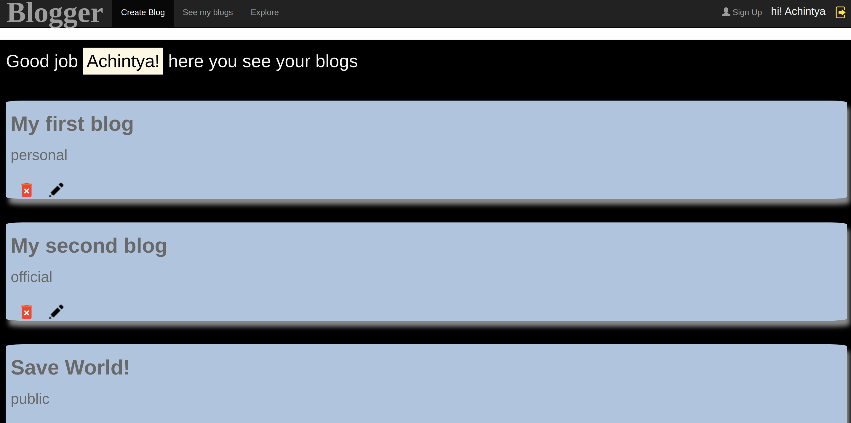

\* When you click on a blog

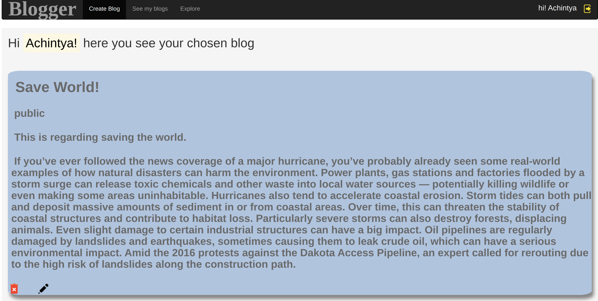

\* When you click to edit the blog

