Blogger

Snapshots of the blogger website:

* If the user is not logged in, he can only be a reader

* Front page

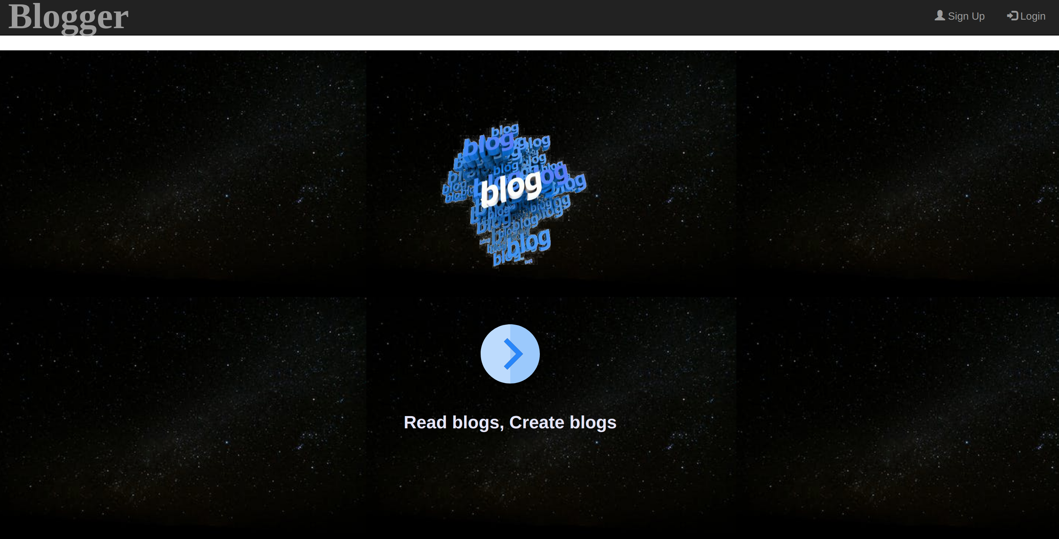
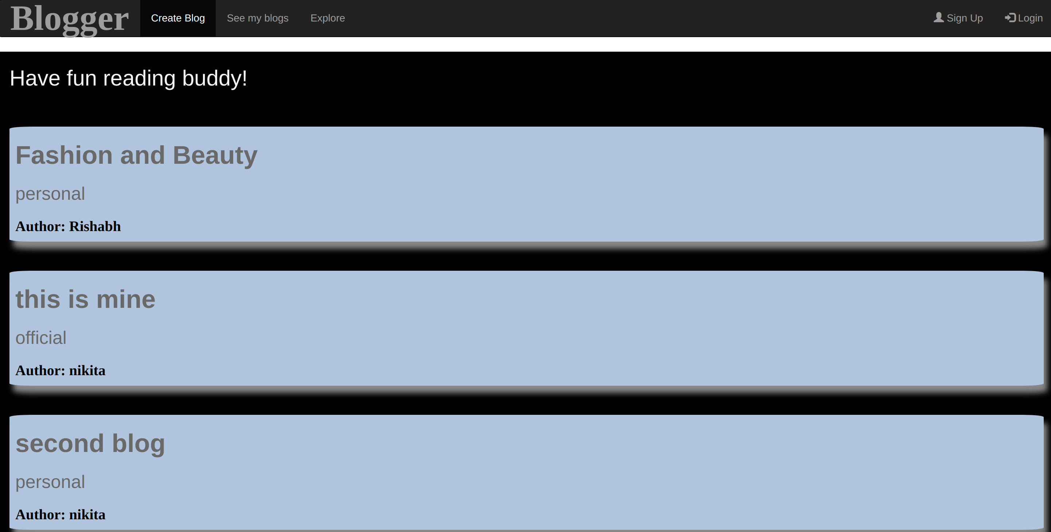
* Explore all blogs to read
*Show chosen blog to read

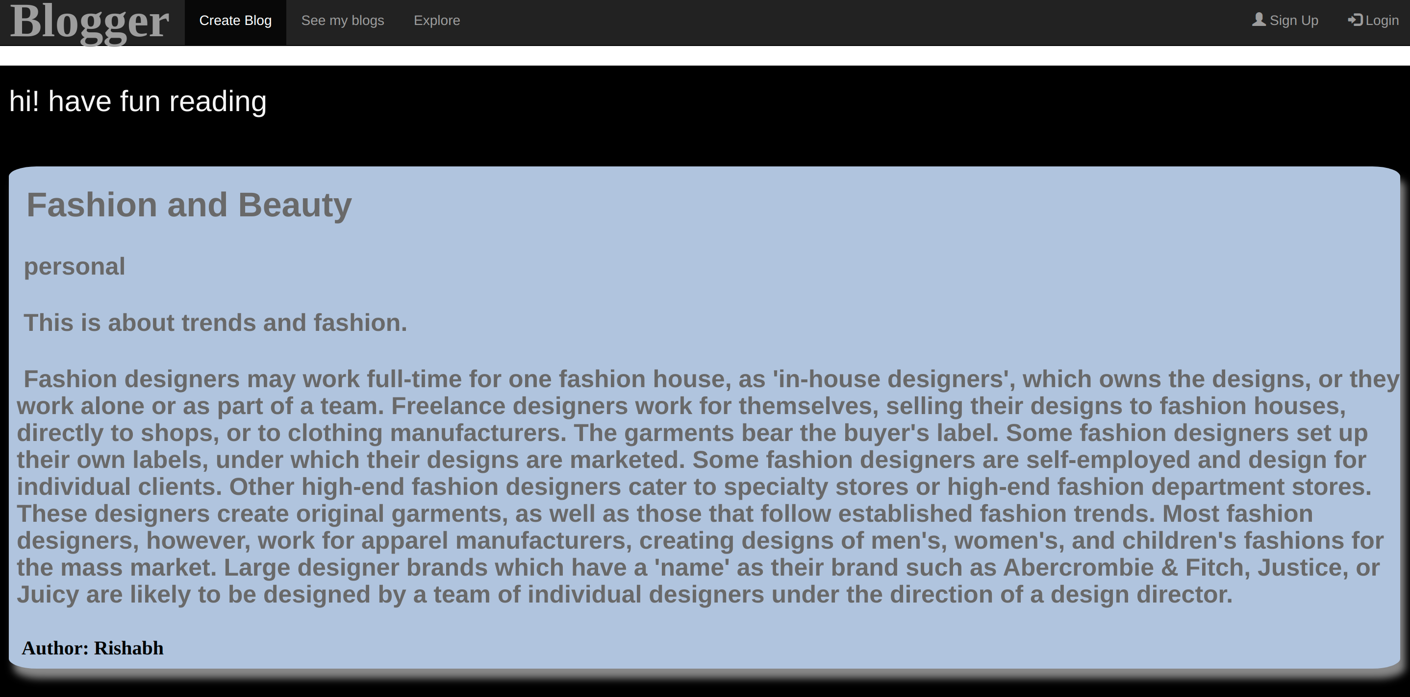

* If you try to access anything beyond the reader’s role

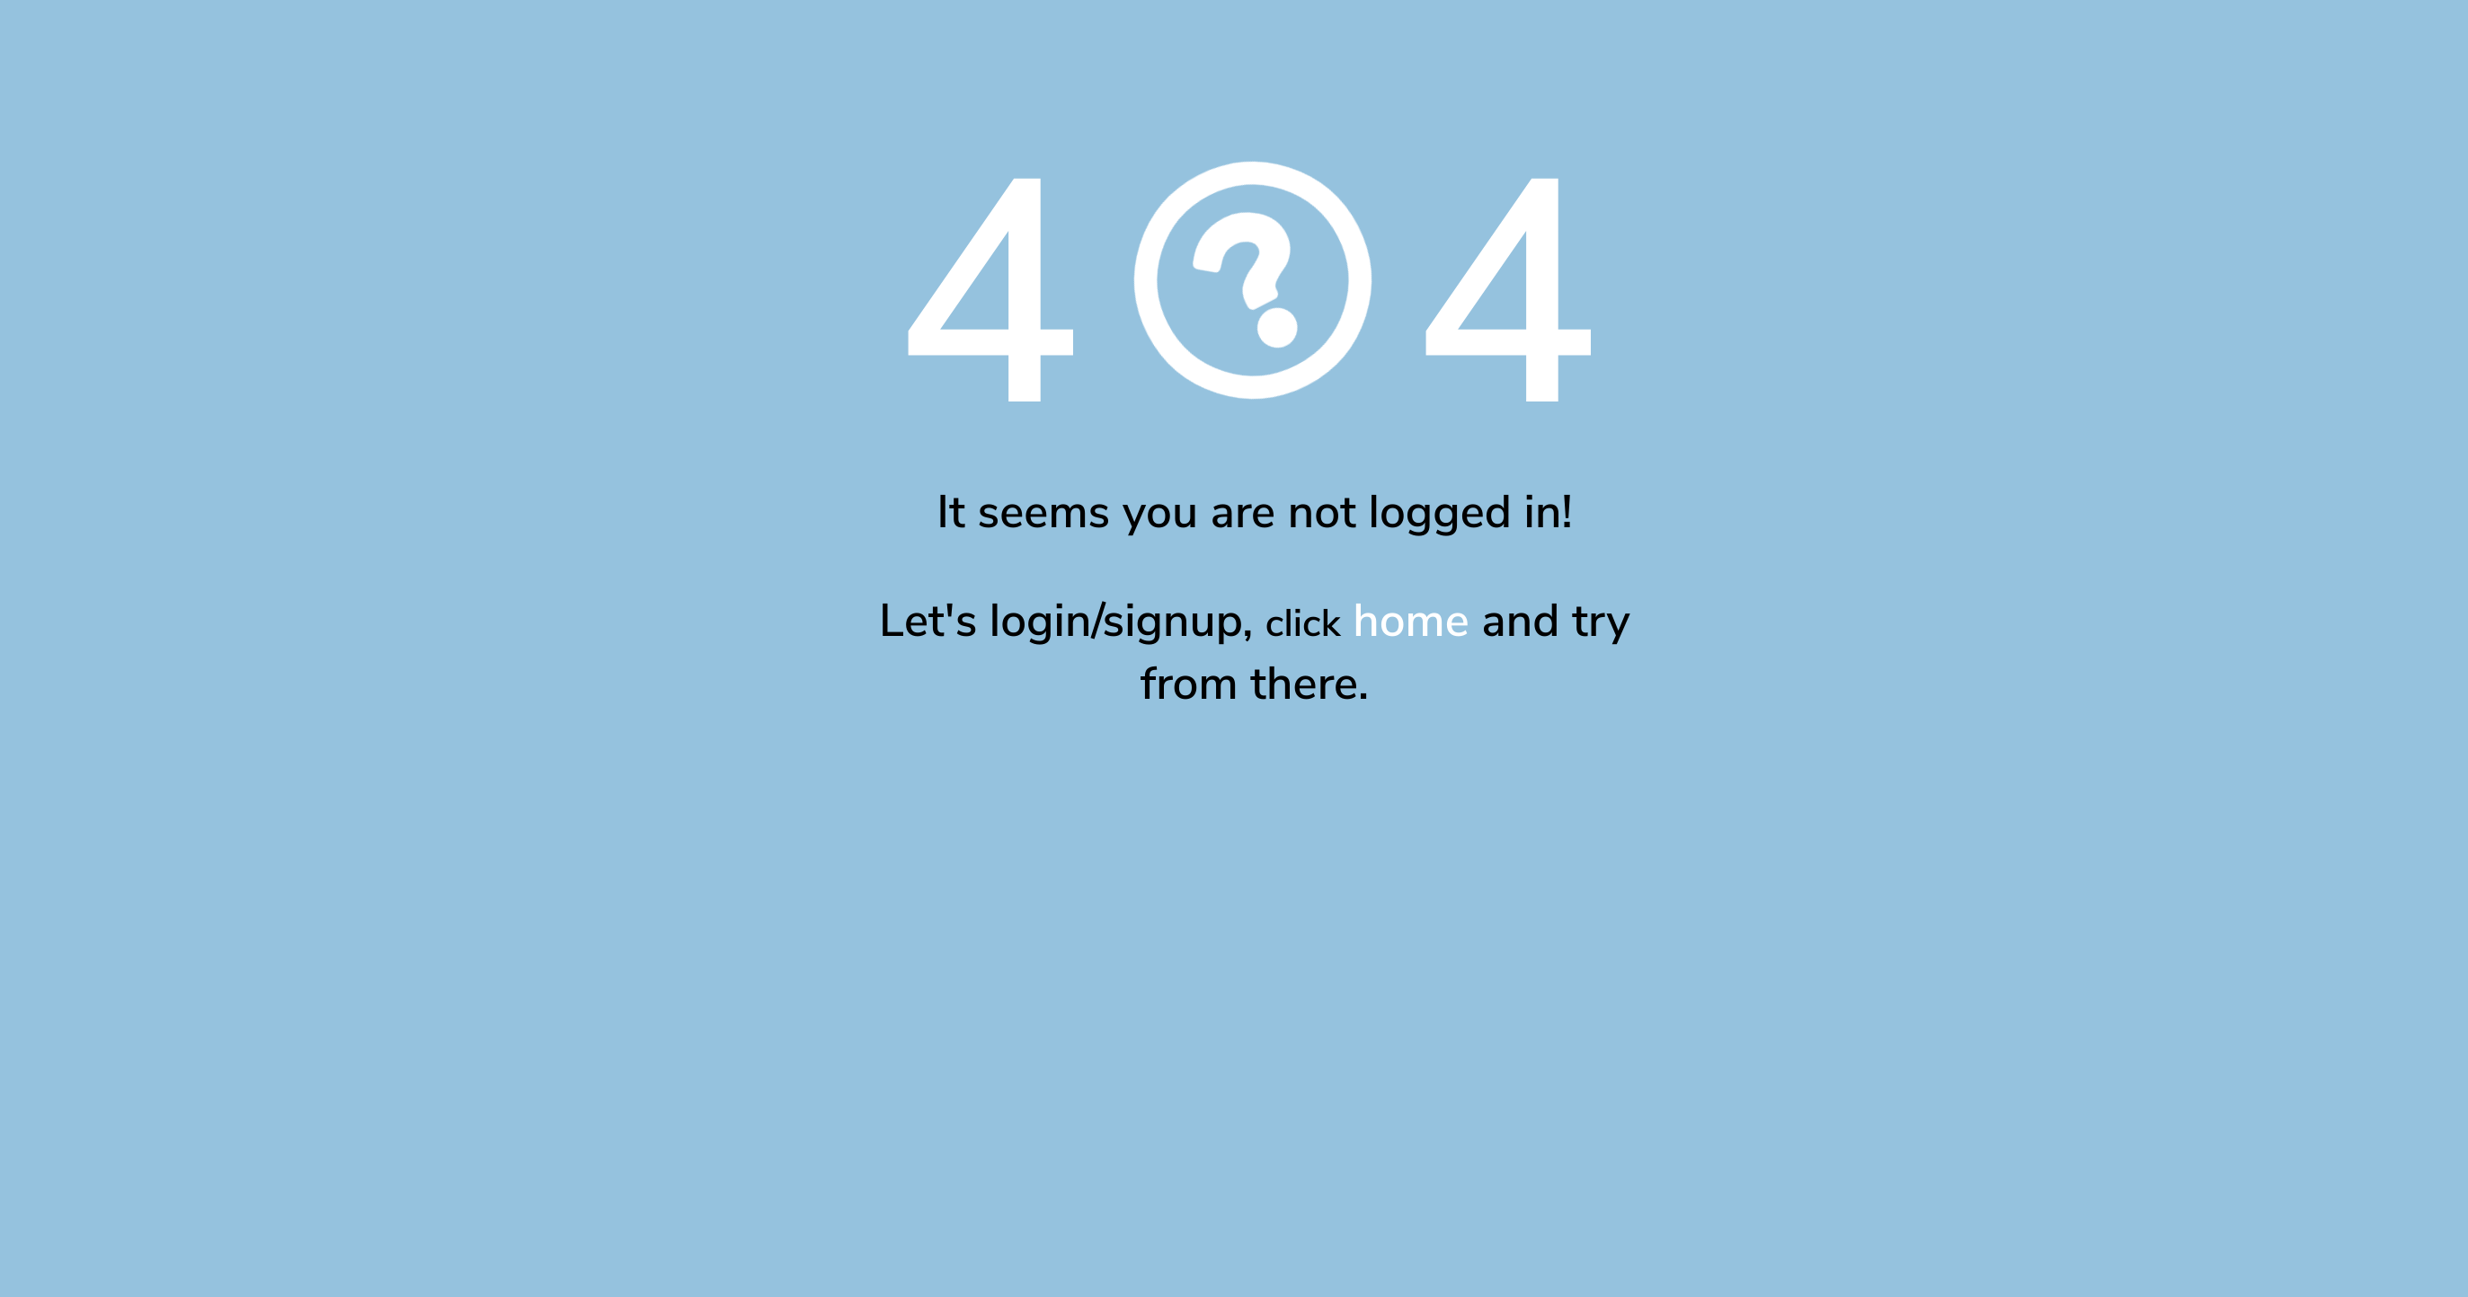
* If the user is logged in, he can be a reader as well as blogger

* When you signup

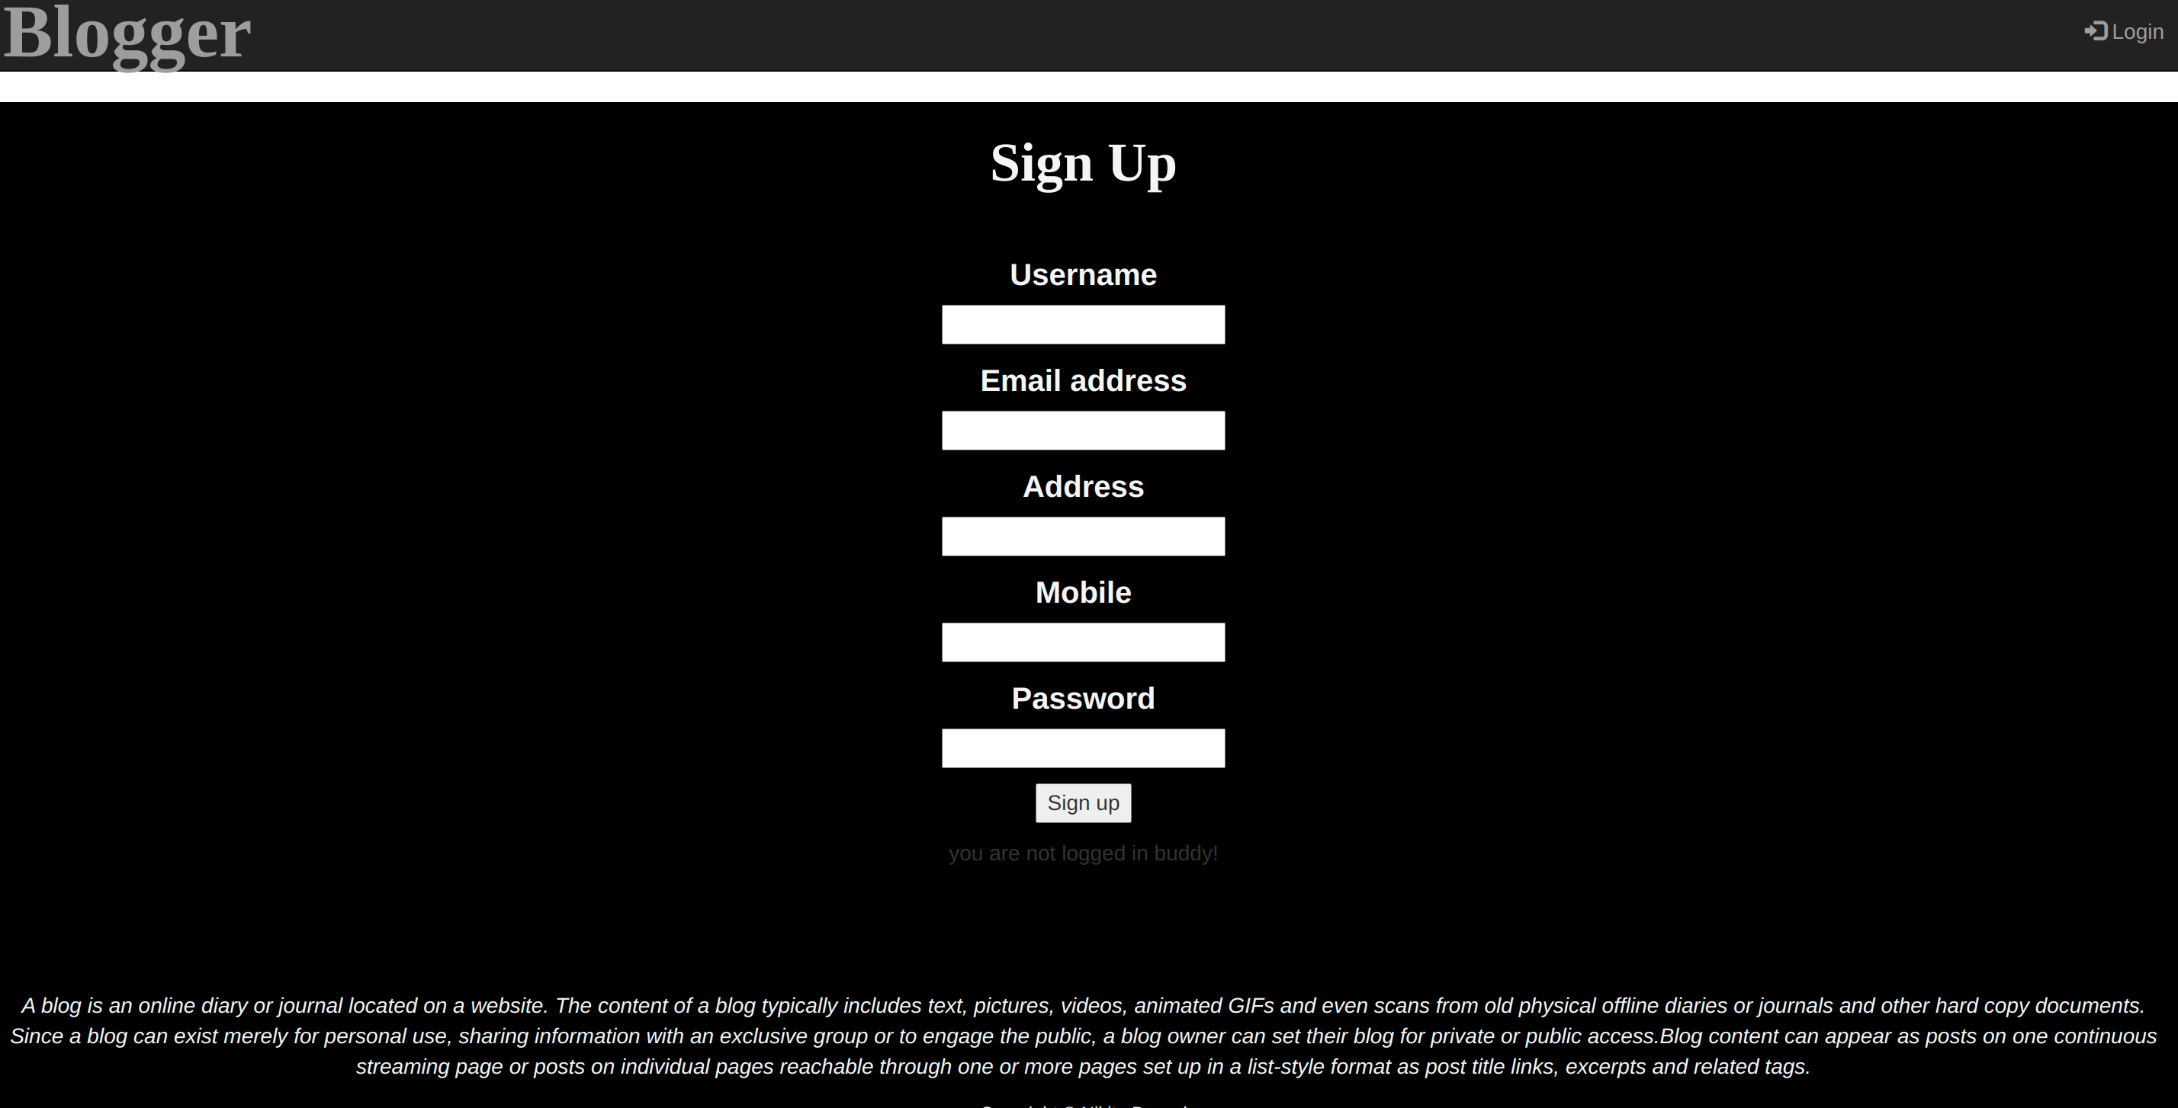
* When you login

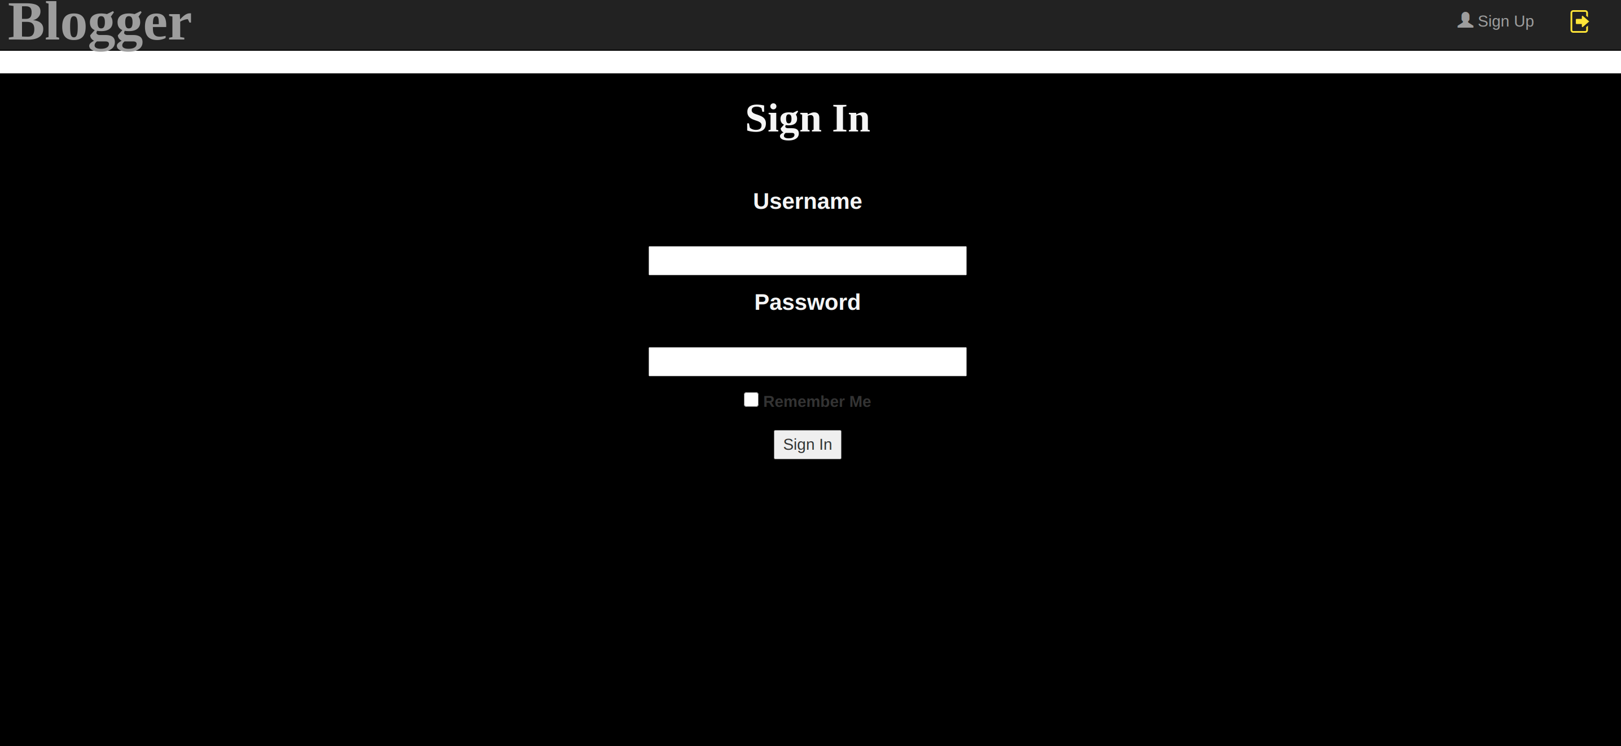

* When you click to create a blog

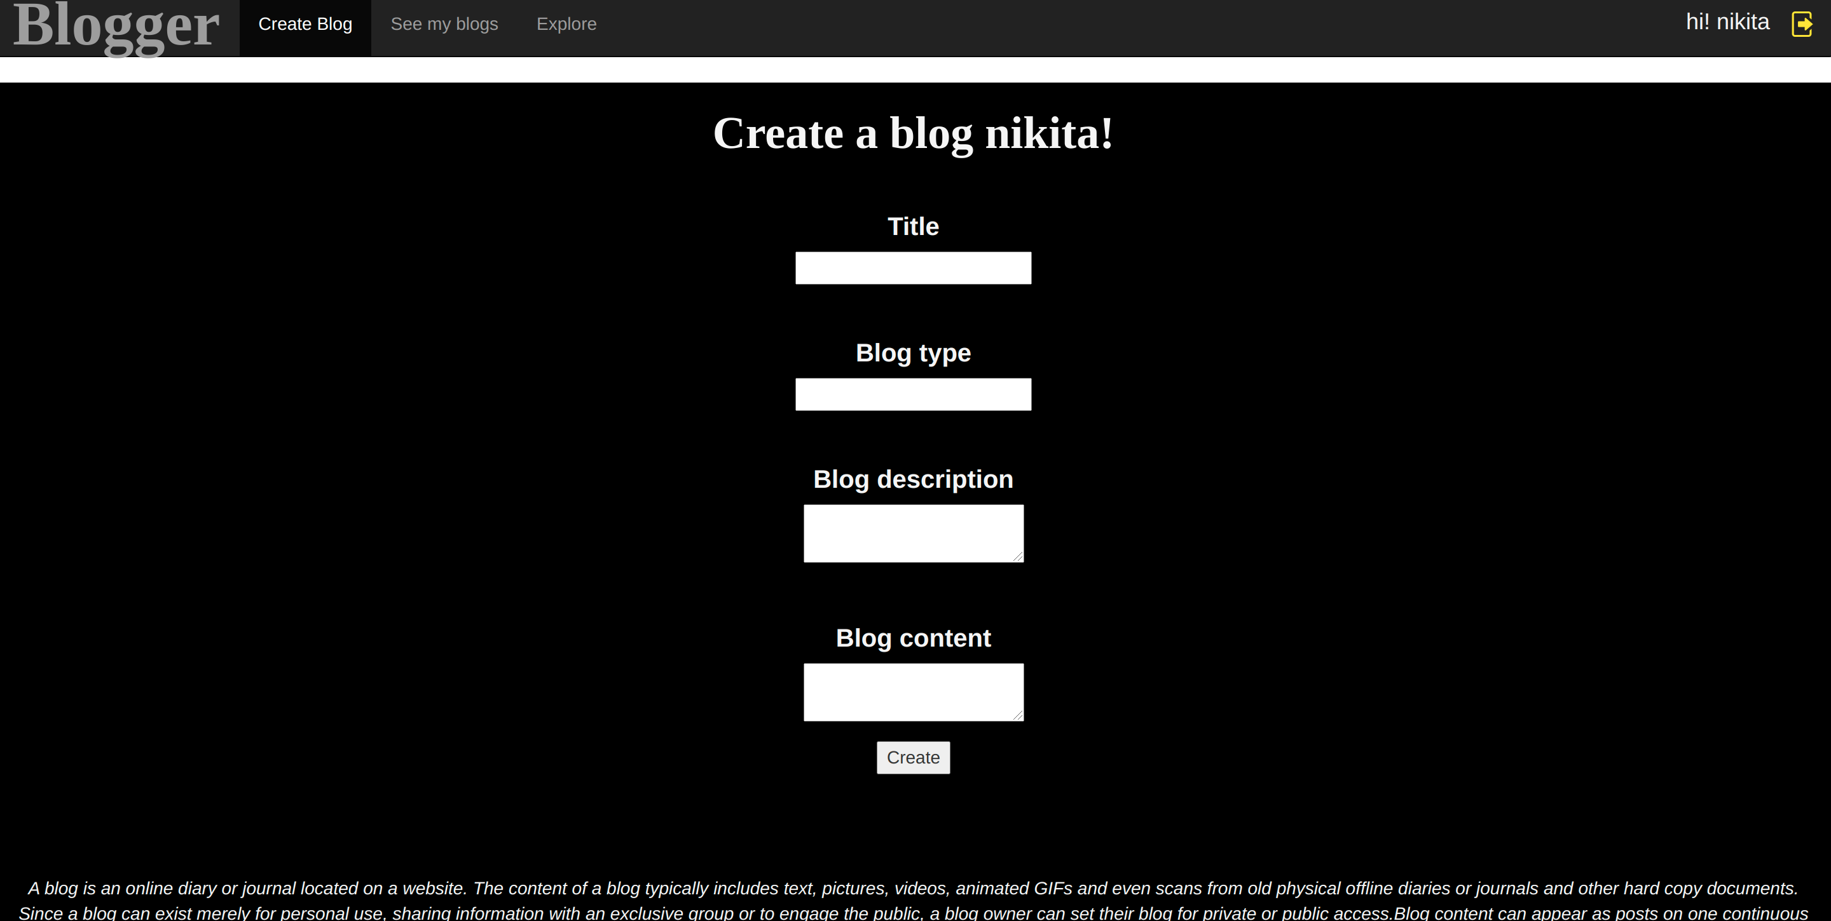

* When u click to see your blogs

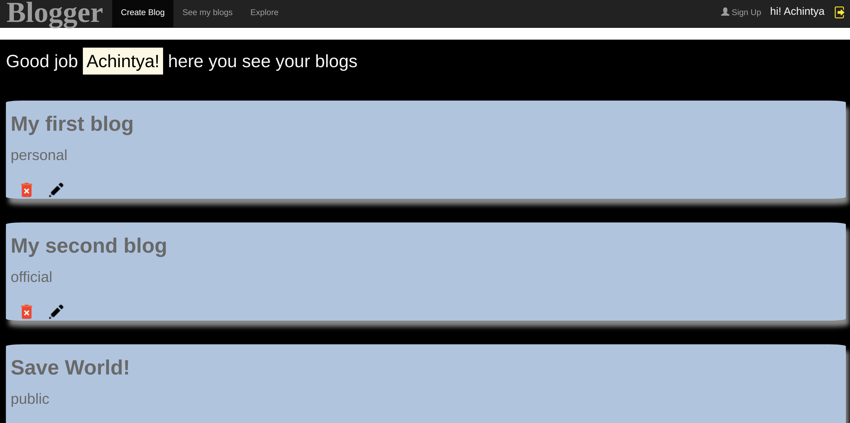
* When you click on a blog

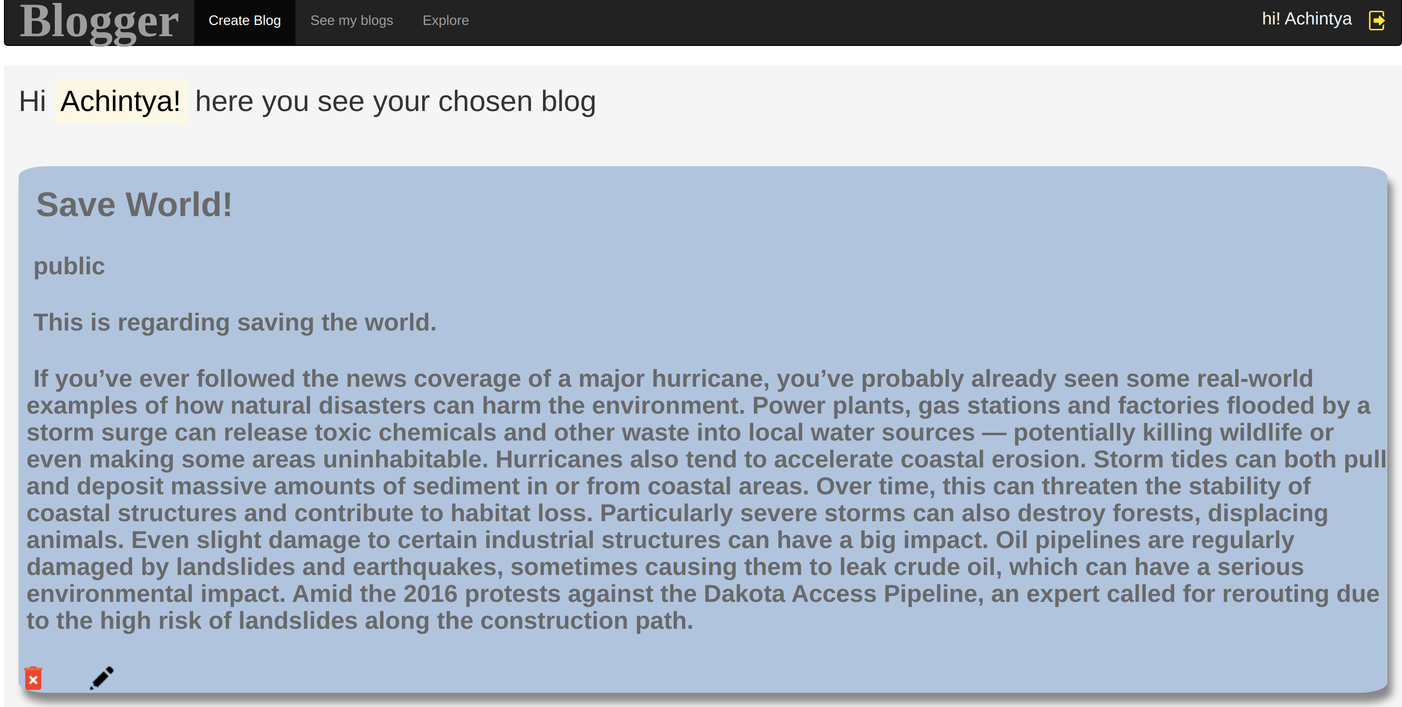
* When you click to edit the blog

