**ECE 594BB – Neuromorphic Computing (fall’19)**

**Assignment 3**

**Nikita Buzov**

*Zip file password: 1701*

**Design Description**

1. **Overview**. The spiking neural network consists of 3 layers: 3 input LIF neurons, 3 hidden-layer neurons, and 2 output neurons. In Verilog, a general module for a spiking LIF neuron was defined with 3 incoming synapses and 1 output synapse. Then the network was constructed as another Verilog module from interconnecting these spiking neurons.
2. **Spiking LIF Neuron**. The general behavior of a spiking LIF neuron was defined in the module spike_neuron. The inputs included: clock (clk), synapses (neuron_in1, etc.), and synapse weights (w1i, w2i, w3i). The output was just the synapse neuron_out. All inputs and outputs were defined as wires, 3-bit weights and 1-bit for other variables. The constants that govern the dynamics of the neuron were set up as registers, potentials were defined as 5-bit values.
3. **Spiking Neural Network**. The network was constructed in the module named spiking_network. The inputs were the clock (clk) and the incoming spikes from input neurons 1, 2, and 3; all defined as wires. The network has two wire-type outputs: the output neuron layer that consists of neuron_7 and neuron_8. Since all the synaptic weights for the network were given and constant, they were set as 3-bit registers and defined inside the module. The hidden-layer neural connections were also defined as wires (neuron_4, etc.). Ultimately, the network was formed by connecting the inputs from neurons 1, 2, 3 to neurons 4, 5, 6, using the spike_neuron module, and then doing the same to connect the hidden layer to the output layer.
4. **Testbench**. The only purpose for the testbench was to feed the given input firing sequences into the spiking network and record the outputs. This was done by suppling the network bit-by-bit each clock cycle (10ns) from the input sequences that were stored in 40-bit registers.

**Simulation Results**

**Firing Sequence 1**

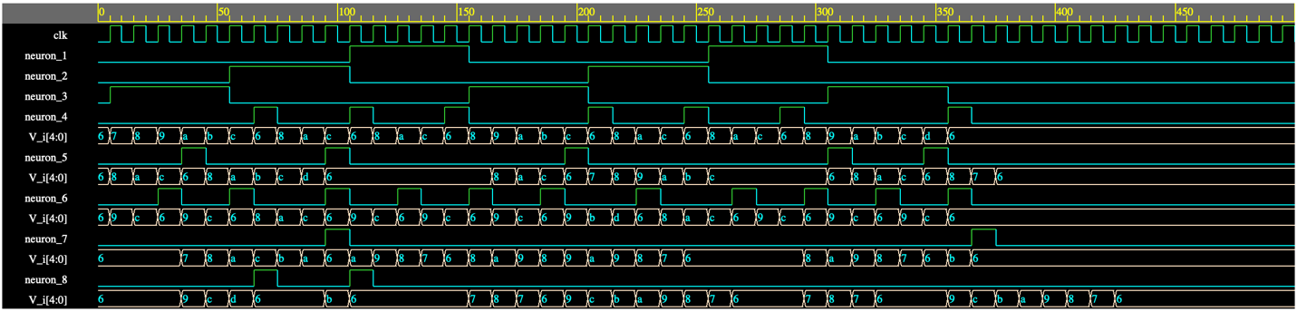

Number of firings for all neurons:

|  |  |  |  |  |  |  |  |  |
| --- | --- | --- | --- | --- | --- | --- | --- | --- |
| Neuron | 1 | 2 | 3 | 4 | 5 | 6 | 7 | 8 |
| Firings | 10 | 10 | 15 | 7 | 5 | 11 | 2 | 2 |

**Firing Sequence 2**

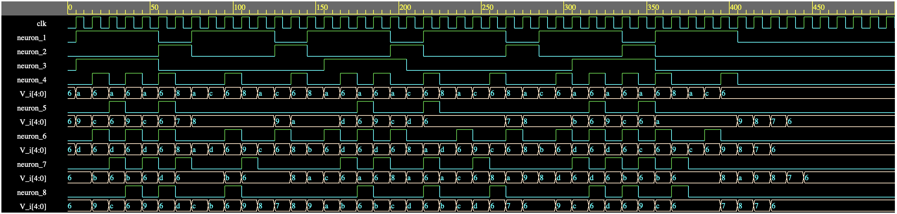

Number of firings for all neurons:

|  |  |  |  |  |  |  |  |  |
| --- | --- | --- | --- | --- | --- | --- | --- | --- |
| Neuron | 1 | 2 | 3 | 4 | 5 | 6 | 7 | 8 |
| Firings | 30 | 10 | 15 | 14 | 6 | 15 | 12 | 9 |

**Firing Sequence 3**

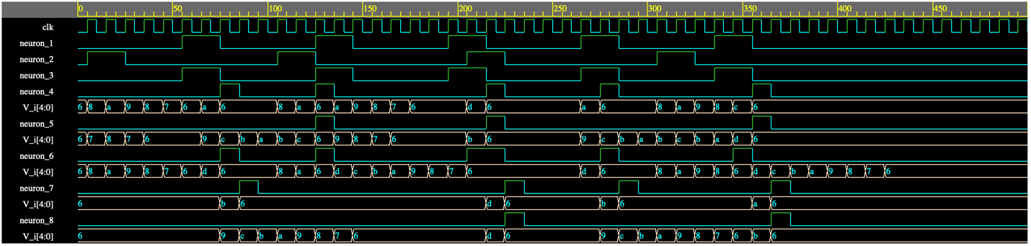

Number of firings for all neurons:

|  |  |  |  |  |  |  |  |  |
| --- | --- | --- | --- | --- | --- | --- | --- | --- |
| Neuron | 1 | 2 | 3 | 4 | 5 | 6 | 7 | 8 |
| Firings | 10 | 8 | 10 | 5 | 3 | 6 | 4 | 2 |

**Firing Sequence 4**

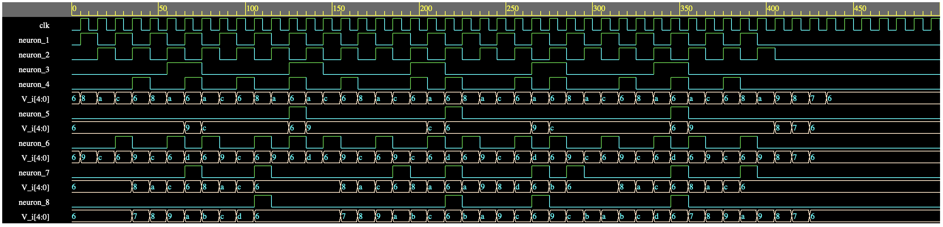

Number of firings for all neurons:

|  |  |  |  |  |  |  |  |  |
| --- | --- | --- | --- | --- | --- | --- | --- | --- |
| Neuron | 1 | 2 | 3 | 4 | 5 | 6 | 7 | 8 |
| Firings | 20 | 20 | 10 | 12 | 3 | 15 | 8 | 4 |