Spring AI RAG with Memory - Consultant Learning Guide
Purpose
This guide explains how Spring AI combines Retrieval Augmented Generation (RAG) with conversational memory. By the end, learners will understand how vector search and ChatMemory work together to deliver contextual and knowledge-grounded responses.

Source Code - https://github.com/nikitachitre79/SpringAIDemo.git
Branch - RAG_with_memory

What is RAG with Memory?
RAG retrieves relevant information from a vector store while ChatMemory remembers previous interactions. Together they enable answers based on both knowledge documents and conversation history.
Why Combine Memory and RAG?
Memory enables follow-up conversations and personalization. RAG provides factual grounding from documents. The combination reduces hallucinations and improves user experience.
Architecture
Question
↓
ConversationId
↓
ChatMemory Lookup
↓
Previous Conversation Retrieved
↓
QuestionAnswerAdvisor
↓
Vector Search
↓
Relevant Company Chunks Retrieved
↓
Memory + Chunks Injected into Prompt
↓
Gemini
↓
Answer
↓
Memory Updated

What is ChatMemory?
ChatMemory stores conversation history. It allows the application to remember previous questions and answers so follow-up questions can be understood in context.
- ChatMemory = What the user and AI have said
- VectorStore = What the company documents contain

Why ChatMemory is Needed
Without memory, every request is treated as a brand new conversation. With memory, users can ask follow-up questions such as: My name is Nikita. What is my name?
For example:
Request 1
User: My name is Nikita
AI: Nice to meet you, Nikita.

Request 2
User: What is my name?
Without ChatMemory, Spring AI treats this as a completely new request.
The model only sees:
What is my name?

It has no idea who Nikita is because the first message is not included.
Result:
I don't know your name.
Or
You have not told me your name.

With ChatMemory
Assume the conversationId is: 123
First Request
/api/ragQnA?conversationId=123&question=My name is Nikita

Spring AI stores inside ChatMemory:
User: My name is Nikita

Assistant: Nice to meet you, Nikita.

Here:
- User = Human message
- Assistant = AI message

Second Request
/api/ragQnA?conversationId=123&question=What is my name?

Before Gemini receives the prompt, MessageChatMemoryAdvisor automatically looks up conversation 123.
It retrieves:
User: My name is Nikita

Assistant: Nice to meet you, Nikita.

and injects it into the prompt.

The final prompt sent to Gemini becomes something like:

Conversation History:

User: My name is Nikita

Assistant: Nice to meet you, Nikita.

Current Question:

What is my name?

Now Gemini can answer:
Your name is Nikita.

What is MessageChatMemoryAdvisor?
MessageChatMemoryAdvisor automatically retrieves previous messages from ChatMemory and injects them into the prompt before the LLM call. Developers do not need to manually manage conversation history. You don't have to write memory retrieval logic yourself.

What is QuestionAnswerAdvisor?
QuestionAnswerAdvisor automatically performs Retrieval Augmented Generation. It generates an embedding for the question, searches the vector store, retrieves matching chunks and injects them into the prompt.
We have discussed about this in more detail under " Spring AI RAG Chunking & QuestionAnswerAdvisor - Detailed Consultant Guide"
Purpose of conversationId
conversationId uniquely identifies a chat session. It ensures memory is separated between users. User A gets Memory A, User B gets Memory B while everybody shares the same knowledge base.
Think of it like a chat room ID or customer ticket number.
When Spring AI sees a conversationId, it knows:
"Which conversation history should I load before answering this question?"

Real World Analogy
Imagine a call center.

Customer A
Calls support and says: My name is Nikita.
The support agent writes this information in Ticket #123.
Later the same customer calls back and provides:
Ticket #123
The agent opens Ticket #123 and sees:
Customer Name: Nikita
so the conversation can continue.
The conversationId works exactly like that ticket number.

Why conversationId Matters
If conversationId is not supplied, requests appear independent. The model cannot reliably remember previous interactions because no chat history is associated with the request. Now every request looks like a brand-new conversation.

ChatConfig
The ChatClient is configured with two advisors. MessageChatMemoryAdvisor provides memory. QuestionAnswerAdvisor provides RAG retrieval. Both happen automatically before Gemini receives the prompt.
@Configuration
public class ChatConfig {

@Bean
public ChatClient chatClient(
ChatClient.Builder builder,
VectorStore vectorStore,
ChatMemory chatMemory) {

return builder
.defaultAdvisors(

MessageChatMemoryAdvisor.builder(chatMemory)
.build(),

QuestionAnswerAdvisor.builder(vectorStore)
.searchRequest(
SearchRequest.builder()
.topK(5)
.similarityThreshold(0.7)
.build())
.build()

)
.build();
}
}

Knowledge Loader
Company.txt is loaded using ResourceLoader. TextReader converts it into Spring AI Documents. TokenTextSplitter creates chunks. Embeddings are generated and stored in the Vector Store.
@Configuration
public class KnowledgeLoader {

@Bean
CommandLineRunner loadKnowledge(
VectorStore vectorStore,
ResourceLoader resourceLoader) {

return args -> {

var resource = resourceLoader
.getResource("classpath:Doc/Company.txt");

var reader = new TextReader(resource);

List<Document> documents = reader.get();

TokenTextSplitter splitter = TokenTextSplitter.builder()
.withChunkSize(500)
.withMinChunkSizeChars(100)
.withMinChunkLengthToEmbed(5)
.withMaxNumChunks(10000)
.withKeepSeparator(true)
.build();
List<Document> chunks =
splitter.apply(documents);

vectorStore.add(chunks);

System.out.println(
"Loaded " + chunks.size() + " chunks");
};
}
}

SearchRequest Configuration
topK(5) retrieves up to five matching chunks. similarityThreshold(0.7) filters out less relevant content and improves answer quality.
QuestionAnswerAdvisor.builder(vectorStore)
.searchRequest(
SearchRequest.builder()
.topK(5)
.similarityThreshold(0.7)
.build())

Controller Walkthrough
The controller accepts conversationId and question parameters and forwards them to the service layer.
@RestController
@RequestMapping("/api/ragQnA")
public class RagControllerQnA {

private final RagServiceQnA ragServiceqna;

public RagControllerQnA(RagServiceQnA ragServiceqna) {
this.ragServiceqna = ragServiceqna;
}

@GetMapping
public String ask(
@RequestParam String conversationId,
@RequestParam String question) {

return ragServiceqna.ask(conversationId,question);
}
}

Service Walkthrough
The service passes ChatMemory.CONVERSATION_ID to advisors. Spring AI automatically loads memory and performs retrieval before sending the prompt to Gemini.
@Service
public class RagServiceQnA {

private final ChatClient chatClient;

public RagServiceQnA(ChatClient chatClient) {
this.chatClient = chatClient;
}

public String ask(String conversationId,String question) {

return chatClient.prompt()
.user(question)
.advisors(advisor -> advisor.param(
ChatMemory.CONVERSATION_ID,
conversationId))
.call()
.content();
}
}

End-to-End Flow
1. User sends question and conversationId. 2. Memory retrieved. 3. Embedding created. 4. Vector search executed. 5. Chunks retrieved. 6. Context and history injected. 7. Gemini generates answer. 8. Memory updated.
1. User Question (Controller Layer)
The request enters RagControllerQnA through /api/ragQnA. The controller receives conversationId and question parameters and forwards them to RagServiceQnA. Example: conversationId=123, question=Tell me about company benefits.
2. Memory Lookup using conversationId
In RagServiceQnA, the conversationId is passed using ChatMemory.CONVERSATION_ID. MessageChatMemoryAdvisor uses this value to retrieve previous messages for the same conversation. Different users can have separate memories while sharing the same vector database.
3. MessageChatMemoryAdvisor
Configured in ChatConfig. Before the LLM call, Spring AI automatically fetches conversation history from ChatMemory and injects it into the prompt context. Example: User says My name is Nikita, later asks What is my name? The advisor provides the previous message to the model.
4. QuestionAnswerAdvisor
After memory retrieval, QuestionAnswerAdvisor starts the RAG process. It takes the current question and prepares retrieval from the VectorStore. This advisor is configured with topK(5) and similarityThreshold(0.7).
5. Vector Search
The question is converted into an embedding using the Google GenAI embedding model dependency. The embedding is compared against embeddings stored in the VectorStore. Similarity search identifies the closest matching document chunks.
6. Retrieved Chunks
The top 5 matching chunks that exceed 0.7 similarity are returned. These chunks originated from Company.txt and were created by KnowledgeLoader using TokenTextSplitter with chunk size 500.
7. Prompt Augmentation (Document Injection)
Spring AI automatically injects the retrieved chunks and memory context into the final prompt. The model therefore sees the question, past conversation, and relevant company knowledge together.
8. Gemini Model Processing
The enriched prompt is sent to Gemini through spring-ai-starter-model-google-genai. Gemini analyzes user question, memory, and RAG content before generating the response.
9. Answer Returned
ChatClient.call().content() extracts the generated answer. The answer flows back through the service and controller and is returned to the user.
10. Memory Update
After the response is generated, Spring AI stores the latest user message and AI response in ChatMemory under the same conversationId. Future requests can reuse this context.
KnowledgeLoader Startup Flow
At application startup, Company.txt is loaded, converted into Document objects, split into chunks, embedded automatically, and stored in the VectorStore. This creates the knowledge base used by RAG.

Testing: End-to-End Example
Step 1: User asks My name is Nikita. Step 2: Memory stores it. Step 3: User asks What is my name? Step 4: Memory fetches earlier message. Step 5: Gemini answers Nikita. Step 6: User asks Tell me about company benefits. Step 7: RAG retrieves relevant chunks from Company.txt. Step 8: Gemini answers using retrieved knowledge.
Memory vs RAG
Memory stores user conversation history. RAG stores business knowledge and retrieves document-based context.
Memory
Stores user-specific conversations.
A123 → Nikita

B123 → John

C123 → Sarah
VectorStore
Stores company knowledge like
Company Benefits

Medical Coverage

Dental Coverage

Training Budget

Holiday Policy

Production Recommendation
Generate and persist a UUID at conversation start and send the same conversationId with every request in that session.
If you're building a web application, generate a UUID when the chat starts:

String conversationId =
UUID.randomUUID().toString();

Store it on the frontend and send it with every request.

{
"conversationId": "550e8400-e29b-41d4-a716-446655440000",
"question": "Tell me about company benefits"
}
This keeps:
User A → Memory A
User B → Memory B
User C → Memory C
separate while all users share the same RAG knowledge base in your VectorStore.
Testing :Execution Example
localhost:8080/api/ragQnA?question=My name is Nikita&conversationId=101
localhost:8080/api/ragQnA?question=what is my name&conversationId=101

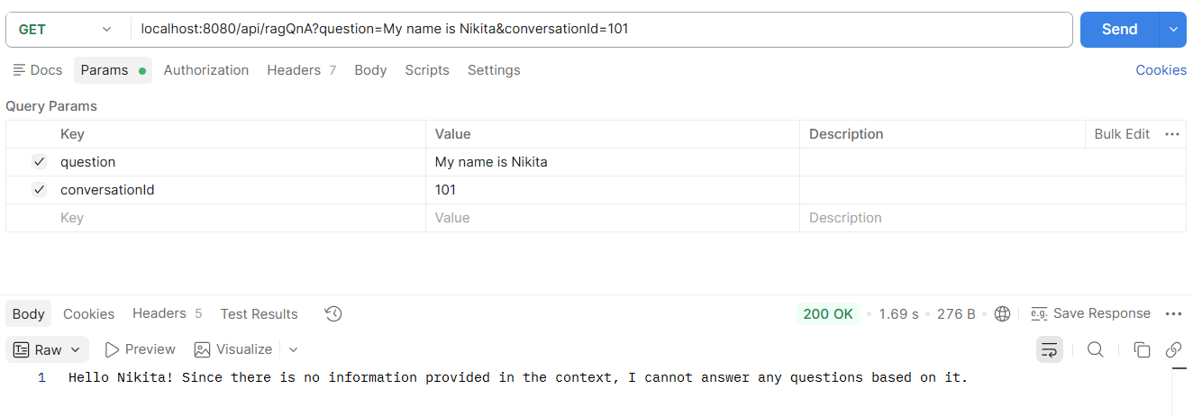
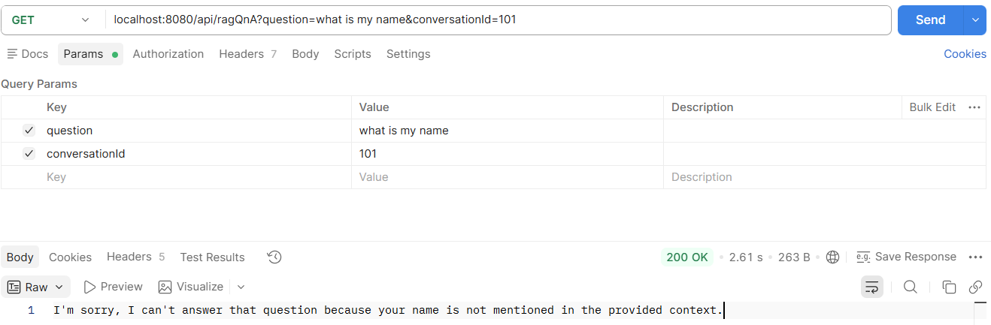

Try changing threshold to 0.5
And check again
For additional knowledge check this RAG chat memory and QnA Advisor Fix.docx

