Spring AI MCP Email Server - Consultant Guide
A hands-on tutorial explaining Model Context Protocol (MCP) concepts and implementation using Spring AI MCP Email Server.

Overview
This tutorial demonstrates how to expose email functionality as an MCP Tool using Spring
AI. An AI client can discover and invoke the email tool through an MCP server.
Source Code - https://github.com/nikitachitre79/SpringAIMCPToolToSendEmail.git
Branch - main

Introduction to MCP
Model Context Protocol (MCP) is an open standard that enables AI models to discover and invoke external tools in a consistent way. Think of MCP as a USB standard for AI tools. Instead of every AI application implementing custom integrations, MCP provides a common protocol for tool discovery and execution.

What is Model Context Protocol (MCP)?
Model Context Protocol (MCP) is an open standard that allows AI models to discover, understand, and use external tools, APIs, services, databases, and applications through a common communication protocol.
Think of MCP as a universal language between AI models and external systems.
Before MCP, every AI application had to build custom integrations for every system it wanted to access.
For example:
ChatGPT --> Gmail

ChatGPT --> Jira

ChatGPT --> Salesforce

Copilot --> Gmail

Copilot --> Jira

Copilot --> Salesforce

Claude --> Gmail

Claude --> Jira

Claude --> Salesforce

Each integration had to be built separately.
This created:
- Duplicate development effort
- Maintenance challenges
- Vendor-specific integrations
- Lack of standardization
MCP solves this problem by introducing a standard protocol.

The USB Analogy
The easiest way to explain MCP is with a USB analogy.
Before USB existed:
Keyboard -> Special Port

Mouse -> Different Port

Printer -> Different Port

Scanner -> Different Port

Every device required:
- Different connectors
- Different drivers
- Different communication methods
Connecting devices was complicated.
Then USB was introduced.
With USB:
Keyboard -> USB

Mouse -> USB

Printer -> USB

Scanner -> USB
Any device could communicate through the same standard.
Users no longer needed to learn:
Device-specific communication
MCP does the same thing for AI.
Instead of:
AI -> Custom Gmail Integration

AI -> Custom Slack Integration

AI -> Custom Jira Integration

AI -> Custom Salesforce Integration
everything communicates through:
AI
|
v
MCP
|
+--> Gmail
|
+--> Jira
|
+--> Salesforce
|
+--> Database
|
+--> ERP

MCP becomes the universal connector.

Why Was MCP Created?
Large Language Models are very good at:
- Understanding language
- Generating text
- Reasoning
- Summarizing information
But they cannot directly:
- Send emails
- Access databases
- Create Jira tickets
- Query Salesforce
- Read files
- Execute business operations
For example:
User asks:
Send an email to John.
Without MCP:
LLM knows HOW to write an email.

LLM cannot ACTUALLY send the email.
The model can only generate:
Dear John,

Hope you are doing well...

Regards
It cannot interact with Gmail.

What MCP Enables
MCP gives AI systems access to capabilities.
Instead of only generating text:
Question
|
v
Answer

AI can now:
Question
|
v
Use Tool
|
v
Take Action
|
v
Return Result
Example:
User: Send an email to John.

The model can:
- Discover the email tool
- Understand how the tool works
- Collect required parameters
- Execute the tool
- Return a success message

How MCP Works
MCP consists of three major components.

1. MCP Client
The MCP Client initiates requests.
Examples:
- Copilot
- Claude Desktop
- Chat Applications
- Agents
- AI Assistants
Example:
User: Send an email
The client decides:
I need a tool

2. MCP Server
The MCP Server exposes tools.
This project is an MCP Server.
Example:
@McpTool(description = "Send an email")

public String sendEmail(...)

This tool becomes discoverable through MCP.
The server publishes:
Available Tool:

sendEmail

3. Tools
Tools perform actions.
Example:
sendEmail()

Possible enterprise tools:
createTicket()
getCustomer()
lookupEmployee()
generateReport()
approveExpense()
These tools allow AI to interact with business systems.

How Tool Discovery Works
One of MCP's biggest innovations is automatic tool discovery.
Without MCP:
Developers manually tell the AI:
There is a tool called sendEmail.

Parameters:

- to

- subject

- body

With MCP:
The client asks:
What tools do you provide?

The server responds:
{

"tool": "sendEmail",

"description": "Send an email",

"parameters": {

"to": "String",

"subject": "String",

"body": "String"

}

}

The model automatically understands:
- Tool name
- Purpose
- Required parameters
No custom integration required.

Architecture Flow
User
|
v
MCP Client
|
v
Discover Tools
|
v
sendEmail Found
|
v
Invoke MCP Tool
|
v
EmailMcpTools
|
v
EmailService
|
v
Gmail SMTP
|
v
Email Sent
|
v
Success Response

Project Structure
EmailMcpTools exposes AI callable functions. EmailService contains email business logic. application.properties contains SMTP and MCP configuration. pom.xml defines required dependencies.

Application Properties
spring.application.name identifies the application.
spring.mail.host=smtp.gmail.com defines the SMTP provider.
port 587 enables TLS email delivery.
username and password authenticate Gmail.
mail.smtp.auth=true enables authentication.
starttls.enable=true encrypts communication.
spring.ai.mcp.server.protocol=STREAMABLE configures MCP transport.
server.port=8083 defines the HTTP port.

Maven Dependencies Deep Dive
spring-ai-starter-mcp-server-webmvc provides MCP server functionality.
spring-boot-starter-mail provides JavaMailSender and SMTP support.
spring-boot-starter-webmvc exposes web endpoints.
spring-ai-bom ensures consistent Spring AI dependency versions.

EmailMcpTools Walkthrough
The @McpTool annotation exposes sendEmail as an MCP tool.
@McpToolParam provides tool metadata describing recipient, subject, and body. AI clients use this metadata to understand how to invoke the tool.

EmailService Walkthrough
EmailService uses JavaMailSender. A SimpleMailMessage object is created, populated with recipient, subject and body, and sent through Gmail SMTP.

Detailed Request Flow
1. User asks AI to send email.
2. MCP Client discovers available tools.
3. Client identifies sendEmail tool.
4. MCP request is sent to Spring AI MCP Server.
5. Spring AI invokes EmailMcpTools.sendEmail().
6. EmailService creates the mail message.
7. JavaMailSender connects to Gmail SMTP.
8. Gmail delivers email.
9. Success response is returned to the MCP client.

How to Verify MCP Server is Running
Start the Spring boot application . Verify the application starts on port 8083. Use Postman to access the MCP endpoint exposed by Spring AI. A successful response indicates the MCP server is available.
Invoke-WebRequest -Method Post `
-Uri http://localhost:8081/mcp `
-ContentType "application/json" `
-Body '{"jsonrpc":"2.0","id":1,"method":"initialize","params":{}}'
And in headers For Accept give application/json, text/event-stream
You will get response with Mcp-Session-id in Headers
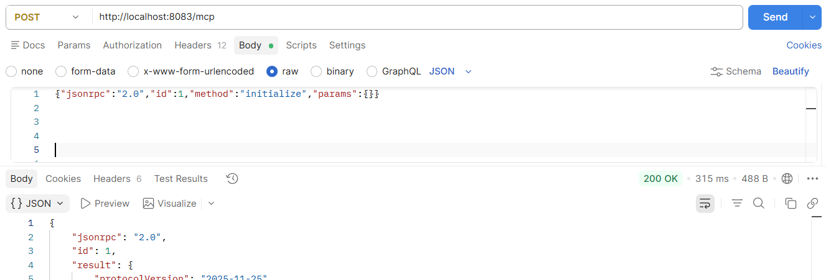

How to Discover Tools Using Postman
Connect to the MCP endpoint. Request the MCP metadata/tool discovery endpoint. The response should list sendEmail as an available tool together with descriptions and parameters.

In next post request http://localhost:8081/mcp
-ContentType "application/json
In header Accept give application/json, text/event-stream
Mcp-Session-id which you received in previous step
-Body {
"jsonrpc": "2.0",
"id": 2,
"method": "tools/list",
"params": {}
}
You will see the tools available
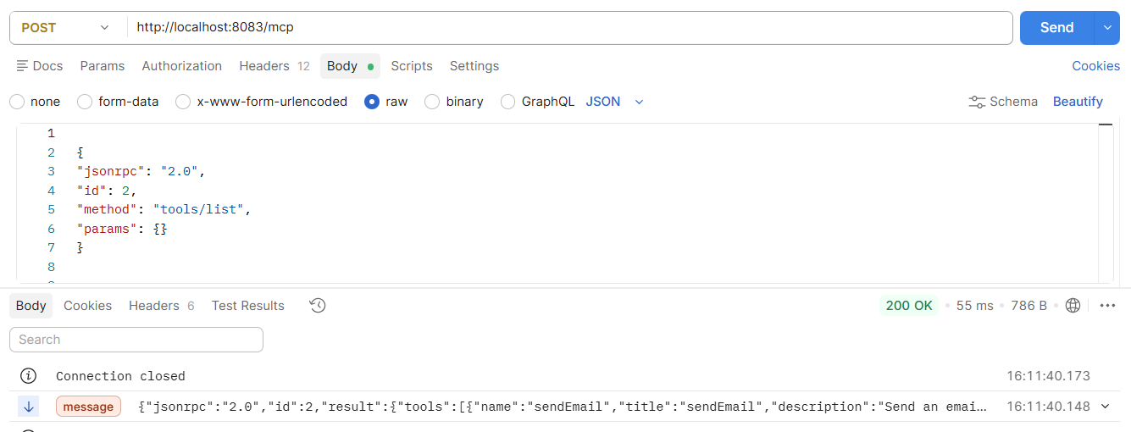

Difference between Tools and MCPTools
Spring AI Tools and MCP Tools are conceptually similar because both expose Java methods that an AI model can invoke, but they differ in scope, discovery mechanism, and communication model.

Spring AI Tool
@Tool

public String getLeaveBalance(String employeeId)
- Used inside a Spring AI application
- Registered directly with a ChatClient
- Available only to that application
- Invoked through Spring AI Tool Calling
- No external discovery protocol required

MCP Tool
@McpTool

public String sendEmail(...)
- Exposed through an MCP Server
- Discoverable by external AI clients
- Can be used by Copilot, Claude, Agent applications, custom MCP clients, etc.
- Invoked through the Model Context Protocol (MCP)

Real World Analogy

Spring AI Tools
Think of Spring AI Tools as:
Internal Company Phone Extension
Example:
HR Department
|
Leave Balance Tool
Only people inside the company can call the extension.
Similarly:
hrAgent
|
+--> getLeaveBalance()
Only your Spring AI application knows about this tool.

MCP Tools
Think of MCP Tools as:
Public Customer Service Line
Example:
Copilot

Claude

Custom Agents

Desktop Apps
can all connect to the same endpoint.
Similarly:
@McpTool

public String sendEmail(...)
becomes available to external clients through MCP.

Summary
MCP is a standard communication contract between AI systems and enterprise tools. The MCP Server exposes capabilities, MCP Clients discover them, and AI models invoke them without custom integrations.

