Spring AI Multi-Agent RAG + MCP Client Tutorial
This tutorial explains how Agents_with_RAG_and_MCPTool_sendEmail works as an MCP Client consuming the Email MCP Server created in the previous project.

Overview
This tutorial demonstrates how to build a Spring AI Multi-Agent RAG application that acts as an MCP Client and connects to an external Email MCP Server. The solution combines Retrieval-Augmented Generation (RAG), specialized AI agents (HR, IT, and Policy), conversation memory, and MCP tool integration to create an intelligent enterprise copilot.
When a user submits a question, the application uses a Router Agent to determine the most appropriate specialist agent. Each agent can retrieve relevant information from its own knowledge base using RAG. For HR-related email requests, the HR Agent discovers and invokes the remote sendEmail MCP Tool exposed by the Email MCP Server. The MCP Server then executes the email functionality and returns the result to the client.
This architecture demonstrates how Spring AI can be used to build enterprise-grade AI solutions that combine:
- Multi-Agent Systems
- Retrieval-Augmented Generation (RAG)
- Vector Databases
- Conversation Memory
- Local Tools
- Remote MCP Tools
- MCP Client-Server Communication
By the end of this tutorial, you will understand how a Spring AI application can act as an MCP Client, dynamically discover remote tools from an MCP Server, retrieve enterprise knowledge through RAG, and orchestrate multiple AI agents to answer questions and perform actions such as sending emails.

Source Code - https://github.com/nikitachitre79/SpringAIDemo.git
Branch - Agents_with_RAG_and_MCPTool_sendEmail -- code is available under package “DocumentInjectionQnAAdv”

Learning Objectives
- Understand RAG, Agents, MCP Client integration
- Learn agent routing architecture
- Understand remote MCP sendEmail invocation

Solution Architecture
- User -> CompanyChatController -> CompanyCopilot -> RouterAgent
- RouterAgent selects HR, IT or POLICY agent
- Agents use RAG via Vector Stores
- HR Agent connects to external MCP Email Server
- MCP Server executes sendEmail tool and Gmail sends email

How This Project Acts As MCP Client
- spring-ai-starter-mcp-client connects to external MCP Server
- ToolCallbackProvider discovers remote tools
- sendEmail tool is exposed as ToolCallback
- HR Agent dynamically invokes remote tool

Agent Responsibilities
- HR Agent: HR RAG + MCP email tool
- IT Agent: IT RAG + local IT tools
- Policy Agent: Policy RAG + local policy tools

Router Agent
- Uses keywords and LLM classification to route requests to the correct specialized agent.

RAG Implementation
- KnowledgeLoader loads Company.txt, hr.txt, it.txt and policy.txt
- Documents are chunked and embedded
- QuestionAnswerAdvisor retrieves relevant chunks

Chat Memory
- MessageWindowChatMemory stores 20 messages per conversation.

MCP Client Configuration

# Enables MCP client support so the application can discover and invoke remote MCP tools.

spring.ai.mcp.client.enabled=true

# Uses synchronous communication, meaning the application waits for the MCP tool response before continuing.

spring.ai.mcp.client.type=SYNC

# Defines the logical name of this MCP client for identification and logging purposes.

spring.ai.mcp.client.name=email-server

# Specifies the MCP client version used during MCP handshake and compatibility checks.

spring.ai.mcp.client.version=1.0.0

# Prevents tool calls from hanging indefinitely by timing out after 30 seconds.

spring.ai.mcp.client.request-timeout=30s

# Discovers and registers MCP tools during application startup.

spring.ai.mcp.client.initialized=true

# Automatically exposes discovered MCP tools as Spring AI ToolCallbacks for LLM tool calling.

spring.ai.mcp.client.toolcallback.enabled=true

# URL of the remote MCP server that hosts the email tool (sendEmail).

spring.ai.mcp.client.streamable-http.connections.email-service.url=http://localhost:8083/mcp

# Enables detailed MCP client/server communication logs for troubleshooting.

logging.level.org.springframework.ai.mcp=DEBUG

# Enables detailed tool invocation logs to help track tool execution and failures.

logging.level.org.springframework.ai.tool=DEBUG

HR Agent Deep Dive

1. User Sends Request
Frontend/Postman sends:
{

"conversationId": "user123",

"question": "Send the leave policy to john@example.com"

}
Request enters:
@RestController

@RequestMapping("/api/chat")

public class CompanyChatController
Method executed:
@PostMapping

public String ask(

@RequestBody ChatRequest request) {

return companyCopilot.ask(

request.conversationId(),

request.question());

}
Flow:
User
↓
CompanyChatController
↓
CompanyCopilot

2. CompanyCopilot Starts Routing
Execution enters:
public String ask(

String conversationId,

String question) {

AgentType agentType =

router.route(question);

...

}
Question:
Send the leave policy to john@example.com

3. RouterAgent Classifies Request
Method:
router.route(question)
Router first checks keywords:
if (q.contains("leave"))

return AgentType.HR;
Question contains:
leave
Therefore:
AgentType.HR
is returned immediately.
No LLM classification needed.
Res RouterAgent
↓
HR Agent

4. CompanyCopilot Sends Request To HrAgent
This block executes:
if (agentType == AgentType.HR) {

return hrAgent.answer(

question,

conversationId);

}
Now execution moves into:
HrAgent.answer()

5. HR Agent Loads MCP Tools
Inside:
public String answer(

String question,

String conversationId)
First:
ToolCallback[] mcpTools =

mcpToolCallbackProvider.getToolCallbacks();
Spring AI MCP Client has already discovered tools from your MCP Server.
Discovered tool:
sendEmail
Available tool callbacks:
[

sendEmail()

]

6. HR Agent Builds Prompt
Code:
ChatClientRequestSpec requestSpec =

chatClient.prompt()

.user(question)

Question:
Send the leave policy to john@example.com

7. Chat Memory Is Loaded
During HR Agent construction:
MessageChatMemoryAdvisor

.builder(chatMemory)

.build()

Chat Memory comes from:
MemoryConfig
@Bean

public ChatMemory chatMemory() {

return MessageWindowChatMemory.builder()

.maxMessages(20)

.build();

}
Conversation Id:
requestSpec.advisors(

a -> a.param(

ChatMemory.CONVERSATION_ID,

conversationId))

Suppose previous messages were:
User: What is leave policy?

Bot : Leave policy allows 25 days.
Spring AI automatically injects them.
Prompt now contains:
Conversation History

+

Current Question

8. HR Vector Store Retrieval Starts
The HR Agent also has:
QuestionAnswerAdvisor.builder(hrVectorStore)
This triggers RAG.
Question:
Send the leave policy to john@example.com
Query sent to:
hrVectorStore

9. Where Did HR Data Come From?
At startup:
KnowledgeLoader
loaded:
classpath:Doc/hr.txt
Code:
TextReader reader =

new TextReader(resource);

List<Document> chunks =

splitter.apply(documents);

hrVectorStore.add(chunks);
Example HR document:
Annual leave entitlement:

25 days.

Unused leave can be carried forward.

10. Vector Search Executes
QuestionAnswerAdvisor searches:
SearchRequest.builder()

.topK(5)

.similarityThreshold(0.7)

Spring retrieves matching chunks:
Chunk 1:

Annual leave entitlement is 25 days

Chunk 2:

Unused leave can be carried forward

11. Prompt Is Enriched (RAG)
Now Spring AI combines:

User Question
Send the leave policy to john@example.com
Memory
Past HR conversation
RAG Context
Annual leave entitlement = 25 days

Carry forward allowed
System Prompt
You are an HR Assistant.

Use only available MCP tools.

The email tool is sendEmail.
Resulting prompt becomes something like:
System:

You are an HR Assistant.

User:

Send the leave policy to john@example.com

Retrieved HR Knowledge:

Employees get 25 days annual leave.

Available Tool:

sendEmail(to, subject, body)

12. MCP Tool Is Attached To Prompt
This line executes:
requestSpec.tools(

(Object[]) mcpTools);

Tool visible to LLM:
sendEmail
Tool schema becomes:
{

"name":"sendEmail",

"parameters":{

"to":"string",

"subject":"string",

"body":"string"

}

}

13. LLM Makes Tool Decision
Model evaluates:
User wants an email sent
and sees:
Available Tool:

sendEmail()
Therefore it chooses:
TOOL CALL
instead of generating a normal answer.

14. LLM Generates Tool Arguments
The model automatically creates:
{

"to":"john@example.com",

"subject":"Leave Policy",

"body":"Employees are entitled to 25 days annual leave..."

}
Notice:

Recipient
Extracted from user question
john@example.com

Body
Generated using:
RAG Content
from HR vectors.
This is a powerful point for demos:
RAG provides the content that gets emailed.

15. MCP Client Executes Tool
Spring AI MCP Client executes:
sendEmail(

"john@example.com",

"Leave Policy",

"Employees are entitled..."

)
Under the hood:
ToolCallback
↓
MCP Client
↓
HTTP Request
Payload:
{
"tool":"sendEmail",
"arguments":{
"to":"john@example.com",
"subject":"Leave Policy",
"body":"Employees are entitled..."
}
}
Request goes to:
localhost:8083
Your MCP Server.

16. MCP Server Receives Request
Server class:
@Service
public class EmailMcpTools
Tool:
@McpTool(description="Send an email")
public String sendEmail(
String to,
String subject,
String body)
Spring MCP Server detects:
Tool Name:
sendEmail
Then invokes:
EmailMcpTools.sendEmail()

17. Email Service Layer Executes
Inside:
emailService.send(
to,
subject,
body);
Execution enters:
@Service
public class EmailService
Method:
public void send(
String to,
String subject,
String body)

18. SMTP Message Is Built
Code:
SimpleMailMessage mail =
new SimpleMailMessage();

mail.setTo(to);
mail.setSubject(subject);
mail.setText(body);
Generated Email:
TO:
john@example.com

SUBJECT:
Leave Policy

BODY:
Employees receive 25 days annual leave.
Unused leave can be carried forward.

19. Gmail SMTP Sends Email
Code:
mailSender.send(mail);
Uses:
spring.mail.host=smtp.gmail.com
spring.mail.port=587
Flow:
EmailService
↓
JavaMailSender
↓
smtp.gmail.com
↓
john@example.com Inbox

20. MCP Server Returns Success
Tool returns:
return "Email sent successfully to "
+ to;
Response:
Email sent successfully to john@example.com

21. MCP Client Receives Result
Spring AI receives:
Tool Result:
Email sent successfully
Tool execution completes.

22. LLM Generates Final Response
The LLM receives:
Tool Result:
Email sent successfully
and creates a user-friendly answer:
The leave policy has been emailed successfully to
john@example.com.

Summary:
• Annual Leave: 25 days
• Carry Forward Allowed

Complete Sequence Diagram

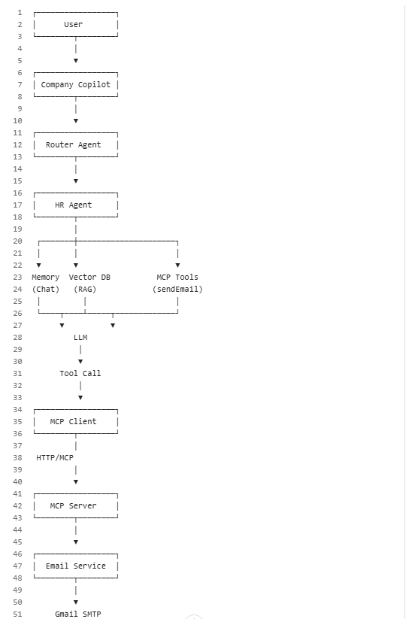

Review End-to-End Email Flow
- User asks: Send leave policy to john@example.com
- Router selects HR Agent
- RAG retrieves HR knowledge
- LLM decides sendEmail tool is needed
- MCP client invokes remote tool
- MCP server runs EmailService
- Gmail SMTP sends email
- Success returned to user

Key Spring AI Components
- ChatClient
- QuestionAnswerAdvisor
- VectorStore
- ToolCallbackProvider
- MessageWindowChatMemory
- MCP Client Starter

Dependencies Explained
- spring-ai-starter-mcp-client enables MCP integration
- spring-ai-vector-store provides RAG
- Google GenAI provides chat and embeddings

Testing Scenarios
Scenario 1 HR Question:
Input: What is annual leave policy?
Expected: HR RAG response.
Scenario 2 Leave Balance:
Input: Check leave balance.
Expected: HR tool execution.
Scenario 3 Send Email:
Input: Send leave policy to john@example.com.
Expected: Router -> HR Agent -> MCP Tool -> Email sent.
Scenario 4 Policy Search:
Input: Remote work policy.
Expected: Policy Agent response.
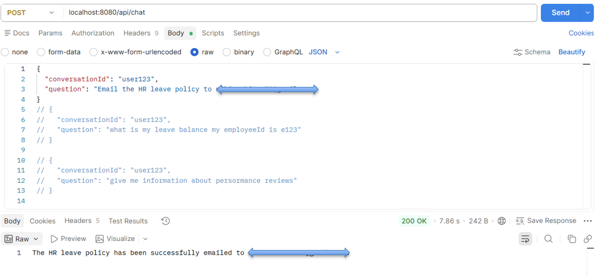

Architecture Comparison
- Previous project = MCP Server hosting sendEmail
- Current project = MCP Client consuming sendEmail tool

Key Learning Outcome
- This solution combines Multi-Agent AI, RAG, Memory, Local Tools and Remote MCP Tools in a single enterprise copilot.

