Hibernate
Hibernate is a high-performance Object/Relational persistence and query service, which is licensed under the open source GNU Lesser General Public License (LGPL) and is free to download.
Hibernate not only takes care of the mapping from Java classes to database tables (and from Java data types to SQL data types), but also provides data query and retrieval facilities. This tutorial will teach you how to use Hibernate to develop your database based web applications in simple and easy steps.

What is JDBC?
JDBC stands for Java Database Connectivity. It provides a set of Java API for accessing the relational databases from Java program. These Java APIs enables Java programs to execute SQL statements and interact with any SQL compliant database.
JDBC provides a flexible architecture to write a database independent application that can run on different platforms and interact with different DBMS without any modification.

Pros and Cons of JDBC
Pros of JDBC | Cons of JDBC
Clean and simple SQL processing  Good performance with large data  Very good for small applications  Simple syntax so easy to learn | Complex if it is used in large projects  Large programming overhead  No encapsulation  Hard to implement MVC concept  Query is DBMS specific

Why Object Relational Mapping (ORM)?
When we work with an object-oriented system, there is a mismatch between the object model and the relational database. RDBMSs represent data in a tabular format whereas object-oriented languages, such as Java or C# represent it as an interconnected graph of objects.
First problem, what if we need to modify the design of our database after having developed a few pages or our application? Second, loading and storing objects in a relational database exposes us to the following five mismatch problems −
Sr.No. | Mismatch & Description
1 | Granularity  Sometimes you will have an object model, which has more classes than the number of corresponding tables in the database.
2 | Inheritance  RDBMSs do not define anything similar to Inheritance, which is a natural paradigm in object-oriented programming languages.
3 | Identity  An RDBMS defines exactly one notion of 'sameness': the primary key. Java, however, defines both object identity (a==b) and object equality (a.equals(b)).
4 | Associations  Object-oriented languages represent associations using object references whereas an RDBMS represents an association as a foreign key column.
5 | Navigation  The ways you access objects in Java and in RDBMS are fundamentally different.
The Object-Relational Mapping (ORM) is the solution to handle all the above impedance mismatches.

What is ORM?
ORM stands for Object-Relational Mapping (ORM) is a programming technique for converting data between relational databases and object oriented programming languages such as Java, C#, etc.
An ORM system has the following advantages over plain JDBC −
Sr.No. | Advantages
1 | Let’s business code access objects rather than DB tables.
2 | Hides details of SQL queries from OO logic.
3 | Based on JDBC 'under the hood.'
4 | No need to deal with the database implementation.
5 | Entities based on business concepts rather than database structure.
6 | Transaction management and automatic key generation.
7 | Fast development of application.
An ORM solution consists of the following four entities −
Sr.No. | Solutions
1 | An API to perform basic CRUD operations on objects of persistent classes.
2 | A language or API to specify queries that refer to classes and properties of classes.
3 | A configurable facility for specifying mapping metadata.
4 | A technique to interact with transactional objects to perform dirty checking, lazy association fetching, and other optimization functions.

Java ORM Frameworks
There are several persistent frameworks and ORM options in Java. A persistent framework is an ORM service that stores and retrieves objects into a relational database.
- Enterprise JavaBeans Entity Beans
- Java Data Objects
- Castor
- TopLink
- Spring DAO
- Hibernate
- And many more

Hibernate is an Object-Relational Mapping (ORM) solution for JAVA. It is an open source persistent framework created by Gavin King in 2001. It is a powerful, high performance Object-Relational Persistence and Query service for any Java Application.
Hibernate maps Java classes to database tables and from Java data types to SQL data types and relieves the developer from 95% of common data persistence related programming tasks.
Hibernate sits between traditional Java objects and database server to handle all the works in persisting those objects based on the appropriate O/R mechanisms and patterns.

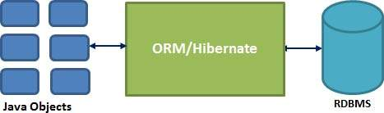

Hibernate Advantages
- Hibernate takes care of mapping Java classes to database tables using XML files and without writing any line of code.
- Provides simple APIs for storing and retrieving Java objects directly to and from the database.
- If there is change in the database or in any table, then you need to change the XML file properties only.
- Abstracts away the unfamiliar SQL types and provides a way to work around familiar Java Objects.
- Hibernate does not require an application server to operate.
- Manipulates Complex associations of objects of your database.
- Minimizes database access with smart fetching strategies.
- Provides simple querying of data.

Supported Databases
Hibernate supports almost all the major RDBMS. Following is a list of few of the database engines supported by Hibernate −
- HSQL Database Engine
- DB2/NT
- MySQL
- PostgreSQL
- FrontBase
- Oracle
- Microsoft SQL Server Database
- Sybase SQL Server
- Informix Dynamic Server

Supported Technologies
Hibernate supports a variety of other technologies, including −
- XDoclet Spring
- J2EE
- Eclipse plug-ins
- Maven

Hibernate - Architecture
Hibernate has a layered architecture which helps the user to operate without having to know the underlying APIs. Hibernate makes use of the database and configuration data to provide persistence services (and persistent objects) to the application.
Following is a very high level view of the Hibernate Application Architecture.
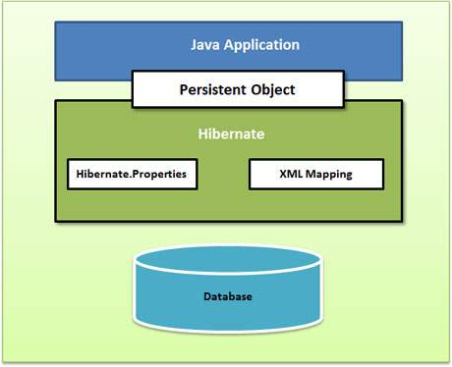
Following is a detailed view of the Hibernate Application Architecture with its important core classes.
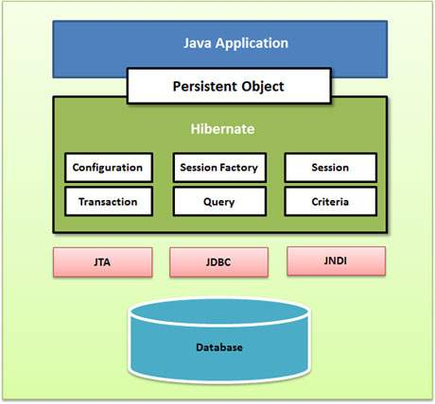
Hibernate uses various existing Java APIs, like JDBC, Java Transaction API(JTA), and Java Naming and Directory Interface (JNDI). JDBC provides a rudimentary level of abstraction of functionality common to relational databases, allowing almost any database with a JDBC driver to be supported by Hibernate. JNDI and JTA allow Hibernate to be integrated with J2EE application servers.
Following section gives brief description of each of the class objects involved in Hibernate Application Architecture.

Configuration Object
The Configuration object is the first Hibernate object you create in any Hibernate application. It is usually created only once during application initialization. It represents a configuration or properties file required by the Hibernate.
The Configuration object provides two keys components −
- Database Connection − This is handled through one or more configuration files supported by Hibernate. These files are hibernate.properties and hibernate.cfg.xml.
- Class Mapping Setup − This component creates the connection between the Java classes and database tables.

SessionFactory Object
Configuration object is used to create a SessionFactory object which in turn configures Hibernate for the application using the supplied configuration file and allows for a Session object to be instantiated. The SessionFactory is a thread safe object and used by all the threads of an application.
The SessionFactory is a heavyweight object; it is usually created during application start up and kept for later use. You would need one SessionFactory object per database using a separate configuration file. So, if you are using multiple databases, then you would have to create multiple SessionFactory objects.

Session Object
A Session is used to get a physical connection with a database. The Session object is lightweight and designed to be instantiated each time an interaction is needed with the database. Persistent objects are saved and retrieved through a Session object.
The session objects should not be kept open for a long time because they are not usually thread safe and they should be created and destroyed them as needed.

Transaction Object
A Transaction represents a unit of work with the database and most of the RDBMS supports transaction functionality. Transactions in Hibernate are handled by an underlying transaction manager and transaction (from JDBC or JTA).
This is an optional object and Hibernate applications may choose not to use this interface, instead managing transactions in their own application code.

Query Object
Query objects use SQL or Hibernate Query Language (HQL) string to retrieve data from the database and create objects. A Query instance is used to bind query parameters, limit the number of results returned by the query, and finally to execute the query.

Criteria Object
Criteria objects are used to create and execute object oriented criteria queries to retrieve objects.

