Hello.jsp-->Hello_Jsp.java Program-->Hello_Jsp.class

The Lifecycle of a JSP Page
The JSP pages follow these phases:
- Translation of JSP Page
- Compilation of JSP Page
- Classloading (the classloader loads class file)
- Instantiation (Object of the Generated Servlet is created).
- Initialization ( the container invokes jspInit() method).
- Request processing ( the container invokes _jspService() method).
- Destroy ( the container invokes jspDestroy() method).

Note: jspInit(), _jspService() and jspDestroy() are the life cycle methods of JSP.

As depicted in the above diagram, JSP page is translated into Servlet by the
help of JSP translator. The JSP translator is a part of the web server which is responsible for translating the JSP page into Servlet. After that, Servlet page is compiled by the compiler and gets converted into the class file. Moreover, all the processes that happen in Servlet are performed on JSP later like initialization, committing response to the browser and destroy.

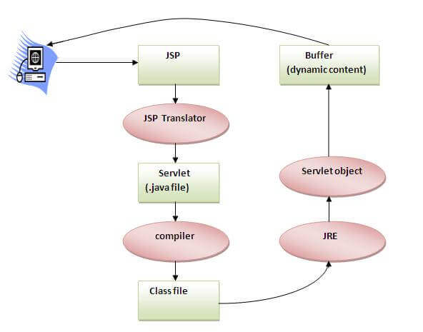

The JSP API
The JSP API consists of two packages:
- javax.servlet.jsp
- javax.servlet.jsp.tagext

javax.servlet.jsp package
The javax.servlet.jsp package has two interfaces and classes.The two interfaces are as follows:
- JspPage
- HttpJspPage
The classes are as follows:
- JspWriter
- PageContext
- JspFactory
- JspEngineInfo
- JspException
- JspError

The JspPage interface
According to the JSP specification, all the generated servlet classes must implement the JspPage interface. It extends the Servlet interface. It provides two life cycle methods.
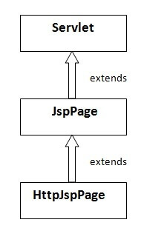

Methods of JspPage interface
- public void jspInit():It is invoked only once during the life cycle of the JSP when JSP page is requested firstly. It is used to perform initialization. It is same as the init() method of Servlet interface.
- public void jspDestroy():It is invoked only once during the life cycle of the JSP before the JSP page is destroyed. It can be used to perform some clean up operation.

The HttpJspPage interface
The HttpJspPage interface provides the one life cycle method of JSP. It extends the JspPage interface.

Method of HttpJspPage interface:public void _jspService():It is invoked each time when request for the JSP page comes to the container. It is used to process the request. The underscore _ signifies that you cannot override this method.

JSP Scriptlet tag (Scripting elements)
In JSP, java code can be written inside the jsp page using the scriptlet tag. Let's see what are the scripting elements first.

JSP Scripting elements
The scripting elements provides the ability to insert java code inside the jsp. There are three types of scripting elements:
- scriptlet tag
- expression tag
- declaration tag

JSP scriptlet tag
A scriptlet tag is used to execute java source code in JSP. Syntax is as follows:
- <% java source code %>

SP expression tag
The code placed within JSP expression tag is written to the output stream of the response. So you need not write out.print() to write data. It is mainly used to print the values of variable or method.

Syntax of JSP expression tag
- <%= statement %>

JSP Declaration Tag<%! Field or method declaration %>
The JSP declaration tag is used to declare fields and methods.
The code written inside the jsp declaration tag is placed outside the service() method of auto generated servlet.
So it doesn't get memory at each request.
The syntax of the declaration tag is as follows:
<%! field or method declaration %>

Difference between JSP Scriptlet tag and Declaration tag
Jsp Scriptlet Tag | Jsp Declaration Tag
The jsp scriptlet tag can only declare variables not methods. | The jsp declaration tag can declare variables as well as methods.
The declaration of scriptlet tag is placed inside the _jspService() method. | The declaration of jsp declaration tag is placed outside the _jspService() method.

Example of JSP declaration tag that declares field
In this example of JSP declaration tag, we are declaring the field and printing the value of the declared field using the jsp expression tag.

index.jsp
- <html>
- <body>
- <%! int data=50; %>
- <%= "Value of the variable is:"+data %>
- </body>
- </html>

Example of JSP declaration tag that declares method
In this example of JSP declaration tag, we are defining the method which returns the cube of given number and calling this method from the jsp expression tag. But we can also use jsp scriptlet tag to call the declared method.

index.jsp
- <html>
- <body>
- <%!
- int cube(int n){
- return n*n*n*;
- }
- %>
- <%= "Cube of 3 is:"+cube(3)%>
- </body>
- </html>

JSP Implicit Objects
There are 9 jsp implicit objects. These objects are created by the web container that are available to all the jsp pages.
The available implicit objects are out, request, config, session, application etc.
A list of the 9 implicit objects is given below:
Object | Type
out | PrintWriter
request | HttpServletRequest
response | HttpServletResponse
config | ServletConfig
application | ServletContext
session | HttpSession
pageContext | PageContext
page | Object
exception | Throwable

JSP request implicit object
The JSP request is an implicit object of type HttpServletRequest i.e. created for each jsp request by the web container. It can be used to get request information such as parameter, header information, remote address, server name, server port, content type, character encoding etc.
It can also be used to set, get and remove attributes from the jsp request scope.
Let's see the simple example of request implicit object where we are printing the name of the user with welcome message.

Example of JSP request implicit object

index.html
- <form action="welcome.jsp">
- <input type="text" name="uname">
- <input type="submit" value="go"><br/>
- </form>

welcome.jsp
- <%
- String name=request.getParameter("uname");
- out.print("welcome "+name);
- %>

3) JSP response implicit object
In JSP, response is an implicit object of type HttpServletResponse. The instance of HttpServletResponse is created by the web container for each jsp request.
It can be used to add or manipulate response such as redirect response to another resource, send error etc.
Let's see the example of response implicit object where we are redirecting the response to the Google.

Example of response implicit object
index.html
- <form action="welcome.jsp">
- <input type="text" name="uname">
- <input type="submit" value="go"><br/>
- </form>
welcome.jsp
- <%
- response.sendRedirect("http://www.google.com");
- %>

4) JSP config implicit object
In JSP, config is an implicit object of type ServletConfig. This object can be used to get initialization parameter for a particular JSP page. The config object is created by the web container for each jsp page.
Generally, it is used to get initialization parameter from the web.xml file.

Example of config implicit object:
index.html
- <form action="welcome">
- <input type="text" name="uname">
- <input type="submit" value="go"><br/>
- </form>
web.xml file
- <web-app>

- <servlet>
- <servlet-name>sonoojaiswal</servlet-name>
- <jsp-file>/welcome.jsp</jsp-file>

- <init-param>
- <param-name>dname</param-name>
- <param-value>sun.jdbc.odbc.JdbcOdbcDriver</param-value>
- </init-param>

- </servlet>

- <servlet-mapping>
- <servlet-name>sonoojaiswal</servlet-name>
- <url-pattern>/welcome</url-pattern>
- </servlet-mapping>

- </web-app>
welcome.jsp
- <%
- out.print("Welcome "+request.getParameter("uname"));

- String driver=config.getInitParameter("dname");
- out.print("driver name is="+driver);
- %>

5) JSP application implicit object
In JSP, application is an implicit object of type ServletContext.
The instance of ServletContext is created only once by the web container when application or project is deployed on the server.
This object can be used to get initialization parameter from configuaration file (web.xml). It can also be used to get, set or remove attribute from the application scope.
This initialization parameter can be used by all jsp pages.
index.html
- <form action="welcome">
- <input type="text" name="uname">
- <input type="submit" value="go"><br/>
- </form>
web.xml file
- <web-app>

- <servlet>
- <servlet-name>sonoojaiswal</servlet-name>
- <jsp-file>/welcome.jsp</jsp-file>
- </servlet>

- <servlet-mapping>
- <servlet-name>sonoojaiswal</servlet-name>
- <url-pattern>/welcome</url-pattern>
- </servlet-mapping>

- <context-param>
- <param-name>dname</param-name>
- <param-value>sun.jdbc.odbc.JdbcOdbcDriver</param-value>
- </context-param>

- </web-app>
welcome.jsp
- <%

- out.print("Welcome "+request.getParameter("uname"));

- String driver=application.getInitParameter("dname");
- out.print("driver name is="+driver);

- %>

6) session implicit object
In JSP, session is an implicit object of type HttpSession.The Java developer can use this object to set,get or remove attribute or to get session information.

Example of session implicit object

index.html
- <html>
- <body>
- <form action="welcome.jsp">
- <input type="text" name="uname">
- <input type="submit" value="go"><br/>
- </form>
- </body>
- </html>

welcome.jsp
- <html>
- <body>
- <%

- String name=request.getParameter("uname");
- out.print("Welcome "+name);

- session.setAttribute("user",name);

- <a href="second.jsp">second jsp page</a>

- %>
- </body>
- </html>

second.jsp
- <html>
- <body>
- <%

- String name=(String)session.getAttribute("user");
- out.print("Hello "+name);

- %>
- </body>
- </html>

JSP directives
The jsp directives are messages that tells the web container how to translate a JSP page into the corresponding servlet.
There are three types of directives:
- page directive
- include directive
- taglib directive

Syntax of JSP Directive
- <%@ directive attribute="value" %>

JSP page directive
The page directive defines attributes that apply to an entire JSP page.

Syntax of JSP page directive
- <%@ page attribute="value" %>

