What is the CSS Box Model?
The box model in CSS is a container that contains various properties, including borders,margins, padding, and the content itself. These properties collectively determine the dimensions and spacing of an element.
Let’s break down the key components:
- Content: The actual data in text, images, or other media forms can be sized using the width and height property.
- Padding:Padding is used to create space around the element, inside any defined border.
- Border: The border is used to cover the content & any padding, & also allows setting the style, color, and width of the border.
- Margin:Margin is used to create space around the element ie., around the border area.

1. Content Area
- Contains the actual data, such as text, images, or other media.
- Sized using the width and height properties.
- Bounded by the content edge.

2. Padding Area
- Surrounds the content area.
- Space within the border box.
- Dimensions are determined by the width and height of the padding box.

3. Border Area
- Lies between the padding and margin.
- Width and height are defined by the border.

4.Margin Area
- Separates the element from neighboring elements.
- Dimensions specified by the margin-box width and height.

The following figure illustrates the Box model in CSS.
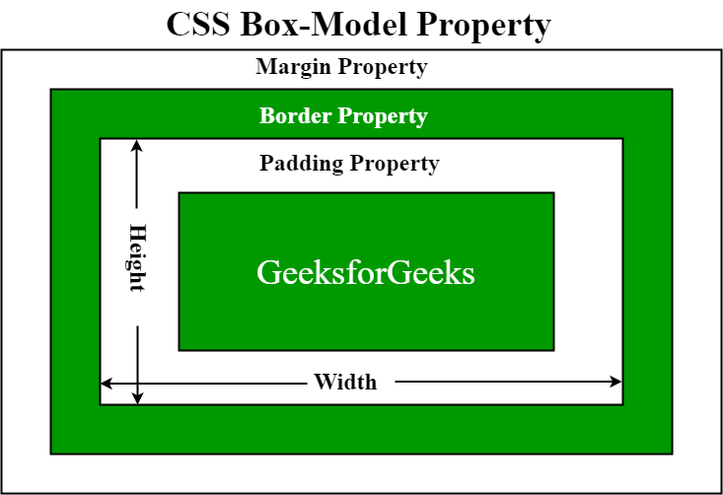

How Does the Box Model Work?
When setting the width and height properties for an element, we’re mainly adjusting the content area. However, to calculate the full size of the element, we need to consider padding, borders, and margins.
While setting the width and height properties of an element with CSS, we have only set the width and height of the content area. We need to add padding, borders, and margins in order to calculate the full size of an element. Consider the below example.
p {
width: 80px;
height: 70px;
margin: 0;
border: 2px solid black;
padding: 5px;
}

Total Width Calculation
Total element width = width + left padding + right padding + left border + right border + left margin + right margin
- Total width of the element is 94px.
- Total width= 80px (width) + 10px (left padding + right padding) + 4px (left border + right border) + 0px (left margin + right margin) = 94px.

Total Height Calculation
Total element height = height + top padding + bottom padding + top border + bottom border + top margin + bottom margin
- Total height of the element is 84px.
- Total height = 70px (height) + 10px (top padding + bottom padding) + 4px (top border + bottom border) + 0px (top margin + bottom margin) = 84px.

Examples of Box models in CSS
Now, We have learned the working of the CSS Box Model in-depth and now we will see Box Model examples so that we can properly understand it.

What are Pseudo-Elements?
A CSS pseudo-element is used to style specified parts of an element.
For example, it can be used to:
- Style the first letter, or line, of an element
- Insert content before, or after, the content of an element

Syntax
The syntax of pseudo-elements:
selector::pseudo-element{
property:value;
}

The ::first-line Pseudo-element
The::first-line pseudo-element is used to add a special style to the first line of a text.
The following example formats the first line of the text in all <p> elements:
p::first-line{
color:#ff0000;
font-variant:small-caps;
}

Note:The::first-line pseudo-element can only be applied to block-level elements.
The following properties apply to the ::first-line pseudo-element:
- font properties
- color properties
- background properties
- word-spacing
- letter-spacing
- text-decoration
- vertical-align
- text-transform
- line-height
- clear

The ::first-letter Pseudo-element
The::first-letter pseudo-element is used to add a special style to the first letter of a text.
The following example formats the first letter of the text in all <p> elements:
p::first-letter{
color:#ff0000;
font-size:xx-large;
}
Note:The ::first-letter pseudo-element can only be applied to block-level elements.
The following properties apply to the ::first-letter pseudo- element:
- font properties
- color properties
- background properties
- margin properties
- padding properties
- border properties
- text-decoration
- vertical-align (only if "float" is "none")
- text-transform
- line-height
- float
- clear
p.intro::first-letter{
color:#ff0000;
font-size:200%;
}

CSS - The ::before Pseudo-element
The::before pseudo-element can be used to insert some content before the content of an element.
The following example inserts an image before the content of each <h1> element:
h1::before{
content:url(smiley.gif);
}

CSS - The ::after Pseudo-element
The::afterpseudo-element can be used to insert some content after the content of an element.
The following example inserts an image after the content of each <h1> element:
h1::after{
content:url(smiley.gif);
}

CSS - The ::marker Pseudo-element
The ::marker pseudo-element selects the markers of list items.
The following example styles the markers of list items:
<!DOCTYPE html>
<html>
<head>
<style>
::marker {
color: red;
font-size: 23px;
}
</style>
</head>
<body>

<ul>
<li>Coffee</li>
<li>Tea</li>
<li>Milk</li>
</ul>

<ol>
<li>First</li>
<li>Second</li>
<li>Third</li>
</ol>

</body>
</html>

CSS - The ::selection Pseudo-element
The::selectionpseudo-element matches the portion of an element that is selected by a user.
The following CSS properties can be applied to::selection:color,background,cursor, andoutline.
The following example makes the selected text red on a yellow background:
<!DOCTYPE html>
<html>
<head>
<style>
::selection {
color: red;
background: yellow;
}
</style>
</head>
<body>

<h1>Select some text on this page:</h1>

<p>This is a paragraph.</p>
<div>This is some text in a div element.</div>

</body>
</html>

CSS Flexbox Layout Module
Before the Flexbox Layout module, there were four layout modes:
- Block, for sections in a webpage
- Inline, for text
- Table, for two-dimensional table data
- Positioned, for explicit position of an element
The Flexible Box Layout Module, makes it easier to design flexible responsive layout structure without using float or positioning.

Flexbox Elements
To start using the Flexbox model, you need to first define a flex container.

1

2

3
The element above represents a flex container (the blue area) with three flex items.

Example
A flex container with three flex items:
<div class="flex-container">
<div>1</div>
<div>2</div>
<div>3</div>
</div>
<html>
<head>
<style>
.flex-container {
display: flex;
background-color: DodgerBlue;
}

.flex-container > div {
background-color: #f1f1f1;
margin: 10px;
padding: 20px;
font-size: 30px;
}
</style>
</head>
<body>

<h1>Create a Flex Container</h1>

<div class="flex-container">
<div>1</div>
<div>2</div>
<div>3</div>
</div>

<p>A Flexible Layout must have a parent element with the <em>display</em> property set to <em>flex</em>.</p>

<p>Direct child elements(s) of the flexible container automatically becomes flexible items.</p>

</body>
</html>

