Nikita Daharia

May 17, 2022

Foundations of Programming: Python

Assignment 05

[GutHubURL](https://github.com/nikitadaharia/IntroToProg-Python)

**Working with Dictionaries:**

**Introduction:**

This paper aims to demonstrate the steps I undertook to create a python script that enables a user to modify a new script that manages a "ToDo list". The latest version of PyCharm Community version is used for this assignment on a Mac OS.

**Writing the python script and output:**

Create a new sub-folder called Assignment05 inside of the _PythonClass folder (you created in Module 01) in the Documents folder on a Mac OS.

***Figure 1. Assignment05 saved as a subfolder inside the folder _PythonClass in Documents.***

Create a new project in PyCharm that uses the _PythonClass\Assignment05 folder as its location.

***Figure 2. Creation of a new project in PyCharm***

Modify the Python Script provided “Assignment05_Starter.py”. The starter script already provides us with 5 options for the menu. Add code to the Script that enables a user to modify a new script that manages a "ToDo list." The "ToDo" file will contain two columns of data, "Task" and "Priority." The columns will be loaded into a Python Dictionary object. Each dictionary object represents one row of data, and these rows must be added to a Python List object to create a table of data.

Choosing strChoice.strip() == 1, if it is true, then it runs for a loop through the list 1sTable. For each row in the table, it prints out the first and second value from the dictionary row. If strChoice.strip() == 2, the user can choose to add a task and the priority of this task. If strChoice.strip() == 3, the user is choosing to remove an existing row from the table. Using strChoice.strip() == 4, the user can save this data after they are done will making all the changes. Lastly, strChoice.strip() == 5, the user can exit the program.

***Figure 3. Snippet of the python script Assignment05_Starter.py***

Run the Script by right clicking on the file and choosing Run.

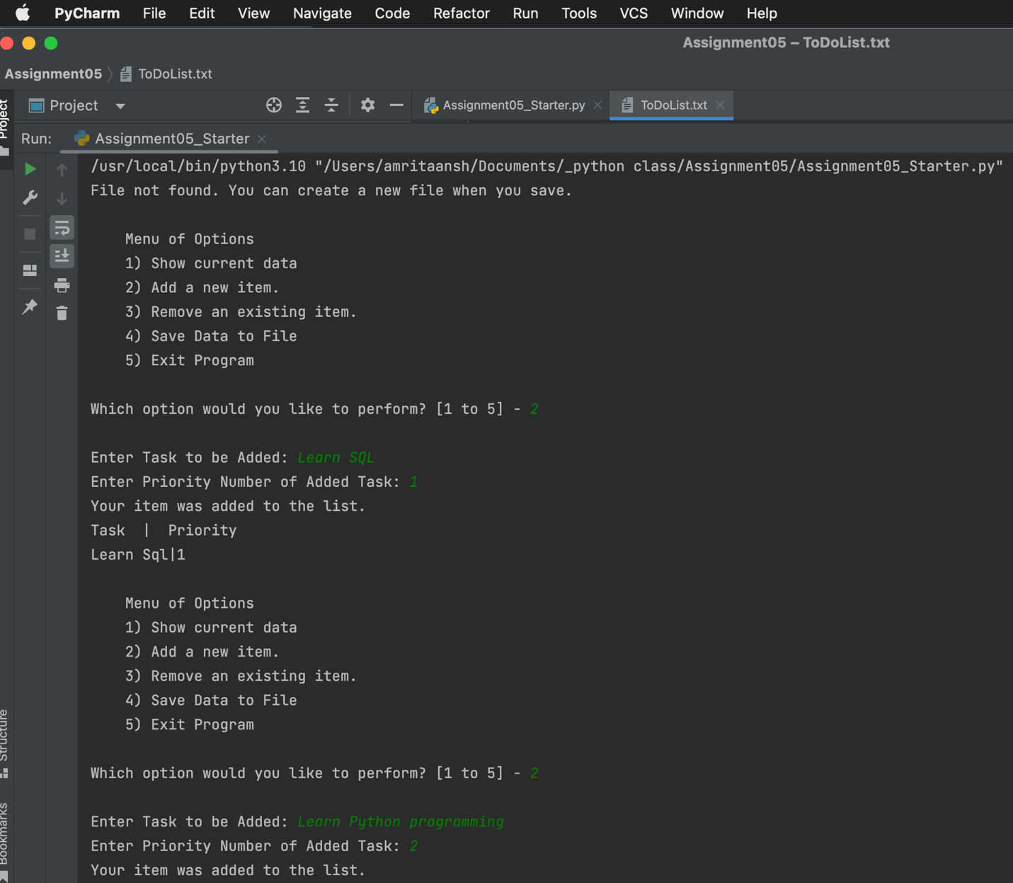

***Figure 4. Snippet of output displayed in PyCharm Shell after running the python script.***

Run the script on the Terminal window

***Figure 5.*** ***Output displayed in Terminal window after running the python script.***

Verify that it code worked by locating the text file and opening it in a text editor.

***Figure 6. ToDoList.txt Window updated the saved value of toaster as entered by the user.***

**Summary:**

Python is a simple yet powerful language programming language that runs on Windows, Linus/Unix, and Mac OS. I used PyCharm to create a python script that script that enables a user to modify a new script that manages a "ToDo list". The script was run both in PyCharm and Terminal . Finally, the code was verified by locating the ToDoList.txt text file and opening it in a text editor and it successfully updated the list saved by the user.