**BRACT’s**

**Vishwakarma Institute of Information Technology, Pune**

Course Name: Artificial Neural Network in Engineering

**Skill and Competency Examination**

**Name:** Nikita Narendra Dara

**Roll No.:** 331071

**Gr No.:** 21920136

**Batch:** TY IT A

**Aim**

Time series forecasting using ANN

**Objective**

To forecast temperature one day in advance using ANN

**Study area/ data:**

Data collected from link: <https://www.imd.gov.in/Welcome%20T0%20!MD/Welcome.php>

Data is as follows:

|  |  |
| --- | --- |
| **YEAR** | **OCT-DEC** |
| 1901 | 21.92 |
| 1902 | 21.49 |
| 1903 | 21.27 |
| 1904 | 21.42 |
| 1905 | 21.48 |
| 1906 | 22.08 |
| 1907 | 21.76 |
| 1908 | 21.17 |
| 1909 | 21.75 |
| 1910 | 20.96 |
| 1911 | 21.48 |
| 1912 | 21.29 |
| 1913 | 21.32 |
| 1914 | 21.52 |
| 1915 | 22.01 |
| 1916 | 21.27 |
| 1917 | 21.01 |
| 1918 | 21.54 |
| 1919 | 21.48 |
| 1920 | 21.85 |
| 1921 | 21.39 |
| 1922 | 21.2 |
| 1923 | 21.4 |
| 1924 | 21.52 |
| 1925 | 21.51 |
| 1926 | 21.26 |
| 1927 | 21.76 |
| 1928 | 21.81 |
| 1929 | 21.42 |
| 1930 | 21.71 |
| 1931 | 21.97 |
| 1932 | 21.75 |
| 1933 | 21.77 |
| 1934 | 21.55 |
| 1935 | 21.65 |
| 1936 | 21.86 |
| 1937 | 21.14 |
| 1938 | 21.31 |
| 1939 | 21.67 |
| 1940 | 21.91 |
| 1941 | 22.3 |
| 1942 | 21.72 |
| 1943 | 21.68 |
| 1944 | 21.76 |
| 1945 | 21.16 |
| 1946 | 22.13 |
| 1947 | 21.39 |
| 1948 | 21.73 |
| 1949 | 21.29 |
| 1950 | 21.14 |
| 1951 | 22.45 |
| 1952 | 21.77 |
| 1953 | 22.01 |
| 1954 | 21.15 |
| 1955 | 21.35 |
| 1956 | 21.41 |
| 1957 | 21.94 |
| 1958 | 22.13 |
| 1959 | 22 |
| 1960 | 21.84 |
| 1961 | 21.17 |
| 1962 | 21.47 |
| 1963 | 22.04 |
| 1964 | 21.58 |
| 1965 | 22.1 |
| 1966 | 21.83 |
| 1967 | 21.68 |
| 1968 | 21.69 |
| 1969 | 22.2 |
| 1970 | 21.55 |
| 1971 | 21.48 |
| 1972 | 21.88 |
| 1973 | 21.53 |
| 1974 | 21.38 |
| 1975 | 21.3 |
| 1976 | 22.25 |
| 1977 | 22.3 |
| 1978 | 22.22 |
| 1979 | 22.59 |
| 1980 | 22.17 |
| 1981 | 21.68 |
| 1982 | 22.02 |
| 1983 | 21.71 |
| 1984 | 21.82 |
| 1985 | 21.84 |
| 1986 | 21.9 |
| 1987 | 22.29 |
| 1988 | 22 |
| 1989 | 21.94 |
| 1990 | 22.11 |
| 1991 | 21.87 |
| 1992 | 22.04 |
| 1993 | 22.21 |
| 1994 | 21.97 |
| 1995 | 23.19 |
| 1996 | 21.76 |
| 1997 | 21.89 |
| 1998 | 22.42 |
| 1999 | 22.29 |
| 2000 | 22.68 |
| 2001 | 22.52 |
| 2002 | 22.58 |
| 2003 | 22.23 |
| 2004 | 22.24 |
| 2005 | 21.93 |
| 2006 | 22.66 |
| 2007 | 22.32 |
| 2008 | 22.87 |
| 2009 | 22.58 |
| 2010 | 22.6 |
| 2011 | 22.71 |
| 2012 | 22.35 |
| 2013 | 22.5 |
| 2014 | 22.47 |
| 2015 | 22.99 |
| 2016 | 24.2 |
| 2017 | 24.21 |

**Model Inputs (names)**

Model gets only one input column which is named as OCT-DEC column in the dataset, and then generates output for the temperature column of OCT-DEC month.

**Model Output(s)**

Output graphs after training the model and testing after its own values which were used as testing dataset. This is graph which shows the comparison between actual and predicted values.

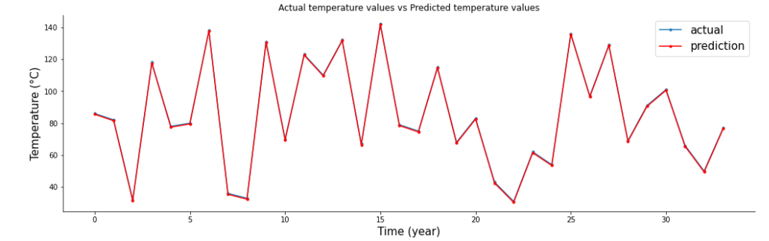

**Number of layers**

There are three layers in this model, those are as follows.

1. Input layer
2. Hidden layer
3. Output layer

**Type of ANN:** FFBP (Feed Forward Back Propagation)

**Algorithm**

Standard back-propagation (Gradient descent)

**Transfer Functions:**

**Performance function:** MSE

**Data Division**

Data division is done by using a sklearn library method called train_test_split(), which divides the data into training dataset and testing dataset on the basis of training size given and random variable.

**Stopping Criteria**

Stopping criteria for the training phase is epoch made by the program. Size of 100 epochs are given for the training phase after that it will stop training the model.

**Results in Testing**

Results in training are as follows.

The loss plot after 100 epoch becomes almost the same as the training plot, this reduces the errors of the model.

**RMES and R between actual and predicted values**

**Scatter plot between actual and predicted values:**

**Discussion of results**

* Model gives error of 13.79.
* More data is needed for more accurate results.
* Model is not overfitting as we can see the results are consistent on several epochs.

**Conclusion**

This model can provide accurate results for forecasting as it’s trained on real time data.