**Question 3:**

**Following map represents the data during busy schedules of election in October 2016.**

**The Blue Blocks represents the states where Hillary Clinton had chance to win whereas red blocks represents the states where Donald Trmp had a chance to win the battle.**

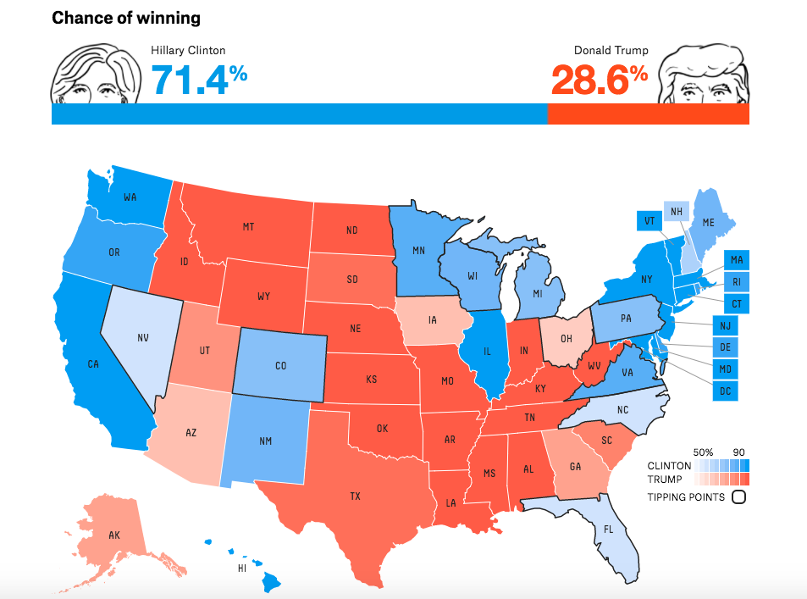

**From overall picture in the map, we can say that Hillary had bright chances to win from west coast of America and Trump had chance to win from central America and East coast of America.**

**Find a dataset of interest to you. First find a data source. Then download the data. Open the data in the visualization software. Make a map if you have the location or geolocation data. Or make some other kind of visualization. Comment about what your visualization is trying to communicate.**

* + **Make a plot of your data on a map using Google Charts (this is from Google Sheets in Google Docs).**
  + **Make the same plot of your data in Tableau.**

**Solution:**

My Data source:

<https://data.worldbank.org/country/>

Then after entering the country names, I referred to Country profile, and got values for GDP (current US$) (billions) for every country.

The data was inserted in MS Excel:

**PART 1:** The excel sheet is been uploaded in the Google sheets in Google docs.The bar chart is displayed below for the data considered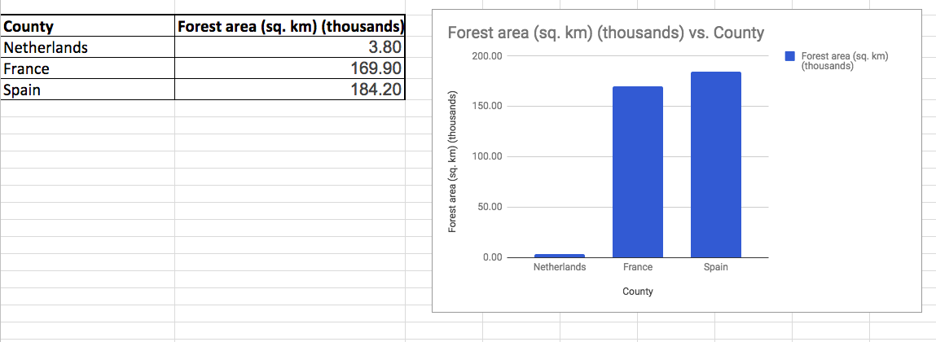:

Another way is to display data by selecting Map – Geo Chart in the chart section:

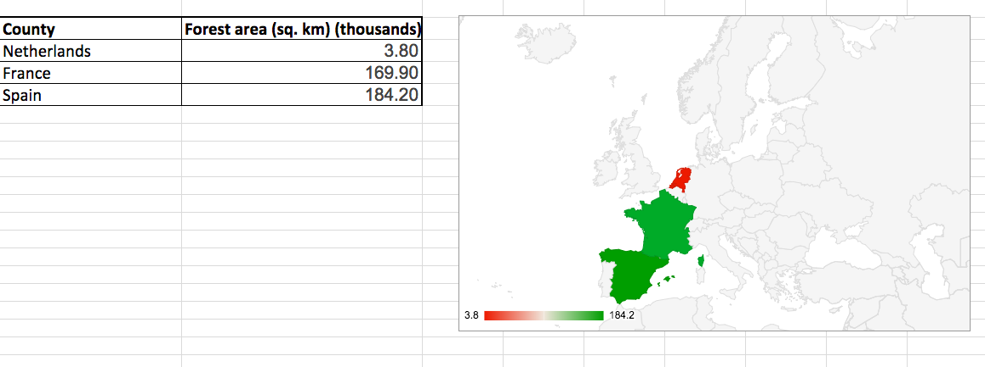

Part 2:

The similar Excel sheet is imported in Tableau.

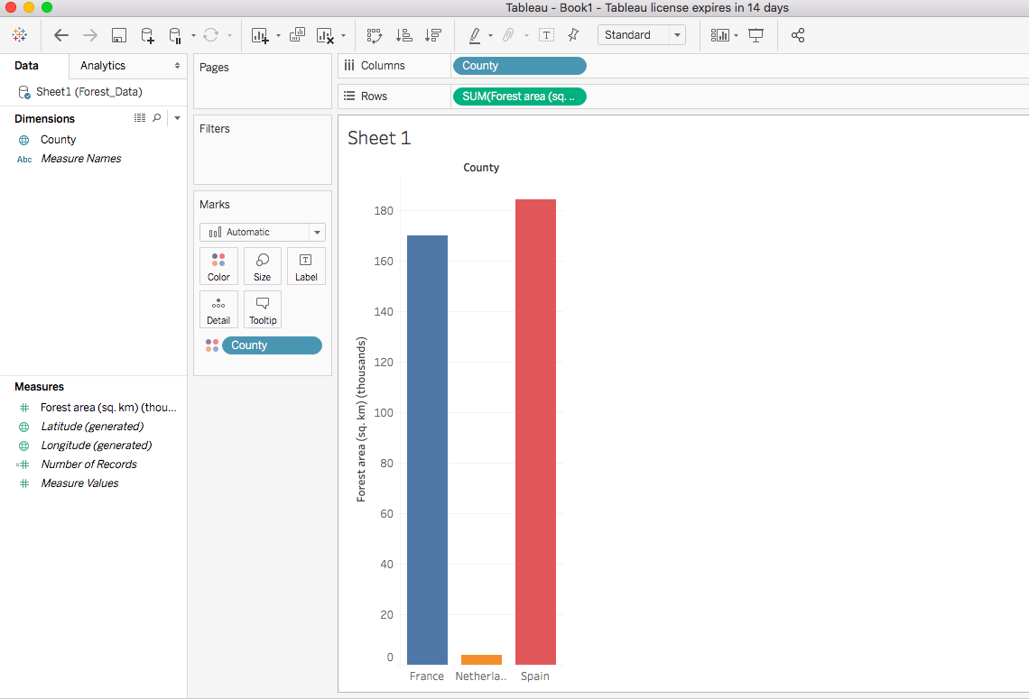

1. **Install the Quandl library in R. Find an interesting dataset from Quandl and make a time series plot in R.**

**Solution:**

I have selected data from FRED - Industrial Production Index (INDPRO)

“INDPRO” is used in the R code to extract the graph from the FRED using Quandl.

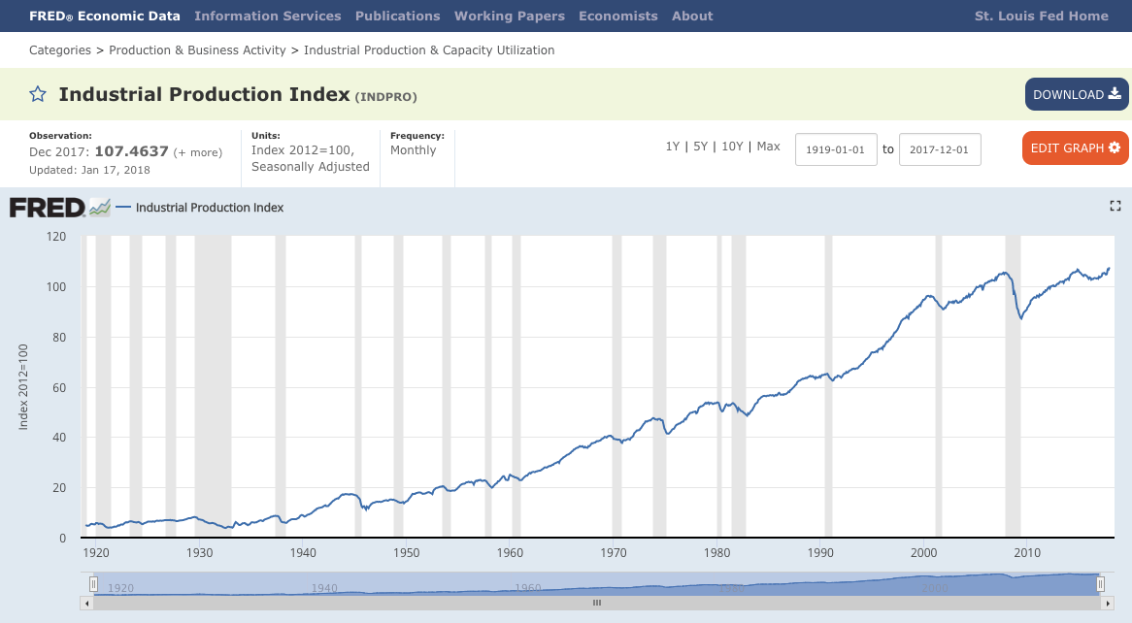

The code in R and the Time series plot for the above data in R is as follows:

library(Quandl)

mydata <- Quandl("FRED/INDPRO",type="ts")

mydata

plot(mydata)

# ts.plot(mydata)

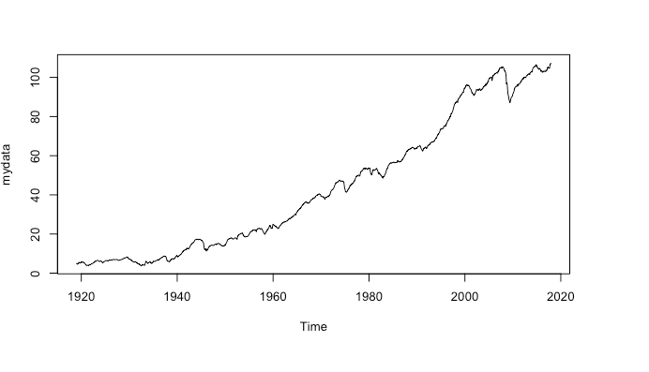

1. **Using R run the mtcars examples from the end of the**[**Tools**](http://www.sci.csueastbay.edu/~esuess/classes/Statistics_6610/viz/viz5/Tools.html#/)**presentations. Show the plots you have created in your homework document.**

**Solution:**

