1. Prerequisite
   1. python
   2. chrome driver path - C:/Users/Jeevni/Downloads/chromedriver_win32\chromedriver.exe

To change the path open inputdata.csv and edit the variable value – chromedriver

2. Copy the project in the local folder

3. Open terminal

4. Go to path where project is copied

5. Run python app.ipynb

6. Localhost run <http://127.0.0.1:5000>

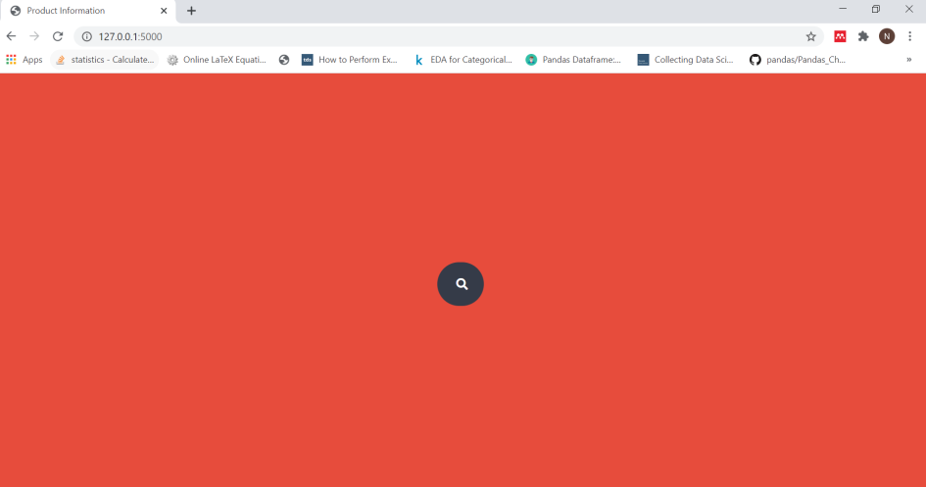

7. Search the Items – keyword as given in inputdata.csv (

Macbook Pro 13inch

iPhone 11 Pro Max 256 GB

Nutribullet Full Size Blender

7.1 Enter keyword Macbook Pro 13inch and wait for some seconds.

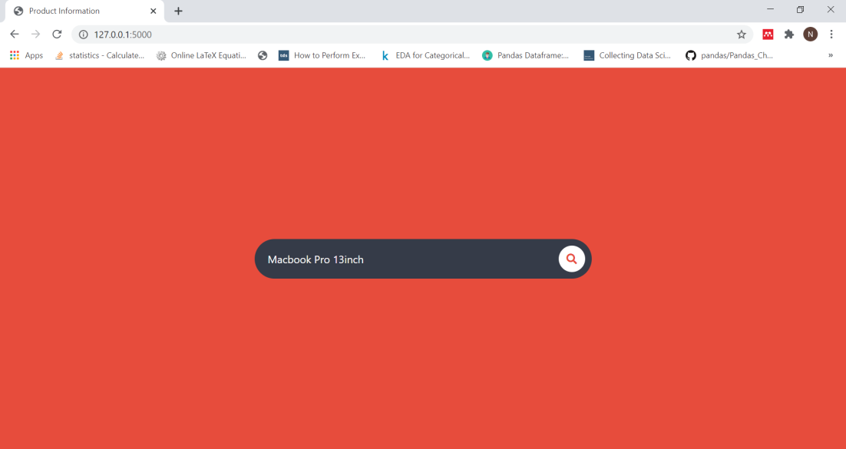

7.2 It will get the details from amazon, noon and sharafdg and give the results.

Result for Macbook Pro 13inch

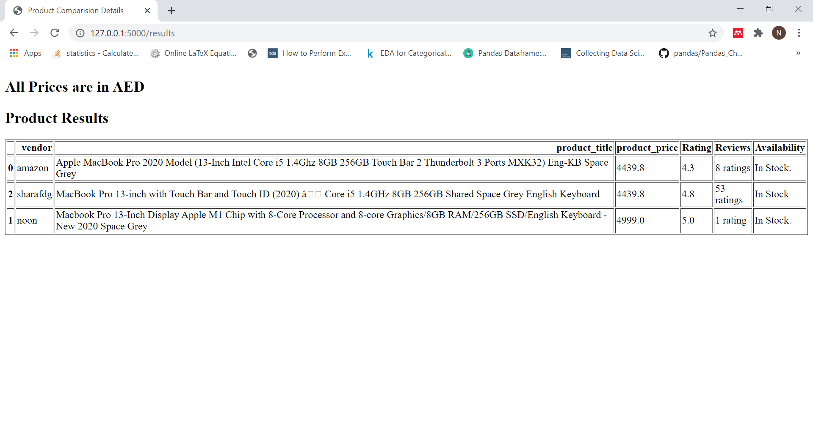

Result for Nutribullet Full Size Blender

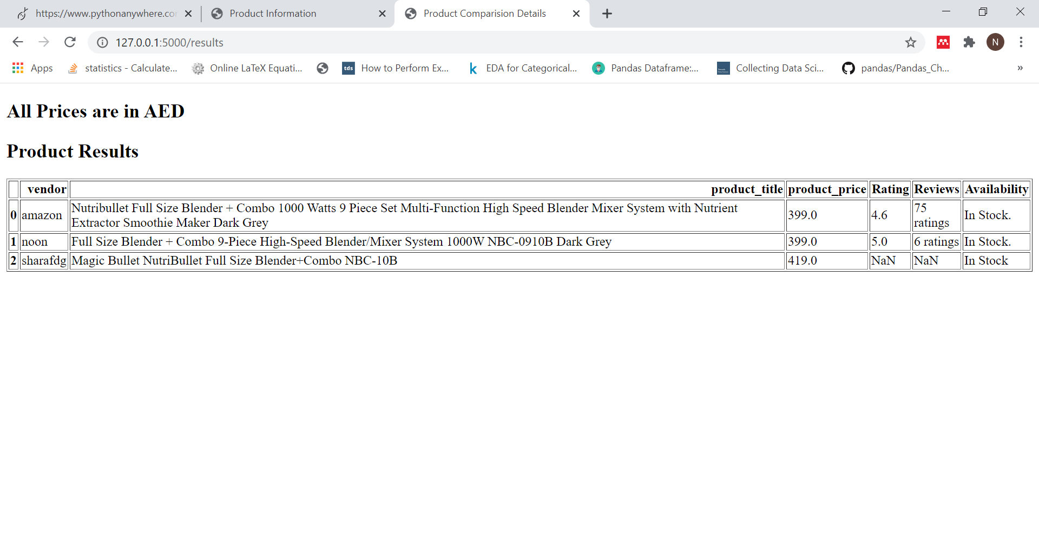

Results for iPhone 11 Pro Max 256 GB

